**ON-THE-JOB-TRAINING IN**

**MANAGEMENT INFORMATION SYSTEMS OFFICE,**

**CITY COLLEGE OF TAGAYTAY**

A Narrative Report

Submitted to the Faculty of the

School of Computer Studies

City College of Tagaytay

In partial fulfillment of

the requirements for the degree,

Bachelor of Science in Computer Science

**RIVERA, GIZELLE ANN C.**

**OCTOBER, 2024**

Republic of the Philippines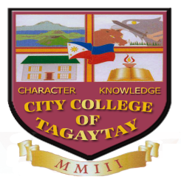

|  |
| --- |
| City of Tagaytay |
| **CITY COLLEGE OF TAGAYTAY**  **SCHOOL OF COMPUTER STUDIES** |
| Department of Computer Science  **APPROVAL SHEET**  **Narrative Report** |
|  |

This **NARRATIVE REPORT** on **ON-THE-JOB TRAINING** from **November** to **April 2024** was undertaken at the **MANAGEMENT INFORMATION SYSTEM (MIS) OFFICE, CITY COLLEGE OF TAGAYTAY**, and is prepared and submitted by **RIVERA, GIZELLE ANN C.** in partial fulfillment of the requirement for the CSPC99(Practicum/Internship).

Approved by the PRACTICUM/INTERNSHIP COORDINATOR with a rating of ______.

**JEFERLYN A. AÑONUEVO, MIT**

Practicum/Internship Coordinator

Accepted as partial fulfillment of the requirements for the CSPC99 (Practicum/Internship).

**ANGELITO M. CARAAN, MIT**

Department Chair

**JEFERLYN A. AÑONUEVO, MIT**

School Dean

**BIOGRAPHICAL DATA**

Rivera, Gizelle Ann C. was born on November 05, 2002 in Bungahan, Lian, Batangas. She is the yougest daughter of Mr. Fidel E. Rivera and Mrs. Anastacia C. Rivera.

She finished her primary education at Aga Elementary School in Aga, Nasugbu, Batangas, studying there from 2009 to 2015. After that, she attended Banilad National High School for junior high school and completed it between 2015 and 2019. She then completed her senior high school education at Lian Institute from 2019 to 2021.

Currently, She is pursuing Bachelor of Science in Information technology program at City College of Tagaytay where she is actively enhancing her skills and knowledge in the field.

**ACKNOWLEDGEMENT**

The author would like to express his sincere gratitude to the many individuals and institutions that have supported and guided him throughout his internship at the MIS Office of City College of Tagaytay:

To the on-the-job training coordinator **Mrs. Jeferlyn A. Anonuevo**, for the continuous support and guidance throughout the internship. The efforts in coordinating the activities, providing valuable feedback, and ensuring that he had a meaningful learning experience were greatly appreciated;

To the **Department of the School of Computer Studies**, for the support and commitment in fostering the practical learning environment to students making this internship possible. Their emphasis on real-world application and hands-on experience has been pivotal in shaping my academic and professional journey. Thank you all for your invaluable contributions to my growth and success during this internship.

To the **Ospital Ng Tagaytay** for providing him with this invaluable opportunity to engage in a comprehensive learning experience. The knowledge and skills he has gained during those times were immeasurable, He is deeply appreciative of the trust and responsibilities bestowed upon him.

To the **Ms. Sheryl Joyce B. Acebes** whose guidance and mentorship have been instrumental in my professional development. His insightful feedback and unwavering support were crucial in navigating the various tasks and challenges encountered during the internship;

Her **parents** for the unwavering support, encouragement, understanding, and trust in his capabilities which have been a driving force behind my academic and professional pursuits.

**TABLE OF CONTENTS**

|  |  |
| --- | --- |
| **THE PRELIMINARIES** | **Page** |
| Title Page…………………………………………………………………… | i |
| Approval Sheet……………………………………………………………. | ii |
| Biographical Data………………………………………………………… | iii |
| Acknowledgment………………………………………………………. | iv |
| Table of Contents………………………………………………………… | v-vii |

|  |  |
| --- | --- |
| **I. ORGANIZATION OF THE REPORT** | **Page** |
| Introduction…………………………………………………………………  **Rationale**   1. Significance of On-The-Job Training 2. Hours Required for On-The-Job Training   **Linkage Establishment**   1. Name and General Location 2. Institution’s Objectives/Philosophy 3. Ownership/Management 4. Organizational Chart 5. Facilities (Application Use) 6. Outstanding Characteristics of the Establishment | 1-11 |

|  |  |
| --- | --- |
| **II. BUSINESS INDUSTRIES** | **Page** |
| Organizational Structure………………………………………………. | 12-13 |
| Standard Operating Procedures……………………………………. | 12-15 |
| Facilities and Equipment………………………………………………. | 15-18 |
| Manpower…………………………………………………………… | 19 |
| Work Atmosphere……………………………………………… | 19-20 |
| Use of Materials………………………………………………. | 20-21 |
| Strength………………………………………………………… | 21 |
| Weaknesses/Improvement Areas…………………………… | 21-22 |
| Recommendations………………………………………………………. | 22 |

|  |  |
| --- | --- |
| **III. PRACTICUM EXPERIENCE** | **Page** |
| Task Performed………………………………………………………….. | 23 |
| Observed Strengths and Weaknesses…………………………… | 24 |
| Suggestion for Self-Improvement…………………………………. | 25 |

|  |  |
| --- | --- |
| **IV. SUMMARY, CONCLUSION, AND RECOMMENDATION** | **Page** |
| Summary……………………………………………………………………. | 26-27 |
| Conclusion…………………………………………………………………. | 27 |
| Recommendation………………………………………………………… | 28 |
| Literature Cited…………………………………………………………… | 29 |

|  |  |
| --- | --- |
| **APPENDICES** | **Page** |
| A. Student Trainee’s Personal History Statement……………. | 30 |
| B. Parental Consent or Waiver for On-the-Job Training…… | 31 |
| C. Acceptance Form ………………………………………… | 32 |
| D. Learning Experience Journal ……………………………… | 33-44 |
| E. Daily Time Record or Log Book ……………………… | 45 |
| F. Certificate of Completion ………………………………… | 46 |
| G. English Critic Certification ………………………………… | 47 |
| H. Evaluation Sheet…………………………………….…………… | 48 |
| **APPENDICES** | **Page** |
| I. Practicum Agreement …………………………………… | 49 |
| J. Resume………………………………………………………. | 50 |
| K. Internship Agreement ………………………………… | 51 |

**LIST OF FIGURES**

|  |  |
| --- | --- |
| FIGURES | **PAGE** |
| Figure 1. MIS Office Logo………………………………… | 3 |
| Figure2. Location map of MIS Office at City College of Tagaytay | 4 |
| Figure 3. MIS Office Organizational Chart………………………. | 6 |
| Figure 4. Management Information Systems (MIS) Office……. | 7 |
| Figure 5. Figma………………………………………………. | 7 |
| Figure 6. Microsoft Word………………………………………… | 8 |
| Figure 7. Microsoft Excel…………………………………… | 8 |
| Figure 8. Google Sheet…………………………………………….. | 9 |
| Figure 9. Google App Sheet……………………………… | 9 |
| Figure 10. FlutLab……………………………………………… | 10 |
| Figure 11. Brave Browser………………………………. | 10 |
| Figure 12. Organizational Structure………………………….. | 12 |
| Figure 13. Rack Server…………………………………… | 15 |
| Figure 14. Logitech C920 HD Pro Webcam………………… | 16 |
| Figure 15. Workstation……………………………………… | 16 |
| Figure 16. Epson L3110………………………………………. | 17 |
| Figure 17. Aquos Sharp TV……………………………….. | 17 |
| FIGURES | **PAGE** |
| Figure 18. Soundcraft EFX12…………………………………. | 18 |
| Figure 19. SMART-51D Dual-Sided Thermal ID Card Printer….. | 18 |
|  |  |
|  |  |
|  |  |
|  |  |
|  |  |
|  |  |
|  |  |
|  |  |
|  |  |
|  |  |
|  |  |
|  |  |
|  |  |
|  |  |
|  |  |
|  |  |
|  |  |
|  |  |
|  |  |

**ON-THE-JOB-TRAINING IN**

**MANAGEMENT INFORMATION SYSTEMS OFFICE**

**CITY COLLEGE OF TAGAYTAY**

**RIVERA, GIZELLE ANN C.**

A Narrative Report submitted to the faculty of the School of Computer Studies in partial fulfillment of their requirements for graduation of the degree of Bachelor of Science in Computer Science. Prepared under the supervision of Mr. Aldwin Carlo M. Angcaya.

**INTRODUCTION**

The on-the-job training (OJT) program is a crucial component of the academic curriculum which is designed to bridge the gap between theoretical knowledge and practical application. It aims to equip students with hands-on experience in their chosen fields and allow them to apply classroom-taught concepts in real-world scenarios. The primary objective of this practicum training is to develop the trainee's professional skills, enhance their technical knowledge, and prepare them for the demands of their future careers.

The specific goals of the OJT include fostering a deep understanding of industry practices, improving problem-solving abilities, and cultivating a sense of professionalism. Through this training, the trainee is expected to gain practical experience that complements their academic learning, thereby enhancing their overall competency and employability.

**SIGNIFICANCE OF THE ON-THE-JOB TRAINING**

The significance of the on-the-job training cannot be overstated. It serves as a crucial phase in an academic journey where students experience a transition from theoretical learning to practical application. It not only provides valuable insights into the professional environment but also allows students to develop a better understanding of their future roles within the industry. For the trainee, this OJT was particularly significant as it offered exposure to real-world challenges and opportunities to apply learned concepts in a practical setting. It also provides a platform to interact with professionals, gain industry-specific knowledge, and refine technical skills which are all essential for career readiness. The experience gained through this training is expected to contribute significantly to the trainee's future success equipping them with the confidence and competence needed to excel in their chosen career path.

**TIME AND PLACE OF THE ON-THE-JOB TRAINING**

The practicum training was conducted at the Osptal ng Tagaytay, located at 1315 Aguinaldo Hwy, Tagaytay City. The training commenced on November 27, 2024, and was completed on April , 2024 spanning a total of twenty-seven () days. During this period, the trainee rendered a total of two hundred (486) hours of internship where he diligently worked to meet the program’s objectives.

**THE LINKAGE ESTABLISHMENT**



**Figure 1**. Ospital ng Tagaytay Logo

**Figure 1** Ospital ng Tagaytay is a public healthcare institution serving Tagaytay City and its surrounding areas since its establishment in 1997. As a government-operated hospital, it aims to provide affordable and accessible medical services to residents and visitors alike. The hospital emphasizes patient care, community health, and wellness through its various medical and surgical departments, emergency services, outpatient consultations, and diagnostic facilities.

The logo of Ospital ng Tagaytay reflects its core values and location. The central element is the Caduceus, symbolizing health and medical practice, surrounded by an image of Tagaytay's iconic natural landmarks, such as the rolling hills and the serene depiction of Taal Lake. This design highlights its identity as a community-centered healthcare institution within the scenic city of Tagaytay.

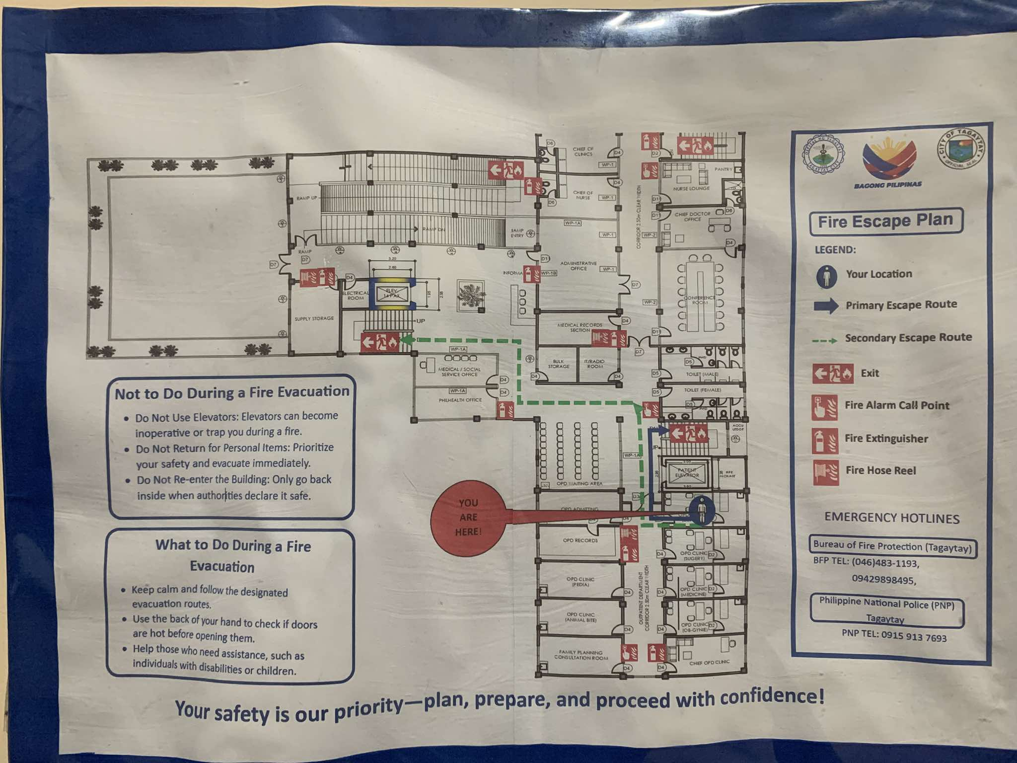

**Figure 2.** Location map of Ospital ng Tagaytay

**Figure 2** Shows a detailed layout of its interior spaces, including key areas like administrative offices, medical records, consultation rooms, the pharmacy, emergency department, and waiting areas. It also highlights fire exits, escape routes, and safety equipment locations to ensure preparedness in emergencies. This layout reflects the hospital's design for efficient navigation and accessibility for both patients and staff.

**Institution’s Objectives/Philosophy**

**Vision**

The Management Information System (MIS) office aspires to make the College a leader in the use of information technology that is effective, efficient, and innovative to its College processes.

**Mission**

The Management Information System (MIS) office’s mission is to provide information technology resources that support and enhance the City College of Tagaytay’s mission and vision.

**Ownership/ Management**

The Management Information Systems (MIS) Office at City College of Tagaytay is managed by a dedicated team of IT professionals who ensure the smooth operation and continuous improvement of the college's technological infrastructure.

**Organizational Chart**

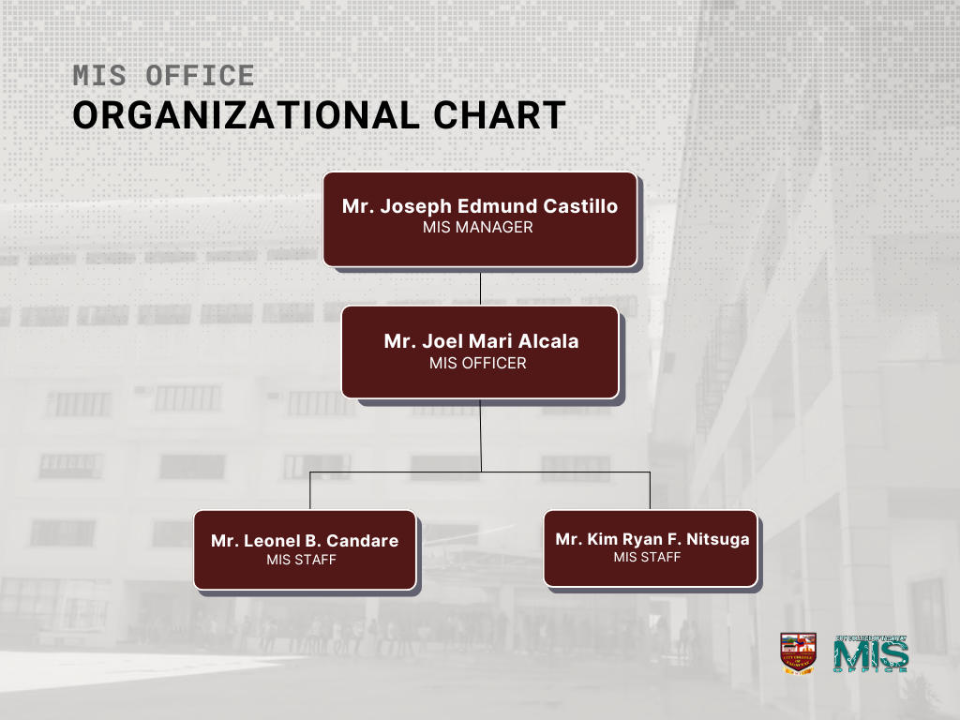

**Figure 3.** Ospital ng Tagaytay Organizational Chart

**Figure 3** shows a visual representation of the organizational structure of the MIS Office at City College of Tagaytay. The MIS Manager plays an important role in the creation, maintenance, and management of the institution's systems, ensuring that updates and modifications are implemented smoothly. The MIS officer, Mr. Aldwin Carlo Alcala, works closely with the manager, where they oversee system performance, managing the college’s server, and ensuring that key systems such as the student and employee portals are functional.

His responsibilities extend to coordinating with various departments to meet the college's evolving technological needs. The MIS staff includes Mr. Leonel Candare who handles the college’s IT infrastructure, resolves technical issues and manages audio systems for school events. Mr. Kim Ryan Nitsuga, the admission officer assists Mr. Candare and contributes to the overall technical operations.

**Facilities (Application Use)**

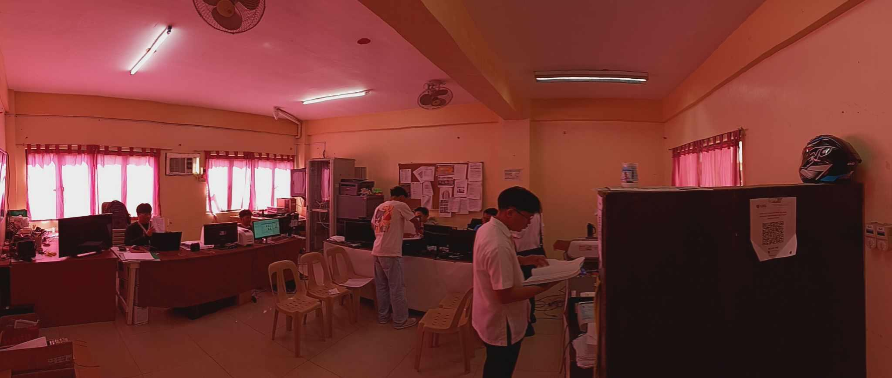

**Figure 4.**  Management Information Systems (MIS) Office

Figure 4 shows the Management Information Systems (MIS) Office at City College of Tagaytay. It is a dedicated space designed to accommodate the essential functions of the office. The office itself is a modestly sized room, capable of comfortably housing up to six personnel at a time. Despite its compact size, the room is efficiently organized to support the office's operational needs.



**Figure 5.** Figma

**Figure 5** shows Figma, a popular web-based design tool primarily used for user interface design and prototyping. It allows multiple users to collaborate in real time which is ideal for teams working on design projects. The intern used Figma to create and refine visual designs for various tasks, ensuring the efficient development of user-friendly interfaces.

**Figure 6.** Microsoft Word

**Figure 6** shows Microsoft Excel, a powerful spreadsheet application used in municipal offices for data analysis. The intern created charts and tables, demonstrating its capabilities for listing the previous personnel who work in school.



**Figure 7.** Microsoft Excel

**Figure 7** shows Microsoft Word, a word processing software for creating and editing documents in OPD admitting office at Ospital ng Tagaytay. The intern used Word to develop structured reports, utilizing features like text formatting and spell check. Its user-friendly interface allows staff to handle writing tasks efficiently.

**Outstanding Characteristics of the Establishment**

One of the most notable characteristics of the Management Information Systems (MIS) Office at City College of Tagaytay is its unwavering commitment to continuous improvement and innovation. The office is deeply dedicated to advancing its systems and processes, ensuring they are aligned with the ever-changing needs of the college. This commitment is reflected in the office's proactive approach to staying ahead of technological trends and implementing upgrades that enhance the overall efficiency and security of the institution's digital infrastructure. A prime example of this dedication is the ongoing efforts to upgrade the office's overall security measures. Recognizing the critical importance of safeguarding the college’s digital assets, the MIS Office is actively enhancing its security protocols to protect against potential cyber threats and ensure the integrity of sensitive information.

**BUSINESS INDUSTRIES**

**Organizational Structure**

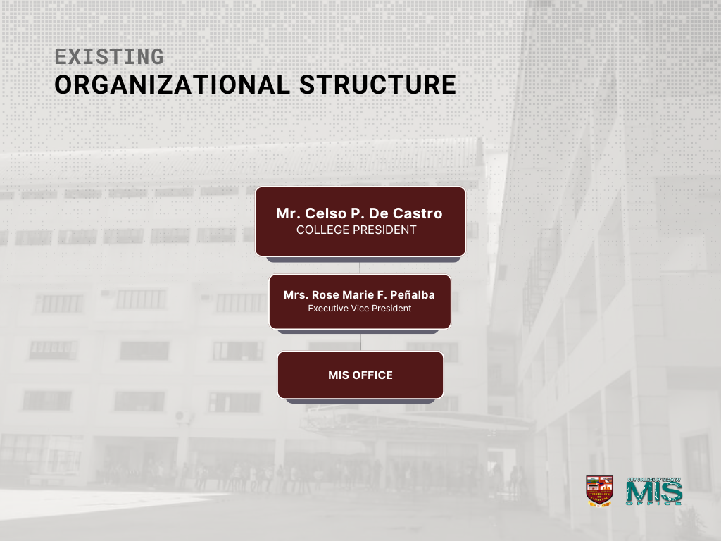

**Figure 12.** Organizational Structure

1. **College President**

The College President, Mr. Celso P. De Castro oversees all operations of the City College of Tagaytay (CCT). He provides strategic leadership and ensures that the college's academic programs, administrative functions, and overall goals align with its vision and mission.

1. **Executive Vice President**

The Executive Vice President, Mrs. Rose Marie F. Peñalba assists the College President by taking charge of the day-to-day administrative functions of the institution. She ensures that operations across various departments are running efficiently and in accordance with the institution's policies.

1. **MIS Office**

The MIS Office handles the management, maintenance, and updates of the entire information systems at the City College of Tagaytay. The team within the MIS Office, including the MIS Manager and Officer, ensures that all technological systems and databases function efficiently and provide technical support to other departments and students.

**Standard Operating Procedures**

Interns at the MIS Office of City College of Tagaytay followed a well-structured set of procedures aimed at maximizing both learning and productivity. The internship started with an orientation that familiarizes interns with the college's mission, values, policies, and the specific goals of the MIS Office. During this time, interns received a detailed overview of the activities and tasks they will undertake throughout their internship. This initial orientation ensured that interns understand both the broader objectives of the office and the expectations for their individual roles.

Following the general orientation, a specific briefing was held to outline the tasks assigned to each intern. With this clear understanding, each workday began with interns promptly starting their assigned duties allowing them to apply their skills effectively.

To facilitate this learning process, the supervisor provides the necessary support and resources for interns to grasp any unfamiliar concepts. Interns are encouraged to ask questions and seek guidance as needed to successfully perform their duties. This supportive atmosphere fosters a collaborative environment where feedback is actively solicited. Interns are encouraged to share their opinions on current tasks and suggest improvements or automation opportunities within the office's systems or projects. Regular discussions and problem-solving sessions create a platform for interns to share insights, provide feedback, and collaboratively tackle challenges, ensuring alignment with project goals and the continuous evolution of the office.

In addition to these collaborative efforts, the MIS Office employs a system to track the data-capturing process for incoming freshmen students. This system logs each intern’s activity, detailing who processed each student, when it occurred, and what tasks were completed. The supervisor systematically monitors this data to ensure all tasks are accurately tracked. The system serves as a troubleshooting tool for any issues that may arise, providing a clear audit trail for discrepancies or problems. Should interns encounter challenges they cannot resolve, the supervisor promptly intervenes to maintain workflow efficiency.

Interns were also expected to maintain professionalism at all times, adhering to company policies and embodying the office's values. At the conclusion of the internship, interns underwent a formal evaluation process, which provides constructive feedback on their performance and contributes to their professional development.

In line with maintaining a productive environment, interns also undertake specific responsibilities each morning to ensure a clean and hygienic workspace. This routine includes thorough cleaning of the office, which encompasses dusting surfaces, organizing workstations, and ensuring that common areas are neat and presentable. Regular waste management is a critical component of these procedures; interns are tasked with taking out the trash daily to prevent any buildup that could lead to unpleasant odors or health hazards.

To further enhance health and safety, alcohol-based sanitizers and disinfecting materials are placed throughout the office. These are readily accessible for all staff and interns, promoting frequent use, especially before and after handling shared equipment or materials.

**Facilities and Equipment**

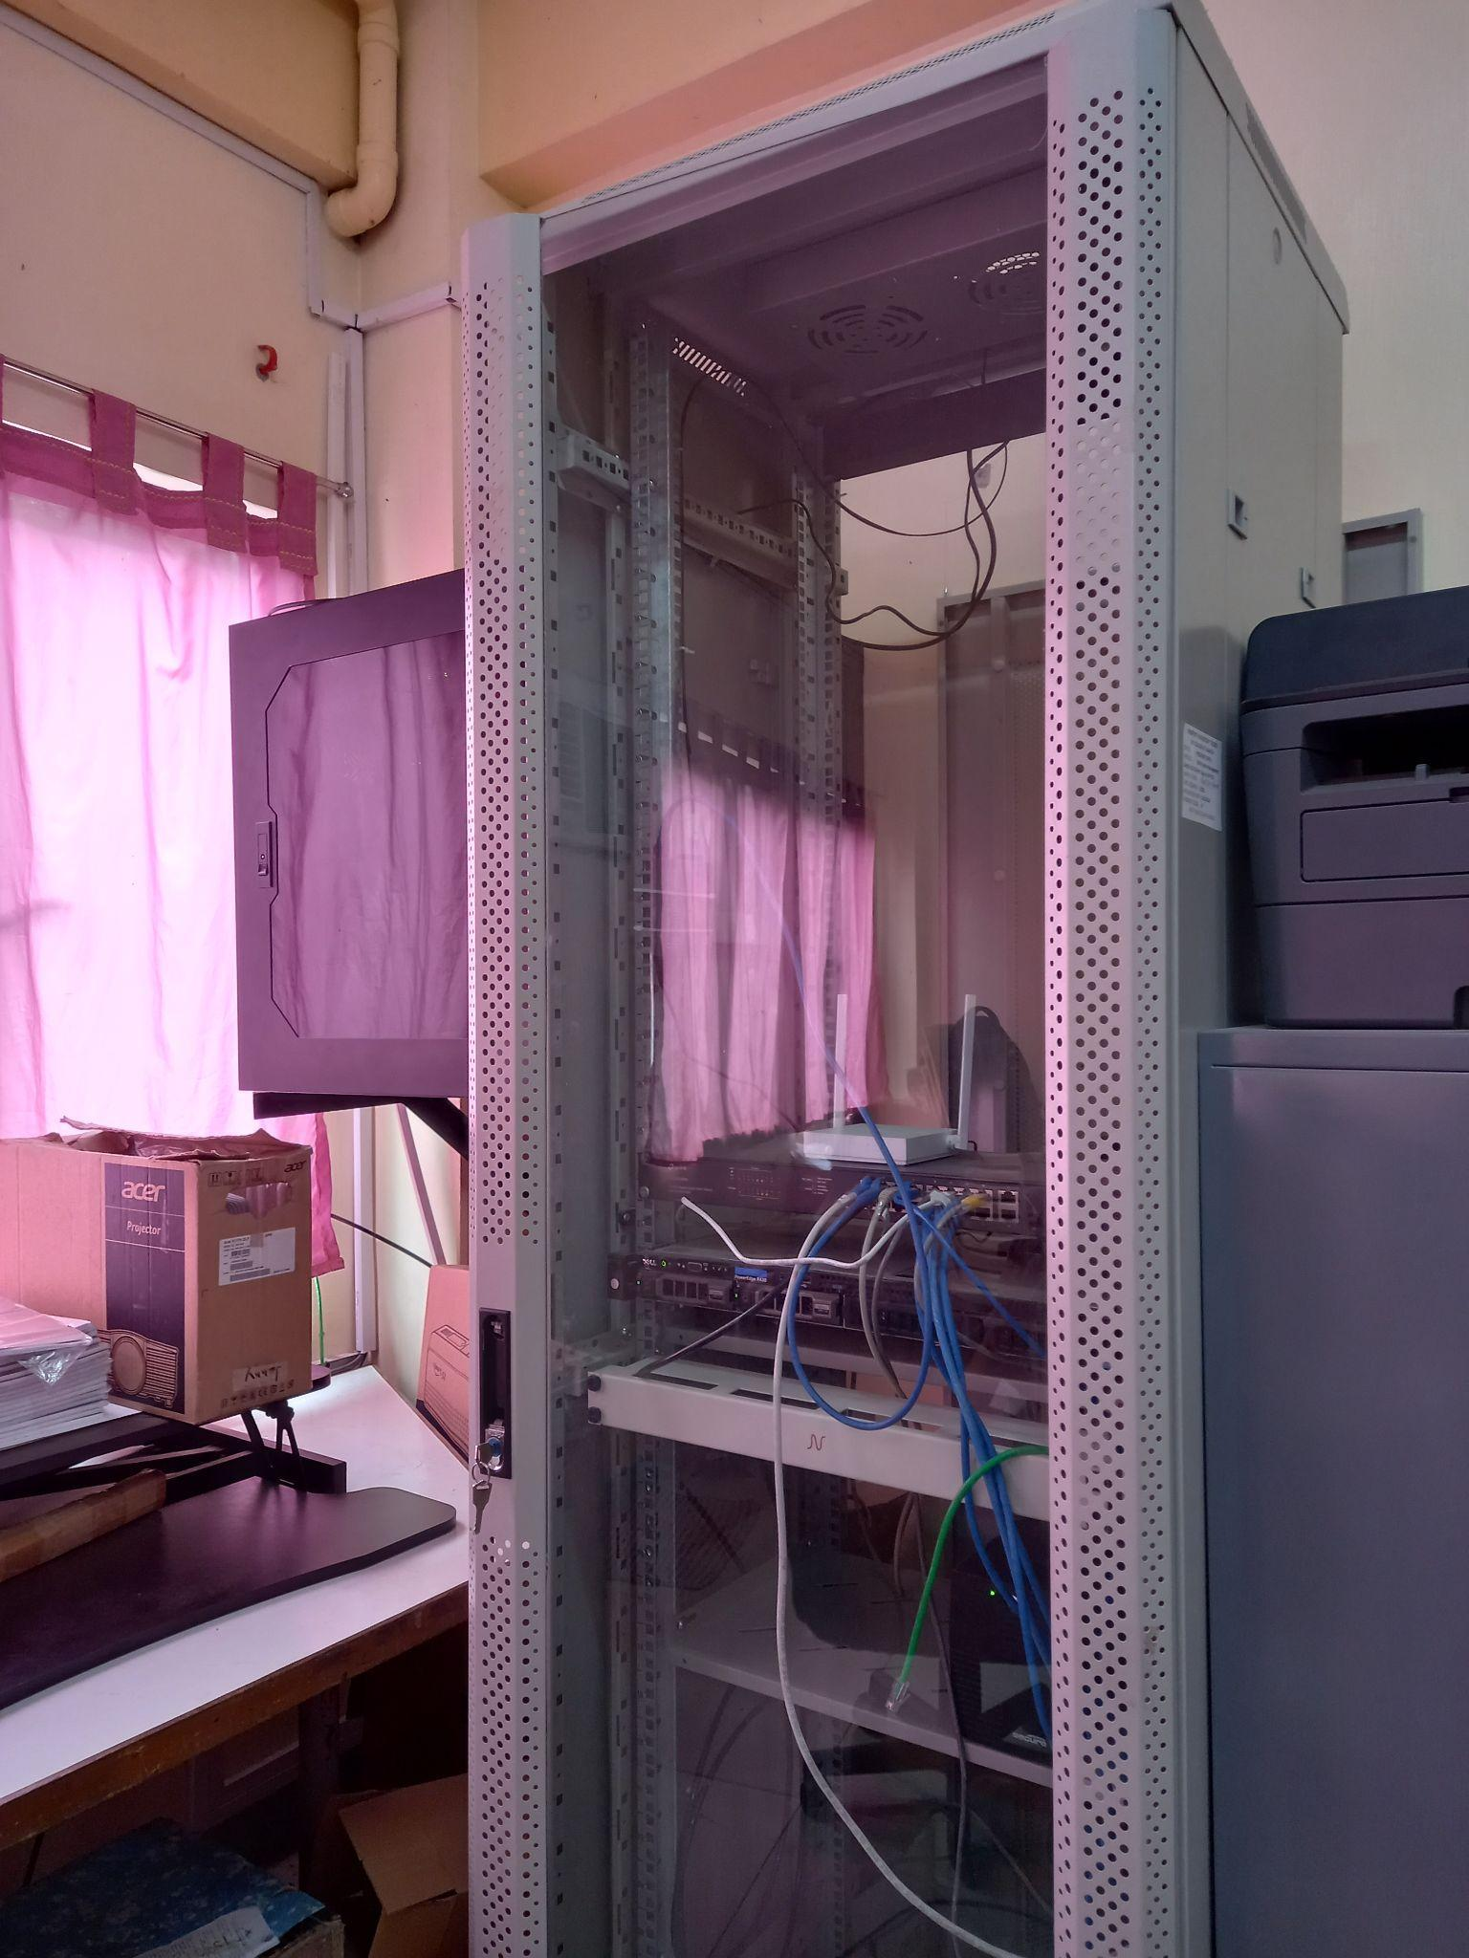

**Figure 13.** Rack Server

Figure 13 shows the rack server in the MIS Office. It is a critical piece of equipment that houses the servers used to manage various digital systems within the institution. It is responsible for storing and processing large amounts of data and ensuring that all school-related systems such as the student portal, employee portal, and internal databases run smoothly. Interns, while not directly responsible for its management learned about the importance of maintaining server health and security through their exposure to the office’s daily operations.

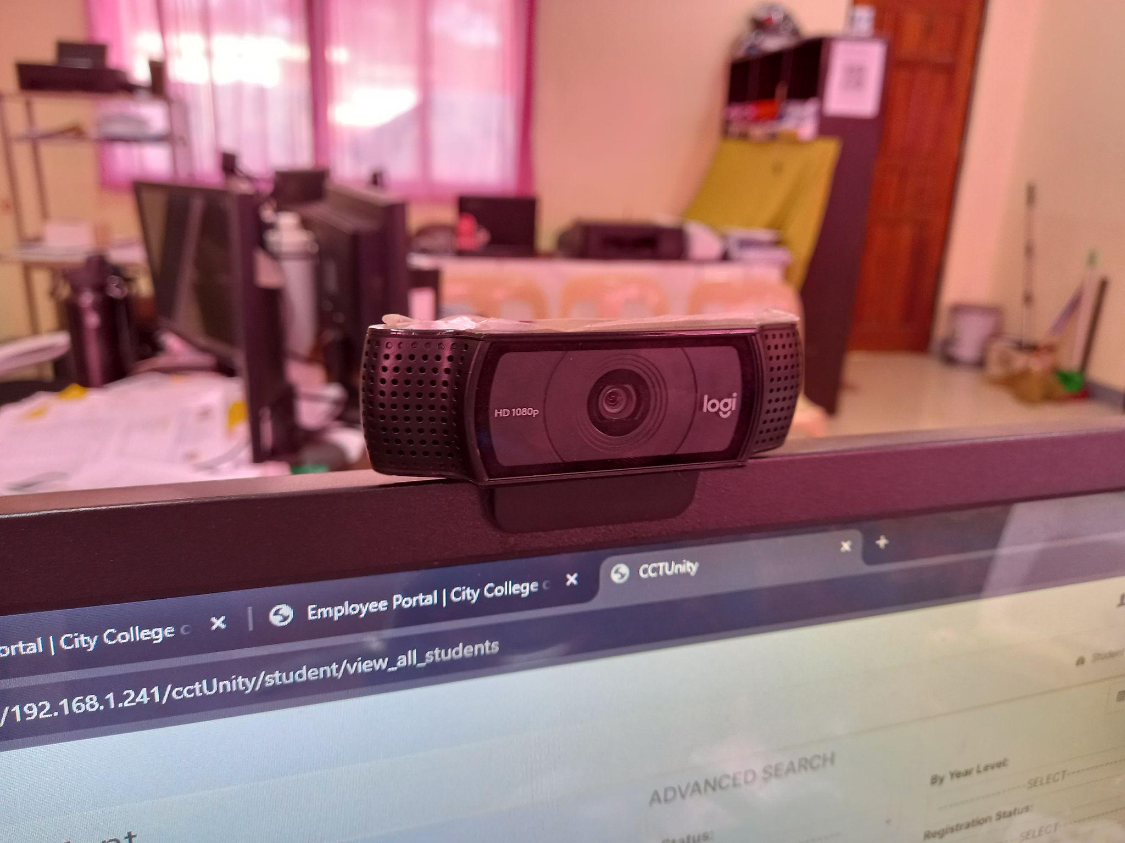

**Figure 14.** Logitech C920 HD Pro Webcam

Figure 14 shows the Logitech C920 HD Pro Webcam. It is a high-definition camera used in the MIS Office for capturing clear and professional-quality images. During the internship, this webcam played a key role in the photo capturing process for incoming first-year students. The images taken using this webcam were essential for student profile creation in the school’s portal system, ensuring each student had an updated profile photo in the database.

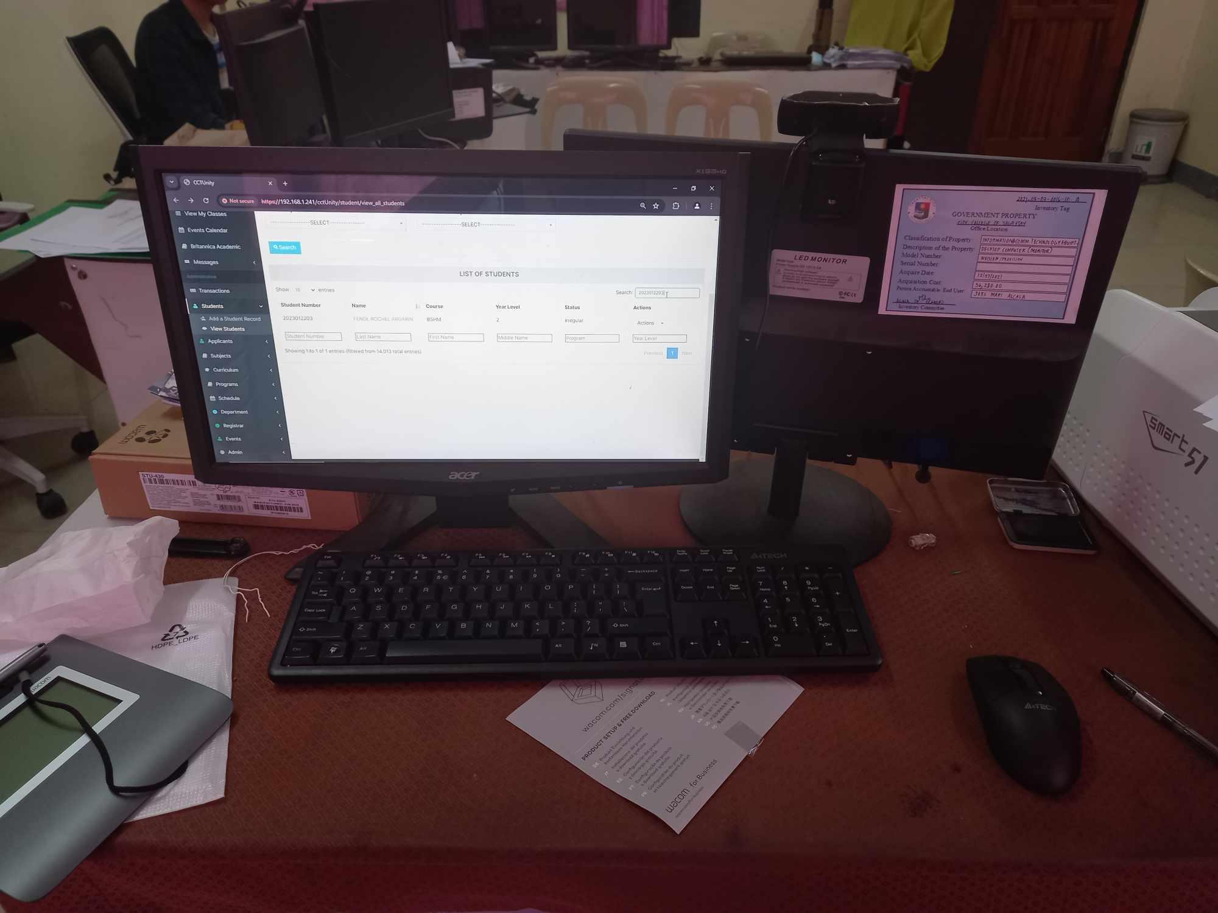

**Figure 15.** Workstation

Figure 15 shows the workstation in the MIS Office. It is an MSI desktop model MS-7A70, featuring an Intel Core i5-7600 CPU at 3.50 GHz with four cores and 24 GB of RAM. It runs Windows 10 Pro 64-bit and supports DirectX 12 for enhanced graphical performance. This setup enables efficient data processing and software testing, essential for the MIS team's daily operations.

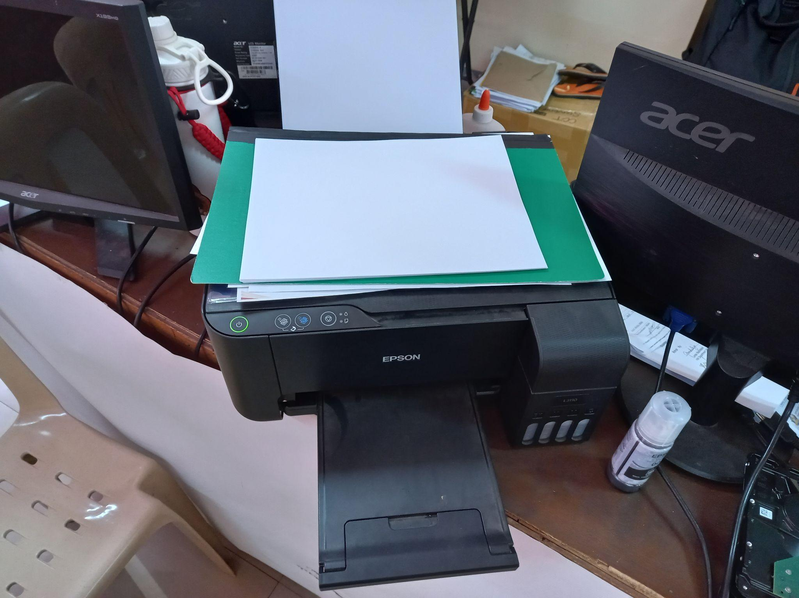

**Figure 16**. Epson L3110

Figure 16 shows the Epson L3110 Printer used in the MIS Office. It is an all-in-one inkjet printer designed for high-volume printing, scanning, and copying. Its compact design and EcoTank feature make it ideal for printing large amounts of documents and reports while minimizing ink costs. Interns and staff use it to handle various printing tasks, including student records, administrative paperwork, and reports.

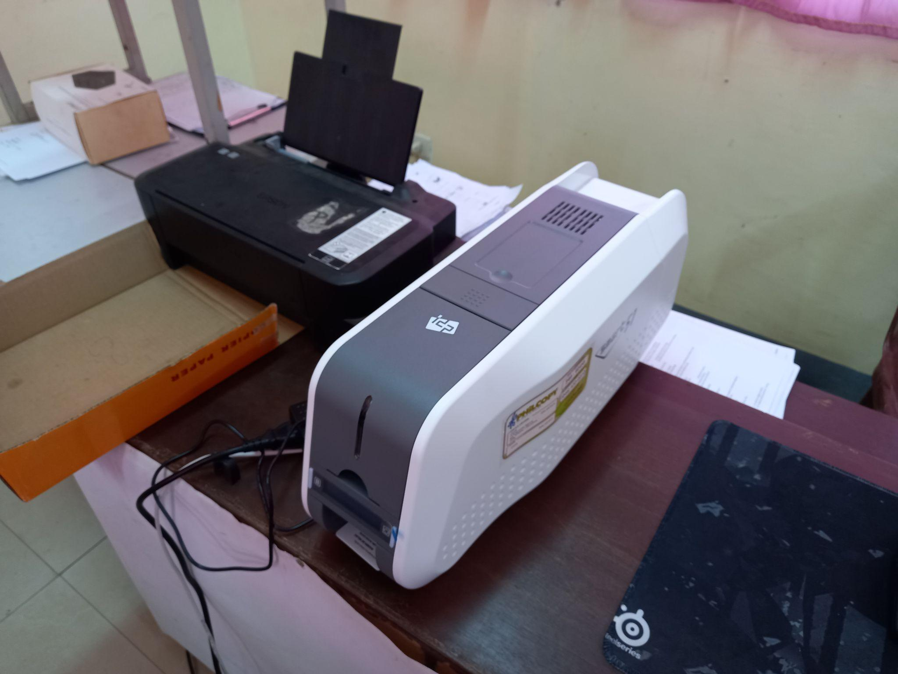

**Figure 19**. SMART-51D Dual-Sided Thermal ID Card Printer

Figure 19 shows the SMART-51D Dual-Sided Thermal ID Card Printer. It is used in the MIS Office for printing identification cards for students and staff. This high-performance printer allows for dual-sided printing, producing durable and professional-grade ID cards quickly and efficiently.

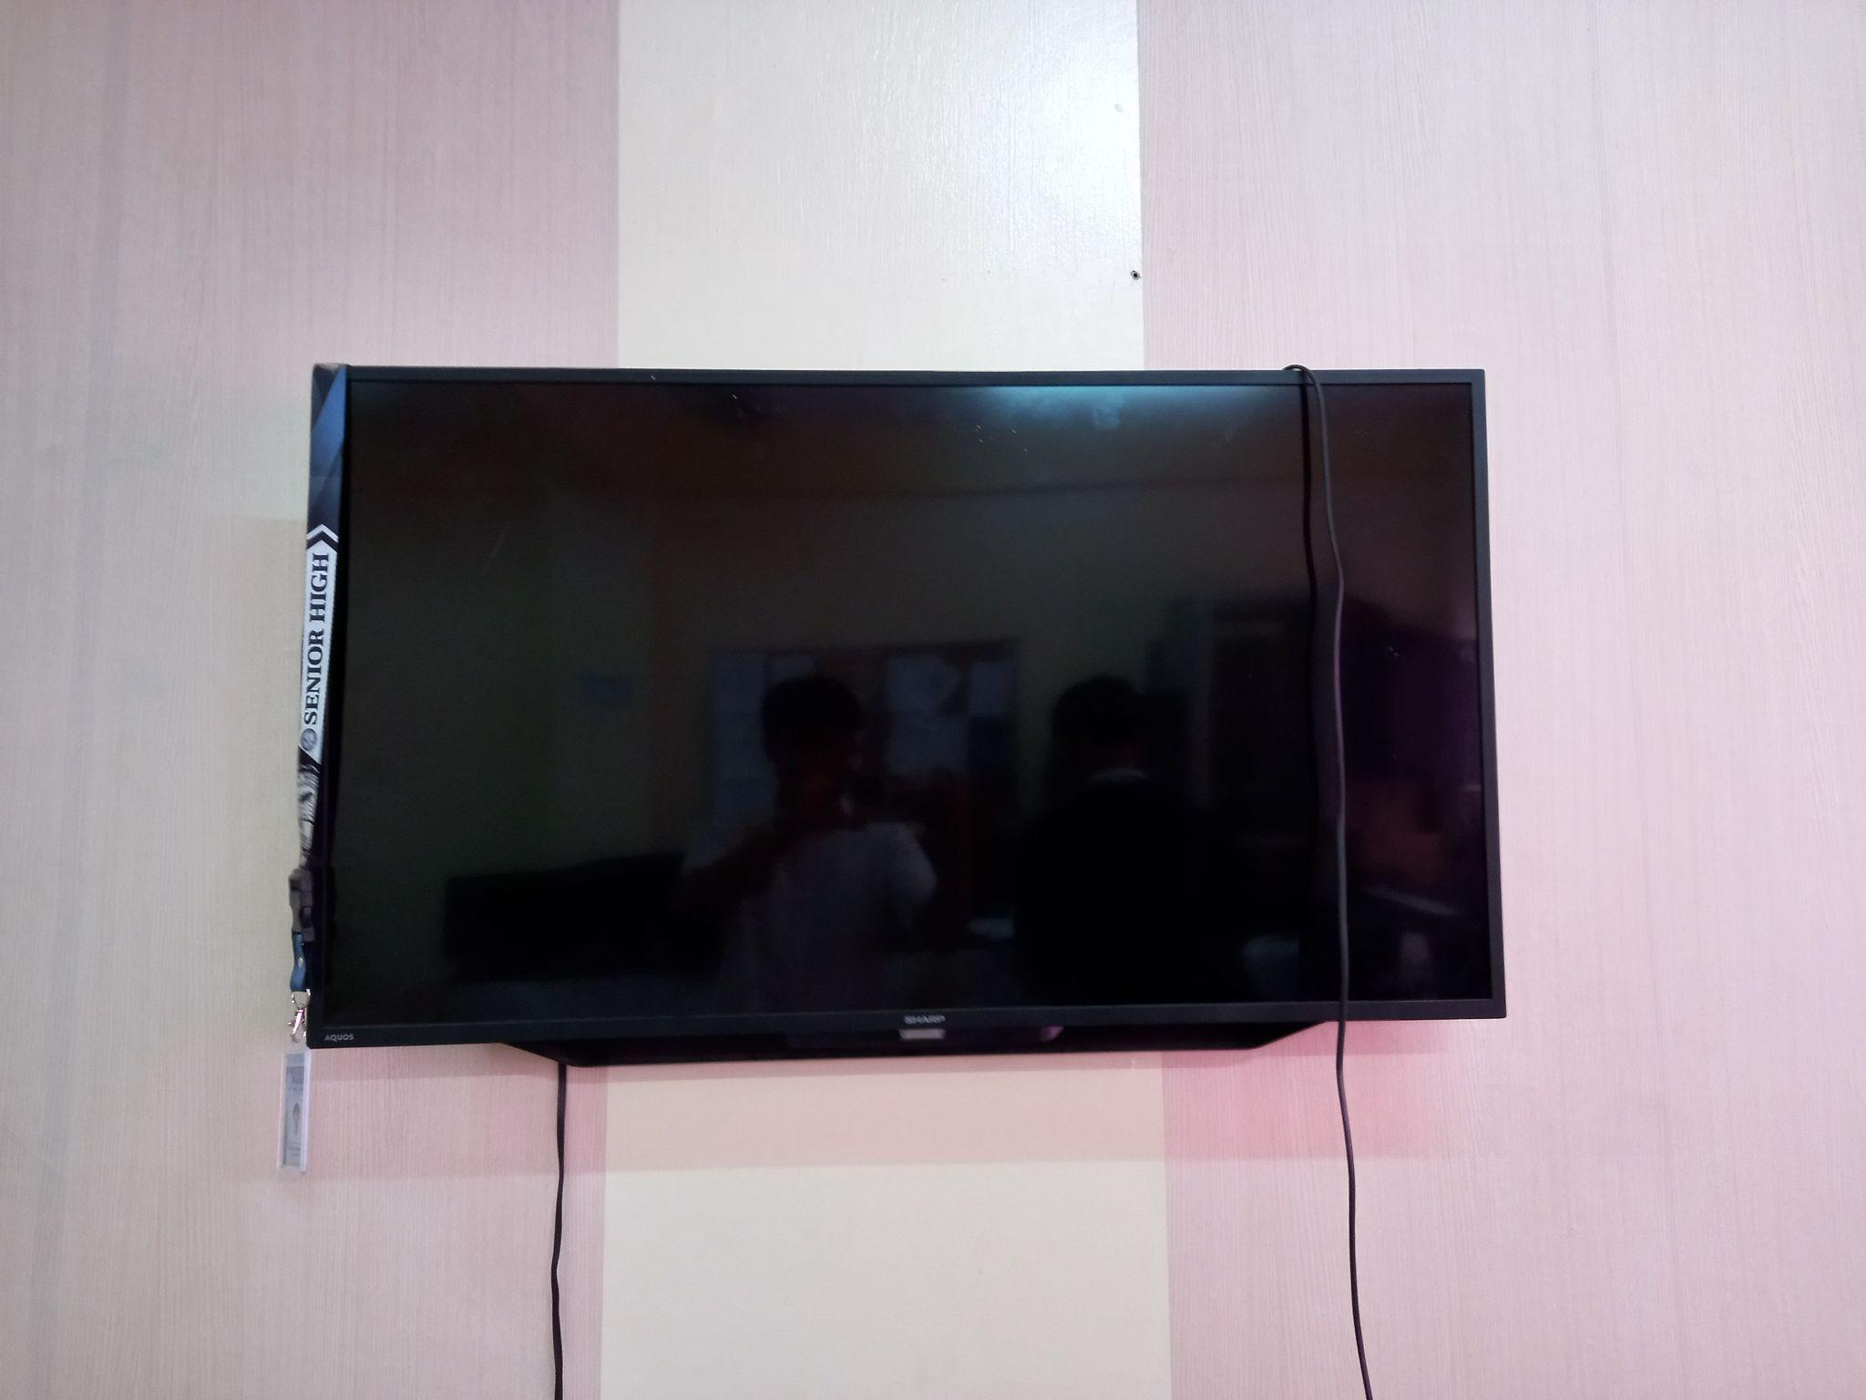

**Figure 17.** Aquos Sharp TV

Figure 17 shows The Aquos Sharp TV in the MIS Office. It serves as a large display for presentations, meetings, and system monitoring. Its high-definition screen is used by the MIS team and interns to display project plans, system dashboards, and other visual data during discussions. It also plays a key role in training sessions, where it helps showcase software interfaces and technical demonstrations clearly to the team.

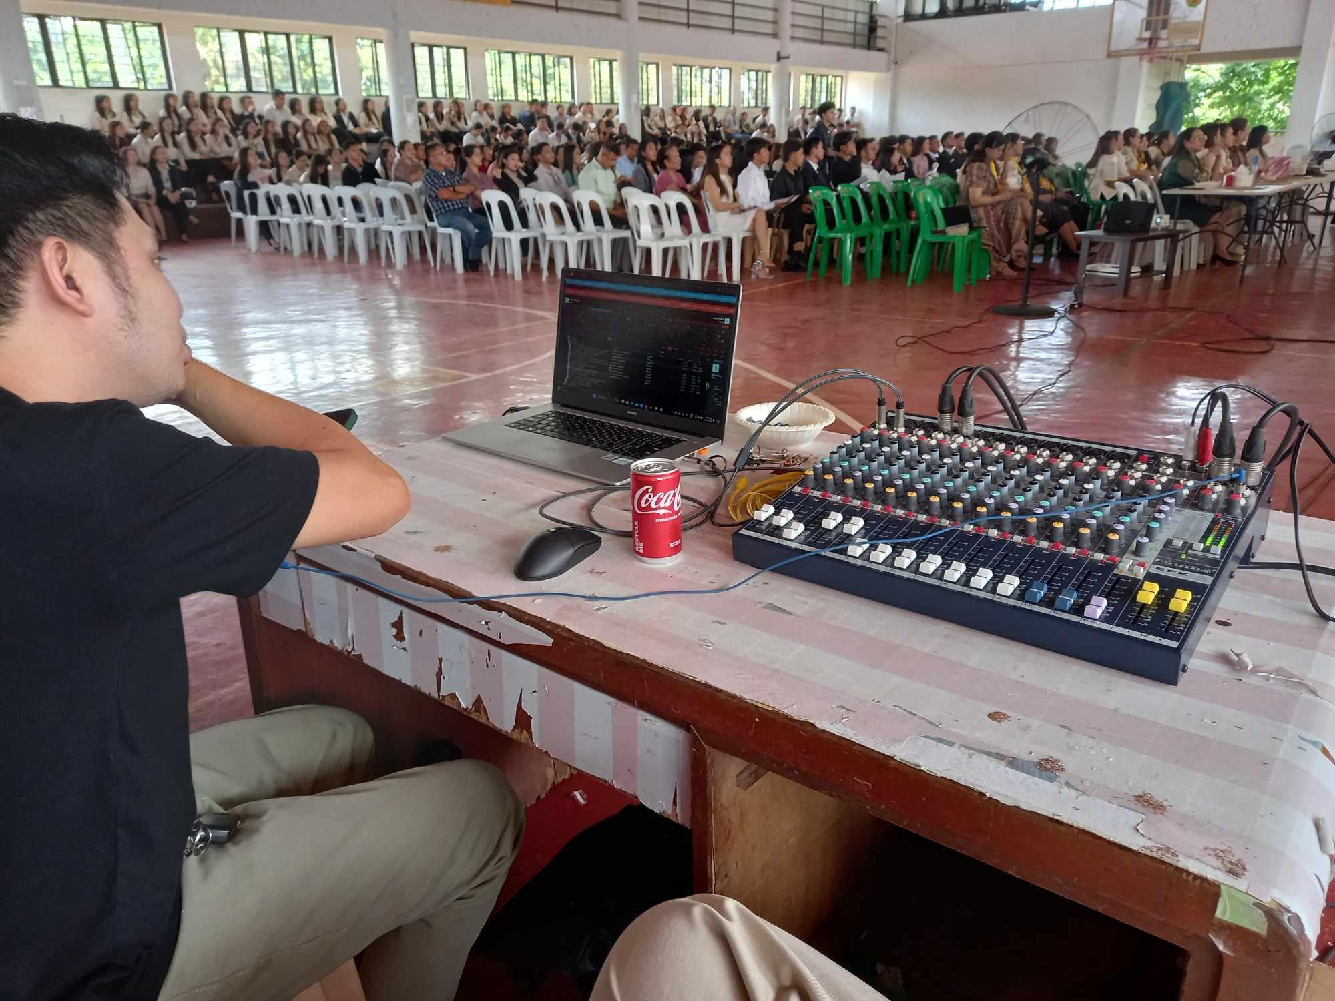

**Figure 18.** Soundcraft EFX12

Figure 18 shows the Soundcraft EFX12. It is a professional audio mixer used in the MIS Office for managing sound during events and technical setups. It provides high-quality audio control with 12 input channels and built-in effects, ensuring clear sound delivery during presentations, meetings, and large school events.

**Manpower**

Interns in the MIS Office begin each workday by promptly addressing their assigned tasks. Typically, all interns are given the same tasks although there are instances where assignments are tailored to align with each intern’s specific strengths and skills, ensuring a balanced and effective workload. Regular team discussions foster open communication, giving interns the opportunity to exchange ideas, share insights, and offer feedback. These discussions not only enhance collaboration but also promote a culture of continuous improvement within the office. Unlike other offices which rely on digital tools for tracking progress in real-time, the MIS Office adopts an output-based performance system. Communication is done directly among interns and staff to ensure that everyone remains aligned, even when working from different locations. Interns are expected to follow structured processes, breaking down their assignments into manageable steps to ensure steady progress and high-quality output. Supervisors are readily available to offer guidance and provide clarity when needed. This supportive environment helps empower interns to approach their tasks with confidence, ensuring precision in their work.

**Work Atmosphere**

The work atmosphere in the MIS Office is characterized by a balance of professionalism and collaboration. Team members are expected to maintain a high standard of professionalism in their tasks, but the environment is also open and conducive to teamwork. The office encourages the sharing of ideas and collaborative problem-solving, creating a space where everyone’s input is valued. This approach fosters innovation and ensures that challenges are met with a collective effort. The environment is supportive, with a strong emphasis on continuous learning and improvement. Team members are encouraged to develop their skills and keep up with the latest technological advancements. Interpersonal relationships within the office are positive and characterized by a strong sense of teamwork and mutual respect. Colleagues interact with one another in a respectful and friendly manner, which contributes to a harmonious work environment. There is a clear understanding that each member’s role is vital to the success of the department, and this mutual respect translates into effective collaboration on projects and tasks. This supportive and cohesive atmosphere makes the MIS Office a productive and enjoyable place to work.

**Use of Materials**

Interns specializing in computer science quickly adapted to the various tools and systems used by the department. The office provided the interns with access to high-speed internet, ensuring smooth communication with other departments and allowing them to complete their tasks efficiently. In addition to these resources, interns were encouraged to use various software applications, such as Figma, Google Sheets, Flutlab, Power BI, and Google AppSheet, to support their tasks. Supervisors also made sure that interns received any additional learning materials or guidance on unfamiliar software, fostering a supportive and dynamic learning environment. This approach allowed the interns to refine their technical skills while effectively contributing to the projects at hand. Interns had the flexibility to choose tools and methods that best suited their workflow, as long as they met the expected quality of work. This adaptability promoted a productive environment, enabling the interns to experiment with different techniques and improve their output while adhering to the office’s standards.

**Strengths**

One of the key strengths of the MIS Office is its commitment to continuous improvement and innovation. The team is proactive in identifying areas for enhancement and implementing new systems and technologies to meet the evolving needs of the college. The staff's strong technical expertise allows them to efficiently manage and maintain critical systems such as the student and employee portals. Additionally, the collaborative work environment fosters effective problem-solving and knowledge-sharing, ensuring that technical issues are resolved swiftly. The use of automation tools further exemplifies the office's strength in optimizing processes, reducing manual work, and increasing overall efficiency.

**Weaknesses/Improvement Areas**

The limited size of the MIS Office has been identified as a significant weakness particularly when accommodating large-scale operations like data and photo capturing for incoming freshmen, which is around three thousand (3,000) students. The office's small space becomes crowded forcing the team to make constant adjustments to manage the compacted students. This situation results in a slower overall process and reduced efficiency highlighting the need for an improved workspace that can better handle such large volumes of people and tasks.

**Recommendations**

To improve the operations of the MIS Office, it is recommended that the MIS Team be relocated to a new, larger office space that can effectively accommodate a large number of students especially during peak activities like data and photo capturing sessions for freshmen. A more spacious office would alleviate the crowding issues, enhance workflow efficiency, and provide a more comfortable environment for both students and staff. Additionally, it is suggested that the current office be repurposed solely as a server room. This would optimize the use of space, ensuring that the server infrastructure is securely housed in a dedicated area, while the team operates from a more suitable and functional office environment.

**PRACTICUM EXPERIENCE**

**Task Performed**

The trainee successfully completed a range of tasks assigned by the supervisor within the MIS Office. These tasks were centered around technical support, data management, and software development. The trainee's responsibilities included setting up and maintaining computers, assisting with the data and photo capturing of incoming freshman students, and performing clerical tasks such as encoding applicant information and updating student grades in the student portal.

A significant part of the trainee’s work involved troubleshooting hardware issues, such as fixing Ethernet cables and routers, as well as supporting various departments with sound system setup for events like recognition days and graduation practices. The trainee was also involved in developing a prototype for a mobile application for the CCT student portal.

All tasks were carried out under the supervision of Mr. Joel Mari Alcala and other MIS staff, with regular feedback and guidance to ensure they were completed accurately and efficiently. Approval from the supervisor was necessary before proceeding with technical installations and data updates, ensuring quality and functionality across all projects.

**Observed Strengths and Weaknesses**

The trainee demonstrated strong technical skills, particularly in troubleshooting and problem-solving from hardware repairs to data processing tasks. The trainee quickly adapted to new technologies and software, including Google Sheets, Power BI, and application development frameworks. Dedication to learning was evident, as the trainee was consistently proactive in acquiring new skills, whether in handling sound systems, formatting PCs, or understanding data capture processes. Furthermore, the trainee displayed excellent attention to detail, ensuring the accuracy of data entries and updates in the student portal. The ability to collaborate with fellow OJTs and work seamlessly with the MIS staff also stood out as one of the trainee’s strengths.

While the trainee excelled in technical tasks, there was occasional difficulty in managing time effectively, especially during high-pressure situations with multiple ongoing tasks. Although quick to learn, the trainee sometimes required more time to become fully comfortable with new tools and processes. In a few instances, the trainee relied heavily on supervision or guidance when handling more complex tasks such as application development or setting up equipment for major events.

**Suggestion for Self-Improvement**

To further enhance professional growth, the trainee could benefit from developing better time management strategies particularly when handling multiple tasks or working under tight deadlines. Implementing a structured approach such as prioritizing tasks and setting smaller manageable goals could help in maintaining productivity even in high-pressure situations.

Additionally, while the trainee has demonstrated a strong technical foundation, there is room for improvement in becoming more independent in tackling complex tasks. Building confidence in problem-solving without immediate supervision and proactively seeking out solutions through research or experimentation could increase efficiency and lessen reliance on guidance.

Improving verbal communication skills could also be beneficial. Actively engaging in discussions and asking clarifying questions when faced with uncertainties would not only contribute to the trainee’s learning but also foster more effective collaboration with colleagues and supervisors.

Lastly, continued practice in new software and tools, especially in app development and data analysis will further solidify the trainee’s technical skill set, preparing them for more advanced challenges in future endeavors.

**SUMMARY, CONCLUSION, AND RECOMMENDATION**

**Summary**

The internship at the Management Information Systems (MIS) Office of City College of Tagaytay offered the trainee valuable insights into information management, technical support, and data processing within an academic setting. Over several weeks, the trainee took on various tasks, all of which contributed to their growth and learning in the field of computer science.

One key experience was assisting with the data-capturing process for incoming freshman students. This task honed the trainee’s attention to detail and ensured accurate validation and entry of student information into the student portal. The repetitive nature of the task underscored the importance of precision, as even small mistakes could cause major issues. The trainee also worked on a major project involving the cleaning, analysis, and visualization of a dataset. By utilizing Google Sheets for data processing and Power BI for visualization, the trainee was able to identify key insights that informed decision-making in the office.

Another notable aspect of the internship was the opportunity to participate in software development. The trainee was assigned to develop a prototype mobile application for the CCT student portal which involved researching suitable frameworks, discussing project requirements, and collaborating with other interns. This hands-on experience was particularly rewarding as it allowed the trainee to apply theoretical knowledge to solve a practical problem, bridging the gap between academics and real-world applications. Additionally, the trainee handled clerical tasks, such as encoding faculty and applicant data which deepened their understanding of the role of data management in educational institutions.

Lastly, learning practical IT support skills such as assembling and disassembling RJ45 connectors and troubleshooting network issues equipped the trainee with essential technical abilities for future IT roles.

**Conclusion**

The practicum training successfully met its goals by offering the trainee a comprehensive experience that connected academic knowledge with real-world application. Through involvement in data management, technical support, and software development, the trainee gained crucial IT skills and a clear understanding of the importance of accuracy and efficiency in managing information systems.

The internship underscored the vital role of the MIS Office in maintaining the seamless operation of the college’s IT infrastructure giving the trainee a deeper understanding of the complexities in supporting a large and varied user base. Additionally, the experience enhanced the trainee's ability to collaborate within a team, communicate effectively with users, and apply problem-solving strategies in practical situations.

**Recommendation**

Based on the trainee's experience, continuing to provide hands-on opportunities in data management and software development will help future interns build a strong foundation in Computer Science. These areas are essential for developing the technical skills necessary in today’s IT field. It is also recommended that the MIS Office extend the scope of training to include more involvement in system management and upgrades, which will allow trainees to gain a deeper understanding of critical infrastructure management.

Furthermore, relocating the MIS Office to a larger space is suggested, as this would better accommodate both staff and the large number of students, particularly during peak periods. A larger workspace could significantly enhance the efficiency and overall effectiveness of the department, providing a more conducive environment for both trainees and regular operations.