SMUBI

*Saint Mary’s University Breaking the Ice*

*Team No: - 8*

Talwinder Saini-A00430396 (Talwinder.saini@smu.ca )

Jiye Wang-A00426401 (Jiye.Wang@smu.ca )

Aditya Tandon-A00432835 (Aditya.Tandon@smu.ca)

Manoj-A00432854 (Manoj.morishetty@smu.ca )

Devvrat Deshwal-A00431503 (Devvrat.Deshwal@smu.ca)

**Table of Contents**

General Description ……………………………………………………………………….. 3

Survey/Interview Questions and Responses ………………………………………….. 3

Requirements ………….…………………………………………………………….. 4

Results of Design thinking process.........…………………………………………. 5-11

Sketches ………….……………………………………………………..…………….. 12-17

SMUBI

*Saint Mary’s University Breaking the Ice*

**General Description**

The project is aiming to provide an effective way of building up a new supporting social network for SMU students to set up connections with students of the same course, alumni, different departments and other communities as well. By establishing new contacts with people, we can provide a solid foundation for students in order to deal with daily life struggles as well as would help them to become mentally strong as they’ll have a lot of people to talk to, hence making them strong both emotionally and mentally. Breaking the ice these days is something one is not comfortable in or is shy/ afraid of and that person is unable to start a conversation with strangers, so helping them in a way to talk to people sharing the same likes/interests is very important.

**Survey/Interview Questions and Responses:**

**Survey: -**

Survey URL Link ( <https://goo.gl/forms/dWDgXDtr21U3APw62> )

Total survey responses received: - 64

**Survey/Interview Questions and Analysis**



**Summary: -**

According to the survey of sixty-four participants and interview of six participants, we discovered several insights of users’ needs. Some of our participants said that they rarely have the time of social lives and rarely reply to strangers online because of the trust issue as well. The major need of these statements is the high quality of social life. Half of the participants are introverted, and they lack the chance of starting a conversation. The extroverted participants also have problems in maintaining the connection. Their hang-out choices are confined to friends from the same department or same cultural background while other connections maintain a nodding social acquaintance, nothing more than faces they recognize. Most of the participants prefer offline social life and said:” It’s weird to talk to strangers online at the first place”. The reasons include lacking common topics, lack of communication of body language and expression, feeling distance and lack of timely reply. They all admitted that ice breaking takes time. Good ice breakers include humour, asking questions, offline events like game night and movie night, etc. For motivation, they are willing to talk to strangers because of the social personality and other reasons like career exploration and feeling responsible to help juniors. But some of the international participants mentioned that the language is an obstacle to talk to strangers in their first year.

**Requirements**

**Types of requirements:**

User Requirements: -

**Data Requirements**:

* Details of students ( ANo., Name, Email, course details, phone number, address )

**Functional Requirements**:

* Login page with SMU login authentication.
* User interface according to type user (student or other).
* Collecting user interests, hobbies, daily routine details.
* Joining the users based on interests, hobbies, study course.
* Request and response should be fast

**Usability Requirements:**

* User Interface should be fast and easy to use.
* Avoid multiple navigations by putting most of them in a single page.
* Each page should be clear by displaying relevant logos and headings.
* For every submits type content there should be a pop –up.
* Pop up messages are categorized and making generic to increase content usability.
* Most frequent content should be cached in Client or server side based on the type of content.

**Environmental Requirements:**

* Application needs 30MB of mobile hard drive and able to install .apk file.
* Need a good amount of RAM and updated OS.
* Application needs acceptable speed internet to connect to the server.

**Results of Design thinking process:**

**Persona(s)**

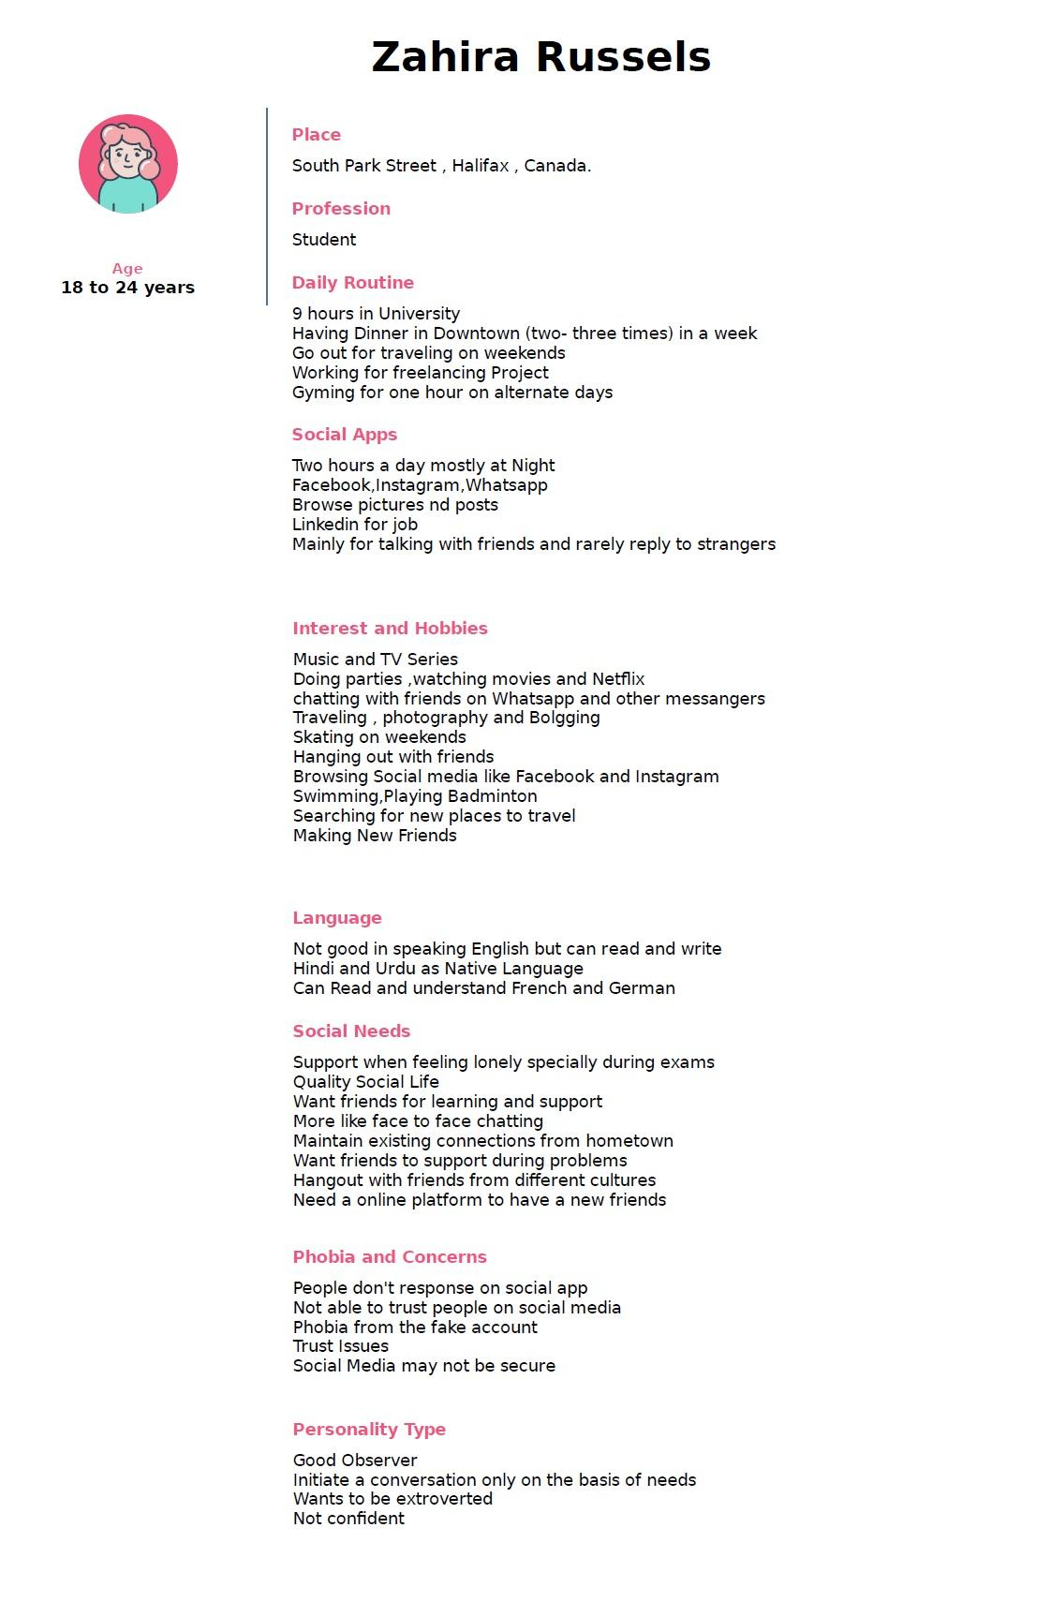

Zahira Russels is a 19 years old undergraduate student at Saint Mary’s University. She is born and brought up in India and currently staying in an apartment at South Park Street in Halifax. She used to go to Halifax Sports centre as her interest is in Swimming and playing Badminton. Other than this, she is interested in making new friends in the university through some social platform, wishes to have company for exploring Halifax and going to pubs. Zahira manages her time well, as she has a busy schedule at the university.

Other than her studies, she used to go to the gym and prepare her dinner on a daily basis. She is not very good in speaking English while she can read and write well. She is fluent in Hindi as it's her native language. She always feels the need for a quality social life like to maintain her existing connections at her home town, make new friends in Halifax may be through some online platform so that she can get some help during her exams or when she feels lonely. She needs some good friends to hang around, do parties and travel.

Even having a busy schedule she manages to watch TV series and go through some posts on social media platforms like Facebook, Instagram. She loves to chat with her friends on WhatsApp and other messengers. She always enjoys photography, blogging, and travelling with friends. Besides her interest in making new friends, she is having a phobia in initiating a conversation as well as she has a concern of insecurity and trust for the social platforms. In spite of having a concern, She is most active on social applications before going to sleep and uses them in various ways like chatting with friends, surfing their posts, and many more.

**Empathy Path:**

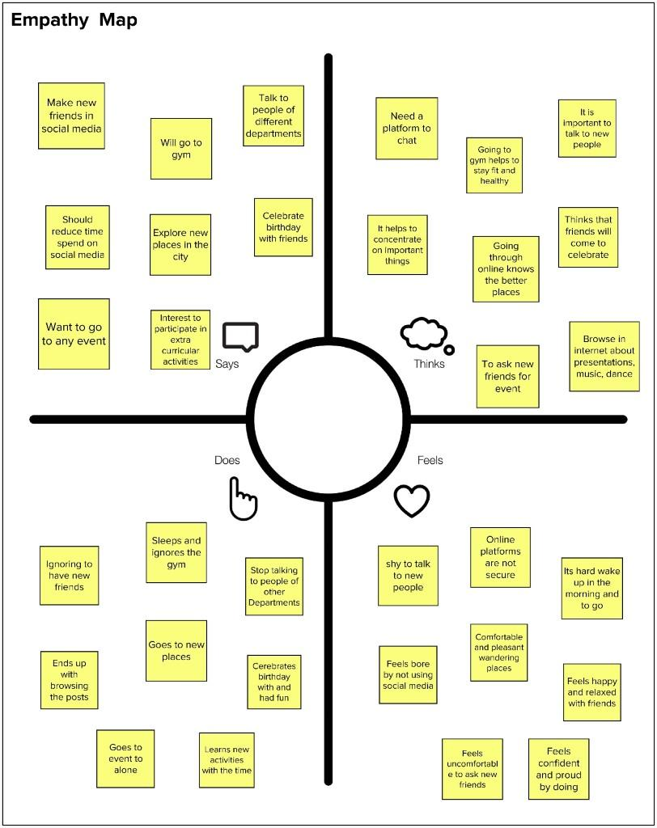

**Summary**: -

Empathy map gives deep insights into our user persona Russell’s. It is a structure which is divided into four quadrants (Do, Say, think and feel).

**"Says"**: It describes our persona that what she says to make new friends on both online and offline methods. She wants to go to gym, new locations, different departments where she can interact with new people. Exploring new places and participating in extracurricular activity to meeting new students from all around the world.

**“Thinks":**This quadrant describes how she thinks, like the need of a platform to chat with new friends, how going to the gym helps her, how it helps to talk to other department students, how the internet helps to find new places and events.

**"Does":** This quadrant tells about how she does to what she says respectively, like how it ended up, she ends up by not talking to new friends, not talking to other department students, not waking up and ignoring the gym, going to new places and event alone and celebrates her birthday with friends.

**"Feels":** It gives the emotion of each experience, our persona feels bored by not using social media, feels insecure of the platform on chatting with new friends, relaxed by wandering the new places nearby, and feels happy by celebrating her birthday with friends.

**As-Is Scenario Map**

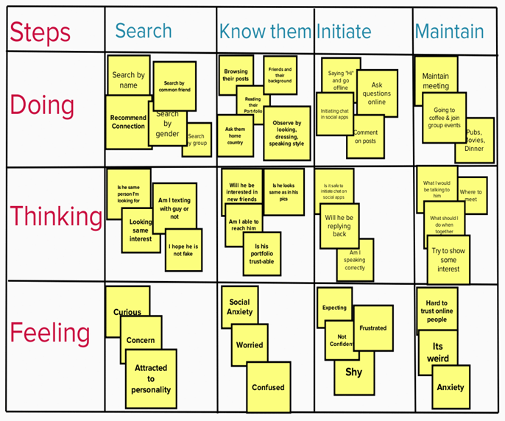

# Difficulties in Making New Connections:

Zahira Russels is facing various difficulties in making new friends. To explain her problems and difficulties we will go through for major steps:

**1) In searching for new friends-**

Through many ways, Zahira is searching for new friends such as by name, a recommendation from a friend and by mutual friends. While doing this she always came across some Questionable thoughts like Is he/she the same person? Is this one a genuine account or fake? And feels concern and curious about such thoughts.

**2) In knowing new friends-**

After searching some couples of friends she tries to find out some information related to them by reading their portfolio, browsing their posts, knowing them from some mutual friends like details about their residence, education. She also tries to observe them from their past posts, dressing styles, and many such factors. While doing this she always came across some questionable thoughts like Am I able to reach him? Are their portfolio is trustable? Will he/she be interested in making new friends? And feels worried and confused about such thoughts.

**3) In initiating a conversation-**

She used to initiate a conversation by saying ”Hi” when she is nearby to any of her friends. On the online platform, she used to initiate it by asking some relative question or by talking about some common topic. She also used to comment on her friend's post to initiate a conversation. While doing this she always came across some Questionable thoughts like Am I speaking correctly? , Will they reply back? , How they will react if she is going to initiate a conversation and is it safe on an online platform? And feels very Insecure, frustrated, shy, not confident and expecting.

**4) In maintaining the friendship-**

She maintains her friend circle by moving forward from a conversation to meetups like coffee, dinner or maybe a date. She also wants to hang out with friends, watch movies, doing parties. While doing this she always came across some Questionable thoughts like where to meet? , What should I do when we will be together? , what would I be talking to him? And feels weird, confused, anxiety and lonely while being in the friend's group.

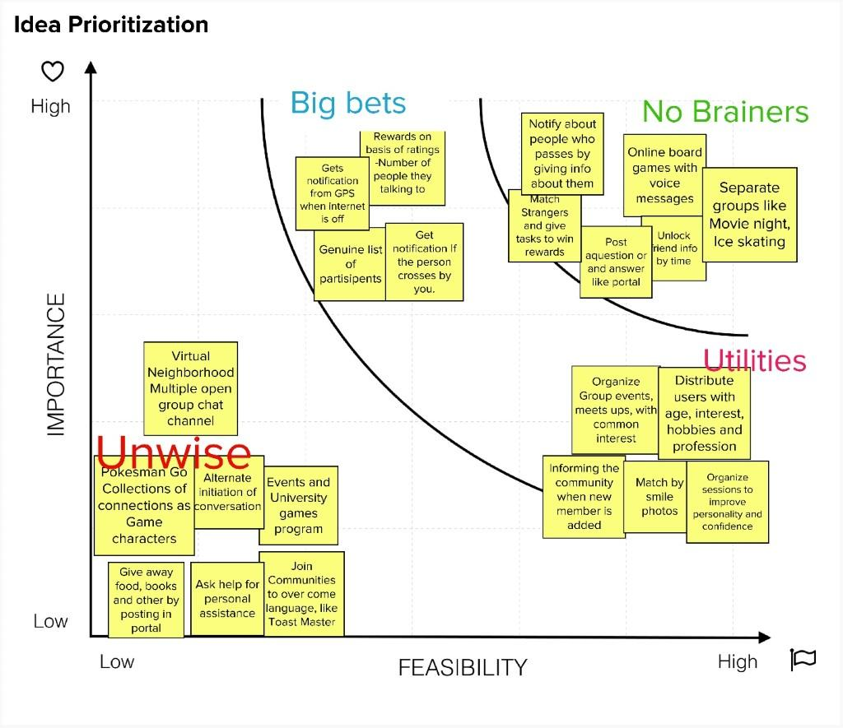

**Summary**

All the ideas are divided into four parts (No brainers, Big bets, Utilities and Unwise) based on feasibility and importance of the idea.

**No brainers**: These are the one which are the most important and feasible ideas and will be out first and foremost features in the application few of them are playing board games with voice messages, unlock friend information with time, Application notifies the info about she/he when an app friends are nearby and post a question or an answer.

**Big bets and Utilities:** These ideas are either most important or feasible, they will support as secondary features to the application like rewards based on ratings for user, notifies when friend crosses by, organize group events and meetups, match by smile photos, informing to the community when new friends are added.

# **Sketches**

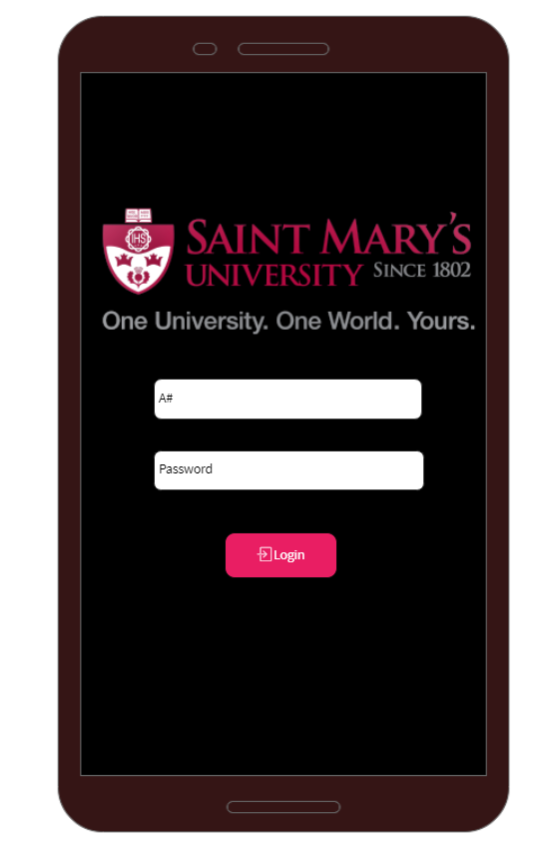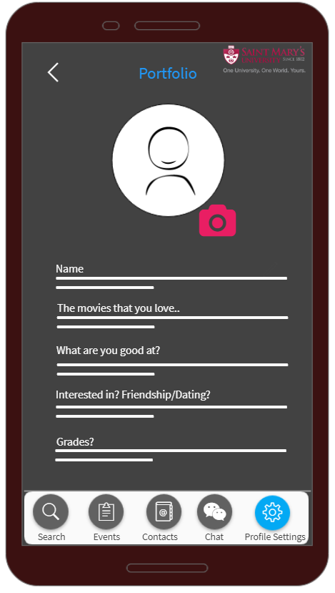

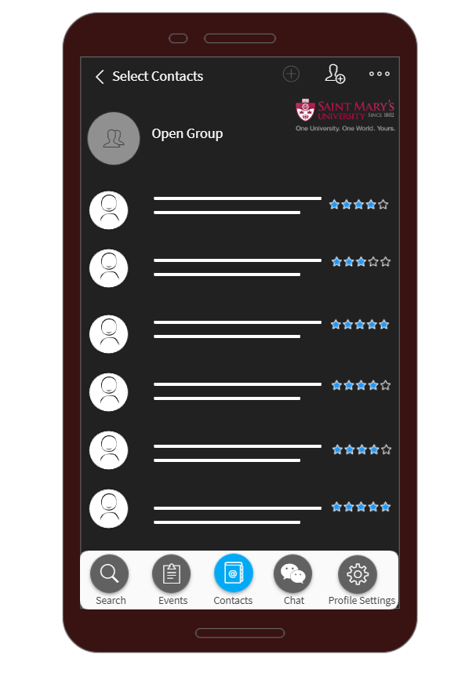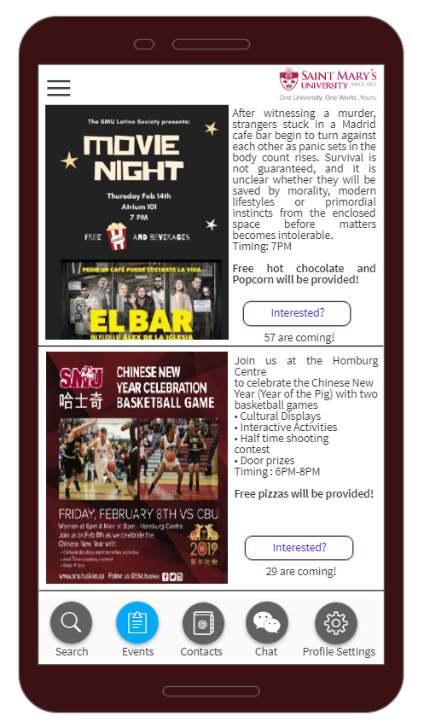

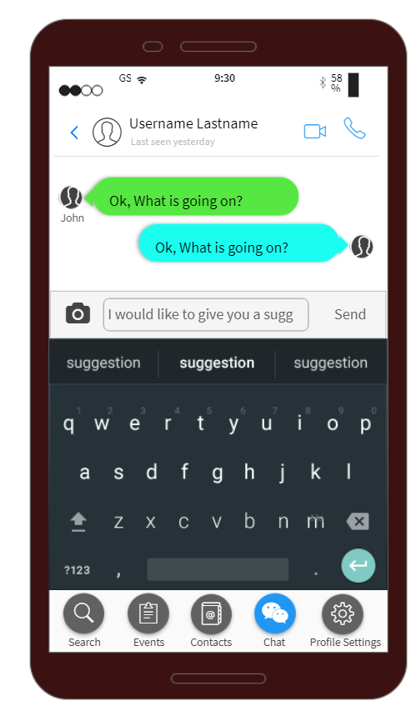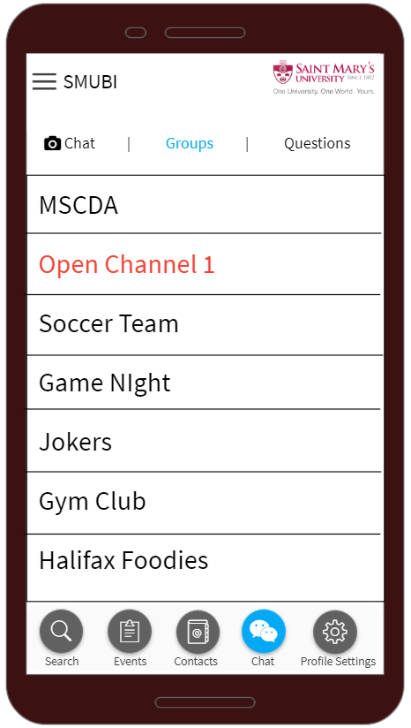

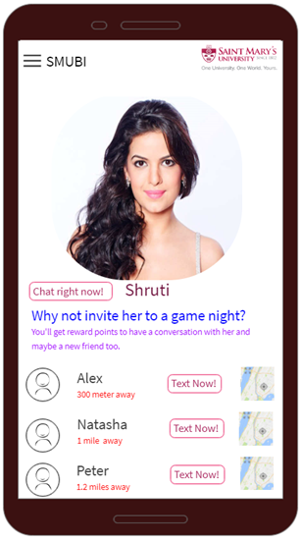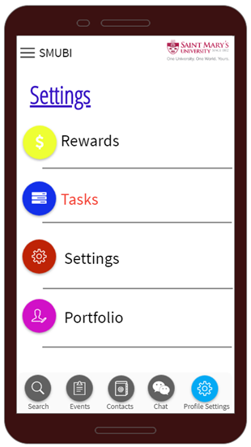

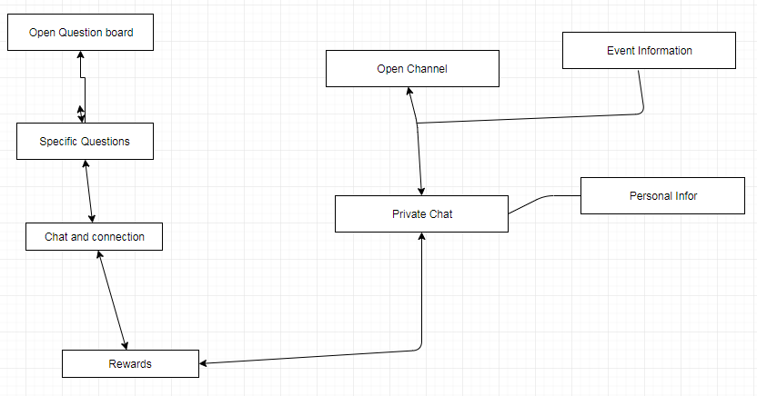

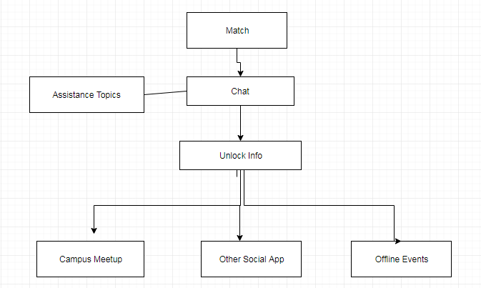

We can provide four sections inside SMU student community to generate more social connections, which are matching students with other students by using an algorithm which chooses random people, question board like quora, open channels and event info. Through each of them, strangers in SMU can start a conversation with each other. We have also added some ice breakers for users to start a conversation more easily like topic assistance, funny matching, event attendance info and one-to-one specific questions. And we also provide a reward-based system as a push for further maintaining the connection and finally leading to offline social life or other social applications. After which we’ve clustered all the overlapping parts to make it simple. During the usage of this application, SMU students can establish new connections easily in multiple ways as well as be informed with campus events and other information and finally better understand the university and generate a feeling of belonging to this SMU community.