**Survey/Interview Questions and Responses:**

Survey URL Link ( <https://goo.gl/forms/dWDgXDtr21U3APw62> )

Total survey responses received: - 64

**C:\Users\Saini\AppData\Local\Microsoft\Windows\Temporary Internet Files\Content.MSO\FDED30D1.tmp**

**C:\Users\Saini\AppData\Local\Microsoft\Windows\Temporary Internet Files\Content.MSO\9EB7838B.tmp**

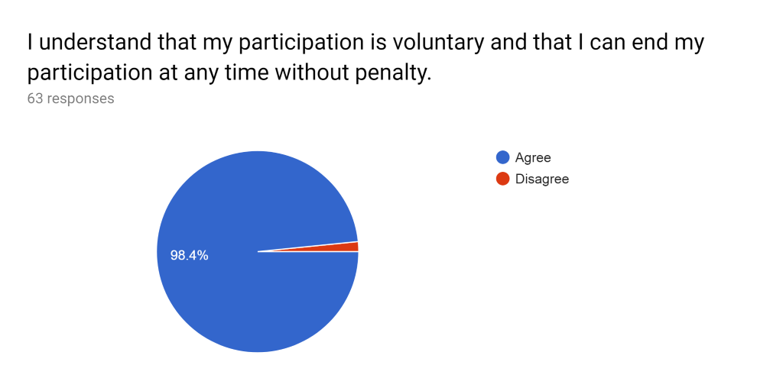

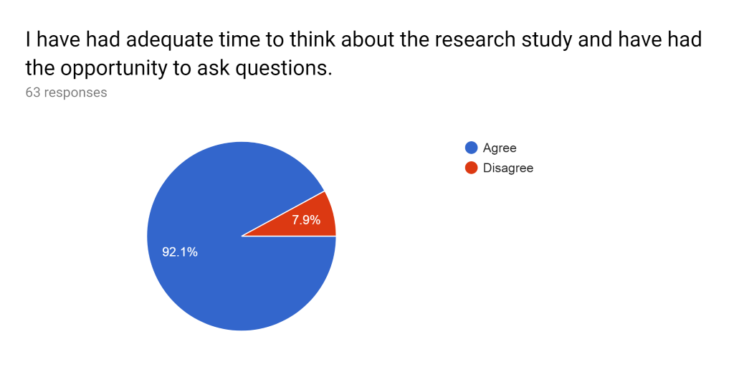 C:\Users\Saini\AppData\Local\Microsoft\Windows\Temporary Internet Files\Content.MSO\917F9E43.tmp 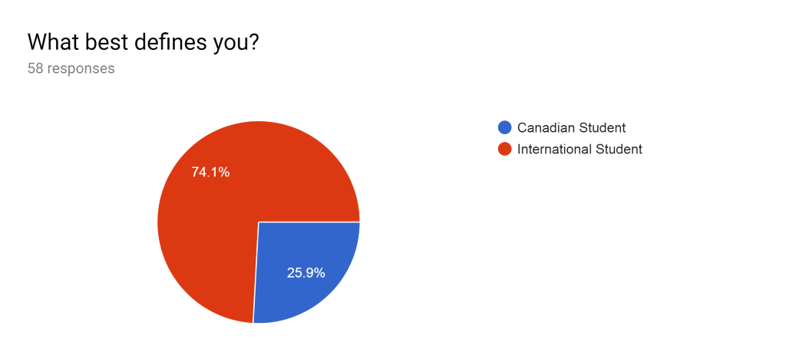

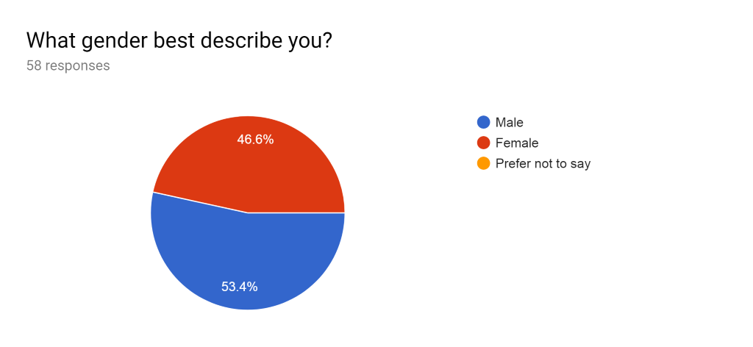

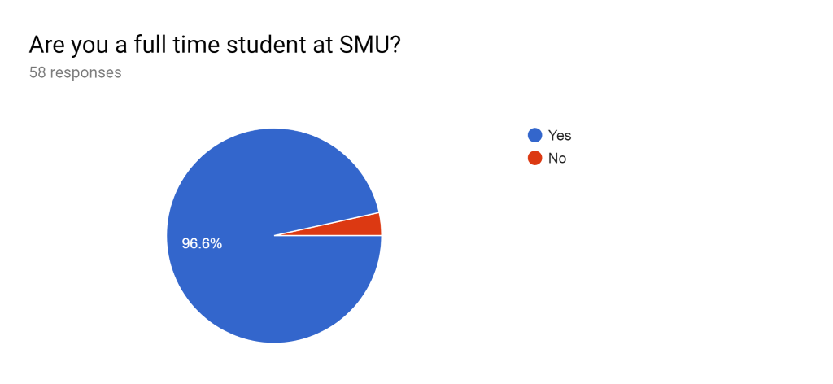

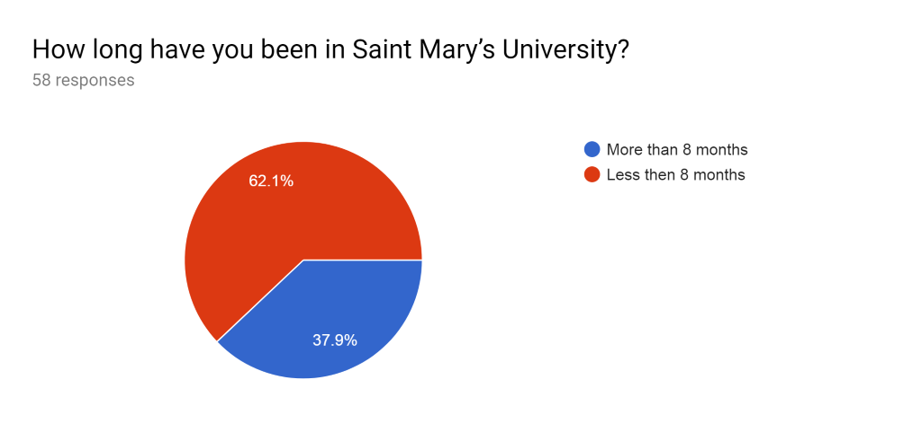

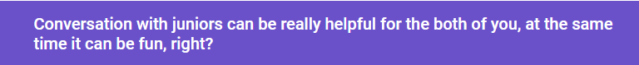

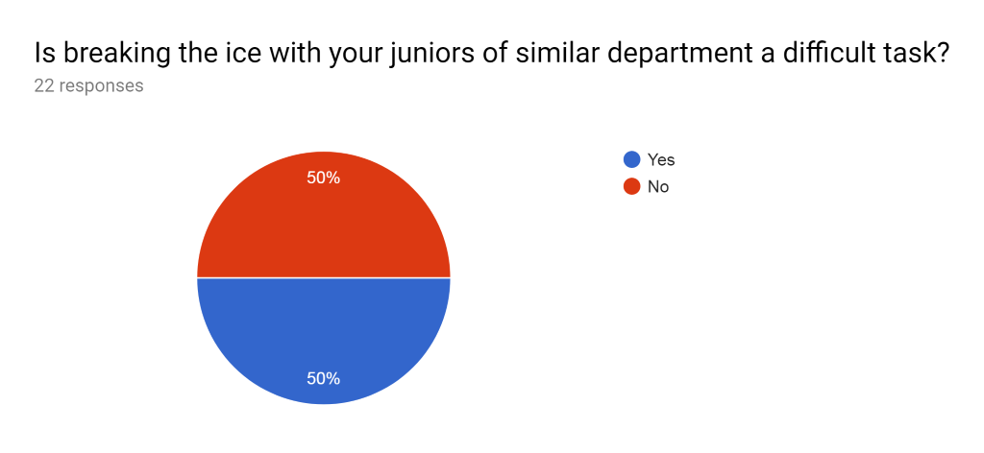

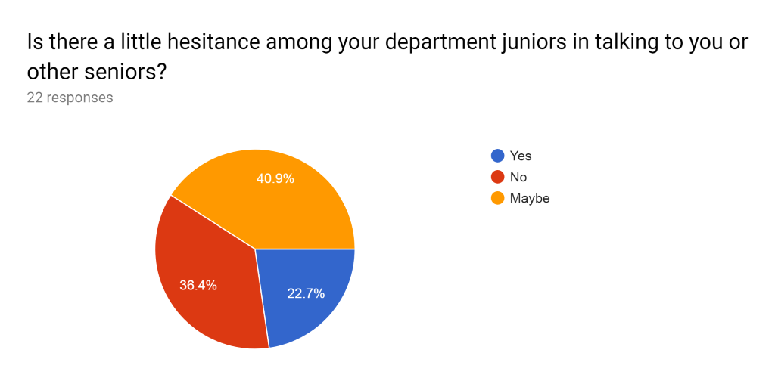

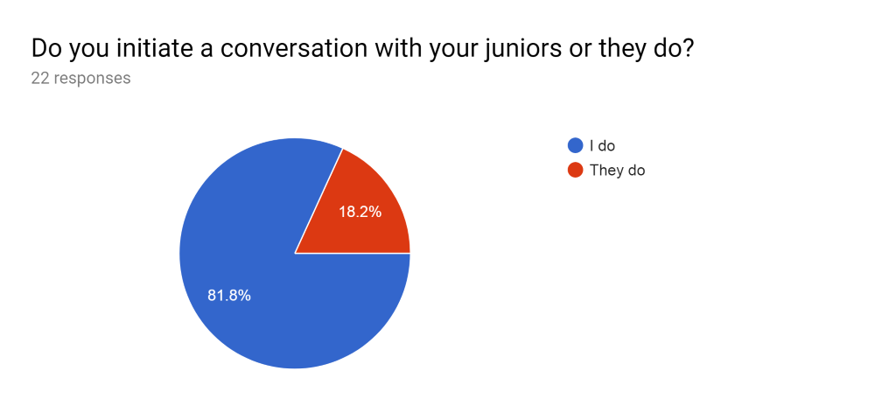

C:\Users\Saini\AppData\Local\Microsoft\Windows\Temporary Internet Files\Content.MSO\27E7A839.tmp 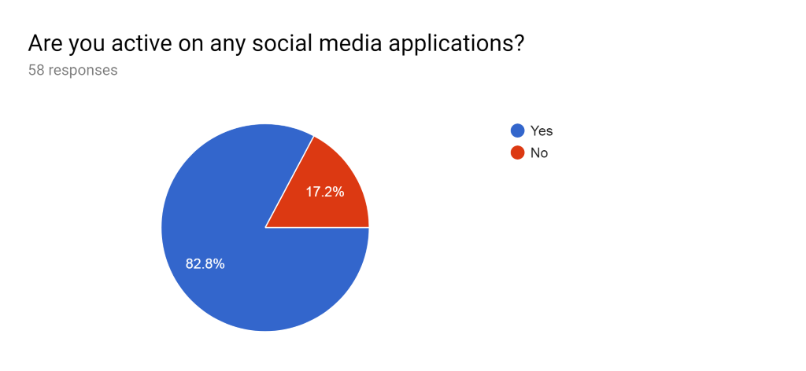

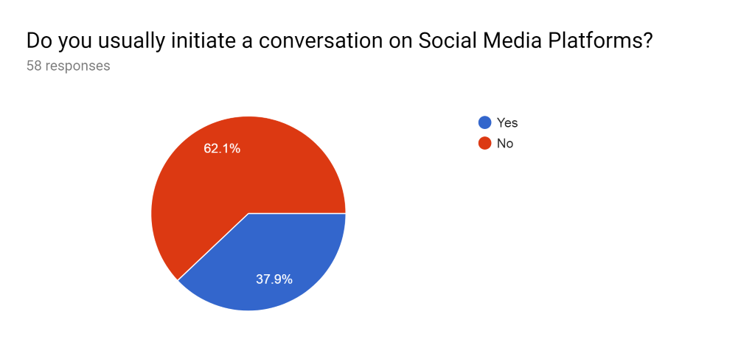

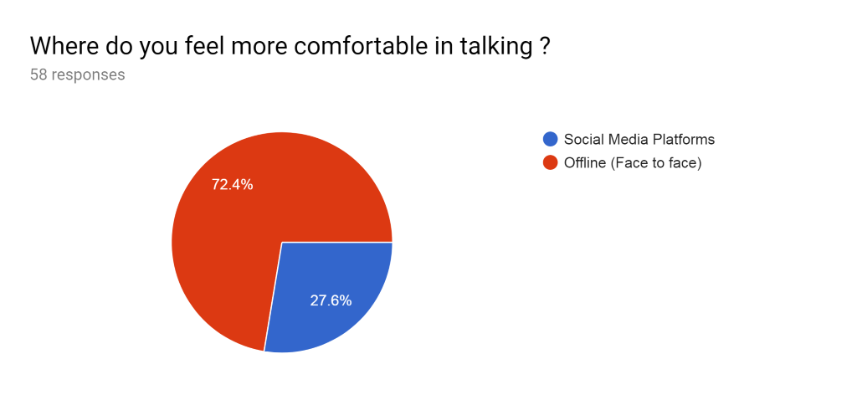

C:\Users\Saini\AppData\Local\Microsoft\Windows\Temporary Internet Files\Content.MSO\8C4E06FE.tmp 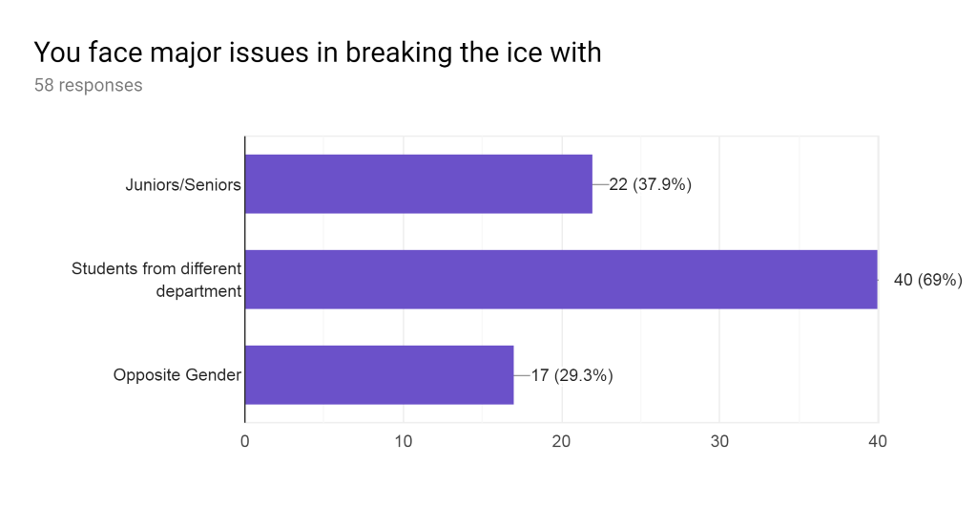

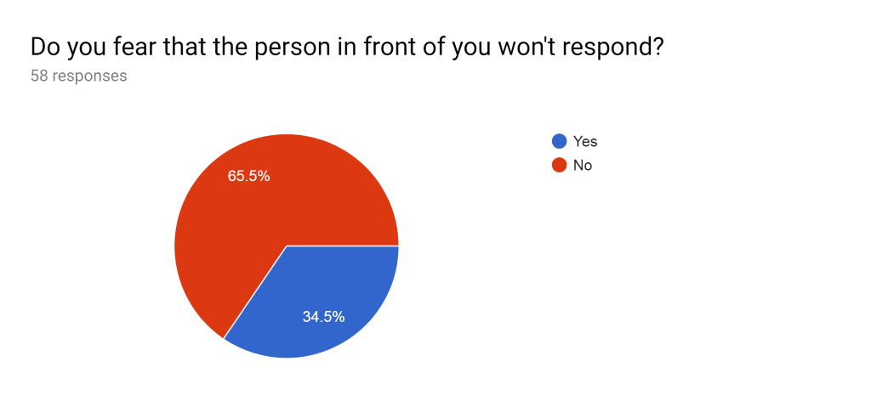

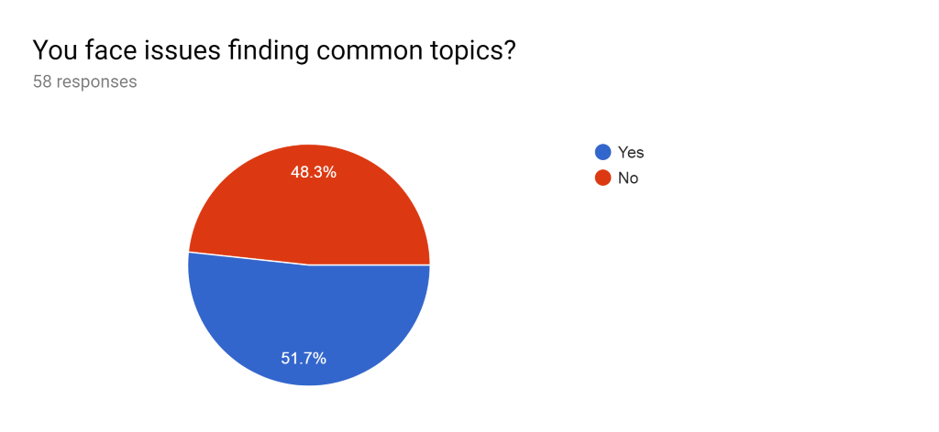

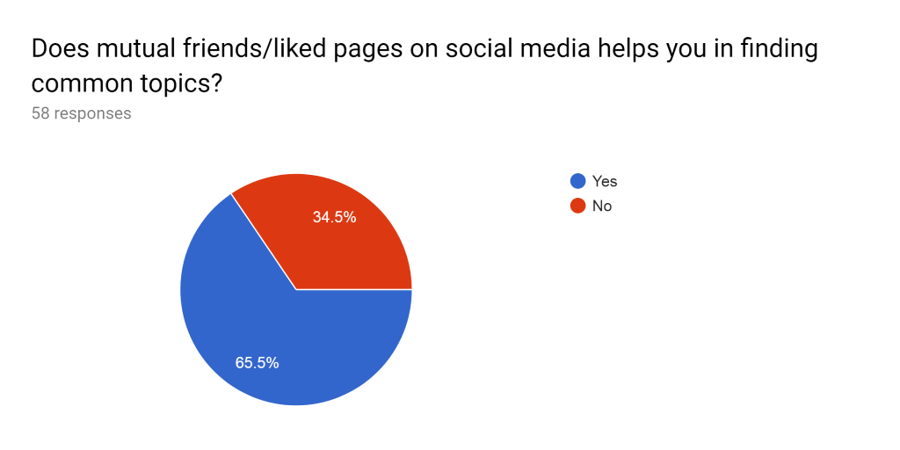

C:\Users\Saini\AppData\Local\Microsoft\Windows\Temporary Internet Files\Content.MSO\A8719016.tmp 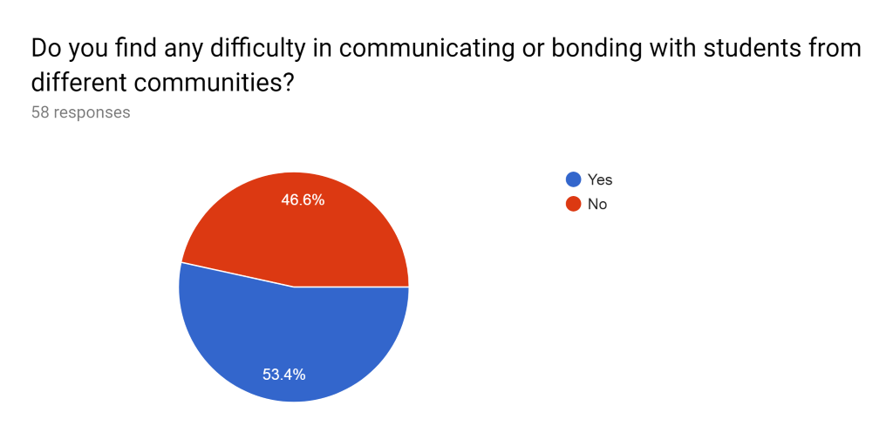 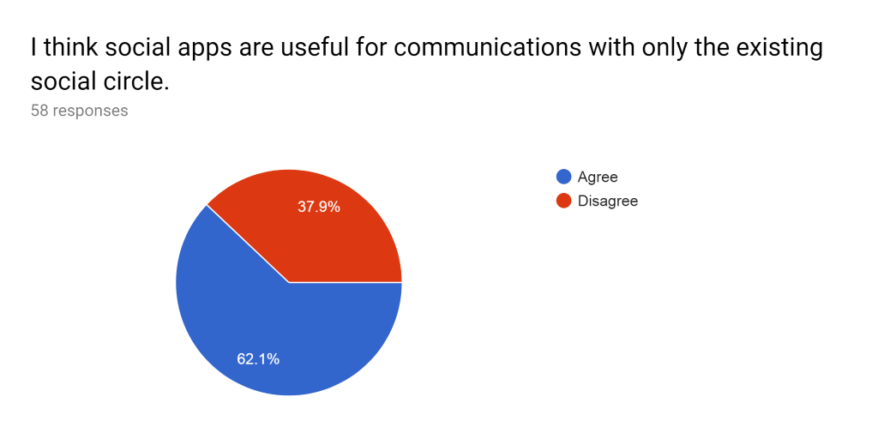

C:\Users\Saini\AppData\Local\Microsoft\Windows\Temporary Internet Files\Content.MSO\96DE3C2E.tmp

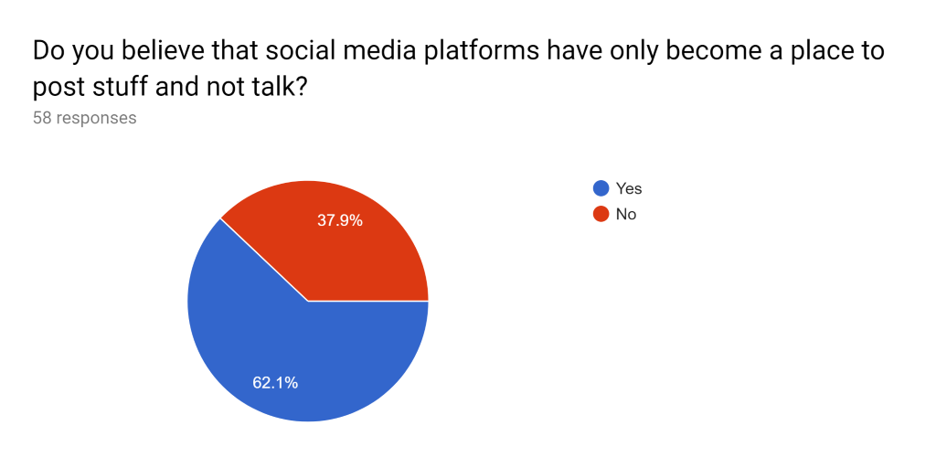

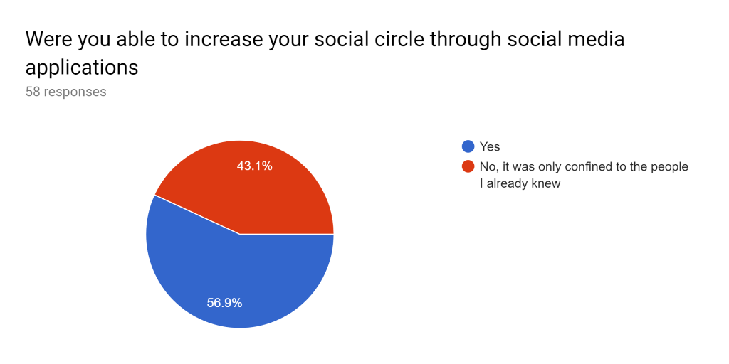

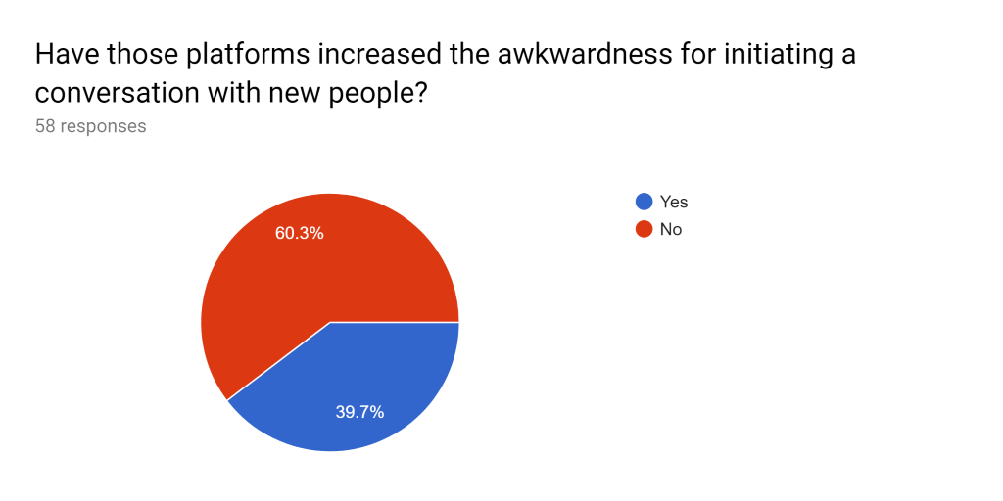

C:\Users\Saini\AppData\Local\Microsoft\Windows\Temporary Internet Files\Content.MSO\94B55F44.tmp

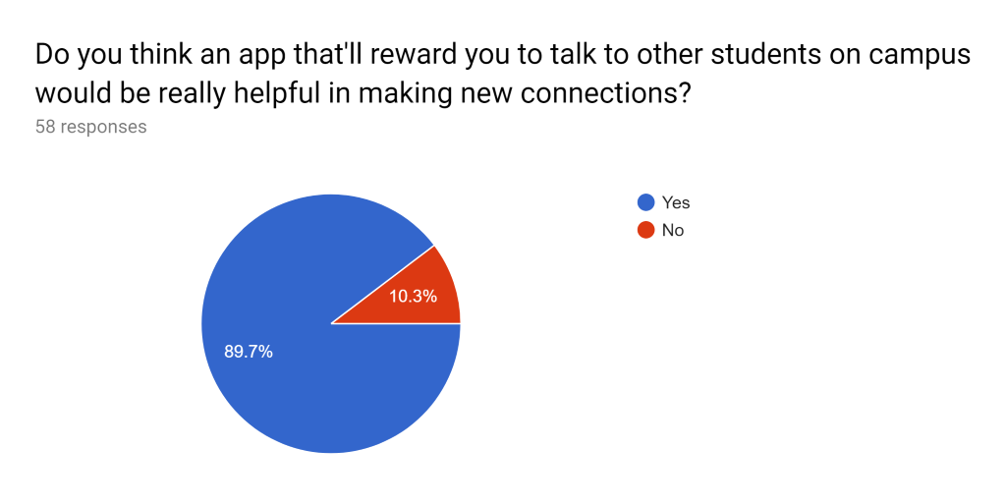

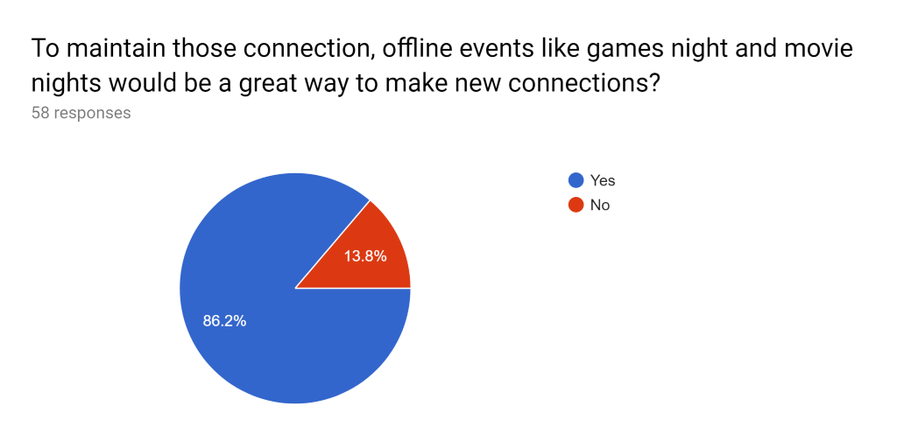

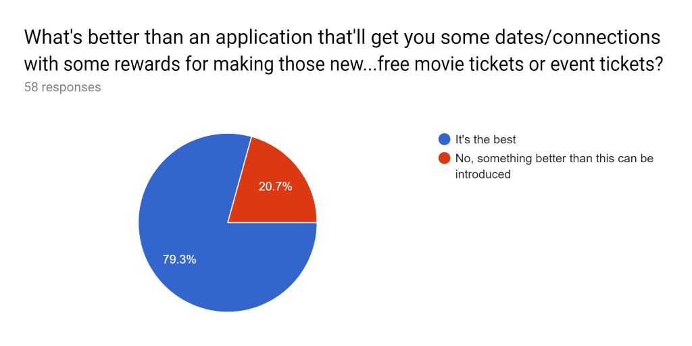

**This is for interview questions.**

1. Where are you from
2. How long have you been in Canada?
3. Have you had the feeling of unsupported or lonely? How often?
4. Do you believe the supporting social network can help release the pressure and solve problems both in daily life and in academic field?
5. What social applications do you use?
6. What for
7. How many hours a day do you spent on social apps? When usually?
8. Do you think those apps useful for new connection? Or just existing ones?
9. When do you feeling ice breaking with new friends (take how much time?)
10. Do you prefer talking with friends online or offline?
11. Motivation of meeting new people (if having supporting network)
12. Problems of meeting new people