

**MCDA 5540: Managing and Programming Databases**

**Relational Database Schema Design**

**Submitted By:**

**Jasmeet Singh (Student Id: A00433036)**

**Jiye Wang (Student Id: A00426401)**

**Saranjyot Singh (Student Id: A00432530)**

**Talwinder Saini (Student Id: A00430396)**

**Submitted To:**

**Trishla Shah**

**Table of Contents**

1. Executive Summary 3

**General Description** 3

**Tools** 3

2. About Data 3

**Given Data** 3

**Data Not Given** 3

3. Enhanced Entity Relationship (EER) Diagram for H.S.L. 4

**Entities taken into consideration:** 5

**Assumptions** 5

4. Relational Database Model 6

5. Relational Database Model After Normalization 8

6. Conclusion 9

**Completed Tasks** 9

**Tasks Not Completed** 9

**Future Work** 9

7. References: 10

# **Executive Summary**

## **General Description**

This project is to implement the immediate plans of the Halifax Science Library (HSL), adding three new functions to the existing SQL database. The three new functions are as following:

a. To record all articles in each scientific magazine.

b. To record all the customer and transaction information about library items purchasing.

c. To record the monthly expenses including utility cost and rent. Daily working hours of all employees should also be recorded each month.

## **Tools**

In this phase, Microsoft Visio has been used to design the EER diagram and relational schema. This project will use MySQL to store data in relational database and MongoDB will also be required to store data in non-relational database.

# **About Data**

## **Given Data**

The existing tables and data include library items, magazines and authors. The given data include all the articles from available magazines in json file and existing table data in sql file.

In items table, the price of each item is recorded. In magazine table, each magazine name is recorded. In magazine table, the information of first name, last name and email address of each author is recorded.

## **Data Not Given**

The data of existing employees and other costs including rent and utility cost is not given. Other missing data include the names of library items, the time of publication and the volume number of each magazine.

# **Enhanced Entity Relationship (EER) Diagram for H.S.L.**

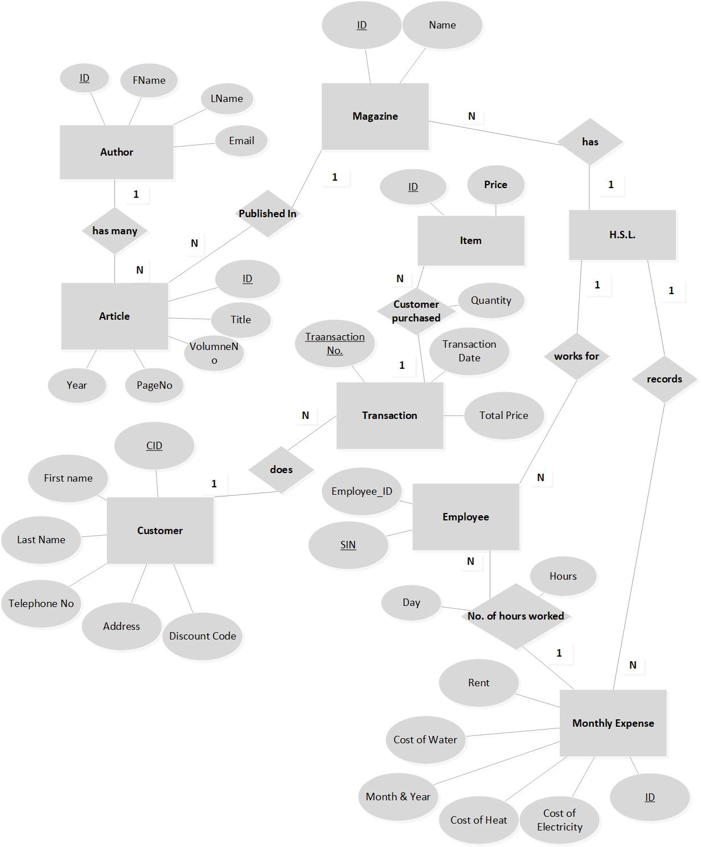

Fig. 3.1: EER diagram for Halifax Science Library (HSL)

## **Entities taken into consideration:**

* H.S.L.
* Magazine: *Primary key (ID)*
* Author: *Primary key (ID)*
* Item: *Primary key (ID)*
* Article: *Primary key (ID)*
* Customer: *Primary key (CID)*
* Transaction: *Primary key (Transaction No.)*
* Employee: *Primary key (SIN)*
* Monthly Expense: *Primary key (ID)*

## **Assumptions**

* There are existing tables about the employee information including SIN number and hourly salary.
* The daily working hours can be calculated and recorded based on the records of punch machine. As well as all salary will be calculated based on the time of punch machine records.
* All prices of library items as well as the rent and utility cost include tax.
* There are existing table to store other detailed information of library items such as name and inventory. All changes to these tables caused by transactions are automatically implemented by existing code.
* The library keeps all history transaction records on rent and other utility cost as well as items selling. And these records are in the same format of the database design in this project.
* The salary of employees is included in monthly expense and the salary will only be calculated by the hourly salary and the working hours of each month.

# **Relational Database Model**

**MAGAZINE** *(_id, Name)*

**AUTHOR** *(_id, LName, FName, Email)*

**ARTICLE** *(Id, Title,* *Author_ID, volNo, pageNo, Year_publication,* *Magazine_ID)*

Foreign Key **ARTICLE** *(Author_ID)* references **AUTHOR** *(_id)*

Foreign Key **ARTICLE** *(Magazine_ID)* references **MAGAZINE** *(_id)*

**CUSTOMER** *(CID, FirstName, LastName, TelephoneNo, MailingAddress, DiscountCode)*

**TRANSACTION** *(TransactionNo, CID, TransactionDate, TotalPrice)*

Foreign Key **TRANSACTION** *(CID)* references **CUSTOMER** *(CID)*

**ITEM** *(_id, Price)*

**ITEMSPURCHASED** *(TransactionNo, ItemId, Quantity)*

Foreign Key **ITEMSPURCHASED** *(TransactionNo)* references **TRANSACTION** *(TransactionNo)*

Foreign Key **ITEMSPURCHASED** *(ItemId)* references **ITEM** *(_id)*

**EMPLOYEE** *(SIN, EmployeeID)*

**MONTHLYEXPENSE** *(MonthlyExpense_ID, ElectricityCost, HeatCost, WaterCost, Rent, MonthYear)*

**EMPLOYEEWORKINGHOURS** *(EmployeeID, Day, MonthYear, NoOfHours, MonthlyExpense_ID)*

Foreign Key **EMPLOYEEWORKINGHOURS** *(EmployeeID)* references **EMPLOYEE** *(EmployeeID)*

Foreign Key **EMPLOYEEWORKINGHOURS** *(MonthlyExpense_ID)* references **MONTHLYEXPENSE** *(MonthlyExpense_ID)*

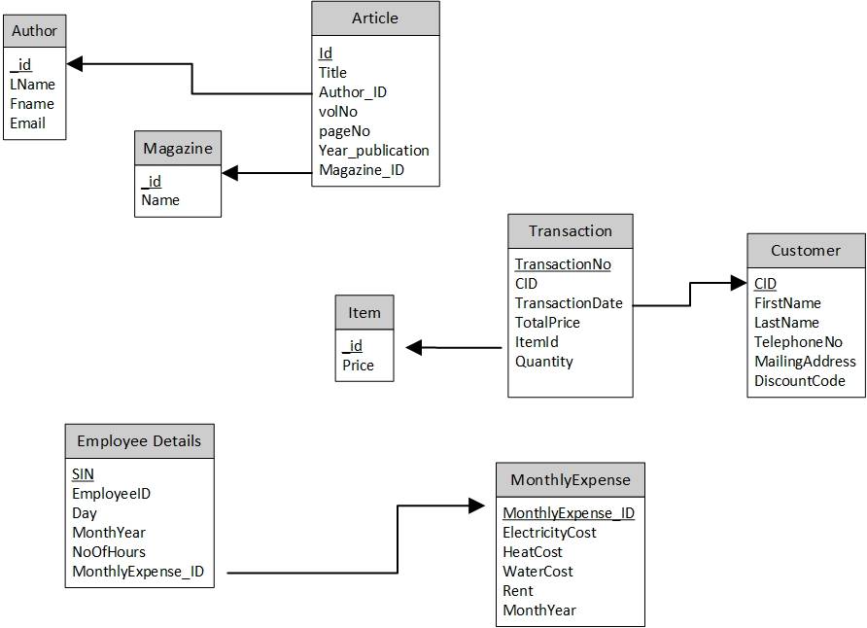

Fig. 4.1: Diagram for Relational Database Model before Normalization

# **Relational Database Model After Normalization**

We have normalized the data up to 3NF.

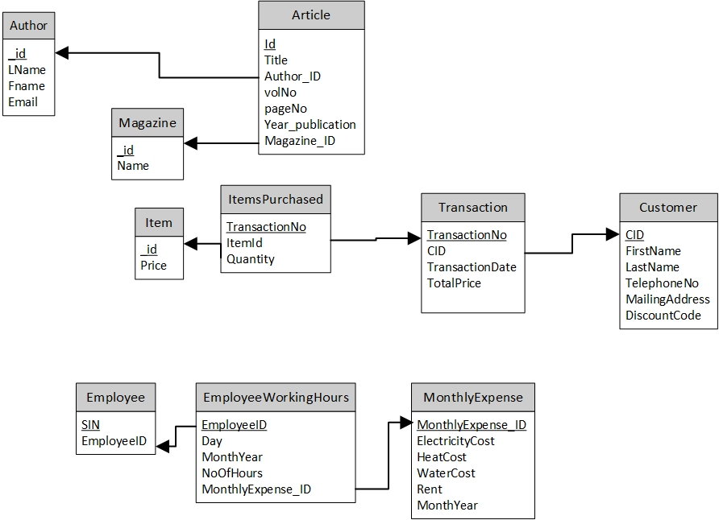

Fig. 5.1: Diagram for Relational Database Model After Normalization (3NF)

# **Conclusion**

## **Completed Tasks**

The design of EER diagram of the relational database is completed. The EER diagram is mapped into relational database model and relational schema. All tables are normalized.

## **Tasks Not Completed**

During the normalization of the tables, we found that some of the data in specific fields is repeated such as MonthYear in EmployeeWorkingHours table and Year_Publication and Magazine_ID in Article table. There are difficulties and redundancy in this database structure. As a result, further design including non-relational database will be discussed and implemented.

**Future Work**

1. The design of non-relational database MongoDB.

The articles as well as some part of the relational database such as EmployeeWorkingHours will be further discussed and stored in non-relational database

1. The bash script to create Mongo collections from MySQL database.

Generate the tables in MySQL database using given sql file and also generate corresponding Mongo collection on Author. Create another Mongo collection on Articles using given json file.

1. The bash script to update MySQL database from Mongo collections.

Insert and update data to new and existing tables in MySQL database using corresponding Mongo collections.

1. PHP web application.

Design a PHP we application to allow users to implement following actions:

* Check all the tables in the database and print all the records in chosen table.
* Add new articles in the existing table.
* Add new customer in the existing table.
* Add new transaction records and cancel existing transaction records in the existing table.
* In each action to change the data in the database, the error prevention message and validation is required in this web application.

# **References:**

* Trishla, S. (2019). Computing and Data Analytics 5540 —— Team Project. Retrieved on 25th February, 2019 from <https://smu.brightspace.com/d2l/le/content/45923/viewContent/474077/View>
* Trishla, S. (2019). Articles.json. Retrieved on 25th February, 2019 from <https://smu.brightspace.com/d2l/le/content/45923/viewContent/474079/View>
* Trishla, S. (2019). Existing_tables.sql. Retrieved on 25th February, 2019 from <https://smu.brightspace.com/d2l/le/content/45923/viewContent/474080/View>
* Trishla, S. (2019). Lecture-5 EER Diagram. Retrieved on 25th February, 2019 from <https://smu.brightspace.com/d2l/le/content/45923/viewContent/470609/View>
* Trishla, S. (2019). Lecture-8 Mapping of ER to RDB. Retrieved on 25th February, 2019 from <https://smu.brightspace.com/d2l/le/content/45923/viewContent/472088/View>
* Trishla, S. (2019). Normalization. Retrieved on 25th February, 2019 from [https://smu.brightspace.com/d2l/le/content/45923/viewContent/474086/View](https://smu.brightspace.com/d2l/le/content/45923/viewContent/474086/View%20) [https://smu.brightspace.com/d2l/le/content/45923/viewContent/474085/View](https://smu.brightspace.com/d2l/le/content/45923/viewContent/474085/View%20) <https://smu.brightspace.com/d2l/le/content/45923/viewContent/474084/View>