

**Master of Science in Computing and Data Analytics**

**Data and Text Mining**  
 **MCDA 5560**

**Deep Learning Assignment**

**Submitted by**:

Jiye Wang (A00426401)

**Submitted to**:

Mr. Predrag Rajnis

# **1 Prediction Model on Fruit Image Dataset**

According to the description of the dataset, there are 26 kinds of images including “No Fruit”. However, there are similar labels as Apple Red 1, Apple Red 2 and Apple Red 3. By reducing the similar labels in the dataset, there are 22 kinds of images in total. So, I set the num classes value as 22. Besides, the epochs value was set as 30 and batch size value as 32. The model was trained on 10204 samples and validated on 3438 samples.



It took around 30 minutes to train the model and after training for 30 epochs, the test loss is 0.1802 and the test accuracy is 0.9814.

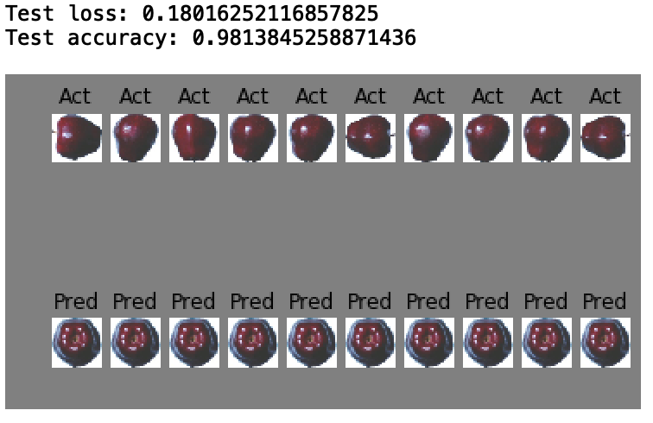

By observation of each epoch, the train loss and test loss are fluctuating but dropping gradually, which indicates that the model was continually learning from the dataset. From the third epoch, those two values changed insignificantly as well as train accuracy and test accuracy. It’s highly possible that the dataset was cleaned before. It will take more time to train the model with more epochs, but the accuracy won’t significantly change.

