Introduction  
The Cost of Progress: How the Pursuit of Income Fuels Pollution Mortality

# Motivation:

Climate change brings vast and profound implications, yet pollution continues to pose a substantial and distinct threat. Rather than solely detailing the already well-documented harms of pollution, I wish to delve into its root causes and the systems that perpetuate it. I am concerned by the potential for today's seemingly insignificant actions to fuel a future of the destruction of our own planet, and the lack of action by society.

# Aim:

I aim to uncover the "where" and "what" of pollution's origins. By focusing on these underlying factors, I hope to provide a clearer understanding of what drives this unending treadmill of materialism.

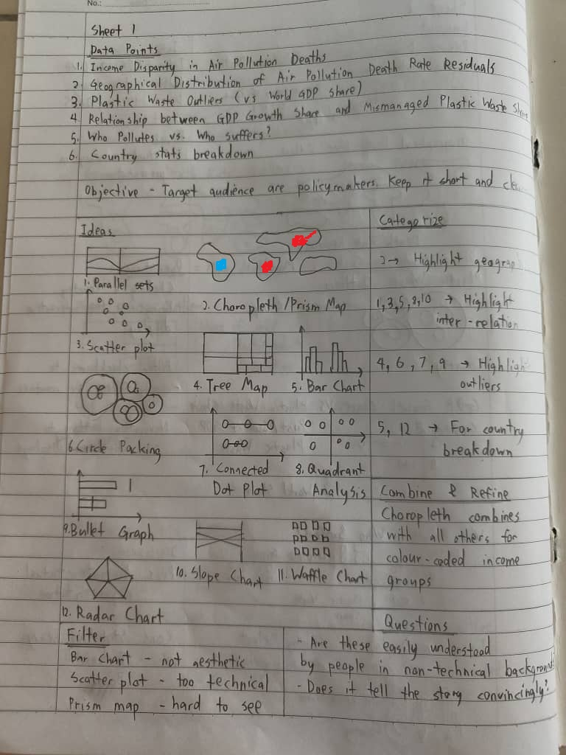

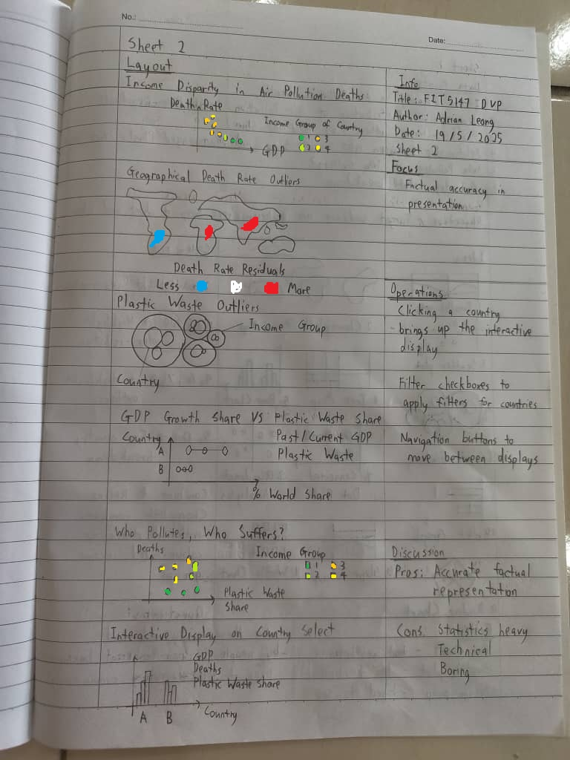

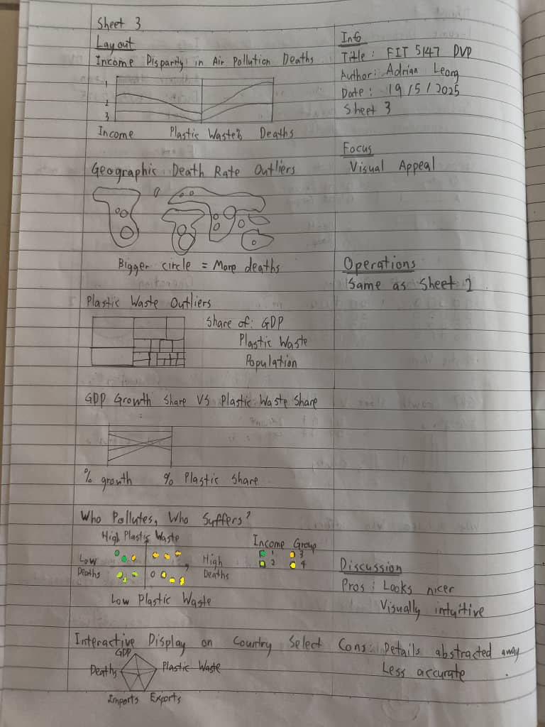

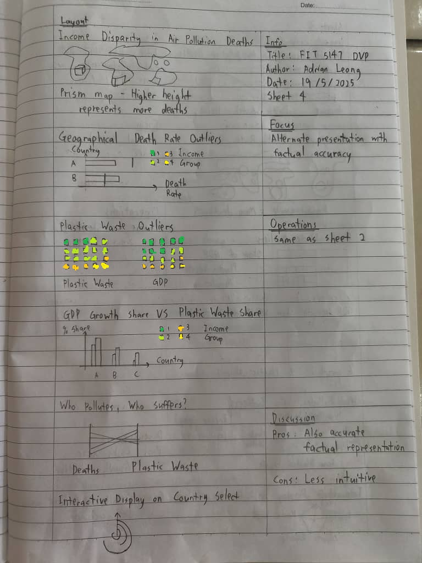

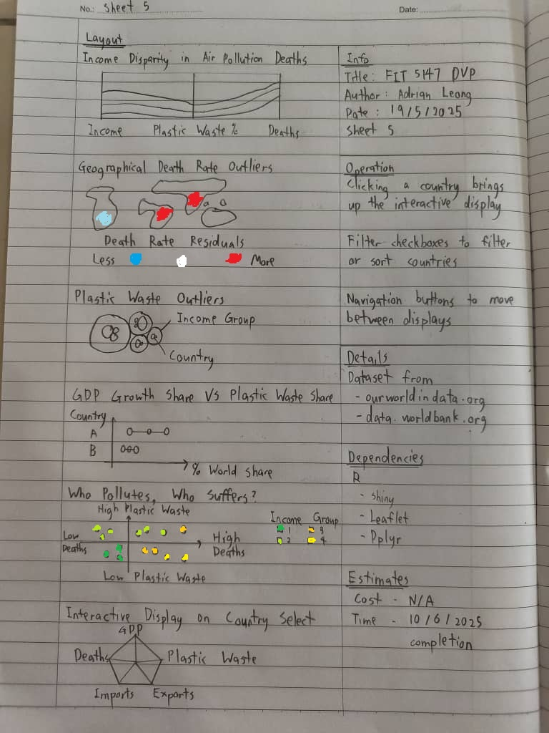

Data sources:  
<https://ourworldindata.org/grapher/gdp-per-capita-worldbank>  
<https://ourworldindata.org/grapher/death-rate-household-and-ambient-air-pollution>  
<https://ourworldindata.org/grapher/share-of-global-mismanaged-plastic-waste>  
 <https://ourworldindata.org/explorers/population-and-demography>  
<https://data.worldbank.org/indicator/NE.IMP.GNFS.ZS?view=map>