# The Price of Progress: How the Pursuit of Income Fuels Pollution Mortality.

Contents

The Price of Progress: How the Pursuit of Income Fuels Pollution Mortality. 1

Introduction 2

Key Findings 2

Design Process 3

Core Data Points and Their Visualizations 3

Consistency in Design and Interaction 4

Layout Structure 4

Typography 5

Munzner's What-Why-How Framework 5

Choice of Genre and Narrative Style 5

Implementation 6

Technical Implementation 6

Interactive Narrative Visualisation Implementation 7

Overview: 7

Filtering Capabilities: 7

Main Visualizations (Tabs): 8

Interactive Radar Chart (Left Sidebar) 10

Filter Checkboxes (Left Sidebar) 10

Using the Implementation 11

Prerequisites: 11

Launching the Application 11

Interactive Elements and Features to Note 11

Conclusion 12

References 13

Appendix 14

# Introduction

Climate change brings vast and profound implications, yet pollution continues to pose a substantial and distinct threat. This narrative visualization aims to precisely and succinctly convey crucial findings and messages by delving into the root causes and perpetuating systems of pollution, rather than merely detailing its harms. Through a focused examination of underlying factors, this project seeks to provide a clearer understanding of what drives the "unending treadmill of materialism" and its environmental consequences.

## Key Findings

1. Income Disparity in Air Pollution Deaths: Highlighting how different income levels correlate with vulnerability to pollution-related mortality.

2. Geographical Distribution of Air Pollution Death Rate Residuals: Identifying regions that show unexpected deviations from expected pollution death rates.

3. Plastic Waste Outliers (vs World GDP Share): Pinpointing countries with disproportionately high plastic waste contributions relative to their economic size.

4. Relationship between GDP Growth Share and Mismanaged Plastic Waste Share: Exploring the direct link between economic growth and the generation of mismanaged plastic waste.

5. Who Pollutes vs Who Suffers? Addressing the critical question of how the burden of pollution is distributed across nations.

The intended audience for this narrative visualization is policymakers and government entities. The objective is to present complex data in an accessible and impactful manner, thereby enabling informed decision-making regarding environmental policies and sustainable development strategies.

# Design Process

To present complex environmental and economic data to policymakers in an intuitive and impactful way, the narrative visualization was designed as such to ensure clarity in conveying the identified findings and insights.

## Core Data Points and Their Visualizations

**1. Income Disparity in Air Pollution Deaths**

Visualization – Scatter plot

Justification – A scatter plot, although being somewhat technical, provides a very clear trend line showing the very direct correlation between income levels and air pollution deaths. This chart type is particularly effective for visualizing the relationship between two numerical variables and can easily show patterns, trends, and correlations, making it ideal for demonstrating how changes in one variable (income) relate to changes in another (air pollution deaths) (Sinclair, 2020). Because it is a more mathematical graph and naturally goes in conjunction with the second finding, it is placed below the visualization of point #2. This was used in place of parallel sets as I realized that parallel sets are meant for categorical data, and not numerical data, so an alternative was needed.

**2. Geographical Distribution of Air Pollution Death Rate Residuals**

Visualization – Choropleth world map

Justification – A choropleth map is ideal for showing geographical distribution of air pollution death rates and residuals, allowing policymakers to quickly identify regions with high burdens or unexpected deviations from the norm. It is a powerful tool for visualizing how a measurement varies across defined geographic areas, particularly useful for representing standardized data like rates or ratios (From Data to Viz, n.d.).

**3. Plastic Waste Outliers (vs World GDP Share)**

Visualization – Treemap

Justification – A treemap visually highlights outliers effectively, to show how disproportionate an outlier some countries are relative to the rest of the world. Treemaps are highly effective for displaying hierarchical data and visualizing part-to-whole relationships, especially when dealing with large datasets where space is a constraint. They enable quick comparisons of quantities and the identification of dominant categories or 'outliers' within nested structures (FusionCharts, n.d.). This was used in place of circle packing due to technical difficulties and it being a virtually identical alternative.

**4. Relationship between GDP Growth Share and Mismanaged Plastic Waste Share**

Visualization – Connected dot plot

Justification – This shows the evolution of a country’s economic share and its correlation with mismanaged plastic waste. It shows how countries which rapidly grew in economic share, like China and India, are the biggest contributors to mismanaged plastic waste. A connected dot plot functions similarly to a Cleveland dot plot but graphs two or more data series, allowing for the visualization of trends or changes between points, often over time or across related variables (Knaflic, 2020).

**5. Who Pollutes vs Who Suffers?**

Visualization – Quadrant Analysis

Justification – This quickly shows which countries fall within “polluters” and “victims”, or both, at a glance. Quadrant analysis is highly effective for segmenting data into distinct categories based on two key dimensions, enabling users to quickly classify items, identify notable positions, and uncover relationships among variables. This makes it ideal for categorizing countries based on their pollution contribution and impact (Lumivero, n.d.).

**6. Country Stats Breakdown**

Visualization – Radar Chart

Justification – A radar chart offers a comprehensive summary of key country-specific metrics (GDP, Deaths, Plastic Waste, Import % of GDP, Export % of GDP). This allows for a quick comparative overview of a selected country's performance across multiple dimensions, providing a detailed breakdown upon user interaction. The radar chart is color-coded by income group to maintain visual consistency in the app. Radar charts excel at displaying multivariate data, allowing for the simultaneous observation of several quantitative variables on axes originating from a common point, making them useful for comparing entities across various attributes (Bold BI, n.d.).

## Consistency in Design and Interaction

A consistent colour scheme is used throughout the application to represent the four income groups: Low income, Lower middle income, Upper middle income, and High income. This consistency aids in the rapid interpretation of data across different visualizations. Care was taken to choose a colour scheme with distinctive hues for each group to allow for obvious categorizing without need for inspecting how similar adjacent groups are, while being clearer for colour-blindness. Interactive elements, such as hovering for tooltips and clicking for detailed views, are applied uniformly to enhance usability and data exploration.

## Layout Structure

The application layout uses a two-column structure. The left column is dedicated to interactive filters (income group, GDP range, continent, country) and the dynamic radar chart for selected countries. This ensures that filtering options are always accessible and that country-specific details are readily available upon selection. The right column houses a tabbed interface for the main narrative visualizations, allowing users to navigate between different aspects of the data story.

In most scenarios, navigation menus are located at either the left or the top section of the app. Moreover, the optical centre of the app is where users will look at first. The chosen layout fulfils both of these criteria, and provides a logical separation of controls and visualizations. This improves the user experience by providing a familiar and intuitive environment.

## Typography

To ensure optimal readability and a clear visual hierarchy, a contrast in font styles was applied. Sans-serif fonts (Arial) were chosen for body text and detailed information due to their clean lines and legibility on digital screens, for ease of continuous reading. In contrast, serif fonts (Georgia) were used for titles and headings. Their distinctive strokes provide visual anchors, enhancing their prominence and guiding the narrative, thereby differentiating major sections and improving overall navigation for policymakers. This combination leverages the strengths of each font style to improve clarity and structure.

## Munzner's What-Why-How Framework

The design process aligns with Munzner's what-why-how framework:

**What (Data):**

The underlying data encompasses a wide range of indicators, including GDP per capita, air pollution death rates, mismanaged plastic waste share, import and export percentages of GDP, population data, and percentage of world GDP. Pre-processing involved meticulous merging of datasets, handling of missing values, and data transformation to ensure suitability for visualization.

**Why (Tasks):**

The primary analytical tasks driving this visualization are to identify the populations most affected by pollution, to understand the influence of income levels on pollution, and to explore the role of trade dynamics in waste management and pollution mortality. The statistical tests and visualization choices were specifically made to support these critical inquiries.

**How (Visualizations and Interaction):**

The chosen array of visualizations—choropleth maps, scatter plots, tree maps, connected dot plots, quadrant analysis, and radar charts—are implemented with rich interactive features. These interactions, including filtering, hover tooltips, and clickable elements for detailed views, facilitate users to freely explore the data dynamically and progress through the narrative.

## Choice of Genre and Narrative Style

The narrative style is geared towards an explanatory and analytical approach, designed to systematically guide policymakers through key insights. The tabbed interface with distinct "Income and Pollution," "Economic Impact," "Growth & Waste," and "Pollution Burden," establishes a structured narrative flow. This leads users to explore different facets of the complex pollution and development issues in a logical and progressive manner.

# Implementation

## Technical Implementation

The interactive narrative visualization was implemented using the Shiny framework in R, which is well-suited for building interactive web applications directly from R code.

Libraries used:

shiny: For building the web application and handling user interface elements.

dplyr: For data manipulation and transformation.

ggplot2: For creating static graphical plots, which form the basis for some interactive plots.

plotly: For generating interactive plots, enabling features like hover tooltips and zoom.

leaflet: For creating interactive choropleth maps.

sf: For handling spatial data required for map visualizations.

scales: For managing graphical scales, such as color palettes.

fmsb: Specifically for generating the radar chart.

forcats: For working with factor variables, ensuring correct ordering of income groups.

shinyWidgets: For enhanced UI input widgets, like the pickerInput for multi-select dropdowns.

External Code Sources:

The implementation relies on standard R Shiny practices and the functionalities provided by the listed libraries, as found on R graph gallery and Leaflet for R. (*Adding Quadrants to R Scatterplots, and Lines Pointing From Plots to Their Respective Labels*, n.d.) details how to do a quadrant analysis.

Challenges in Implementation

Many Visualizations – Many different visualizations were used in the project. Each visualization needed a different implementation, and typically also separate libraries.

Data Wrangling – This was already done in the prior Data Exploration Project (DEP). The techniques used were: flattening to long format, merging (by year and country), computing extra information from the available data, removing NA values, identifying inconsistently named variables. After the original DEP data wrangling, they were then saved as preprocessed data objects which were then loaded at startup.

## Interactive Narrative Visualisation Implementation

The final implemented visualization provides a dynamic and interactive experience for exploring pollution and development insights.

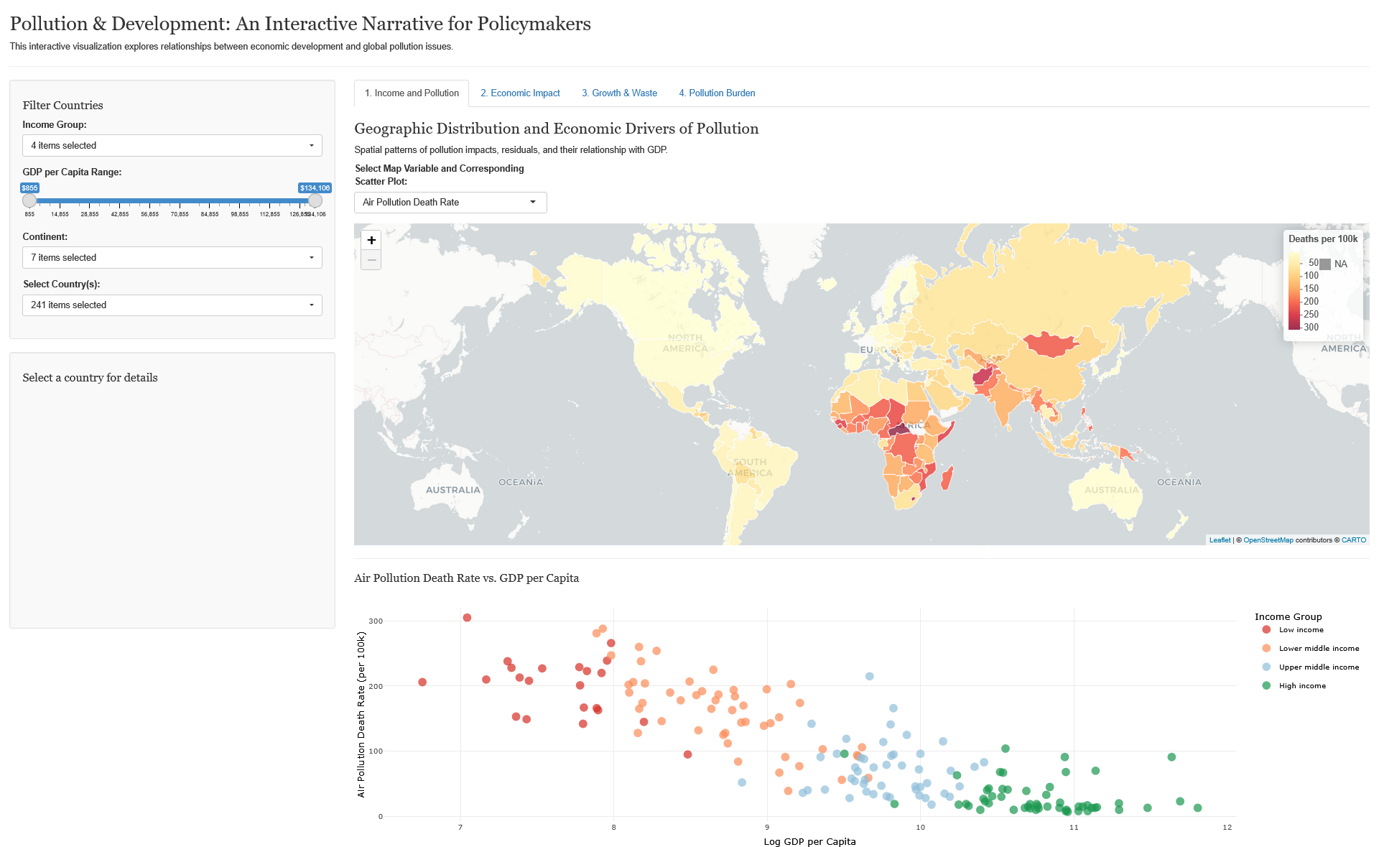

### Overview:

The application starts with a title "Pollution & Development: An Interactive Narrative for Policymakers" and a brief introductory paragraph. The screen is divided into a left sidebar for interactive filtering and country-specific details, and a main area with tabbed visualizations.

### Filtering Capabilities:

The left sidebar is equipped with multi-select dropdowns and slider widgets, providing granular control over the displayed data:

Income Group: Users can select income groups (Low, Lower middle, Upper middle, High income) to focus on specific economic strata.

GDP per Capita Range: A slider allows users to filter countries based on their GDP per capita.

Continent: A multi-select dropdown to filter countries by continent.

Country: A country filter dynamically updates based on the selected continents, allowing users to select specific countries for analysis.

### Main Visualizations (Tabs):

1. **Income and Pollution:**   
   The default view on app launch, this tab features a combined Choropleth world map and a scatter plot. The map visually represents the geographic distribution of selected environmental metrics (e.g., "Air Pollution Death Rate," "Mismanaged Plastic Waste Share"). The scatter plot dynamically updates to show the relationship between GDP per capita (on a logarithmic scale) and the selected environmental variable. This highlights findings such as the general decrease in air pollution mortality with higher GDP per capita, often showing distinct clustering by income group. The option to view residuals allows for identifying deviations from expected trends (e.g., Mongolia as an outlier for high death rates despite its economic status). Interactivity includes hover tooltips on map countries revealing country names and data values, and a click interaction that populates the radar chart in the sidebar.
2. **Economic Impact:**   
   This tab presents a tree map visualization that illustrates the distribution of plastic waste. Users can toggle between grouping the tree map "By Income Group" or "By Country." This visualization vividly demonstrates how mismanaged plastic waste shares are distributed across different economic categories and individual nations, reinforcing the insight that rapidly growing economies, particularly in lower-middle income groups, are significant contributors to global plastic waste.

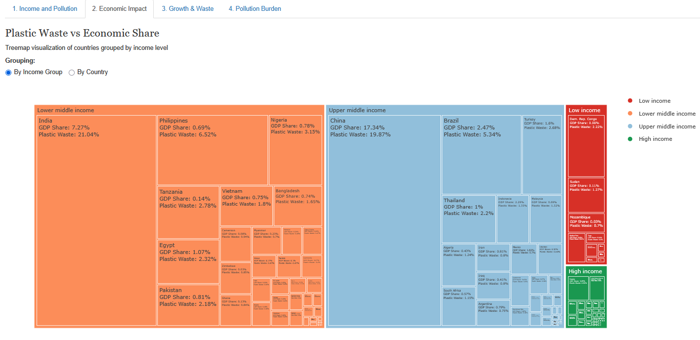

1. **Growth & Waste:**   
   This tab features a Connected Dot Plot designed to compare a country's current and past world GDP share with its current mismanaged plastic waste share. This plot effectively highlights significant outliers, notably China and India, which show massive contributions to mismanaged plastic waste that far exceed other nations. This reinforces the finding that the growth rate in world GDP share is a dominant factor in mismanaged plastic waste.

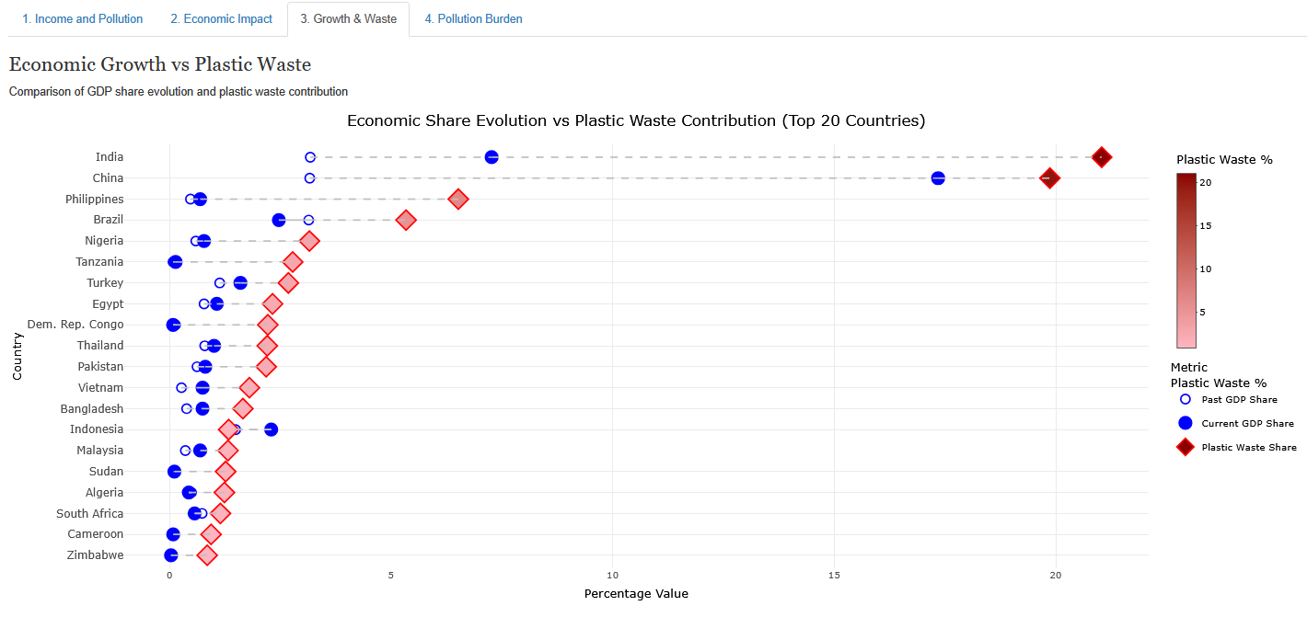

1. **Pollution Burden:**   
   This tab contains a Quadrant Analysis plot, which visually categorizes countries based on their contribution to plastic waste and their air pollution death rates. This chart is designed to address the question "Who pollutes vs. Who suffers?" by mapping countries into quadrants that represent different combinations of pollution burden and contribution.

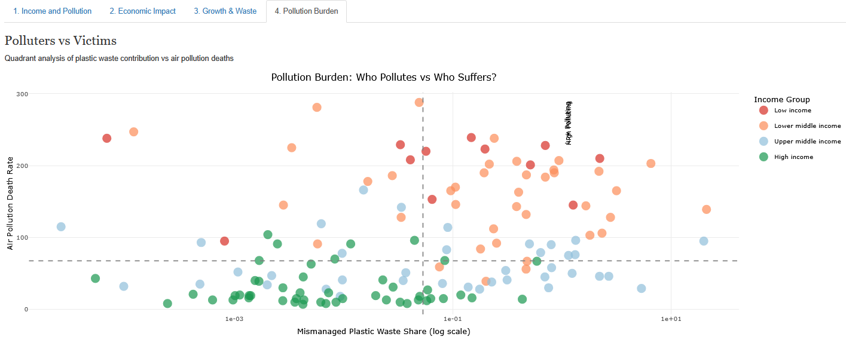

### Interactive Radar Chart (Left Sidebar)

A dynamic Radar Chart is prominently displayed in the left sidebar. This chart provides a detailed, multi-dimensional statistical breakdown for a *single selected country*, illustrating its GDP per capita, air pollution death rate, mismanaged plastic waste share, and import/export percentages of GDP. The chart's segments are color-coded by the country's income group, maintaining visual consistency throughout the application. This detailed chart is activated and populated specifically when a user clicks on a country's polygon on the world map within the "Income and Pollution" tab.

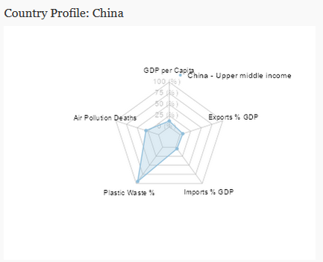

### Filter Checkboxes (Left Sidebar)

Filter checkboxes are provided at the left sidebar to select and deselect any grouping of your data for your analysis.

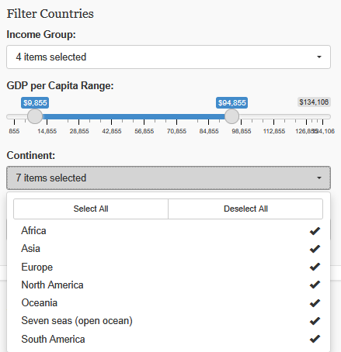

## Using the Implementation

To run, view, and interact with the narrative visualization, please follow these instructions:

### Prerequisites:

1. **R and Required Libraries:** Ensure you have R installed on your system. If you don’t have the R libraries used in the app already installed, it will install it on launch, which may take a while, please wait for it.
2. **Application Files:** The application and the preprocessed data files, preprocessed_pollution_data.rds and scale_limits_mortality_resid.rds, must be located in the same directory. Do not move them.

### Launching the Application

You may use RStudio, or VSCode, or any other IDE you prefer to run app.R as a standard R script.

### Interactive Elements and Features to Note

* **Activating the Radar Chart:** The detailed radar chart in the left sidebar is not visible until you click on a specific country. You can do this on any of the tabs. This targeted interaction provides a deeper dive into individual country statistics and is a key feature that users might initially overlook.
* **Dynamic Filtering:** Filtering options are located in the left sidebar (Income Group, GDP per Capita Range, Continent, and Country). All visualizations will dynamically update in real-time to reflect your applied filters for your custom analysis. Note that you can also click on the legends on any of the graphs to filter their respective data groups.
* **Graph Zoom:** On any of the graphs (anything with a numbered axis), you can click and drag your mouse cursor to zoom in to the selected area. Double click anywhere on the graph to revert to the default zoom level.
* **Hover-Based Tooltips:** On any of the interactive plots, hovering your mouse cursor over data points will display a small tooltip revealing specific statistical information related to that data point (e.g., country name, GDP value, pollution rate). This provides a quick and efficient way to gather contextual data without requiring additional clicks.
* **Map Variable Selection:** Within the "1. Income and Pollution" tab, utilize the dropdown menu labeled "Select Map Variable and Corresponding Scatter Plot" to change the environmental metric being displayed on the world map and its linked scatter plot. This allows for comprehensive exploration of different facets of pollution and their economic relationships.
* **Treemap Grouping Option:** In the "2. Economic Impact" tab, the radio buttons "Grouping: By Income Group" and "By Country" allow users to toggle grouping on and off. Users can choose if they want to see countries as grouped by income group or not.

# Conclusion

This narrative visualization project conveys complex insights into the relationship between economic development and global pollution. The key findings reinforce that lower-income countries disproportionately suffer from air pollution deaths, and that rapid economic growth, particularly in developing economies, is a major driver of mismanaged plastic waste.

One significant learning from this project was the challenge of data availability and consistency. Obtaining comprehensive, free, and consistent datasets proved difficult, which limited the scope for even more detailed analysis. While the project identified China and India as major outliers in plastic waste, further research could explore the confounding variable of waste export from other countries to these nations, which was beyond the scope of this project due to its complexity.

In this project, air pollution deaths were used as a proxy for impact of pollution, and the percentage of global mismanaged plastic waste share was used as a proxy for which countries were responsible for pollution. However, pollution does a lot more than cause air pollution deaths, and there are many more factors to causing pollution than simply mismanaged plastic waste share. If time and resources allow for it, a more comprehensive analysis of this would be desirable.

# References

*GDP per capita*. (2025, January 15). Our World in Data. <https://ourworldindata.org/grapher/gdp-per-capita-worldbank>

*Death rate attributed to household and ambient air pollution*. (n.d.). Our World in Data. <https://ourworldindata.org/grapher/death-rate-household-and-ambient-air-pollution>

*Share of global mismanaged plastic waste*. (n.d.). Our World in Data. <https://ourworldindata.org/grapher/share-of-global-mismanaged-plastic-waste>

*World Bank Open Data*. (n.d.). World Bank Open Data. <https://data.worldbank.org/indicator/NE.IMP.GNFS.ZS?view=map>

*World Bank Open Data*. (n.d.-b). World Bank Open Data. <https://data.worldbank.org/indicator/NE.EXP.GNFS.ZS?view=map>

*Population & Demography Data Explorer*. (n.d.). Our World in Data. <https://ourworldindata.org/explorers/population-and-demography>

Bold BI. (n.d.). *Mastering Radar Charts: Best Practices and Usage Examples*. Retrieved June 7, 2025, from <https://www.boldbi.com/resources/blog/radar-charts-best-practices-and-examples/>

From Data to Viz. (n.d.). *Choropleth map*. Retrieved June 7, 2025, from <https://www.data-to-viz.com/graph/choropleth.html>

FusionCharts. (n.d.). *Understanding Treemaps: Visualizing Hierarchical Data*. Retrieved June 7, 2025, from [https://www.fusioncharts.com/resources/chart-data-visualization-gallery/treemap-chart](https://www.google.com/search?q=https://www.fusioncharts.com/resources/chart-data-visualization-gallery/treemap-chart)

Knaflic, C. N. (2020, December 9). *What is a dot plot?*. storytelling with data. <https://www.storytellingwithdata.com/blog/2020/12/9/what-is-a-dot-plot>

Lumivero. (n.d.). *Quadrant Analysis: An Overview*. Retrieved June 7, 2025, from [https://lumivero.com/resources/guides/what-is-quadrant-analysis/](https://www.google.com/search?q=https://lumivero.com/resources/guides/what-is-quadrant-analysis/)

Sinclair, P. (2020, January 10). *When To Use A Scatter Plot*. Make Data Useful. [https://makedatauseful.com/when-to-use-a-scatter-plot/](https://www.google.com/search?q=https://makedatauseful.com/when-to-use-a-scatter-plot/)

*Adding Quadrants to R Scatterplots, and lines pointing from plots to their respective labels*. (n.d.). Stack Overflow. <https://stackoverflow.com/a/35510338>

# Appendix

