
KAUNAS UNIVERSITY OF TECHNOLOGY
FACULTY OF INFORMATICS
T120B166 Development of Computer Games and Interactive Applications

Banisher

Group, Name and Surname:
IFF 7-11, Mantas Klimašauskas
IFF 7-11, Deividas Verbickas
Date: 2020-03-02

Kaunas, 2020
Tables of Contents
Tables of Images 3
Table of Tables/functions 4
Distribution Table: 5
Description of Your Game 6
Laboratory work #1 7
List of tasks 7
Solution 7
Task #1. Title of Task 7
Task #2. Title of Task 7
Task #3. Title of Task 8
Laboratory work #2 9
List of tasks 9
Solution 9
Task #1. Title of Task 9
Task #2. Title of Task 10
Task #3. Title of Task 10
Laboratory work #3 12
List of tasks 12
Solution 12
Task #1. Title of Task 12
Task #2. Title of Task 12
Task #3. Title of Task 13
User's manual 15
Literature list 16
ANNEX 17

Tables of Images
Figure 1. Screenshot #1 7
Figure 2. Screenshot #2 8
Figure 3. Screenshot #3 8
Figure 1. Screenshot #1 9
Figure 2. Screenshot #2 10
Figure 3. Screenshot #3 10
Figure 1. Screenshot #1 12
Figure 2. Screenshot #2 13
Figure 3. Screenshot #3 13
Figure 4. Screenshot #5 15
Figure 5. Screenshot #5 15

Table of Tables/functions
Table 1. Title of fragment #1 7
Table 2. Title of fragment #2 8
Table 3. Title of fragment #3 9
Table 1. Title of fragment #1 9
Table 2. Title of fragment #2 10
Table 3. Title of fragment #3 11
Table 1. Title of fragment #1 12
Table 2. Title of fragment #2 13
Table 3. Title of fragment #3 14

Work Distribution Table:

Name/Surname | Description of game development part
Mantas Klimašauskas | Programming
Deividas Verbickas | Programming, level design

Description of Your Game

Description of Your Game.
- 3D or 2D? 3D
- What type is your game? Aenean congue ligula sed risus dapibus, eu posuere arcu ornare. Pellentesque habitant morbi tristique senectus et netus et malesuada fames ac turpis egestas. Donec ut auctor lorem. Proin pulvinar turpis ut libero molestie.
- What genre is your game? Nunc quis ultricies lectus, et tristique nibh.
- Platforms (mobile, PC or both?) Nunc sollicitudin placerat leo id pulvinar.
- Scenario Description. Vivamus semper mollis pellentesque. Sed a interdum quam. Aenean ut auctor mi. Maecenas mattis justo eget facilisis interdum. Vivamus feugiat ante sit amet sem finibus, eget pellentesque urna vehicula. Praesent at elementum urna, vel faucibus dui. Maecenas pulvinar quam dui, a luctus risus iaculis a. Cras vel eros porttitor, blandit lectus nec, finibus mauris. Quisque turpis mi, interdum at eleifend in, mollis et nisi. Praesent facilisis velit ipsum. Aenean quis mauris mollis, maximus odio vulputate, interdum augue. Nunc vel lacinia leo. Phasellus in diam tincidunt, condimentum dui in, lacinia nulla. Aliquam consectetur id tortor feugiat blandit. Mauris ac vehicula tortor. Mauris sagittis ante sed velit pharetra, a posuere lectus consequat. Aenean dignissim aliquam eros. Praesent a ullamcorper nulla. Quisque ut turpis ligula. Ut finibus, ipsum eget vehicula efficitur, sem nisi mollis augue, et finibus dui augue a sem.

Laboratory work #1

List of tasks
- First level design
- Second level design
- VR player controller
- VR interactions with environment objects

Solution

First level design

Screenshot
Figure 1. Screenshot #1

Second level design
Created a small alleyway, that leads to a warehouse. The warehouse also contains a second-floor office.

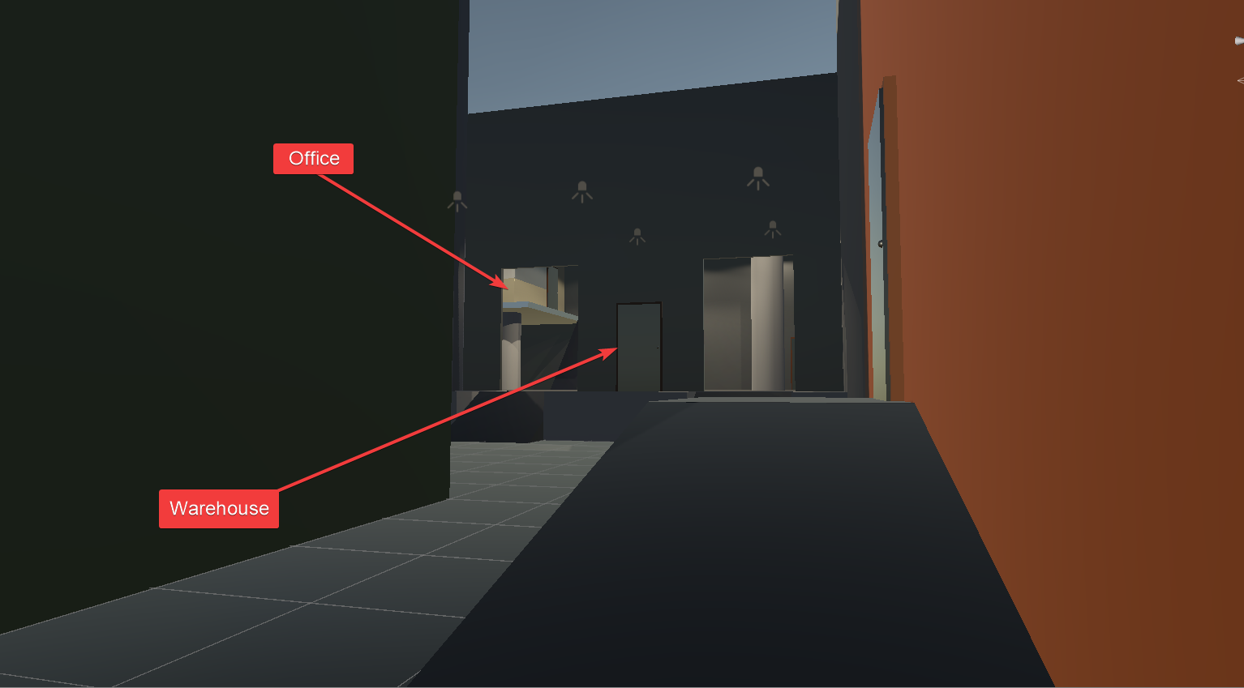
Figure 2. Second level design

VR player controller
Imported SteamVR plugin for Unity and adjusted the relevant settings, for SteamVR to properly run. Made sure that it works properly with VR hardware (headset and hand controllers).

VR interactions with environment objects
Added relevant SteamVR plugin components to the relevant “interactable” objects and made sure they work properly with the virtual hands.

Laboratory work #2

List of tasks (main functionality of your project)

- Title of Task #1
- Title of Task #2
- Title of Task #3
- …

Solution

Task #1. Title of Task
Description of implementation (3-5 sentences). Vestibulum hendrerit felis at turpis ultrices imperdiet. Nulla facilisi curabitur vitae semper nulla. Etiam rhoncus orci dolor, ac dictum erat iaculis sed. Aliquam pulvinar viverra consequat. Nam eu mi in mauris semper pellentesque eget ut erat.

Screenshot
Figure 4. Screenshot #1

In the case of using functions, the description of each main function should be completed with the source code FRAGMENTS (the functions should be indexed in a separate table of contents);
Fragment of Source Code
Table 4. Title of fragment #1

Task #2. Title of Task
Description of implementation (3-5 sentences). Lorem ipsum dolor sit amet, consectetur adipiscing elit. Sed ultricies nunc sit amet sem blandit, at ultricies nibh commodo. Duis ut mollis risus. Proin hendrerit libero eu felis dapibus imperdiet. Fusce posuere felis ornare luctus molestie. Duis ut odio pretium, bibendum elit et, molestie quam.

Screenshot
Figure 5. Screenshot #2

In the case of using functions, the description of each main function should be completed with the source code FRAGMENTS (the functions should be indexed in a separate table of contents);
Fragment of Source Code
Table 5. Title of fragment #2

Task #3. Title of Task
Description of implementation (3-5 sentences). Vestibulum hendrerit felis at turpis ultrices imperdiet. Nulla facilisi curabitur vitae semper nulla. Etiam rhoncus orci dolor, ac dictum erat iaculis sed. Aliquam pulvinar viverra consequat. Nam eu mi in mauris semper pellentesque eget ut erat.
Screenshot
Figure 6. Screenshot #3

In the case of using functions, the description of each main function should be completed with the source code FRAGMENTS (the functions should be indexed in a separate table of contents);
Fragment of Source Code
Table 6. Title of fragment #3
Laboratory work #3

List of tasks (main functionality of your project)

- Title of Task #1
- Title of Task #2
- Title of Task #3
- …

Solution

Task #1. Title of Task
Description of implementation (3-5 sentences). Vestibulum hendrerit felis at turpis ultrices imperdiet. Nulla facilisi curabitur vitae semper nulla. Etiam rhoncus orci dolor, ac dictum erat iaculis sed. Aliquam pulvinar viverra consequat. Nam eu mi in mauris semper pellentesque eget ut erat.

Screenshot
Figure 7. Screenshot #1

In the case of using functions, the description of each main function should be completed with the source code FRAGMENTS (the functions should be indexed in a separate table of contents);
Fragment of Source Code
Table 7. Title of fragment #1

Task #2. Title of Task
Description of implementation (3-5 sentences). Lorem ipsum dolor sit amet, consectetur adipiscing elit. Sed ultricies nunc sit amet sem blandit, at ultricies nibh commodo. Duis ut mollis risus. Proin hendrerit libero eu felis dapibus imperdiet. Fusce posuere felis ornare luctus molestie. Duis ut odio pretium, bibendum elit et, molestie quam.

Screenshot
Figure 8. Screenshot #2

In the case of using functions, the description of each main function should be completed with the source code FRAGMENTS (the functions should be indexed in a separate table of contents);
Fragment of Source Code
Table 8. Title of fragment #2

Task #3. Title of Task
Description of implementation (3-5 sentences). Vestibulum hendrerit felis at turpis ultrices imperdiet. Nulla facilisi curabitur vitae semper nulla. Etiam rhoncus orci dolor, ac dictum erat iaculis sed. Aliquam pulvinar viverra consequat. Nam eu mi in mauris semper pellentesque eget ut erat.

Screenshot
Figure 9. Screenshot #3

In the case of using functions, the description of each main function should be completed with the source code FRAGMENTS (the functions should be indexed in a separate table of contents);
Fragment of Source Code
Table 9. Title of fragment #3
User's manual (for the Individual work defence)

How to play? Aenean eu quam gravida, laoreet nisl eu, sagittis quam. Donec sit amet nunc nisi. Sed vel ipsum metus. Nullam accumsan vestibulum ex. Aenean eu quam gravida, laoreet nisl eu, sagittis quam. Donec sit amet nunc nisi. Sed vel ipsum metus. Nullam accumsan vestibulum ex.

Screenshot
Figure 10. Screenshot #5

Nunc vel enim vel magna interdum dapibus id nec nisl. Suspendisse elit augue, accumsan tempor erat sed, gravida suscipit urna. Duis blandit lacus et finibus finibus. Mauris pretium pharetra orci dictum luctus. Nullam commodo magna a tincidunt malesuada.

Screenshot
Figure 11. Screenshot #5

Sed sollicitudin justo erat, viverra luctus mi consequat non. Sed ut condimentum libero. Duis rutrum lacus ante, vitae feugiat ex faucibus at. Maecenas pulvinar et augue sed commodo.

Descriptions of the rules of the game. Nunc quis condimentum lacus. Quisque felis neque, ullamcorper vel posuere eget, blandit non neque. Nam in varius erat. Duis molestie sit amet eros vel rhoncus. Nunc quis condimentum lacus. Quisque felis neque, ullamcorper vel posuere eget, blandit non neque. Nam in varius erat. Duis molestie sit amet eros vel rhoncus.

Descriptions of the controls / keys. Donec et lorem vitae ligula bibendum faucibus. Suspendisse interdum quis augue sed luctus. Curabitur ac diam augue. In hac habitasse platea dictumst. Curabitur maximus maximus tortor. Nunc quis condimentum lacus. Quisque felis neque, ullamcorper vel posuere eget, blandit non neque. Nam in varius erat. Duis molestie sit amet eros vel rhoncus.

Literature list
- Source #1. Url
- Source #2. Url
- ...
- Source #N. Url

ANNEX
All source code is contained in this part.

