ShopKeeper AI
Architecture Document
v1.0 · May 2026 · Phase 2 — Design & Architecture
Developer: Advait Joshi

1. System Architecture
ShopKeeper AI is a retro pixel-art game with a real multi-agent AI backend. The system is organized into five layers: User, Frontend, Backend, Agent Layer, and External Services. All data flows top-to-bottom with REST handling CRUD and game state, and WebSocket handling real-time agent event streaming.

1.1 Layer Overview
Layer | Technology | Responsibility
User | Browser | Login, role selection, game interaction, chat
Frontend | React + Tailwind + Phaser 3 | Game canvas, UI overlays, chat window, event bus
Backend | FastAPI + WebSockets | REST routes, WS handler, LangGraph orchestration, middleware
Agent Layer | LangGraph (internal) | Sales, Recommendation, Inventory, Payment, Supplier, Post-Purchase
External Services | Groq, Supabase, Redis, LangSmith | LLM calls, database, cache, trace archive

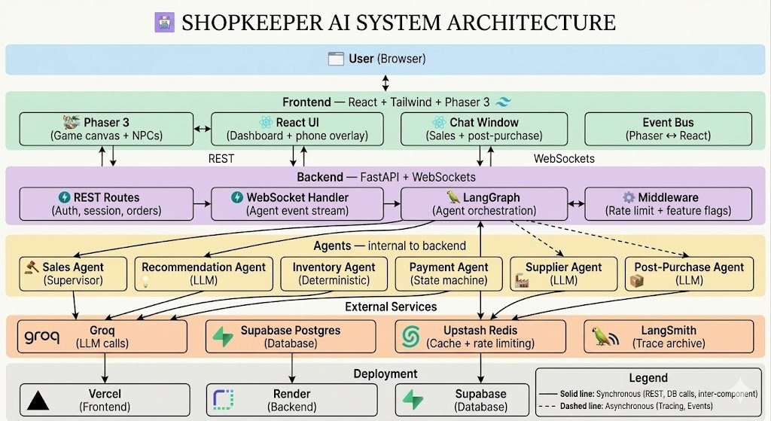
Figure 1 — ShopKeeper AI System Architecture

1.2 Core Data Flow
Frontend sends message → Backend via WebSocket → Redis (session check + rate limit) → Supabase (fetch state + context) → Groq (LLM call) → Backend formats response → LangSmith (async trace write, non-blocking) → Supabase (save message + update state) → Frontend via WebSocket

1.3 Communication Protocols
Protocol | Used For | Direction
REST / JWT | Auth, session management, cart, orders, supply approvals | Bidirectional
WebSocket — Sales Agent | Customer chat with Sales Agent | Bidirectional
WebSocket — Post-Purchase | Post-purchase support chat | Bidirectional
WebSocket — Event Stream | Live agent events to businessman dashboard | Server to client only

2. Tech Stack
Layer | Technology | Rationale
Agent Orchestration | LangGraph | LangChain dropped — not needed. LangGraph runs standalone with less overhead.
API Layer | FastAPI + WebSockets | Native async, built-in WebSocket support, auto OpenAPI docs.
API Versioning | /api/v1/ prefix | All routes versioned from day one. v2 can coexist without breaking changes.
Database | Supabase Postgres | Two projects: shopkeeper-dev and shopkeeper-prod. One DB engine everywhere.
ORM + Migrations | SQLAlchemy + Alembic | 19 tables with real relationships. Clean migration history from day one.
Auth | bcrypt + python-jose + Google OAuth | Full control over JWT payload including role field. Custom auth from scratch.
Guardrails | Pydantic strict schemas + output parser + retry | NeMo Guardrails dropped. Pydantic is the right level for AI-generated NPCs.
Observability | LangSmith + OpenTelemetry + WebSocket | Three separate concerns — real-time, trace archive, distributed tracing.
Cache | Upstash Redis | Session cache + rate limiting. Serverless, free tier, zero ops.
Rate Limiting | Slowapi + Redis + session cap | Slowapi middleware on FastAPI. Counters in Redis. Max concurrent sessions enforced.
Logging | Loguru + Correlation IDs | Every request gets a UUID that flows through all logs and agent calls.
Config Management | Pydantic Settings | Validates entire .env on startup. App refuses to start if required vars are missing.
Feature Flags | Supabase flags table + middleware | Toggle agents and features without redeploying.
Frontend | React + Tailwind + Phaser 3 | Phaser owns canvas. React owns UI. Event bus connects them.
LLM | Groq (free tier only) | No fallback for MVP. Rate limits managed at app level.
Deployment | Vercel + Render | Vercel for frontend. Render for backend with health check cron to prevent spin-down.

3. Database Schema
19 tables following single-responsibility principle. UUID primary keys throughout. DECIMAL for all money fields. Every table has created_at and updated_at except append-only tables.

3.1 Design Principles
- Entities first, tables later — list real-world things before designing columns
- Never store a list in a column — use junction tables
- Never store computed values — derive at query time
- Separate what a thing IS from the current STATE of that thing
- Use DECIMAL for all money fields — never FLOAT
- Use UUID for all primary keys
- Index what you filter, join, or sort by — not everything

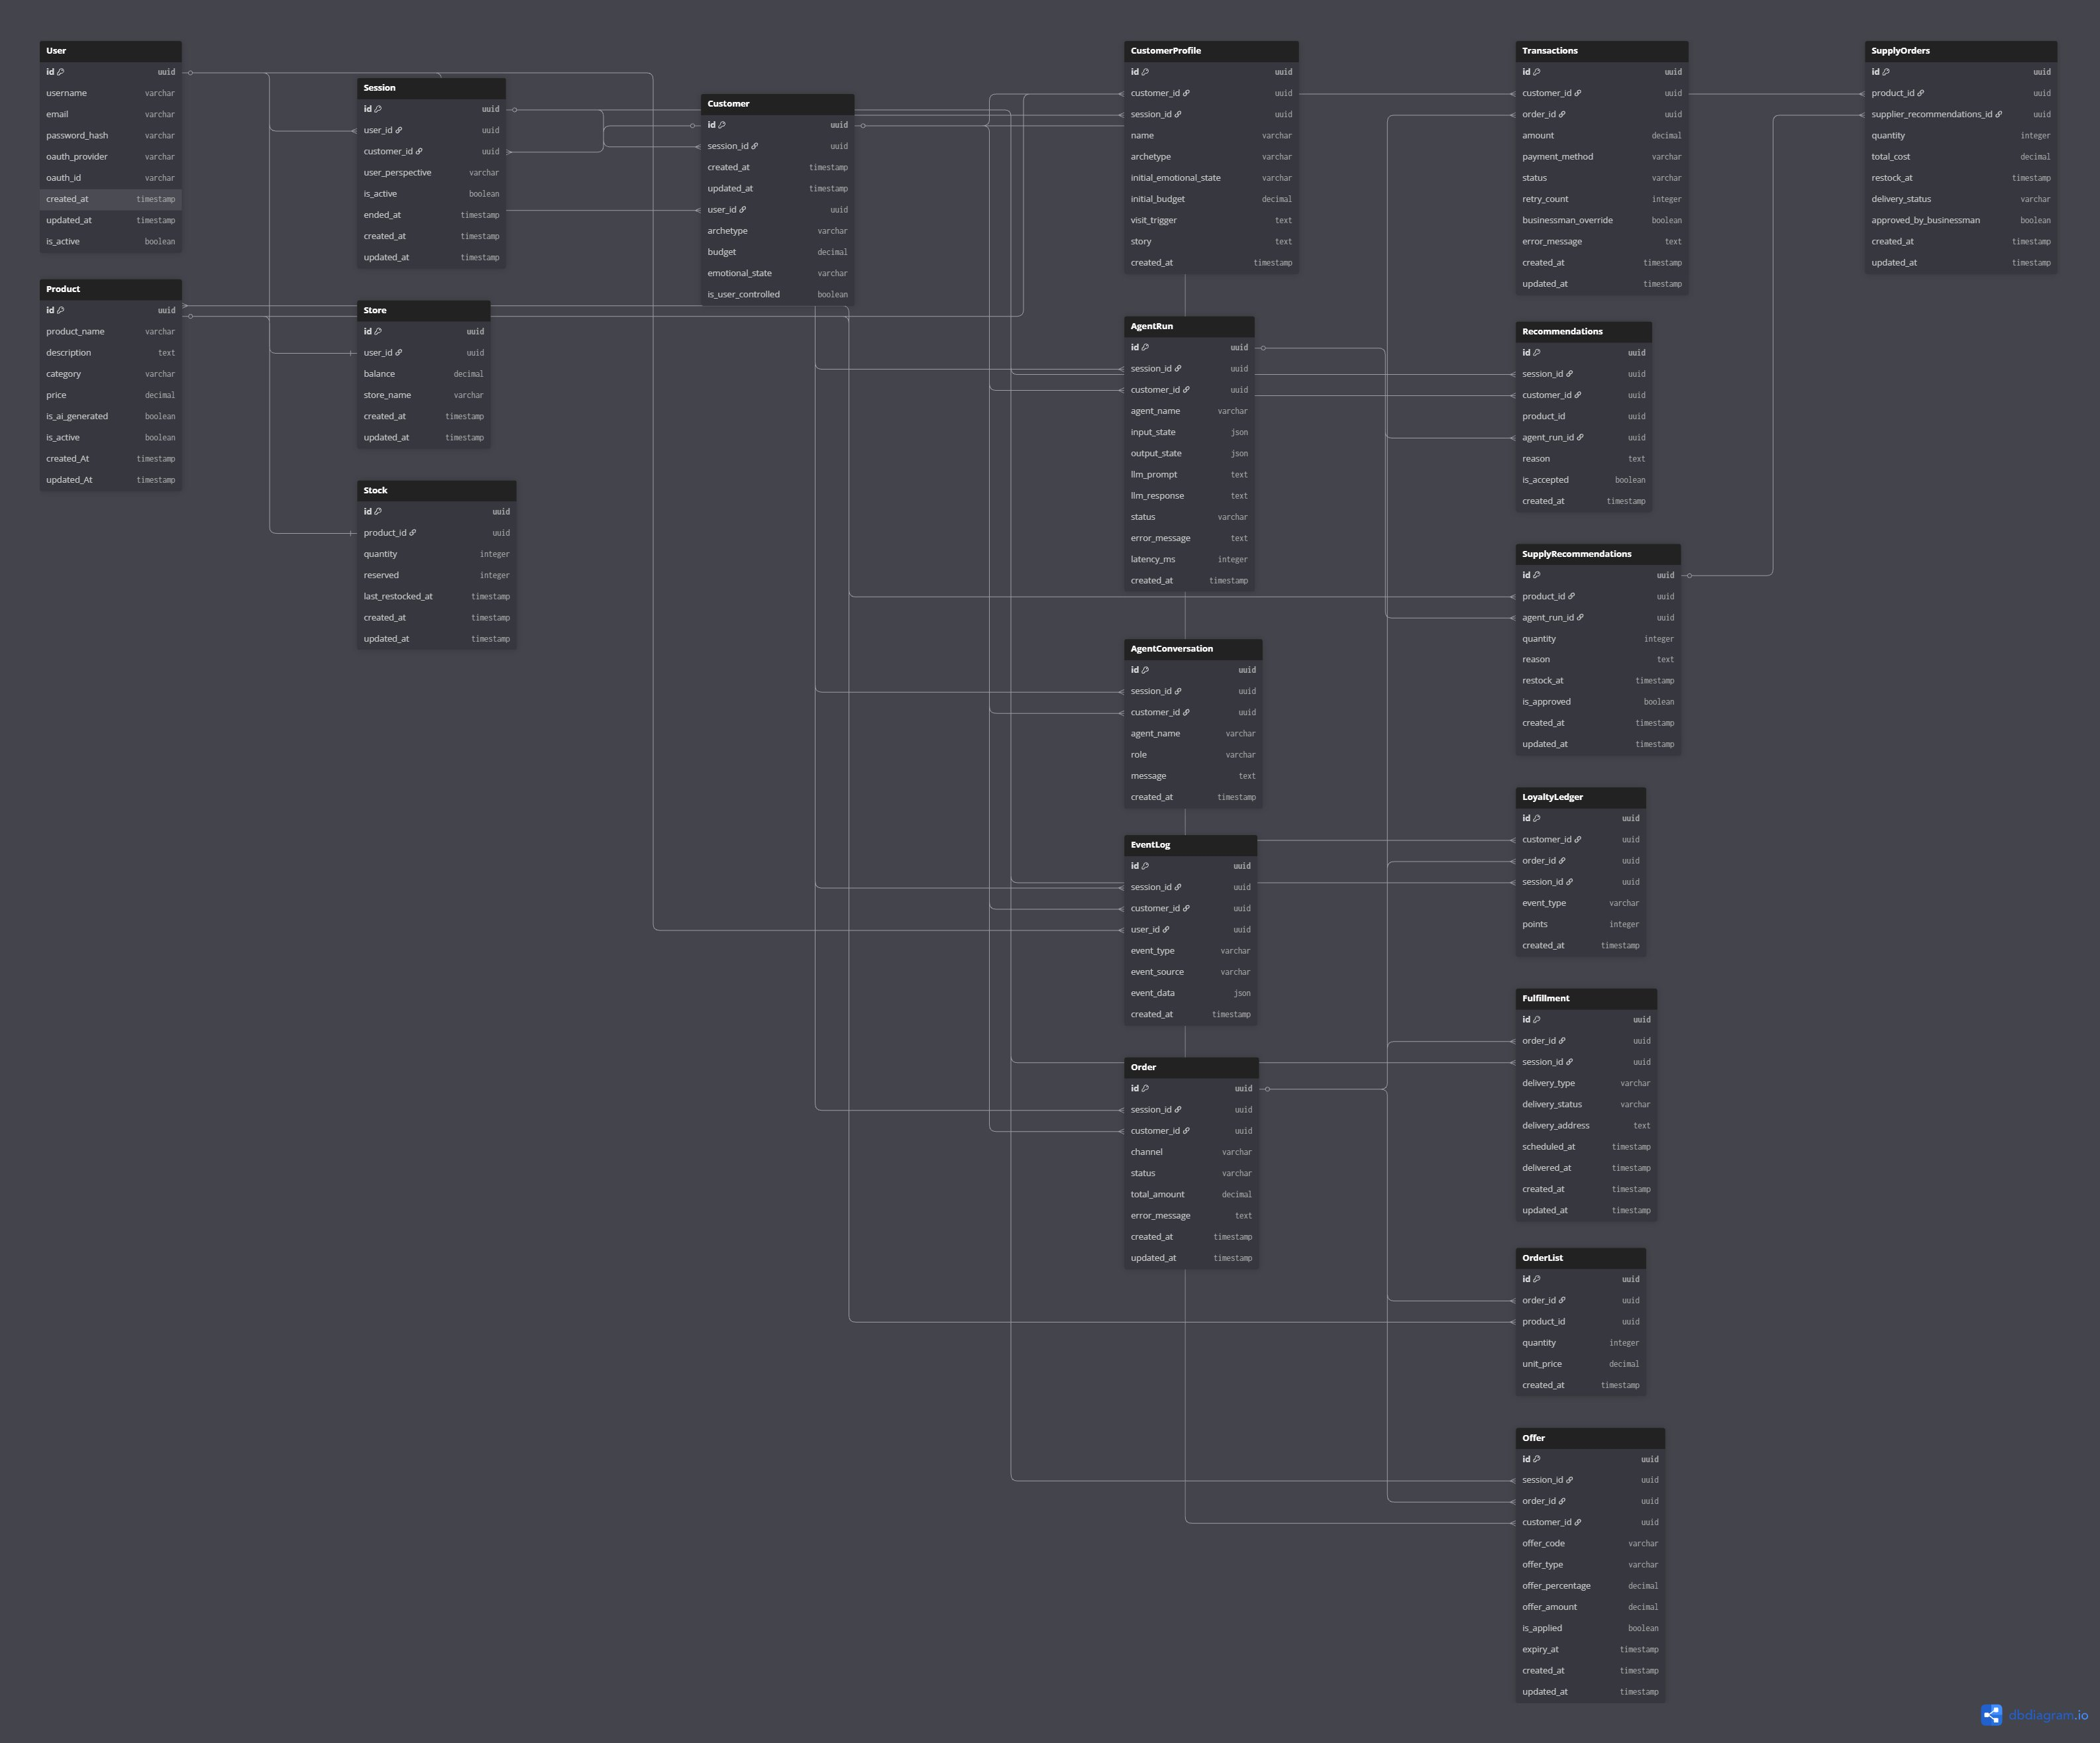
Figure 2 — ShopKeeper AI Database Schema (19 tables)

3.2 Table Overview
Table | Responsibility | Key Relationships
User | Auth and account data | One-to-one with Store
Store | Store balance and name | Belongs to User
Session | One game session per visit | Belongs to User
Customer | NPC or user-controlled buyer | Belongs to Session
CustomerProfile | AI-generated profile per visit | Belongs to Customer
Product | Store catalog | One-to-one with Stock
Stock | Live inventory levels | Belongs to Product
Order | Purchase intent per channel | Belongs to Customer, Session
OrderList | Line items per order | Junction: Order x Product
Transactions | Payment attempts and retries | Belongs to Order
Fulfillment | Delivery and pickup scheduling | Belongs to Order
Offer | Coupons and promo codes | Belongs to Customer, Order
LoyaltyLedger | Points earned and redeemed | Belongs to Customer, Order
AgentRun | Every agent execution log | Belongs to Session
AgentConversation | Chat messages per agent | Belongs to Customer
Recommendations | Product suggestions to customer | Belongs to AgentRun
SupplyRecommendations | Restock suggestions to businessman | Belongs to AgentRun
EventLog | Full game event audit trail | Belongs to Session
SupplyOrders | Approved restock orders | Belongs to SupplyRecommendations

3.3 Key Relationships

One to One
- User → Store
- Product → Stock

One to Many
- User → Session, Customer, EventLog
- Session → Customer, Order, AgentRun, AgentConversation, EventLog
- Customer → CustomerProfile, Order, Transactions, LoyaltyLedger, Offer
- Order → OrderList, Transactions, Fulfillment, Offer, LoyaltyLedger
- AgentRun → Recommendations, SupplyRecommendations

Many to Many
- Product x Order — resolved by OrderList junction table

4. API Contract
REST handles all CRUD and game state operations. WebSocket handles real-time agent event streaming. All protected routes require a valid JWT in the Authorization header.

4.1 JWT Payload
Field | Type | Description
user_id | UUID | Unique user identifier
session_id | UUID | Current session. Populated after /session/start.
is_active | boolean | Whether the session is currently active
role | customer | businessman | Current perspective. Changes on /session/switch.

4.2 Auth Endpoints
Method | Endpoint | What it does
POST | /auth/register | Create account with username and password
POST | /auth/login | Verify credentials, return JWT and refresh token
GET | /auth/google/initiate | Redirect user to Google OAuth consent screen
GET | /auth/google/callback | Receive Google response, issue JWT
POST | /auth/refresh | Issue new access token from refresh token
POST | /auth/logout | Invalidate session and refresh token

4.3 Store Endpoints
Method | Endpoint | Access
GET | /store | Public (balance hidden from customer)
PATCH | /store | Businessman only
GET | /store/inventory | Public (visible products only for customer)
GET | /store/inventory/{product_id} | Public
PATCH | /store/inventory/{product_id} | Businessman only

4.4 Cart & Order Endpoints
Method | Endpoint | What it does
GET | /cart/{session_id} | Fetch current cart for a session
PATCH | /cart/{session_id} | Add, remove, or update items in cart
POST | /orders | Convert cart to order, initiate checkout
GET | /orders/{order_id} | Fetch order details and current status

4.5 Session Endpoints
Method | Endpoint | What it does
POST | /session/start | Create new session, assign starting perspective and NPC
POST | /session/resume | Load existing session state for returning user
POST | /session/switch | Switch perspective — returns full updated session object
POST | /session/reset | Clear locked NPC and reset game state
GET | /session/{session_id}/customers | All customers in session (businessman view)
GET | /session/{session_id}/events | Fetch historical event log for the session
GET | /session/{session_id}/stats | End-of-day stats

4.6 Agent Endpoints
Method | Endpoint | What it does
POST | /orders/{order_id}/payment/initiate | Start payment transaction
GET | /orders/{order_id}/payment | Fetch payment status and transaction history
POST | /orders/{order_id}/payment/retry | Retry a failed payment
POST | /orders/{order_id}/payment/override | Businessman manually approves failed payment
GET | /orders/{order_id}/fulfillment | Fetch delivery and pickup status
GET | /supply_recommendations | Fetch Supplier Agent restock recommendations
POST | /supply_recommendations/{id}/approve | Approve recommendation, create supply order
GET | /supply_orders | Fetch all approved supply orders

4.7 WebSocket Connections
Connection | URL | Direction
Sales Agent chat | ws://domain/ws/sales-agent/{customer_id} | Bidirectional
Post-purchase chat | ws://domain/ws/post-purchase/{session_id} | Server initiates first
Agent event stream | ws://domain/ws/events/{session_id} | Server to client only

5. LangGraph Agent Graph

5.1 Entry Point — Customer Generator
Fires once at session start. Generates the full day queue of 7–10 customers upfront as a batch. Mix of online and offline archetypes. Customers trickle into the store throughout the in-game day — not all at once.

5.2 Sales Agent — Supervisor
Entry point for every customer message. Orchestrates all worker agents.
Trigger | Agent Called | Purpose
Conversation start | Recommendation Agent | Generate gist carried through whole conversation
During browsing | Inventory Agent | Fetch live stock levels and product details
Hesitation / long browse | Offers Agent | Discount nudge to prevent drop-off
Random interval | Offers Agent | Promo visibility across the store
Checkout / payment talk | Recommendation Agent | Comfort and upsell nudge
Cart confirmed | Payment Agent | Hand off to payment flow

5.3 Payment Agent Flow
- Runs transaction state machine: INITIATED → PROCESSING → SUCCESS / FAILED / TIMEOUT
- On SUCCESS → calls Loyalty Agent + Fulfillment Agent together
- On FAILURE → retries once automatically
- If retry fails → surfaces override prompt to Businessman dashboard

5.4 Post Purchase Agent
- Fires automatically after set in-game minutes post purchase
- Always active for that customer for complaints and queries
- Proactive first message — agent reaches out first, then reactive

5.5 Supplier Agent
- Fires when stock drops below threshold — not end-of-day only
- Fires when demand or trend signals emerge from customer conversations
- Surfaces restock recommendations with reasoning to Businessman dashboard
- On approval: deducts ₹ from store balance, sets delivery pending, updates inventory next in-game day

5.6 Agent Type Reference
Agent | Type | Calls Groq
Sales Agent | LLM — Supervisor | Yes
Recommendation Agent | LLM — Worker | Yes
Inventory Agent | Deterministic | No
Payment Agent | Deterministic — State machine | No
Fulfillment Agent | Deterministic | No
Loyalty & Offers Agent | Deterministic | No
Supplier Agent | LLM — Worker | Yes
Customer Generator | LLM + Deterministic | Yes (lightweight call per customer)
Post-Purchase Agent | LLM — Worker | Yes

5.7 Customer Generator
Fires once at session start. Builds the full day queue upfront then releases customers one by one throughout the in-game day.

Archetype Skeletons — Deterministic
Archetype | Behaviour Pattern
Bargain Hunter | Price-sensitive, compares options, likely to abandon cart
Festival Shopper | Occasion-driven, clear intent, high conversion
Loyal Regular | Knows the store, asks for specific items, earns loyalty points
Impulse Buyer | Browsing with no clear intent, responds well to recommendations
Difficult Returner | Post-purchase complaints, tests the Post-Purchase Agent
Gift Buyer | Shopping for someone else, needs guidance, budget-conscious
Tech-Savvy Browser | Compares extensively before deciding, detail-oriented

LLM Flesh-Out — Per Visit
- A lightweight LLM call takes the archetype skeleton and generates visit-specific details
- Generates: name, age, what triggered the visit today, opening message, budget, emotional state
- Every customer feels unique without the unpredictability of fully random generation
- Mix of online and offline customers in the day queue — set at generation time

11. Observability Design
Observability is a first-class feature in ShopKeeper AI — not an afterthought. It serves three purposes simultaneously: debugging tool, game mechanic, and interview demo. Split across three tools, each with a distinct job.

Tool | Purpose | When It Fires
WebSocket Event Stream | Real-time agent activity on businessman dashboard | Every agent event streamed live. Drives dashboard cards. Server-to-client only.
LangSmith | Agent trace storage and deep inspection | Logs every LangGraph run. View Trace button pulls data from LangSmith API on click. Not real-time — drill-down only.
OpenTelemetry | System-wide distributed tracing | Traces full request journey: FastAPI → Redis → LangGraph → Supabase → WebSocket. Shows where latency lives.

11.1 Design Principle
The WebSocket stream is the real-time layer. LangSmith is the trace archive. OpenTelemetry is the system profiler. Never use LangSmith for real-time dashboard updates — it is not designed for low-latency reads.

11.2 Businessman Dashboard — Agent Cards
Each agent gets its own dedicated card in the full-screen dashboard. Every card has a View Trace button that surfaces the LangSmith execution trace inline — inputs, outputs, LLM prompt, reasoning, latency. An interviewer can see not just what the agent decided, but why.
Agent Card | What It Shows
Sales Agent | Active conversations, customer intent summaries, emotional tone per customer
Recommendation Agent | What was shown to each customer, acceptance rate, rejections and why
Inventory Agent | Live stock levels, reserved items, low stock alerts, out-of-stock events
Payment Agent | Transaction log, success/fail/retry breakdown, ₹ cash flow
Supplier Agent | Restock recommendations, pending orders, demand signals, new product suggestions
Customer Generator | Today’s customer queue, archetypes, auto-generated profiles
Loyalty & Offers Agent | Points issued today, points redeemed, active offers, top loyal customers
Post-Purchase Agent | Open support tickets, sentiment analysis, resolution status

11.3 Logging
- Loguru for structured local logging
- Every request gets a correlation UUID that flows through all logs, agent calls, and WebSocket events
- Every agent invocation, state transition, WebSocket event, and payment step is logged

6. State Schema
The single structured object passed between all agents. No natural language between agents. All inter-agent communication is structured state updates only.

Bucket 1 — Customer Identity
Field | Description
customer_id | Unique identifier for this customer
archetype | Base archetype: Bargain Hunter, Festival Shopper, Loyal Regular, etc.
name, age | LLM-generated per visit
emotional_tone | calm | frustrated | excited | hesitant
is_user_controlled | Is the user currently possessing this NPC
channel | online | offline

Bucket 2 — Session Context
Field | Description
session_id | Session this customer belongs to
current_stage | home | browsing | checkout | payment | post_purchase
day_number | Which in-game day this is

Bucket 3 — Intent
Field | Description
intent | What the customer came in for
budget | Approximate spend limit in ₹
browsing_context | Categories or products they have looked at

Bucket 4 — Cart
Field | Description
cart_items | List of products and quantities
cart_total | Running total in ₹

Bucket 5 — Agent Decisions
Field | Description
recommendation_gist | Output from Recommendation Agent, carried through conversation
recommendation_fired_checkout | Flag — has the checkout nudge fired
offers_shown | List of offers already shown to this customer
loyalty_points_earned | Points issued this session

Bucket 6 — Payment
Field | Description
payment_status | initiated | processing | success | failed | timeout
retry_count | Number of retry attempts
override_approved | Businessman manually approved or not

Bucket 7 — Post Purchase
Field | Description
post_purchase_message_sent | Flag — has the proactive message been sent
open_issue | Complaint or query if customer returned
issue_status | open | resolved

7. Auth Strategy
Custom auth implemented from scratch. No Supabase Auth. Two login methods supported. Full control over JWT payload including the role field which drives role-based access throughout the system.

Method | Implementation
Username + Password | bcrypt hashes password on register. bcrypt.verify() on login. Hash stored in DB, never the password.
Google OAuth 2.0 | Two endpoints: /auth/google/initiate redirects to Google. /auth/google/callback receives response and issues JWT.
JWT | python-jose issues access token + refresh token. Payload: user_id, session_id, is_active, role.
Security | HTTPS only. Passwords never logged. JWT secret in env vars. Tokens expire on schedule.

7.1 Role-Based Access
Feature | Customer | Businessman
Visible agents | Sales, Recommendation, Post-Purchase | All agents
Dashboard | No | Yes
Store balance | No | Yes
Other NPCs | Not visible | All visible
Phone overlay | Yes | No
Shelf overlays | Yes | Read-only view

8. Possession Mechanic
The ability for the user to switch between two perspectives mid-session — Customer NPC and Businessman — without losing state, breaking any agent, or corrupting the game world.

8.1 Switch Trigger
A persistent but subtle button in the top bar — always visible but not intrusive. Clicking triggers the switch. A transition animation plays on click.

8.2 Switch Flow — Step by Step
Step | Layer | What Happens
1 | Frontend | Transition animation plays. Frontend re-renders based on new role from session response.
2 | Backend | POST /session/switch called. Server updates role in session and JWT. Returns full updated session object in one response.
3 | Agent State | State object is NOT reset. Preserved exactly as it was at moment of switch. New perspective reads from same state.
4 | Left Behind Character | Sales Agent takes over the abandoned customer immediately and continues their journey autonomously using existing state.

8.3 Locked NPC Mechanic
- One customer NPC assigned at session start
- Switch button only ever takes the user to that one NPC — not any customer in the store
- Reset World clears this lock and lets the user pick a fresh perspective and archetype

9. Game World Design

9.1 Store Floor Layout
2x2 grid layout. Entry at bottom center. Checkout counter at top center. Businessman fixed in top right corner behind the counter.
Position | Section
Top left | Groceries & Veggies
Top right | Clothing
Bottom left | Electronics
Bottom right | Grooming
Top center | Checkout counter
Top right corner | Businessman (fixed, never moves)
Bottom center | Entry door

9.2 Offline Shelf Interaction Flow
- Customer walks up to shelf section → proximity triggers shelf overlay
- React UI panel opens on top of Phaser canvas — product grid for that category
- Inventory Agent fires → fetches live stock for that category
- Recommendation Agent fires once per shelf visit → 'you might also like' strip at bottom
- Customer adds to cart → Inventory Agent reserves stock
- Customer walks to checkout counter → Payment Agent fires
- Post purchase → Post Purchase Agent fires after set in-game minutes

9.3 Phone-in-Game UI Overlay
A real functioning ecommerce website rendered as a React UI inside a pixel-art phone frame overlay on the game canvas.

Two Configurations
Configuration | Form Factor | Toggle
Phone | Centered phone frame overlay on game canvas | Toggle button inside overlay
Desktop | Full browser-width panel slides in from side | Same toggle switches back

What's Inside the Overlay
- Home / landing — store name, featured products, active offers
- 4 category sections — Groceries, Clothing, Electronics, Grooming
- Product pages — name, price ₹, stock level, add to cart
- Cart — running total, checkout button
- Floating chat button — opens Sales Agent chat alongside the store

Product Visibility Rules
- Out of stock → hidden from online store automatically
- Low stock → visible but flagged
- Supplier Agent adds new products → appear on next in-game day
- Trend-based hiding — toggleable via feature flags

Technical Rendering
- Phone frame — pixel art SVG frame rendered by React, sits on top of Phaser canvas
- Website inside — real React UI rendered inside the frame
- Desktop config — same React UI, no phone frame, wider layout
- Toggle — switches CSS layout class, no full re-render, state preserved
- Phaser fires event to React → React renders overlay → same event bus pattern as shelf overlay

10. Deployment Environment

10.1 Environments
Two environments only — dev and prod. No staging because free tier resources are limited. Dev is local. Prod is live.

10.2 Services and Free Tier Map
Service | Platform | Notes
Frontend | Vercel | Auto-deploy from main branch. Vercel-generated URL.
Backend | Render | Free tier. Health check prevents spin-down.
Database | Supabase | Two projects: shopkeeper-dev and shopkeeper-prod.
Cache | Upstash Redis | Serverless, free tier, zero ops.
LLM | Groq | Free tier. Rate limits managed at app level.
Observability | LangSmith Cloud | Free tier. Trace storage only. Pulled via API on View Trace click.

10.3 Render Spin-Down Fix
- A /health endpoint on FastAPI returns a simple 200 OK
- External cron job pings it every 10 minutes — keeps Render awake on free tier
- No cost, no ops, no spin-down delays for users

10.4 CI/CD Pipeline — GitHub Actions

On Every PR
- Lint — Ruff + Black for Python, ESLint + Prettier for React
- Run test suite — pytest for backend, Jest for frontend
- PR cannot merge if either fails

On Merge to Main
- Auto-deploy frontend to Vercel
- Auto-deploy backend to Render
- Never deploy manually

10.5 Branching Strategy
Branch | Purpose
main | Production. Merging here triggers deploy.
dev | Integration branch. PRs merge here first.
feature/* | Individual feature branches off dev.

10.6 Environment Variables in Production
Set directly in Vercel and Render dashboards — never in code.
Variable | Used By
GROQ_API_KEY | Backend — all LLM agent calls
LANGSMITH_API_KEY | Backend — trace storage
JWT_SECRET | Backend — token signing and validation
SUPABASE_DB_URL | Backend — database connection
UPSTASH_REDIS_URL | Backend — cache and rate limiting
CORS_ORIGINS | Backend — allowed frontend domains

ShopKeeper AI · Architecture Document v1.0 · May 2026

