ShopKeeper AI
Database Schema Design

Overview
The ShopKeeper AI database is designed to support a full multi-agent AI system wrapped inside a retro pixel-art game. The schema follows a single-responsibility principle — each table owns one concern and nothing else.

Design Principles
- Entities first, tables later — list real-world things before designing columns
- Never store a list in a column — use junction tables for one-to-many and many-to-many
- Never store computed values — derive them at query time
- Separate what a thing IS from the current STATE of that thing
- Use DECIMAL for all money fields — never FLOAT
- Use UUID for all primary keys
- Every table gets created_at and updated_at except append-only tables
- Index what you filter, join, or sort by — not everything

Tables (19 Total)

Table | Responsibility | Key Relationships
User | Auth and account data | One-to-one with Store
Store | Store balance and name | Belongs to User
Session | One game session per visit | Belongs to User
Customer | NPC or user-controlled buyer | Belongs to Session
CustomerProfile | AI-generated profile per visit | Belongs to Customer
Product | Store catalog | One-to-one with Stock
Stock | Live inventory levels | Belongs to Product
Order | Purchase intent per channel | Belongs to Customer, Session
OrderList | Line items per order | Junction: Order x Product
Transactions | Payment attempts and retries | Belongs to Order
Fulfillment | Delivery and pickup scheduling | Belongs to Order
Offer | Coupons and promo codes | Belongs to Customer, Order
LoyaltyLedger | Points earned and redeemed | Belongs to Customer, Order
AgentRun | Every agent execution log | Belongs to Session
AgentConversation | Chat messages per agent | Belongs to Customer
Recommendations | Product suggestions to customer | Belongs to AgentRun
SupplyRecommendations | Restock suggestions to businessman | Belongs to AgentRun
EventLog | Full game event audit trail | Belongs to Session
SupplyOrders | Approved restock orders | Belongs to SupplyRecommendations

Relationship Types

One to One
- User → Store
- Product → Stock

One to Many (key relationships)
- User → Session, Customer, EventLog
- Session → Customer, Order, AgentRun, AgentConversation, EventLog
- Customer → CustomerProfile, Order, Transactions, LoyaltyLedger, Offer
- Order → OrderList, Transactions, Fulfillment, Offer, LoyaltyLedger
- AgentRun → Recommendations, SupplyRecommendations
- SupplyRecommendations → SupplyOrders

Many to Many
- Product x Order — resolved by OrderList junction table

Indexing Strategy
Indexes are added on columns frequently used to filter, join, or sort. Low-cardinality columns (booleans, status enums) are not indexed alone — they are combined into composite indexes with high-cardinality columns like session_id or customer_id.

Example composite indexes:
- (session_id, status) on AgentRun — fetch failed agent runs in a session
- (customer_id, event_type) on LoyaltyLedger — fetch earned vs redeemed points
- (product_id, is_accepted) on Recommendations — acceptance rate per product
- (session_id, is_user_controlled) on Customer — find the possessed NPC instantly
- (order_id, status) on Transactions — fetch all retry attempts for an order

ER Diagram
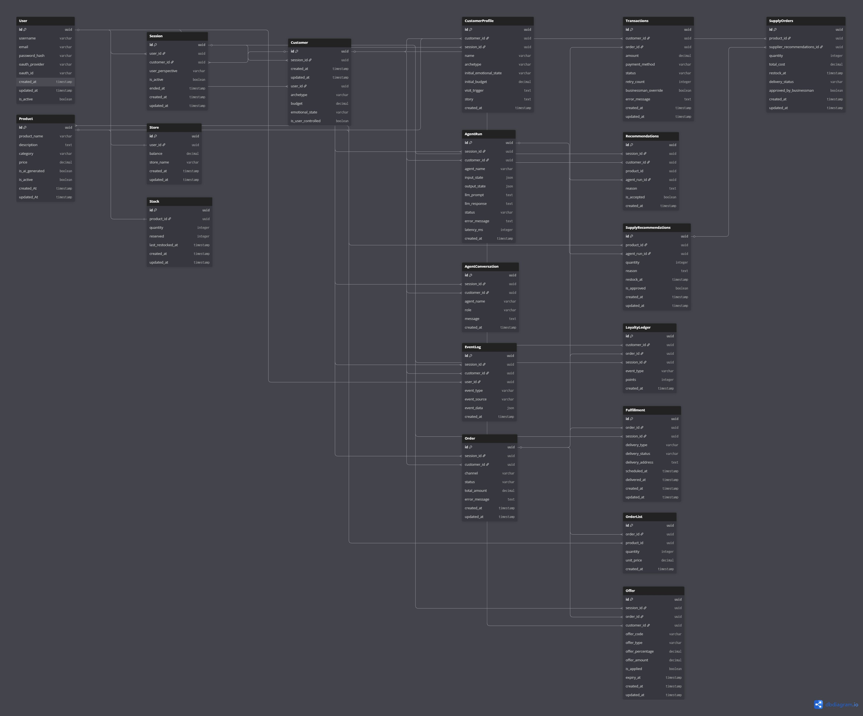
Full schema visualised on dbdiagram.io
ShopKeeper AI · Database Schema v1.0 · Phase 2 — Design & Architecture

