**Feature**

**Ground-truth**

**Net output**

**Widefield**

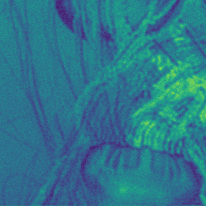

**Custom Loss 1**

**Feature**

**Ground-truth**

**Net output**

**Widefield**

**L1 Loss**



**Custom Loss 1**

**L1 Loss**