Introduction to Multimedia :

Coursework 2 report

# CANDIDATE INFO

Name: Vaios Karpathakis

Candidate number : 146682

Module title : Introduction to Multimedia

Degree title : BSc Computer Science

Date of submission : December 9, 2015

# INTRODUCTION

This is the report for my second coursework for the Introduction to Multimedia module. The purpose of this report is to demonstrate in detail the design and development process that I followed working on this project, both for the website and the animation.

# Design and development

## Website development

This is the first website I have ever made that includes multiple pages. It took me about 3 weeks of working several hours per day to make it look the way that I wanted. This was because I had very little experience with HTML, CSS, and web development in general. The editor I used to work is called Brackets. I picked it because it is free and easy to use with a user friendly interface.

I started working by learning how page navigation works. I learned how to connect the different parts of my website by putting links that lead to different pages. The most important part of it for me was the navigation bar. I wanted it to be eye catching, appealing, and easy to look at. This is why I chose light shades of orange and black to color it. Since I did not know how to make the navigation bar the way I wanted it, I looked for a website online that showcased some responsive navigation menu ideas. ( referenced at the end of the report )

C:\Users\Alpha\Desktop\Screenshot_3.png

To style my website, I used my CSS knowledge that I acquired at the lab exercises of the module, as well as Bootstrap, an open source framework designed to help build websites. I used its jumbotron and container functions to create eye catching boxes for the information that I put in the pages.

In order to learn how to use bootstrap I searched the internet for tutorials, which I have referenced below. There, I found useful information like how to put rounded borders around an image. The same website showed me how to add an introduction video that I recorded with my phone’s camera to one of my pages.

I looked up online on how to add a background image to my pages. After that, I added the background functions to a main CSS file that was linked to all of my 6 pages. The same CSS file included the navigation bar style.

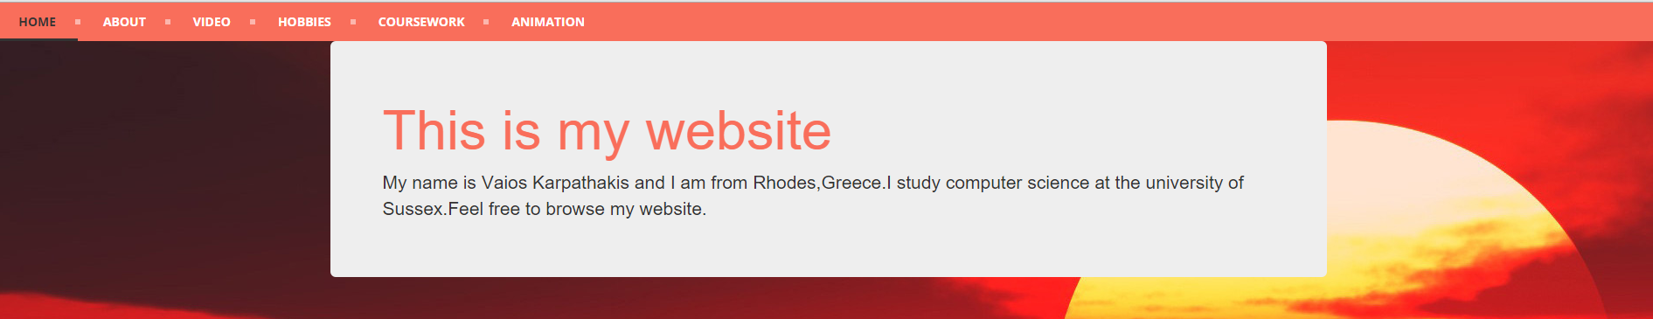

I also made 3 extra CSS files to further style my Hobbies, Home, and About pages.

## Animation development

Creating the animation was the hardest part, as I had zero Javascript knowledge before lab 6 in the Introduction to Multimedia module. After completing the lab exercise and watching some tutorial videos on Youtube I had the tools to make the animation.

For the animation, I used the Raphaeljs library which included useful functions like the Raphael canvas, and the .circle and .rect functions, which I used to create my shapes. My first concern was to make my animation relatable to the sound playing. To do that, I used the setTimeout method, which allowed me to make my shapes pop up to the first 4 beats of the song. My animation includes both transformation, movement, and on click functions. In order for it to last 19 seconds as required by the assignment, I created several move functions that lasted milliseconds that together add up to 19, which is the song’s length.

Finally ,I added a nice sea floor background, that fits with the slow sinking of one of the shapes, which can be clicked to bounce up. After bouncing up, it starts sinking again because the bounce method calls the sinking method. This adds interactivity with the user, since the user can keep playing with the sinking ball even after the animation ends.

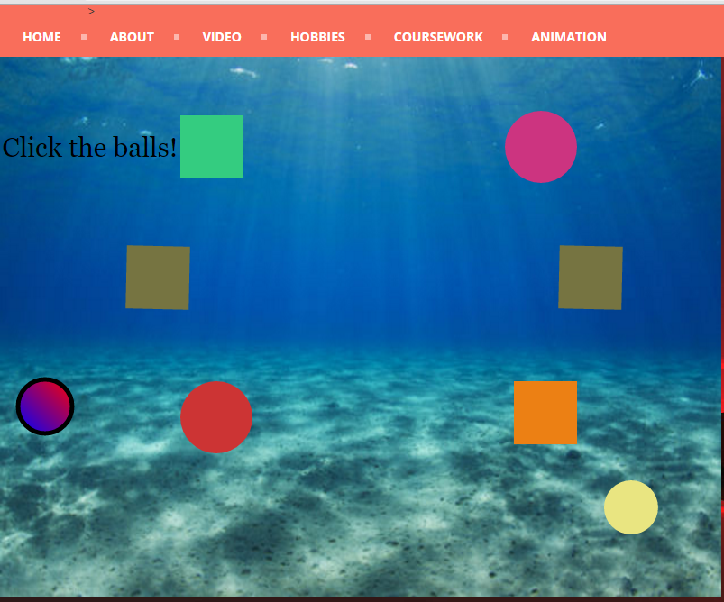

# Conclusion

To sum up, it must be noted that I achieved my aim. The result exceeded my expectations, considering the little experience I had. However, it is far from perfect. My website can be much prettier if I added some more options for the user, like switching styles on each page, or if I structured my personal information better. As for the animation, I found it very difficult to pair animation and shape creation when using the setTimeout method. If I didn’t have this difficulty my animation would have been a bit more complex and fun to watch, but overall I am satisfied with my work.

# References

<http://cssmenumaker.com/blog/6-exceptional-menu-bar-navigation-designs>

<http://cssmenumaker.com/menu/simple-responsive-menu>

<http://getbootstrap.com/>

<http://www.w3schools.com/>

<http://getbootstrap.com/css/>

<http://www.w3schools.com/bootstrap/default.asp>

<http://stackoverflow.com/>

<https://www.codecademy.com/en/skills/make-a-website>

<http://www.templatemonster.com/help/js-animated-how-to-add-a-background-music-using-html.html>

<http://salmanshaheen.com/children-of-the-sunset/sunset/>

<http://www.sitepoint.com/>

<http://raphaeljs.com/>

<http://raphaeljs.com/reference.html>