**Part 1. DMM Basics**

1. What are the color-code bands of a 47k Ω resistor? What is the tolerance of the one in your lab box? (2 pts)
   1. Yellow, violet, orange, gold (+-5%)
2. Use your DMM to measure the actual resistance of this resistor. What is its actual resistance? (2 pts)
   1. 46.5k
3. Show, by drawing, how you would connect your DMM to measure current through R1. Include the circuit inside the DMM. (4 pts)

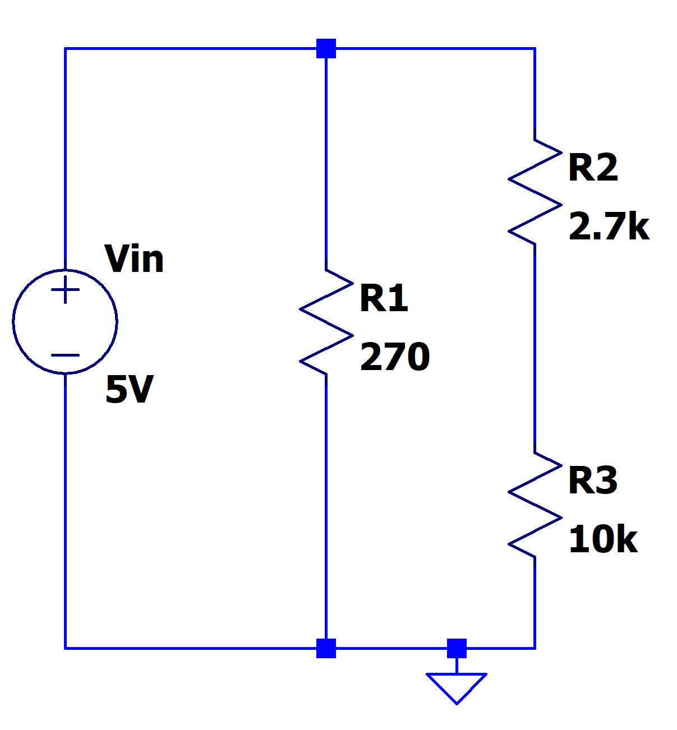

1. Calculate the current through resistor R1. (2 pts)

V=IR

I=V/R

I=5/270 = 18.5mA

1. Use your DMM to measure the current though resistor R1. You can use your power supply as the input voltage source. Report your measurement below. (2 pts)
   1. 18.8mA
2. How much power is dissipated in R1? Use your actual measurement results to calculate this power
   1. P=I*V
   2. P=0.0188*5=0.094W
3. Calculate the voltage across resistor R3. (2 pts)
   1. V=5*(10/[2.7+10])
   2. V=3.94V
4. Use your DMM to measure the voltage across resistor R3. Report your measurement below. (2 pts)
   1. 3.95V

Part 2. Amplifier Design

1. What are the four ideal characteristics of an operational amplifier? (4 pts)
   1. 0 input current
   2. 0 output impedance
   3. Infinite open loop gain
   4. Infinite bandwidth
2. What is a non-inverting amplifier? Draw the schematic of an op-amp implementation of a non-inverting amplifier and derive its gain equation. (4 pts)
   1. Amplifier where the input source goes into the positive side of the op amp.
   2. 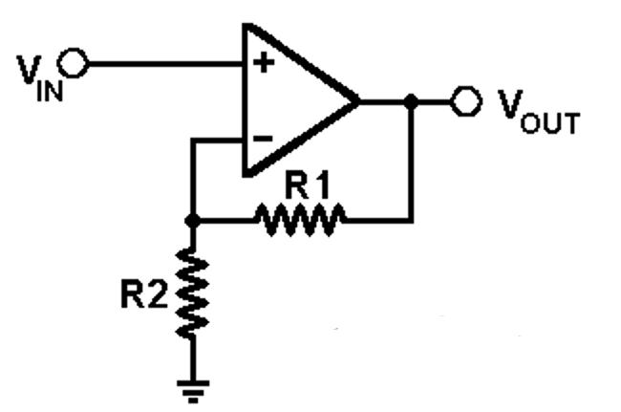V- = V+ = Vin
   3. V- = Vout*[R2/(R2+R1)]
   4. Av=Vout/Vin
   5. Av=R2+R1/R2
   6. **Av=1 + R1/R2**
3. Design a non-inverting amplifier with a gain of approximately 20. You will need to build this circuit; thus please choose components that are available to you in your parts kit. Run a transient simulation on LTspice with an input AC test voltage (100mV amplitude and 1 kHz frequency); measure the output voltage. Paste your LTspice schematic and simulation result (show both input voltage waveform and output voltage waveform) below. (10 pts)

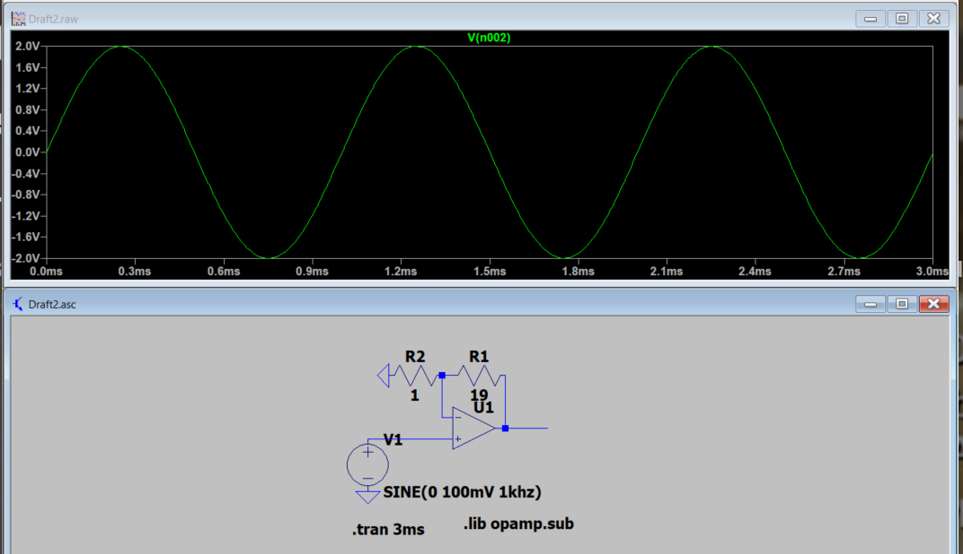

1. Build this non-inverting amplifier on your protoboard. Use the function generator on your AD2 to generate a 100mV amplitude and 1 kHz frequency AC input signal. Use your AD2 oscilloscope to measure both input voltage waveform and output voltage waveform. Use cursors to show the gain of 20. Paste your measurement result below. Compare the measurement result with your simulation results. (10 pts)
2. You have an input signal that ranges from -0.5V to 0.5V. In order to present this signal to an analog to digital converter you want to amplify it by a factor of 2 and shift it so that it occupies the range +0.5 to +2.5V. Design a circuit with op-amps that accomplishes this task, validate it in simulation, build it, and validate that the hardware works as expected. You may use a sine wave of 0.5V amplitude as your test signal. Place all necessary calculations, schematics and validation plots below. (20 pts)

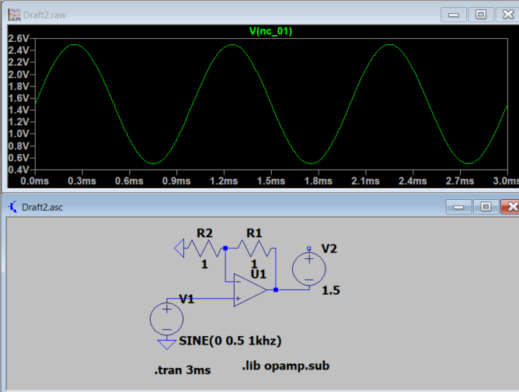

Part 3. Filter Design

1. Design a first order low-pass RC filter that has a break frequency of 20 kHz. Show your calculations. Run an AC sweep from 100 Hz to 1 MHz on LTspice for your circuit and paste your schematic and simulation result below. (10 pts)
   1. F=1/(2piRC)
   2. RC = 1/(2*pi*20,000)
   3. RC = 7.958*10^-6

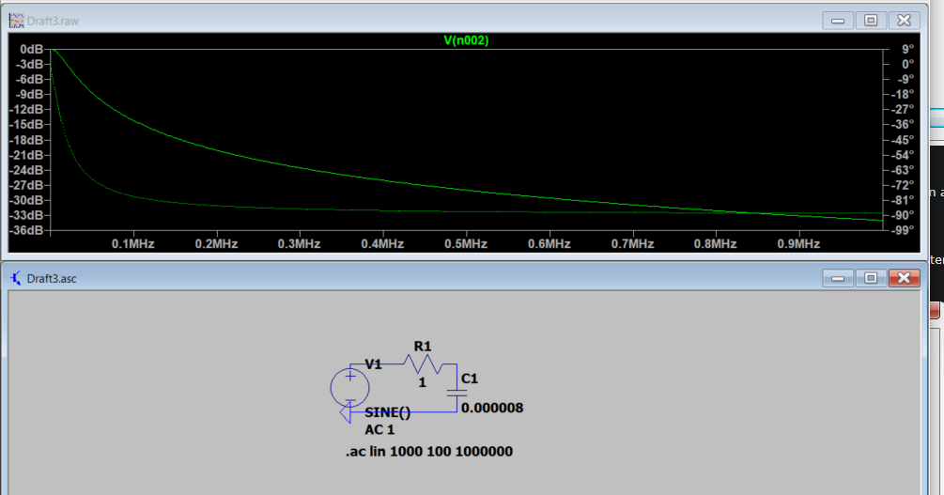

1. Build the circuit on your protoboard and use the network analyzer on your AD2 to measure the frequency response for the RC low pass filter you designed. Make sure to label the 3dB below passband point (break frequency). Compare the measurement result with your simulation results. (10 pts)

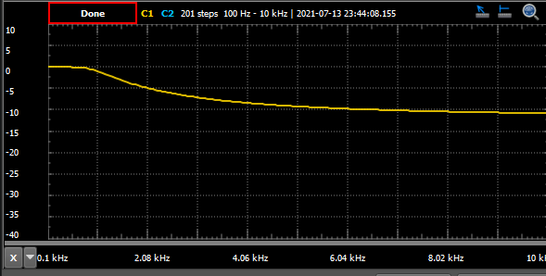

These numbers are completely different to the calculated value because I had to use different values for the capacitor. I did not have a 8uF cap so I used a 10uF. That made the numbers wrong. The resistor is also not perfect so that would change the numbers as well.

1. Design a first order high-pass RC filter that has a break frequency of 5 kHz. Show your calculations. Run an AC sweep from 100 Hz to 1 MHz on LTspice for your circuit and paste your schematic and simulation result below. (10pts)
   1. F=1/(2piRC)
   2. RC = 1/(2*pi*5000)
   3. RC = 3.18*10^-5

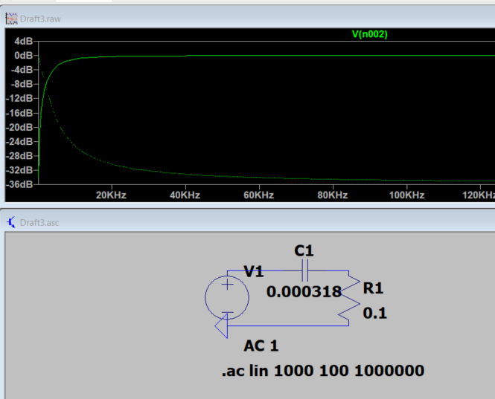

1. Use the network analyzer on your AD2 to measure the frequency response for the RC high pass filter you designed. Make sure to label the 3dB below passband point (break frequency). Compare the measurement result with your simulation results. (10 pts)
2. What is the significance of the 3dB below passband cutoff point? (4 pts)
   1. Its where you get the half power frequency point. The output power is half that of the input.
3. Find a way to combine the previous circuits to produce a bandpass filter that has a lower 3dB point at 5 kHz and an upper 3dB point at 20 kHz. Validate your new circuit with LTspice, implement it, and validate the hardware by measuring its frequency response. In both simulation and measurement, show that the 3dB points are in the correct locations. Paste any necessary calculations, schematics or plots below. (10 points)

