Group 23 ReadMe File for Airline Web Project

(Equal Contribution)

EC2 URL: <http://ec2-18-222-15-230.us-east-2.compute.amazonaws.com:8080/cs336Projects/>

Admin Credentials:

Username: 01

Password: admin

Customer Representative Credentials:

Username: 02

Password: password

Customer Passenger Credentials:

Username: Harsh

Password: password

RDS Hostname: cs336.ctrr9ro7iyao.us-east-2.rds.amazonaws.com

Username: admin

Password: administrator

DEMO Examples:

Search For One Way Flights

Login as a customer user

Search for one-way flights

Put:

Origin:JFK

Destination: LAX

Date: 2019-12-12

Origin:YYZ

Destination: PVG

Date: 2019-11-01

Reserve Flight

Search for one-way, round-trip, etc

Click on Reserve

(You can look through search through all flight in portal to find more sample data)

Put:

Origin: JFK

Destination: LAX

Date: 2019-12-12

|  |  |  |  |  |  |  |  |  |
| --- | --- | --- | --- | --- | --- | --- | --- | --- |
| | Airline | | Flight No. | | From | | To | | Departure Date | | Departure Time | | Arrival Date | | Arrival Time | | Air Fare | |
| 22 | 6666 | JFK | LAX | 2019-12-12 | 12:00:01 | 2019-12-13 | 12:00:00 | 900 |

Origin: PVG

Destination: YYZ

Date: 2019-11-01

Result

|  |  |  |  |  |  |  |  |  |
| --- | --- | --- | --- | --- | --- | --- | --- | --- |
| | Airline | | Flight No. | | From | | To | | Departure Date | | Departure Time | | Arrival Date | | Arrival Time | | Air Fare | |
| AC | 9035 | YYZ | PVG | 2019-11-01 | 04:00:00 | 2019-11-02 | 20:00:00 | 1100 |

Click on RESERVE

AirLine Code : AC

Flight ID Number 9035

Write down travel logistics

Credit Card is optional

Click on confirm

→ Go to Reservation Portal to see reservation

Search and Reserve Round-Trip

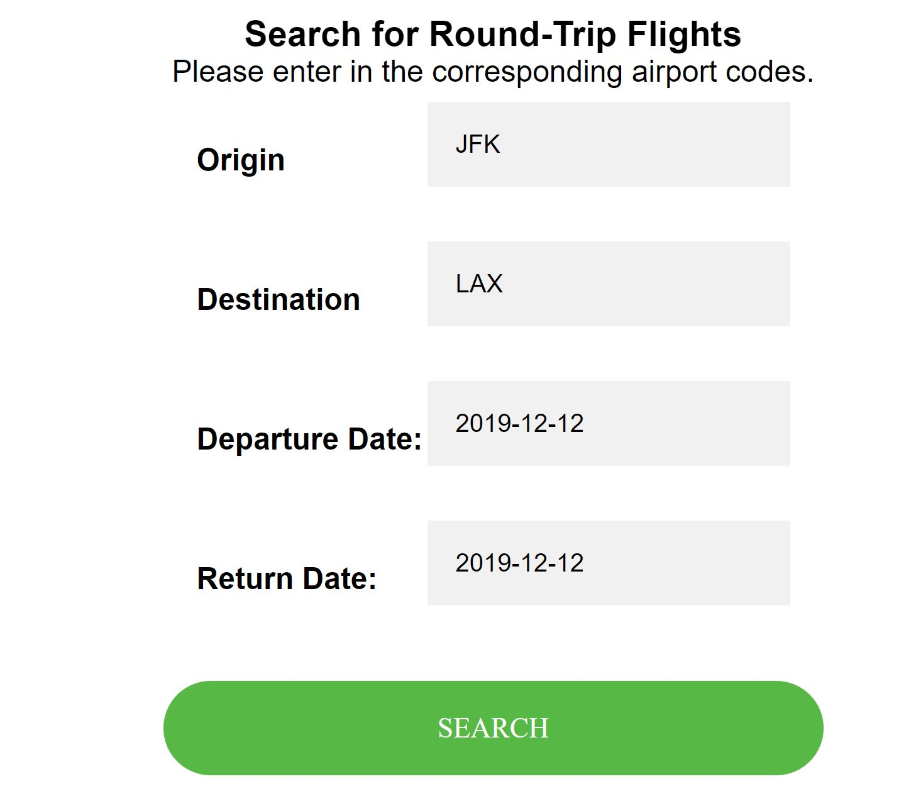

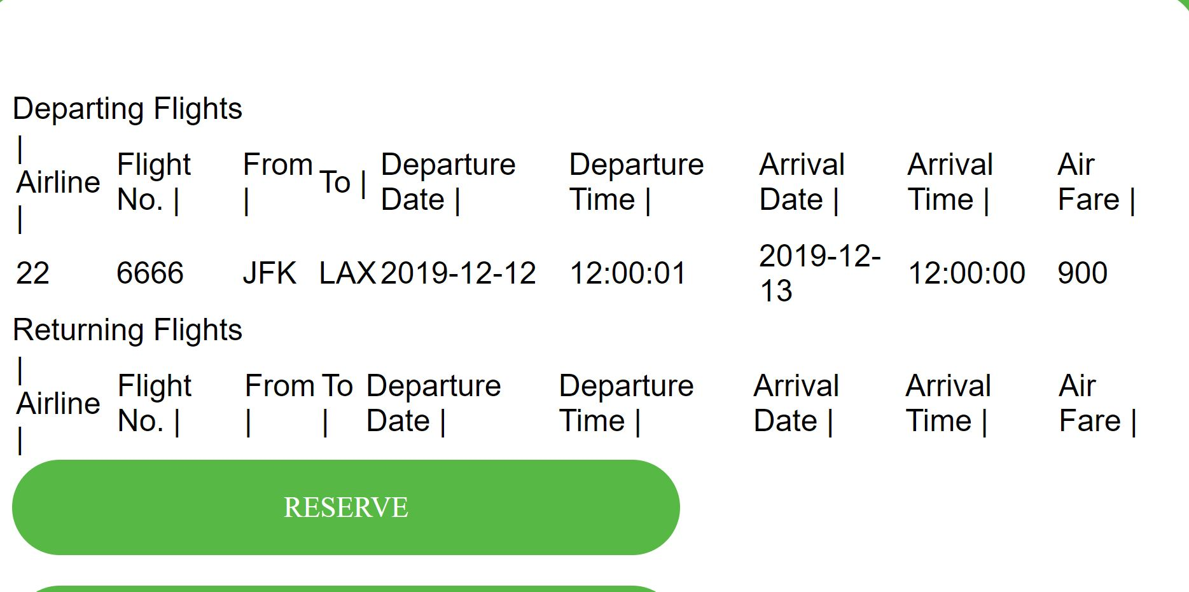

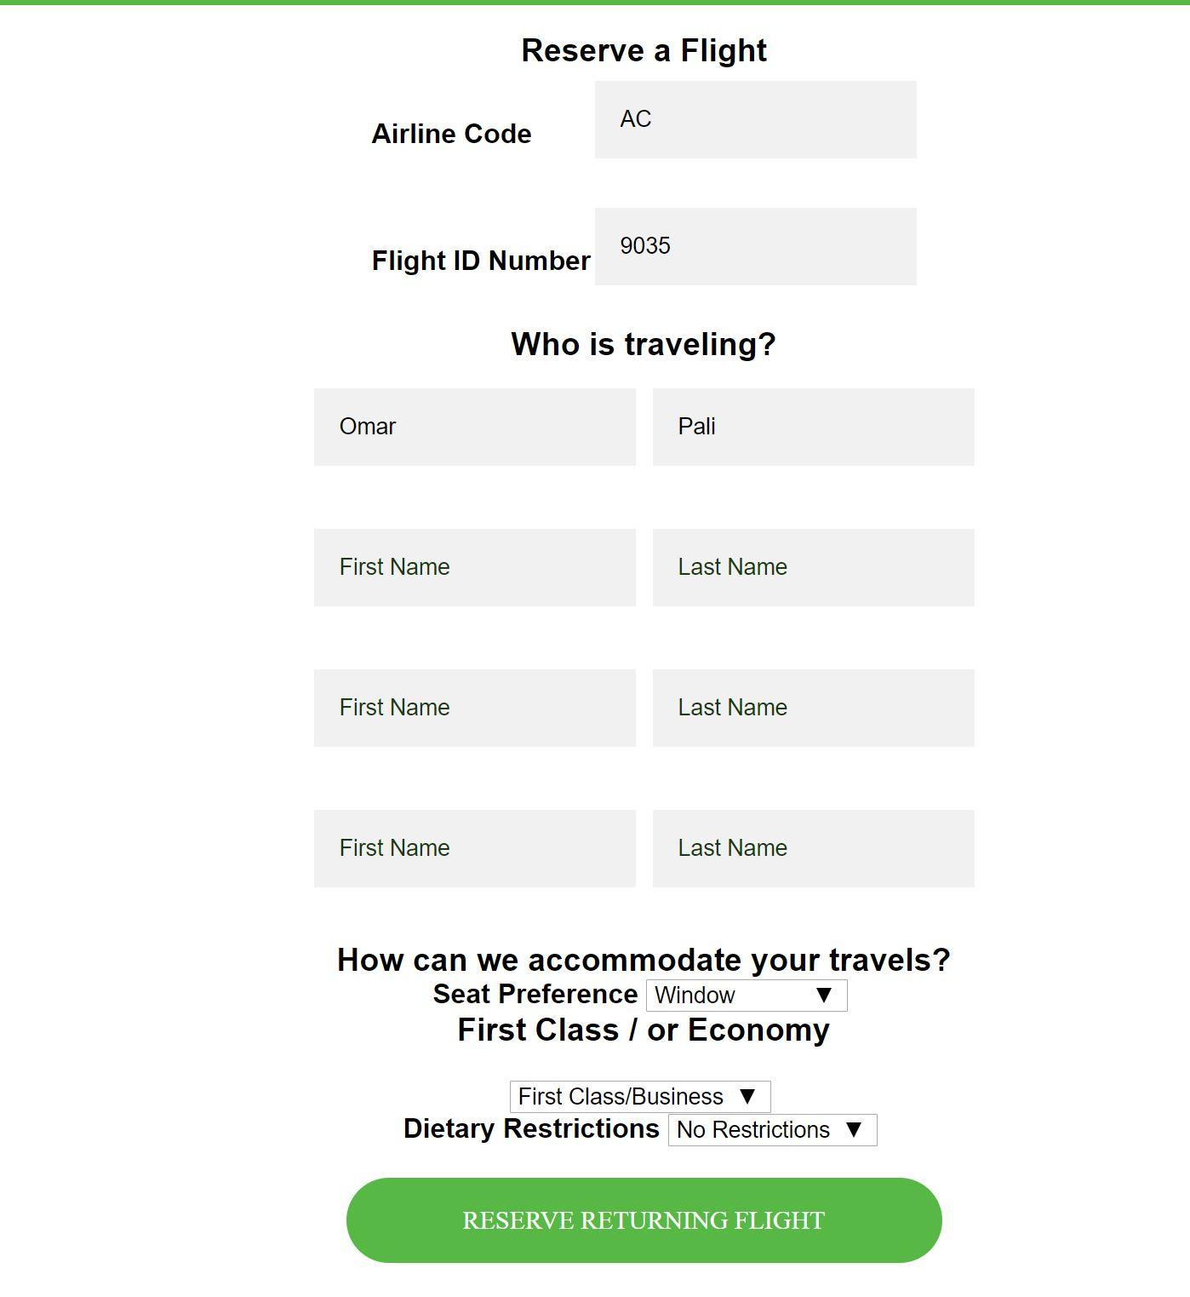

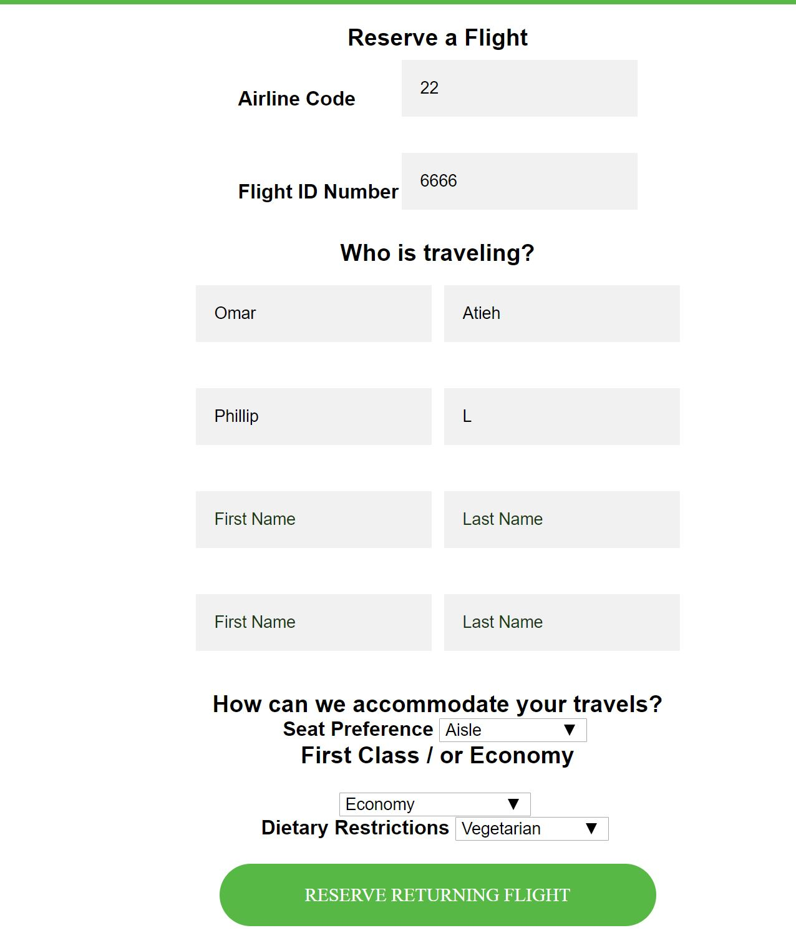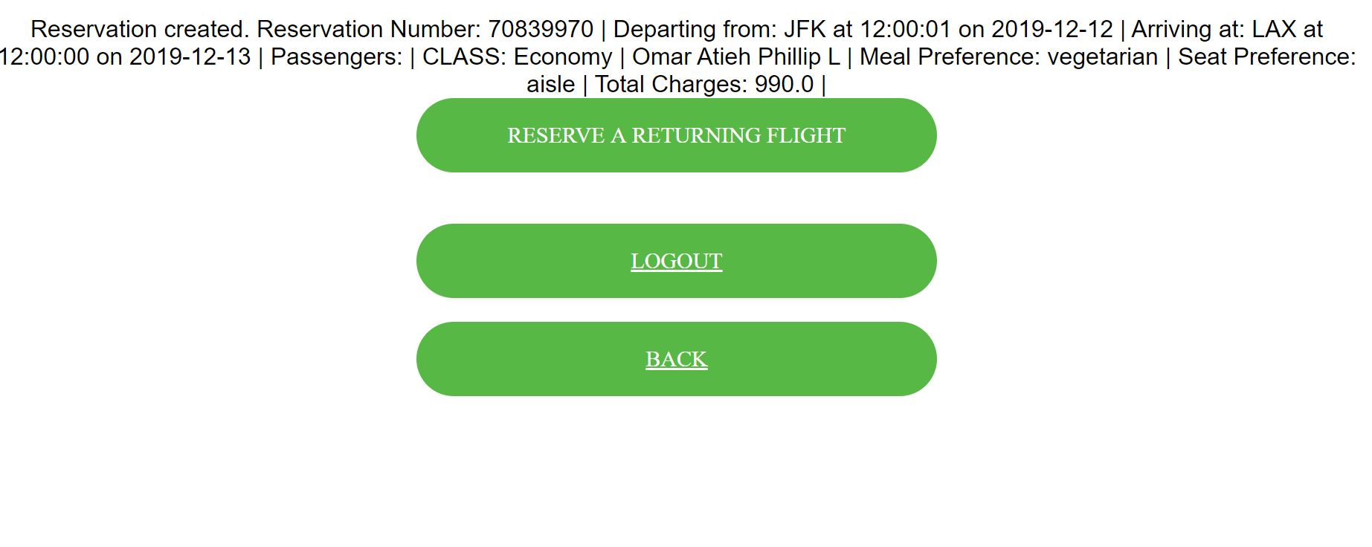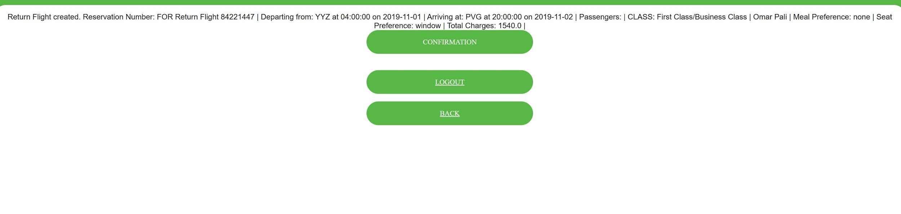

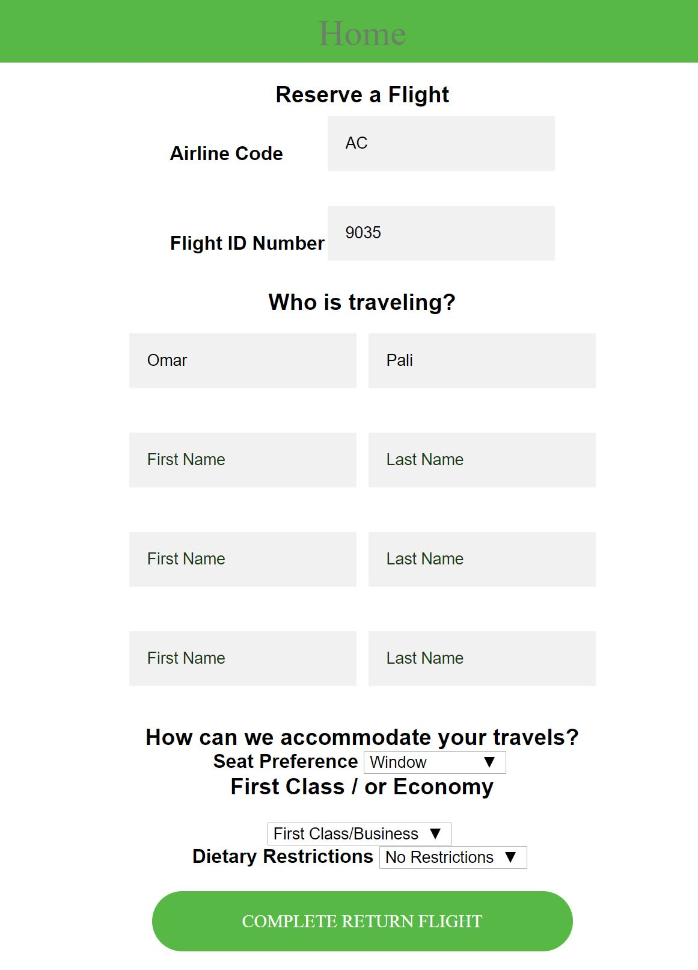

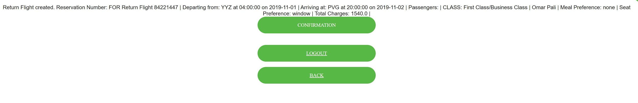

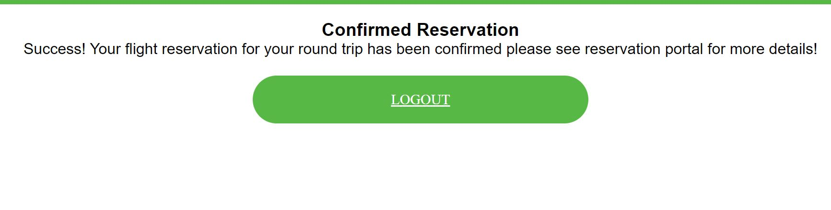

This was just one example of functionality on Reservation, there is more functionality that will Demoed.