

FindMyPet

Reconnect with Your Best Friend.

By Lim Chanvirakyuth

**Final Project Document**

1. Project Description

FindMyPet is an android app that let users upload lost pets or pets that they found on the app. The purpose of this app is to help pet owners locate their lost pets in this digital era.

1. Features and Requirements

This app has:

* User authentication
* Quick search feature with filters

Users:

* need to register an account to use the app
* can upload posts of lost or found pets
* can view all posts of other users
* can search for a post (post title, post description, animal types, animal gender, location)
* can edit or delete their own posts
* their posts need to approved by admins first

Admins:

* can approve all user pending posts
* can delete all user posts

1. Tools and Technologies

* Java Programming Language
* Spring Boot Framework
* Android Studio IDE
* MySQL

1. 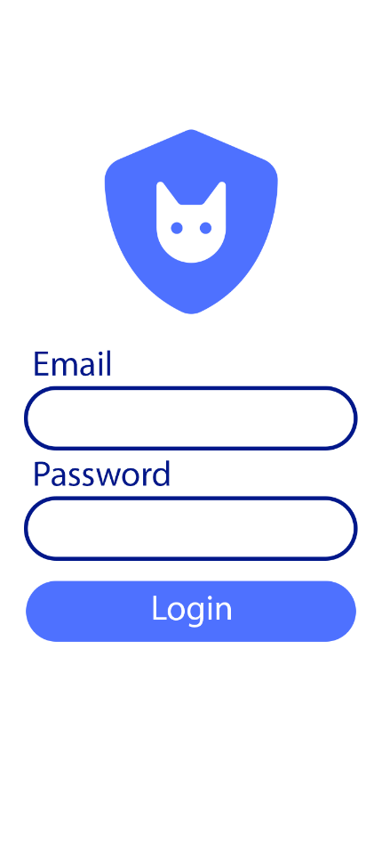UX/UI Design



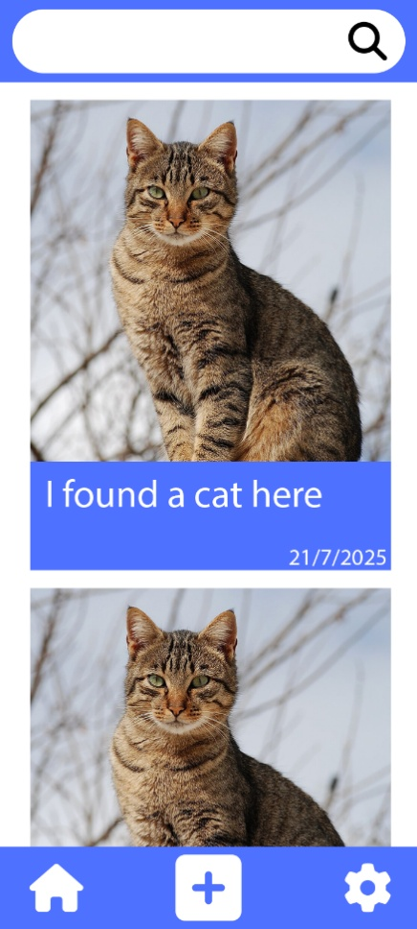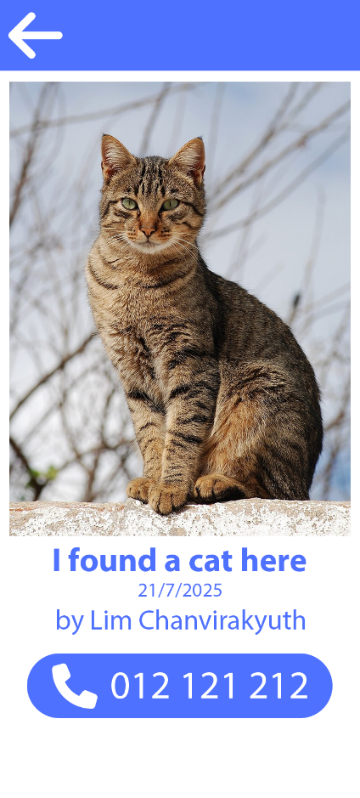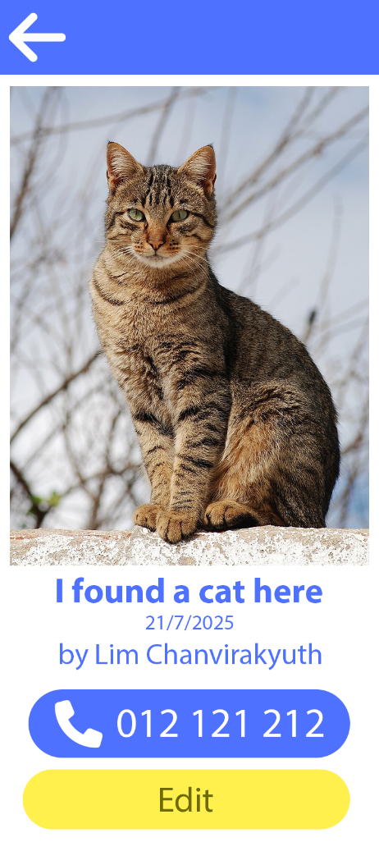

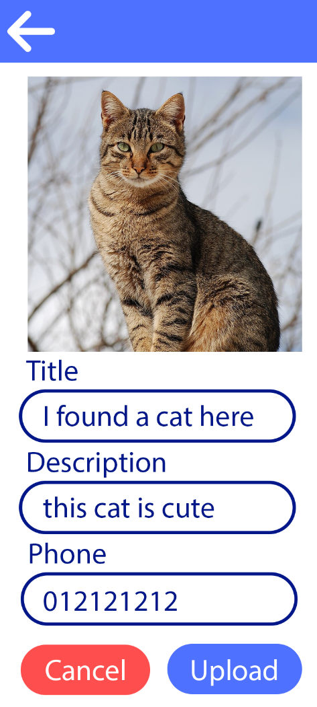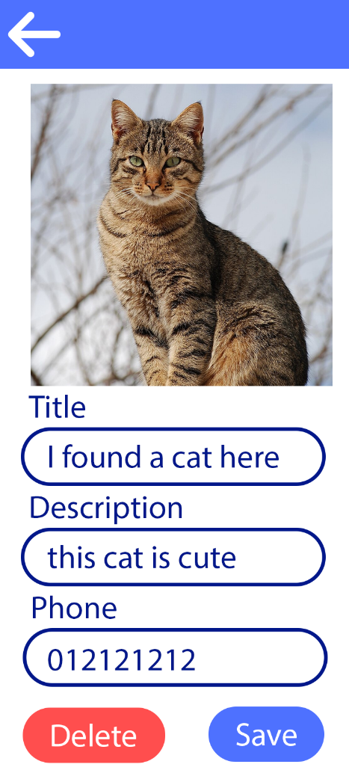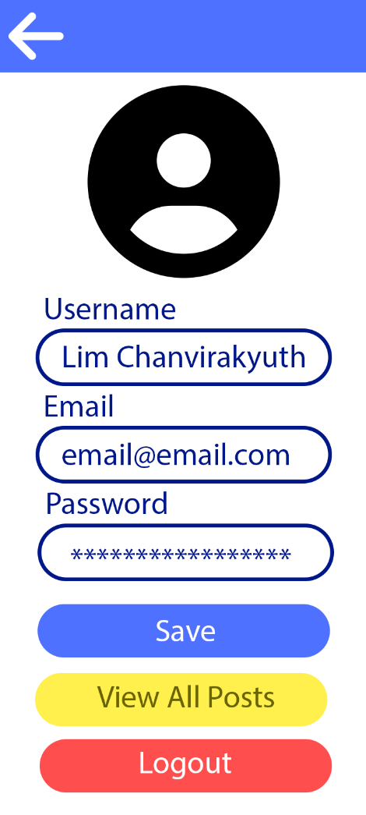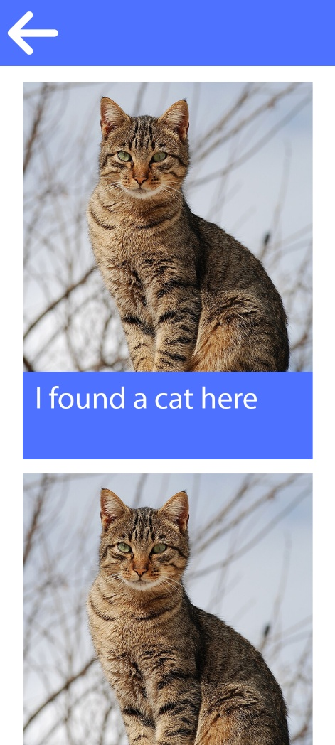5. Navigation Flow