|  |  |  |  |  |  |  |  |  |  |  |
| --- | --- | --- | --- | --- | --- | --- | --- | --- | --- | --- |
| **Robot’s Name** |  |  |  |  | |  | |  | |  |
| **Favorite Mission** |  |  |  | **Maximum Score** | |  | | **Typical Score** | |  |
| **Favorite Robot Feature** |  |  |  | **Most Innovative Robot Feature** | |  | |  | |  |
| **How often does your robot or its attachments break?** *(Circle One)* | | | Frequently | | Fairly Often | | Occasionally | | Almost Never | |
| **How often does your robot get stuck on the field and you have to retrieve it by hand?** *(Circle One)* | | | Frequently | | Fairly Often | | Occasionally | | Almost Never | |
| **Strategy**  *How did you choose the missions you worked on?* | | |  | |  | |  | |  | |

|  |  |  |  |  |  |
| --- | --- | --- | --- | --- | --- |
| **How many Motors and Sensors are on your robot?**  *(See the Robot Game Rules for allowable types)* | | | | | |
| **Large Motors** | | **Medium Motors** | | **Color / Light Sensor** | |
|  |  |  |  |  |  |
| **Ultrasonic Sensor** |  | **Touch Sensor** |  | **Gyro / Angle Sensor** |  |
|  |  |  |  |  |  |

**Design Process**

*What processes did you use to design your robot? Did you follow the Engineering Design Process (Explore -> Imagine -> Create -> Test -> Improve)? (Attach additional pages or use the back if needed. Show the Judges your Engineering Design Notebook and any photos, drawings or diagrams of your robot throughout the season, if you have them.)*

**Program Summary**

*What can your robot do? List every program you plan to run during the tournament. Attach additional pages if needed.*

**Programming Language Used:** 🞎LEGO MINDSTORMS EV3 🞎OTHER_____________________________________________

|  |  |  |  |  |  |  |
| --- | --- | --- | --- | --- | --- | --- |
| **Program Name** | **Mission(s)**  **Accomplished** | **Robot Actions** | **Attachments Used** | **Program Structure**  **(Architecture)** | **Mechanical and/or Sensor Feedback Used** | **Mission Success Rate** |
| *What is this program called in your robot?* | *List the missions your robot will accomplish when you run this program.* | *List the types of actions performed during this mission (Forward / Turn / Lower attachment / etc.) You may include a more detailed outline and/or path diagram on a separate sheet.* | *Do you add anything to your robot while running this program?* | *List the types of programming commands used*  *[actions (start motor, read sensor, etc.), loops, do until, switches (if-then), subroutines (MyBlocks), parallel programs, etc.]* | *Does your robot make decisions based on input from a sensor or mechanical feature? If yes, explain how the input is used.* | *How often does your robot accomplish the mission(s)?*  *Show the Judges any data you collected from your trial runs!* |
| ***EXAMPLE***  *From HYDRO DYNAMICSSM* | ***Fountain*** | ***Drive forward. Lower arm to release Big Water. Reverse back to base.*** | ***Arm*** | ***Forward in Rotations*** | ***None*** | ***Fairly Often***  ***(85% from data)*** |
|  |  |  |  |  |  |  |
|  |  |  |  |  |  |  |
|  |  |  |  |  |  |  |
|  |  |  |  |  |  |  |

**Program Name __________________________________________________________**

**Robot Path Diagram**

*Create one Robot Path Diagram for each program you’re planning to run. Sketch the path the robot takes as it executes the program. Each time the robot stops or takes an action, use the diagram to show what the robot is doing. Show the path diagram for your team’s best program to the Judges during your Robot Design judging session.*

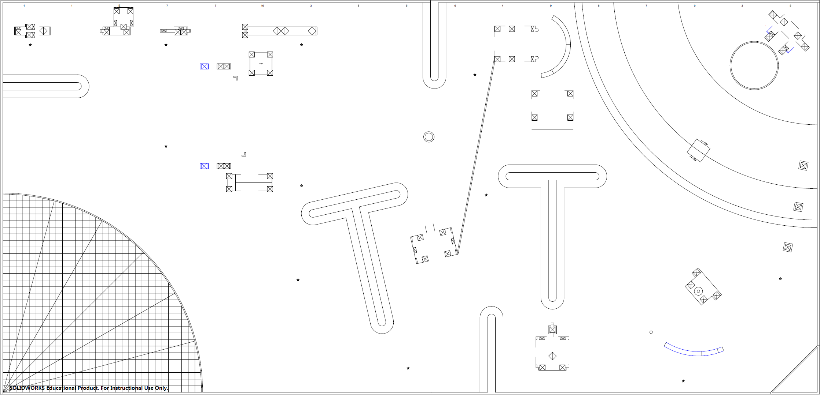

**Program Description**

*Explain each Path Diagram by showing your code, pseudocode (written outline), flow chart, or some other way. Assume the Judges have never seen the language you’re using to code. How can you help them understand how your program works? (Use the back or additional pages if needed)*