Move Straight

**Move Straight Challenge:**

* Move your robot from the black line to the red line and back using **seconds**.
* Move your robot from the black line to the red line and back using **degrees**.
* Move your robot from the black line to the red line and back using **rotations**.

1) What did you notice?

2) How long did it take you to get your robot to go exactly to the red line and back? Did you have to guess and check a lot?

**Now, repeat Challenge using port view to read the sensor values first.**

1) Was this easier than using seconds, degrees and rotations?

**Day 1 Review Quiz:**

1. What block is used to move straight: Motor Steering or Move?
2. What tab can I find Motor Steering in?
3. How do you get a robot to move backwards?
4. What is port view?

Review Quiz:

Name: ___________________________________

1. What are the two types of turns?
2. Which type of turn do you use in tight places?

3) Where do you go on your brick to get sensor readings such as “what color the robot sees” and “how many degrees the robot moved”?

5) What block do you use to repeat an action?

6) What block would you use to select between two different actions based on a sensor reading?

7) To program using a sensor and perform an action UNTIL a sensor is activated (black line seen, touch pressed), what block do you use?

Name: ___________________________________

**Switches**

**Switches Challenge:**

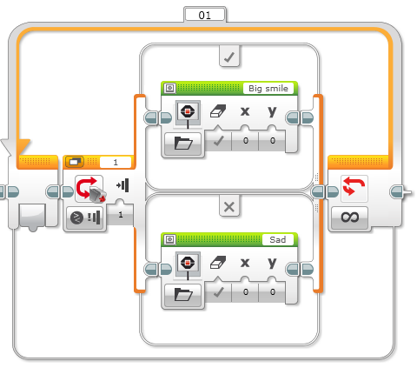Write a program that changes based on if the touch sensor is pressed or not pressed.

If pressed, your EV3 is happy! Display a smiley face. If not pressed, the EV3 is sad! Display a sad face.

What else can you use the display block for?

**Line Following**

**Line Following Challenge:** Write a program that follows a line.



What was the hardest part of this challenge?

**Review Quiz:**

1. What part of a line does a robot follow? Middle or edge?

2) Why do you need a switch block for a line follower?

3) Why do you need a loop?