Name: Vishesh Kansugia
UID: 24BAI70184
Subject: ADBMS

Question 1:
Write an SQL solution to calculate the total number of bank accounts belonging to each salary category. The classification categories are:
- "Low Salary": All monthly salaries strictly less than $20,000.
- "Average Salary": All monthly salaries in the inclusive range [$20,000, $50,000].
- "High Salary": All monthly salaries strictly greater than $50,000. The final result table must report all three categories, even if a category contains zero accounts.
Answer :
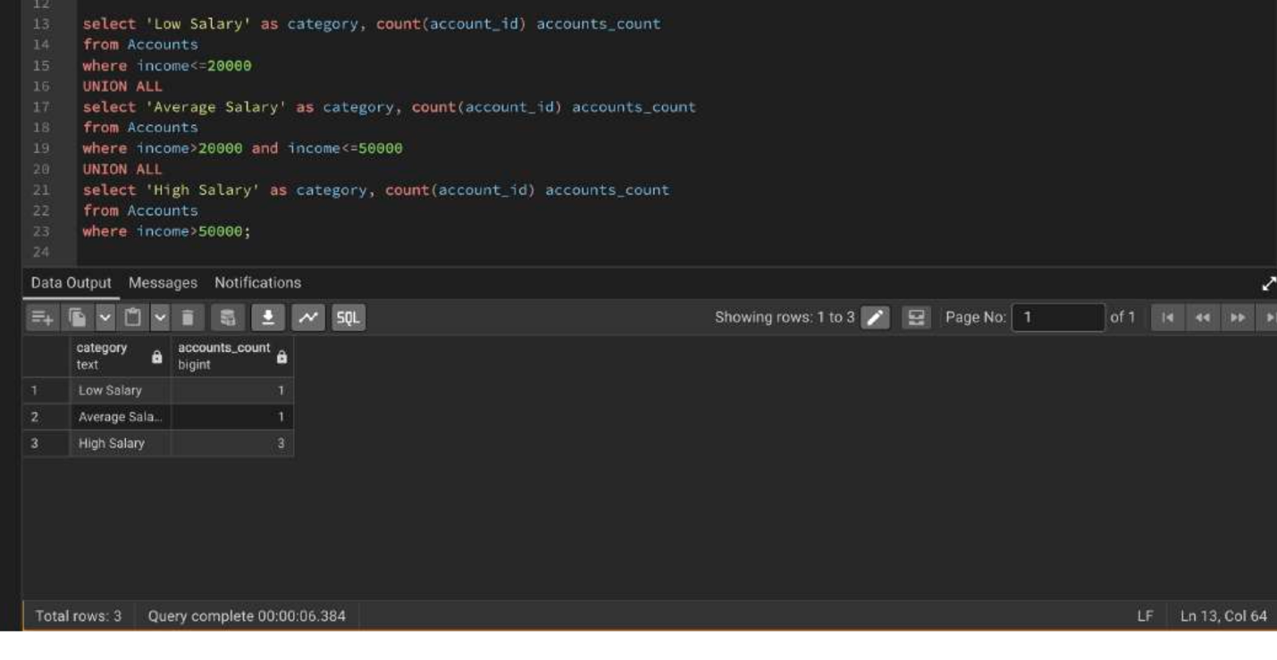

Question 2:
Design an Employee Management System database architecture by implementing the following operations sequentially:
- Create and populate structural tracking tables for Departments, Employees, and Salaries.
- Query the system using multi-table Joins to pull clear department breakdowns, apply a 10% salary enhancement across all members of the HR department, and delete any individual salary record dropping strictly below $30,000.
- List all remaining active employees whose personal salary exceeds the overall company-wide average salary.
- Part B: Apply 10% HR increase using IN subquery filtering

Answer :

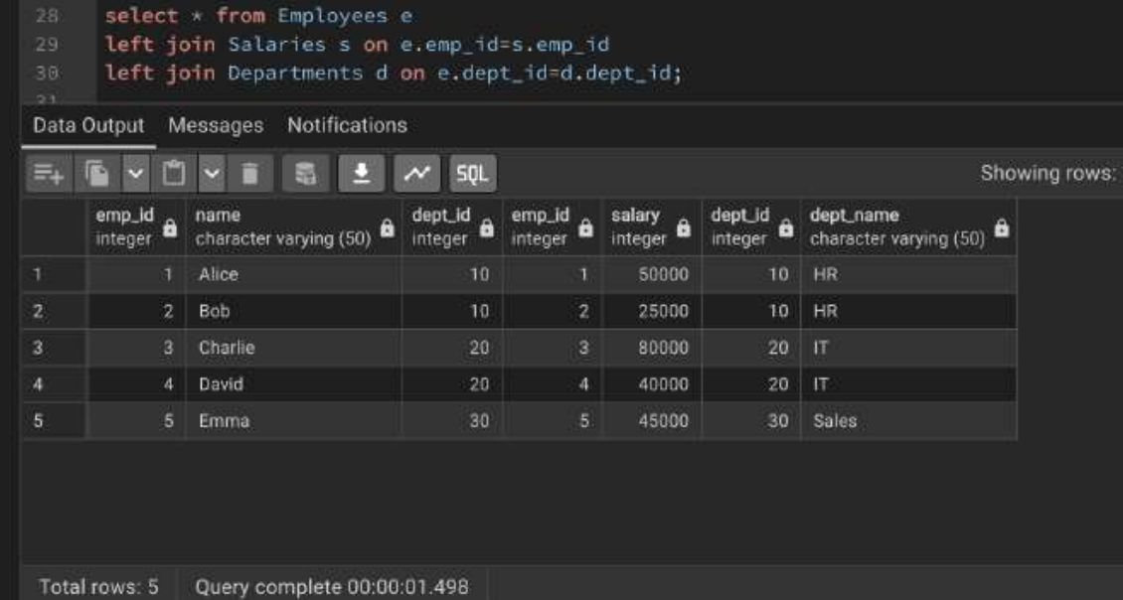
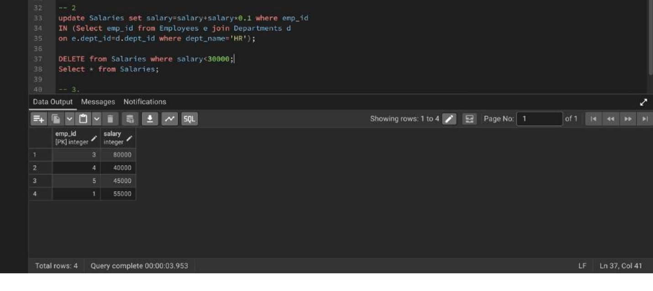

Question 3:
A pizza restaurant stores all the available pizza toppings and their ingredient costs in a table called pizza_toppings.
Every customer must choose exactly 3 different toppings to prepare a pizza.
Write a PostgreSQL query to generate every possible 3-topping pizza combination along with its total ingredient cost.
Requirements
Every pizza must contain exactly 3 different toppings.
The same topping cannot appear more than once in a pizza.
Different arrangements of the same toppings should be considered the same pizza.

Answer:
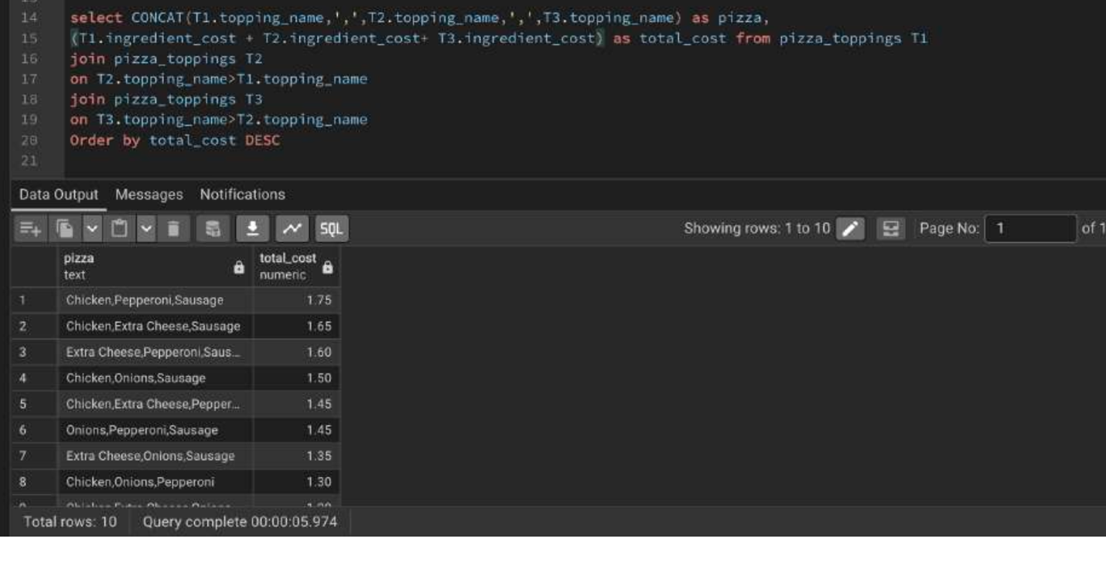
Question 4:
Amazon wants to identify returning customers who made another purchase shortly after their first purchase.
Write a PostgreSQL query to find all users who made another purchase within 1 to 7 days of an earlier purchase.
Requirements
- Compare purchases made by the same user only.
- Ignore comparisons where the same transaction is matched with itself.
- The second purchase must occur after the first purchase.
- Same-day purchases must not be considered.
- The second purchase must occur within 7 days of the first purchase.
- Display only the unique User IDs that satisfy the above conditions.
Sort the output in ascending order of user_id.

