QUESTION 1
ANSWER)
select e.salary,e.emp_name,e.dept_id
from employee e
where e.dept_id in
(select e1.dept_id
from Employee e1
join department d1
on e1.dept_id=d1.dept_id
group by e1.dept_id
having count(e1.emp_id)>2)
and e.salary>
(select avg(salary) from employee
where dept_id=e.dept_id
)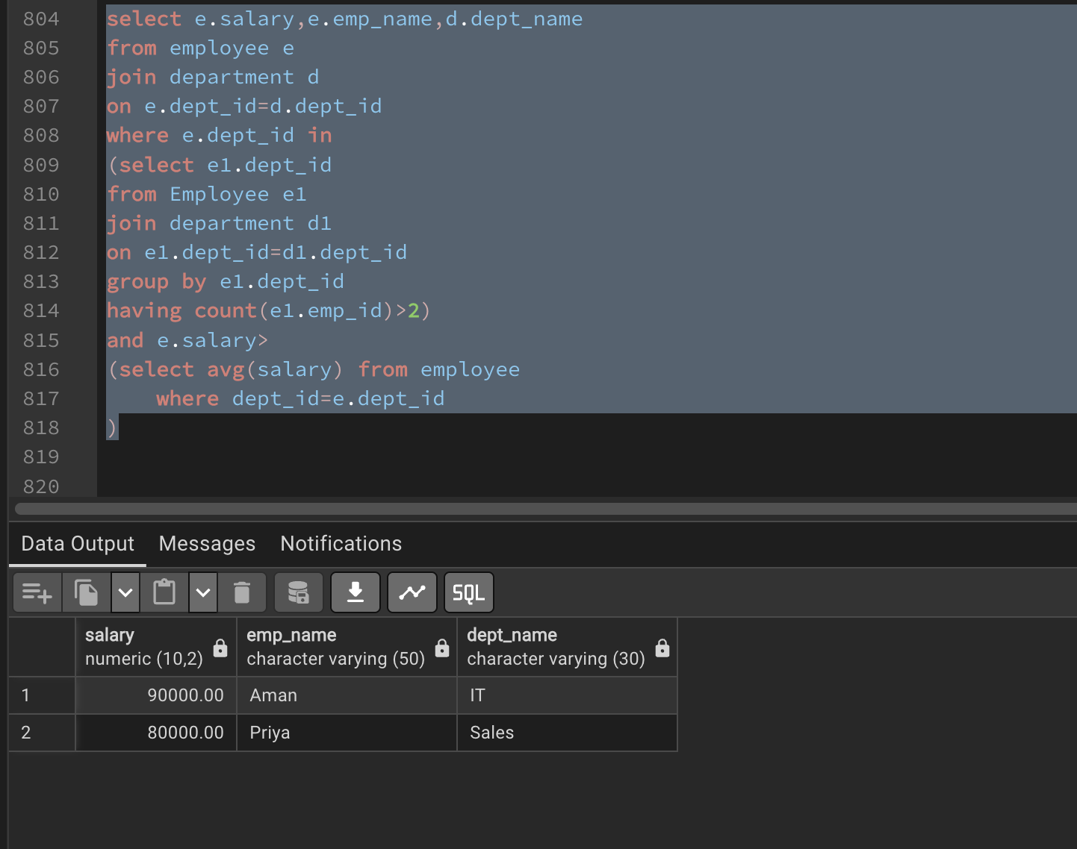
QUESTION 2)
ANSWER
create or replace function caud()
returns trigger
as $$
begin
if TG_OP = 'INSERT' then
insert into customer_audit
(customer_id, customer_name, action, action_time)
values
(NEW.customer_id, NEW.customer_name, 'Add', current_timestamp);

elsif TG_OP = 'DELETE' then
insert into customer_audit
(customer_id, customer_name, action, action_time)
values
(OLD.customer_id, OLD.customer_name, 'Rem', Current_timestamp);
end if;

return null;
end;
$$ language plpgsql;

create trigger caudti
after insert or delete
on bank_customer
for each row execute function caud()