Name: Vishesh Kansugia

UID: 24BAI70184

Experiment 10: Trigger for Automatic Primary Key Generation

AIM
To design a trigger that automatically implements the functionality of a primary key, ensuring unique identification of records without manual intervention.

SOFTWARE REQUIREMENTS

Database Management System:
- Oracle Database Express Edition (Oracle XE)
- PostgreSQL Database

Database Administration Tool / Client Tool:
- Oracle SQL Developer (for Oracle XE)
- pgAdmin (for PostgreSQL)

OBJECTIVE
- To create a database trigger that automatically enforces primary key constraints or generates unique key values.
- To replicate the functionality of a stored procedure using triggers.
- To demonstrate automated primary key functionality in a table.

PROBLEM STATEMENT
In enterprise-level databases, every record must have a unique primary key. Manual assignment of keys can lead to duplication and errors.
Design a trigger that:
- Automatically generates or enforces a primary key value during record insertion.
- Implements logic similar to a stored procedure.
- Ensures every record has a unique identifier.
Industry Relevance: Amazon, Flipkart, Oracle

THEORY
A trigger is a database object that executes automatically in response to specific events such as INSERT, UPDATE, or DELETE.
Primary key automation ensures:
- Data integrity
- Elimination of duplicate entries
- Reduced manual effort
Triggers can be combined with sequences (Oracle) or identity/serial mechanisms (PostgreSQL) to generate unique values.

PROCEDURE / PRACTICAL STEPS
- Identify the table requiring automatic primary key enforcement.
- Create a sequence (for Oracle).
- Design a BEFORE INSERT trigger.
- Assign a unique value to the primary key column inside the trigger.
- Insert multiple records to validate the trigger functionality.

IMPLEMENTATION

PostgreSQL Implementation
CREATE TABLE students (
id SERIAL PRIMARY KEY,
name VARCHAR(50)
);

CREATE OR REPLACE FUNCTION auto_id_function()
RETURNS TRIGGER AS $$
BEGIN
IF NEW.id IS NULL THEN
NEW.id := nextval('students_id_seq');
END IF;
RETURN NEW;
END;
$$ LANGUAGE plpgsql;

CREATE TRIGGER student_trigger
BEFORE INSERT ON students
FOR EACH ROW
EXECUTE FUNCTION auto_id_function();

TESTING
INSERT INTO students (name) VALUES ('Alice');
INSERT INTO students (name) VALUES ('Bob');
INSERT INTO students (name) VALUES ('Charlie');

SELECT * FROM students;

OUTPUT

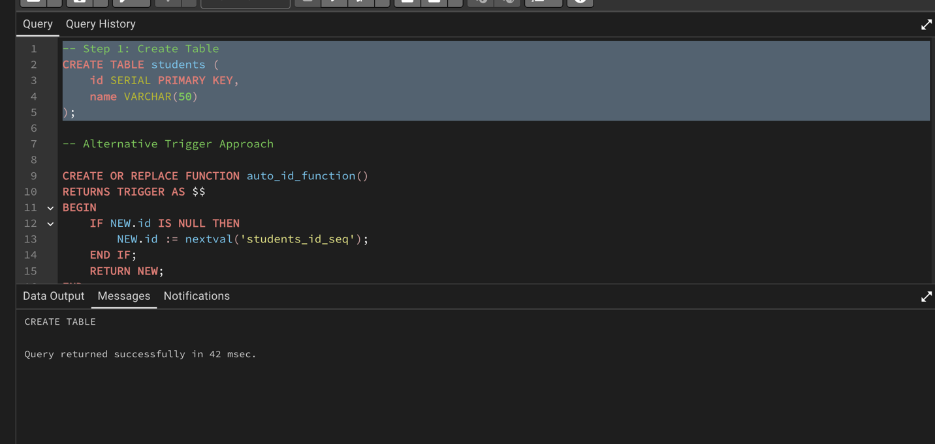

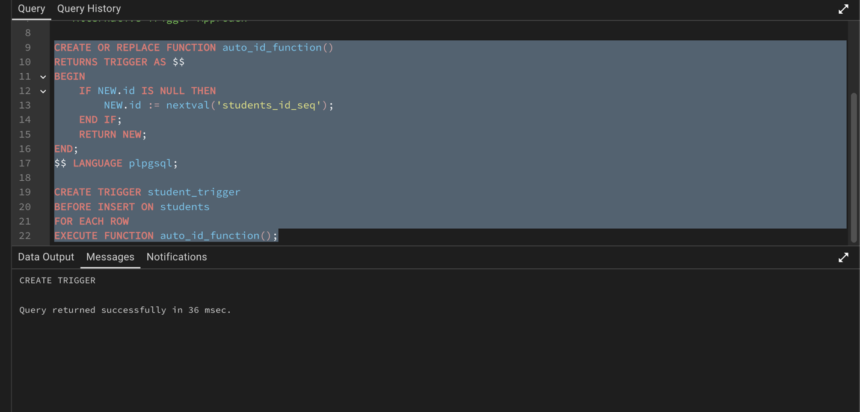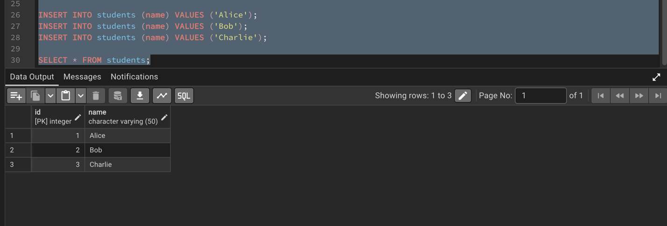

Sample Output Table
ID | Name
1 | Alice
2 | Bob
3 | Charlie

RESULT
The trigger was successfully created and executed. Each inserted record was automatically assigned a unique primary key value without manual input. This confirms that the trigger effectively ensures uniqueness and maintains data integrity.

LEARNING OUTCOME
After completing this experiment, the learner is able to:
- Understand the concept and working of database triggers
- Implement BEFORE INSERT triggers
- Automate primary key generation using sequences and triggers
- Ensure data integrity and uniqueness in database tables
- Apply trigger-based automation in real-world applications

CONCLUSION
Triggers provide an efficient and reliable way to automate primary key generation. This eliminates manual errors and ensures consistency, making it highly useful in enterprise-level database systems.

