Experiment 5: DBMS – SQL Conditional Logic (Odd & Even Values)
Name: Vishesh Kansugia
UID: 24BAI70184
Section: 24AIT_KRG_G1

1. Aim of the Session
To understand and apply conditional logic in SQL by using the MOD (%) operator to analyze numerical data and classify employee salaries as odd or even.

2. Objective of the Session
- To understand the use of the MOD (%) operator in SQL.
- To identify whether a number is odd or even using SQL queries.
- To apply CASE statements for conditional classification.
- To display employee salary data based on conditions.
- To perform data filtering and aggregation using SQL.

3. Practical / Experiment Description
This experiment demonstrates how SQL can be used to apply conditional logic on numerical data.
An Employee table is created and populated with sample records. Using the MOD (%) operator, salaries are checked for odd or even values. The CASE statement is then used to classify each salary dynamically.
Additionally, queries are used to separately display odd and even salaries and count them.

4. Procedure of the Practical
- Open Oracle SQL Developer or pgAdmin.
- Create an Employee table.
- Insert sample data into the table.
- Display all records using SELECT.
- Use the MOD (%) operator to:
  - Identify even salaries
  - Identify odd salaries
- Apply a CASE statement to classify salaries.
- Count the number of odd and even salaries.
- Execute all queries and verify outputs.

5. SQL Code
-- Step 1: Create Employee Table
CREATE TABLE Employee (
Emp_ID INT PRIMARY KEY,
Emp_Name VARCHAR(50),
Salary INT
);
-- Step 2: Insert Sample Data
INSERT INTO Employee VALUES (1, 'Aman', 25000);
INSERT INTO Employee VALUES (2, 'Riya', 32001);
INSERT INTO Employee VALUES (3, 'Karan', 45000);
INSERT INTO Employee VALUES (4, 'Neha', 27555);
INSERT INTO Employee VALUES (5, 'Arjun', 30000);
-- Step 3: Display All Records
SELECT * FROM Employee;
-- Program 1: Even Salaries
SELECT Emp_ID, Emp_Name, Salary
FROM Employee
WHERE MOD(Salary, 2) = 0;
-- Program 2: Odd Salaries
SELECT Emp_ID, Emp_Name, Salary
FROM Employee
WHERE MOD(Salary, 2) <> 0;
-- Program 3: Classification using CASE
SELECT Emp_ID, Emp_Name, Salary,
CASE
WHEN MOD(Salary, 2) = 0 THEN 'Even Salary'
ELSE 'Odd Salary'
END AS Salary_Type
FROM Employee;
-- Program 4: Count Odd and Even Salaries
SELECT
COUNT(CASE WHEN MOD(Salary, 2) = 0 THEN 1 END) AS Even_Count,
COUNT(CASE WHEN MOD(Salary, 2) <> 0 THEN 1 END) AS Odd_Count
FROM Employee;

6. Input / Output Analysis

Input: Employee Table
Emp_ID | Emp_Name | Salary
1 | Aman | 25000
2 | Riya | 32001
3 | Karan | 45000
4 | Neha | 27555
5 | Arjun | 30000

Output Description
- Even salaries are displayed separately
- Odd salaries are displayed separately
- Each salary is classified as Even Salary or Odd Salary
- Total count of odd and even salaries is displayed

7. Output Screenshot
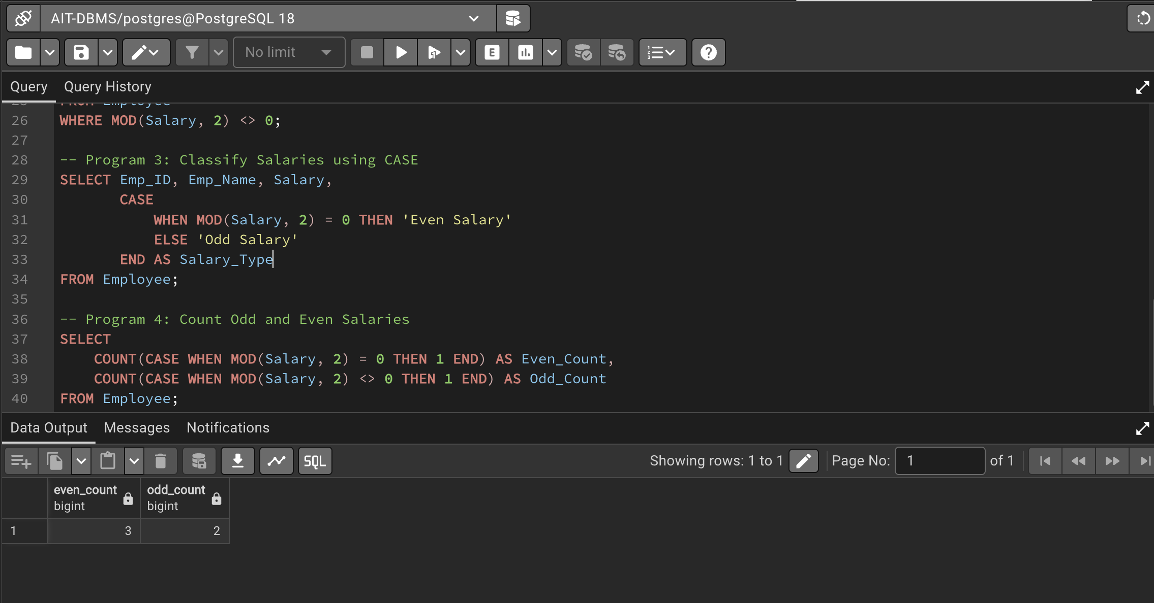

8. Learning Outcome
Through this experiment:
- I learned how to use the MOD (%) operator for numerical classification.
- I understood the use of CASE statements in SQL.
- I gained experience in filtering and categorizing data.
- I learned how to perform aggregation using SQL queries.

