Experiment 6: DBMS – Understanding and Implementing Cursors for Row-by-Row Data Processing
Name: Vishesh Kansugia
UID: 24BAI70184
Section: 24AIT_KRG_G1

1. Aim of the Session
To understand the concept and working of cursors in PL/SQL/PostgreSQL for row-by-row data processing, and to analyze how implicit and explicit cursor-like behavior is used to process multiple rows in a database table.

2. Objective of the Session
- To understand the role of cursors in database systems.
- To differentiate between implicit and explicit cursor concepts.
- To simulate cursor behavior in PostgreSQL using loops.
- To process multiple rows one-by-one.
- To apply business logic during row processing.

3. Practical / Experiment Description
This experiment demonstrates how multiple rows returned from a database table can be processed individually using cursor-like mechanisms.
Since PostgreSQL does not directly use Oracle-style cursors in basic queries, we simulate cursor behavior using:
- FOR loops
- DO blocks
- RAISE NOTICE for output
This allows us to process each row and apply logic similar to real-world enterprise applications.

4. Procedure of the Practical
- Open pgAdmin (PostgreSQL).
- Create a new query window.
- Drop existing table (if any).
- Create an Employee table.
- Insert sample records.
- Display the table data.
- Perform an update operation (implicit cursor behavior).
- Use a DO block with FOR loop to process rows one by one.
- Display output using RAISE NOTICE.
- Verify results and take screenshots.

5. SQL Code
-- Step 1: Drop table
DROP TABLE IF EXISTS Employee;
-- Step 2: Create table
CREATE TABLE Employee (
emp_id INT PRIMARY KEY,
emp_name VARCHAR(50),
salary INT
);
-- Step 3: Insert data
INSERT INTO Employee VALUES (1, 'Aman', 25000);
INSERT INTO Employee VALUES (2, 'Riya', 32000);
INSERT INTO Employee VALUES (3, 'Karan', 45000);
INSERT INTO Employee VALUES (4, 'Neha', 27000);
-- Step 4: Display table
SELECT * FROM Employee;
-- Step 5: Update (Implicit cursor behavior)
UPDATE Employee
SET salary = salary + 1000
WHERE emp_id = 1;
-- Verify update
SELECT * FROM Employee;
-- Step 6: Explicit cursor simulation
DO $$
DECLARE
rec RECORD;
BEGIN
FOR rec IN SELECT * FROM Employee LOOP
RAISE NOTICE 'ID: %, Name: %, Salary: %',
rec.emp_id, rec.emp_name, rec.salary;
END LOOP;
END;
$$;
-- Step 7: Cursor attribute simulation
DO $$
DECLARE
rec RECORD;
counter INT := 0;
BEGIN
FOR rec IN SELECT emp_id, emp_name FROM Employee LOOP
counter := counter + 1;
RAISE NOTICE 'Processing: %', rec.emp_name;
RAISE NOTICE 'Row Count: %', counter;
END LOOP;
END;
$$;

6. Input / Output Analysis

Input: Employee Table
emp_id | emp_name | salary
1 | Aman | 25000
2 | Riya | 32000
3 | Karan | 45000
4 | Neha | 27000

Output Description
- Table records displayed successfully
- Salary updated for one employee
- Each row processed individually using loop
- Output displayed using RAISE NOTICE
- Row count tracked manually

7. Output Screenshot
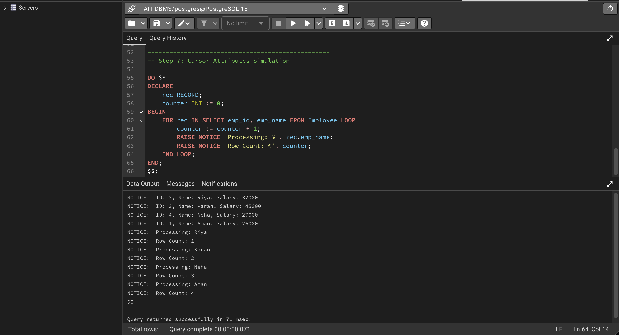

8. Learning Outcome
Through this experiment:
- I understood how cursor-based logic works in databases.
- I learned how to simulate cursors in PostgreSQL.
- I gained experience in processing rows individually.
- I understood how to apply logic during row traversal.
- I developed practical knowledge useful for real-world applications.

