Experiment 7: DBMS – Design and Performance Analysis of Materialized Views
Name: Vishesh Kansugia
UID: 24BAI70184
Section: 24AIT_KRG_G1

1. Aim of the Session
To design and implement simple views, complex views, and materialized views, and to compare their execution time and performance to understand their impact on query optimization.

2. Objective of the Session
- To understand the concept of views and materialized views.
- To create simple views and complex views.
- To implement materialized views in PostgreSQL.
- To analyze and compare query execution performance.
- To understand the role of materialized views in real-world applications.

3. Practical / Experiment Description
In large-scale enterprise systems, repeated execution of complex queries can reduce performance.
This experiment demonstrates how different types of views can optimize query execution:
- Simple View: Based on a single table
- Complex View: Uses joins and aggregation
- Materialized View: Stores precomputed results for faster access
Performance is analyzed using EXPLAIN ANALYZE to compare execution time.

4. Procedure of the Practical
- Open pgAdmin (PostgreSQL).
- Create a new query window.
- Drop existing tables if present.
- Create Employee and Department tables.
- Insert sample data.
- Create a simple view.
- Create a complex view using JOIN and aggregation.
- Create a materialized view.
- Execute SELECT queries on all views.
- Use EXPLAIN ANALYZE to compare performance.
- Refresh the materialized view.
- Take screenshots of outputs.

5. SQL Code
-- Step 1: Drop Tables
DROP TABLE IF EXISTS Employee;
DROP TABLE IF EXISTS Department;
-- Step 2: Create Tables
CREATE TABLE Department (
dept_id INT PRIMARY KEY,
dept_name VARCHAR(50)
);
CREATE TABLE Employee (
emp_id INT PRIMARY KEY,
emp_name VARCHAR(50),
salary INT,
dept_id INT,
FOREIGN KEY (dept_id) REFERENCES Department(dept_id)
);
-- Step 3: Insert Data
INSERT INTO Department VALUES (1, 'HR');
INSERT INTO Department VALUES (2, 'IT');
INSERT INTO Department VALUES (3, 'Finance');
INSERT INTO Employee VALUES (1, 'Aman', 25000, 1);
INSERT INTO Employee VALUES (2, 'Riya', 32000, 2);
INSERT INTO Employee VALUES (3, 'Karan', 45000, 2);
INSERT INTO Employee VALUES (4, 'Neha', 27000, 3);
-- Step 4: Simple View
CREATE OR REPLACE VIEW simple_view AS
SELECT emp_id, emp_name, salary
FROM Employee;
SELECT * FROM simple_view;
-- Step 5: Complex View
CREATE OR REPLACE VIEW complex_view AS
SELECT d.dept_name,
COUNT(e.emp_id) AS total_employees,
AVG(e.salary) AS avg_salary
FROM Employee e
JOIN Department d ON e.dept_id = d.dept_id
GROUP BY d.dept_name;
SELECT * FROM complex_view;
-- Step 6: Materialized View
DROP MATERIALIZED VIEW IF EXISTS materialized_view;
CREATE MATERIALIZED VIEW materialized_view AS
SELECT d.dept_name,
COUNT(e.emp_id) AS total_employees,
AVG(e.salary) AS avg_salary
FROM Employee e
JOIN Department d ON e.dept_id = d.dept_id
GROUP BY d.dept_name;
SELECT * FROM materialized_view;
-- Step 7: Performance Analysis
EXPLAIN ANALYZE SELECT * FROM simple_view;
EXPLAIN ANALYZE SELECT * FROM complex_view;
EXPLAIN ANALYZE SELECT * FROM materialized_view;
-- Step 8: Refresh
REFRESH MATERIALIZED VIEW materialized_view;

6. Input / Output Analysis

Input Tables
Department Table
dept_id | dept_name
1 | HR
2 | IT
3 | Finance
Employee Table
emp_id | emp_name | salary | dept_id
1 | Aman | 25000 | 1
2 | Riya | 32000 | 2
3 | Karan | 45000 | 2
4 | Neha | 27000 | 3

Output Description
- Simple View: Displays employee details
- Complex View: Shows department-wise employee count and average salary
- Materialized View: Returns same result as complex view but faster
- EXPLAIN ANALYZE: Shows execution time differences

7. Output Screenshot
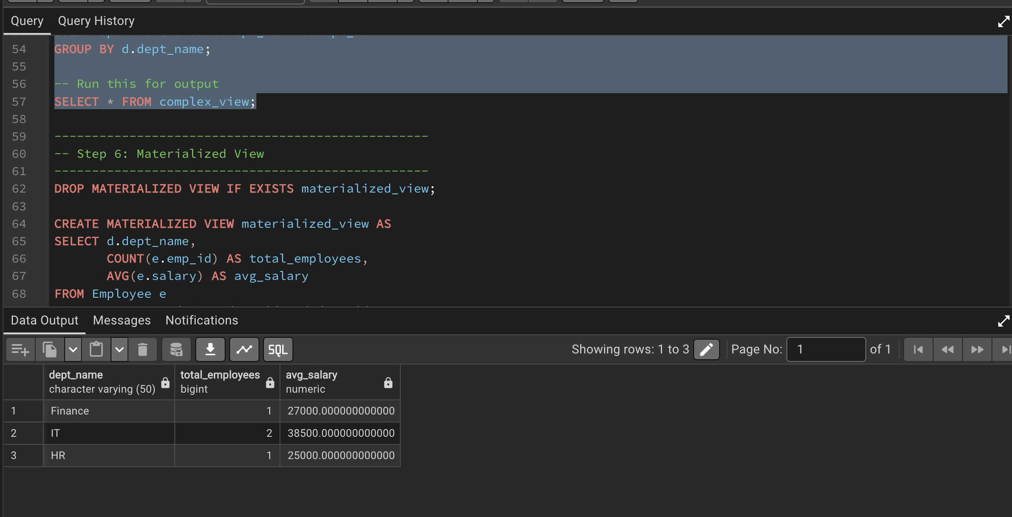
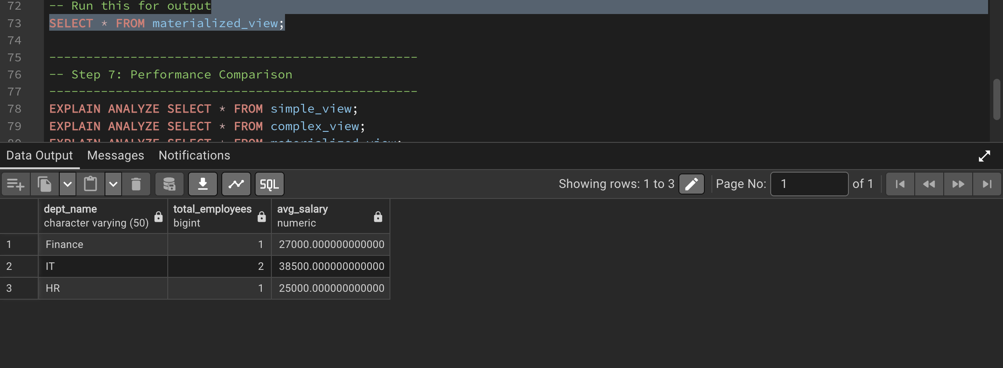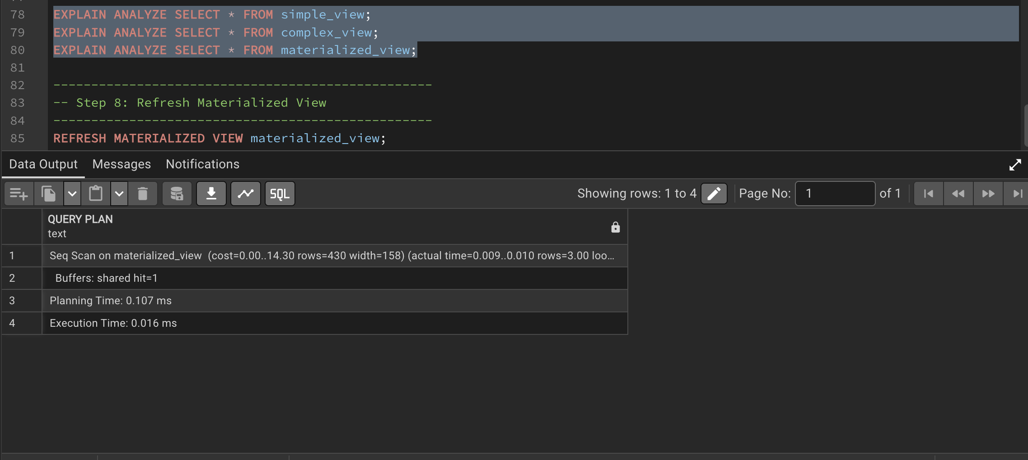

8. Learning Outcome
Through this experiment:
- I understood the difference between simple, complex, and materialized views
- I learned how to create and use materialized views in PostgreSQL
- I analyzed query performance using EXPLAIN ANALYZE
- I observed how precomputed data improves efficiency
- I gained practical knowledge applicable in real-world systems

