**COPY AND PASTE YOUR ARTICLES IN HERE**

SeaWorld: Exposed

By: Peri Murray

A Vitruvian Op-Ed

SeaWorld is the famous marine animal amusement park with showings of the amazing obedience of killer whales. Have you ever wondered “What are the animals like when they aren’t performing?”.

Well, I can tell you this; they aren’t happy.

“SeaWorld of Hurt: Where Happiness Tanks”, a PETA campaign, shows explicit pictures of killer whales floating around bored because they aren’t mentally stimulated. They also slam themselves into the glass and metal bars surrounding the tanks due to them having such a small swimming space.

Killer Whales are used to the vast reaches of the ocean and swimming up to 100 miles a day, not small enclosed spaces where all they can do is swim in endless circles. 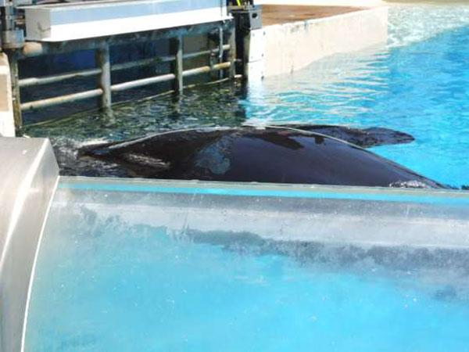

The whales are unhappy and stressed, as marine veterinarian Dr. Heather Rally observed after viewing a SeaWorld show. One Orca,Ikaika, “swam to the center of the pool and proceeded to lie motionless at the surface, occasionally lifting its’ head and opening the mouth as if swallowing air.” She added, “This behavior lasted at least 15 minutes as the public was cleared out of the stadium.”

Orca with deformed dorsal fin, floating lifelessly and bored.

This is unhealthy behavior for an Orca because normally they are always in motion and remain under water 95% of the time, unlike the orcas at SeaWorld.

After being separated from his family he was shipped to MarineLand in Ontario, Canada, and was used as a breeding whale for many years. After being given to SeaWorld, he was given drugs to “mellow” him out and suffered from various physical ailments, including broken teeth, chronic infections and even a collapsed dorsal fin.

Does that sound happy and healthy to you?

When Dr.Rally asked an “educational” guide why this orca’s fin was collapsed, the guide responded that “the bent fin is a genetic trait similar to people with curly vs. straight hair.” This statement is entirely false.

Rally continues by stating “There is also evidence to suggest that the conditions of captivity are responsible for the high sightings of collapsed dorsal fins in [SeaWorld animals], including activities such as spending abnormally long periods of time at the surface in direct sunlight and constantly swimming in small circles”.

Orca with collapsed dorsal fin at SeaWorld San Diego 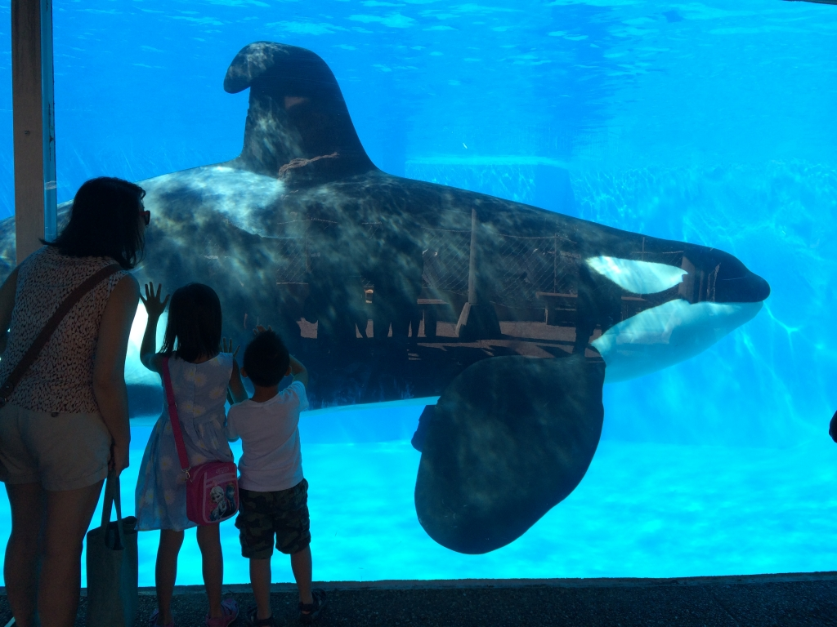

Did you know that SeaWorld purchased Orcas that have killed their trainers in the past? Tilikum, who was snatched from his mother and his ocean home at the age of two, was emotionally and mentally abused by his trainers and other dominant orcas for over a decade.

After performing the same tricks eight times a day, seven days a week,Tilikum dragged Sealand trainer, Keltie Byrne, to the bottom of the pool, where he and the other orcas stripped her of all her clothing and left bite marks and bruises all over her body.

It took nearly two hours to retrieve her body. Not long after Keltie’s death, Sealand closed its doors, and its orcas were purchased by SeaWorld. SeaWorld is now putting their trainers in danger even more danger by making them work with dangerous animals.

The evidence clearly shows that the marine life here are suffering. SeaWorld knows these animals are not happy and still choose to keep them captive for entertainment

What you can do to help is not support SeaWorld in anyway, and to make sure this place is shut down so no more innocent animals are stolen from their homes and hurt, physically, emotionally, or mentally.

How Dangerous is Carbon Dioxide?

By: Miles Ehrhard

The average American household produces 7.5 tons of carbon dioxide a year and the average car produces six tons of carbon dioxide a year, America as a whole produces around a fourth of the world’s carbon dioxide. Knowing this, the United States has vowed to cut CO2 emissions in half as well as China and the United Kingdom leaving only one percent for the rest of the world.

Most people would agree that this is a step in the right direction but larger steps must be taken in order to keep the planet's greenhouse gases at a safe level. The green house gas effect is the main contributor to global warming and the current crisis we are in involving the polar ice caps.

But the environment is not the only concern, the health of the average American is also at risk. The greenhouse effect is the planet over heating because of trapped gases being kept in the planet by the ozone layer. Most Americans do not believe in climate change because people think that the science has not been researched enough to provide answers. The amount of carbon dioxide poisoning has increased in the past three years, according to the CDC. The health risk to people from third world countries has increased because of the increasing amount of greenhouse emissions produced by first world countries.

As of 2013, 82% of the greenhouse gases in the atmosphere are results from human activity. The majority of the green house gasses in the United States come from electricity a total of 37%, and the other big contributor is from car emissions with a total of 33% of car emissions. The way we could help fix our problem regarding carbon dioxide and other greenhouse gasses is to keep informed. Keep taking message to limit the amount that you personally produce. You could do this by limiting the amount of time you send in your car as well as if you

(Working Headlines)

By Tajairi Neuson

As I cruised down a neighborhood in Baldwin Hills, I noticed a subtle change had taken over.

Several homeowners had switched from the traditional-green lawn to a lawn consisting mostly of drought-resistant plants. Californians have had to change from their carefree way of using up as much resources as they’re allotted to living in a world where the resources are becoming scarce.

While some Californians have cutback by watering their lawns less, others particularly the rich have INCREASED their water usage. In an interview with The Washington Post, one homeowner after facing water usage restriction by the government asked reporters  [“What are we supposed to do, just have dirt around our house on four acres?.”](https://www.washingtonpost.com/national/rich-californians-youll-have-to-pry-the-hoses-from-our-cold-dead-hands/2015/06/13/fac6f998-0e39-11e5-9726-49d6fa26a8c6_story.html)

This is one of the many example of Californian's who think their “above the law” hesitating or completely refusing to take the necessary steps to adapt to a water-scarce California.

Although it is imperative for homeowners to reduce the amount of water they use on their lawns, [urban water use only accounts for 10% of California's overall use](http://www.ppic.org/main/publication_show.asp?i=1108).

The agriculture industry accounted for annually 40% of California’s water usage. This is 4x the amount of water used by urban California, but the restrictions placed on urban areas aren't as severe for agriculture farmers.

If anyone should be being the most restricted during the drought are farmers specifically livestock farmers. But, if governor Jerry Brown would ration out the water then the price of meat would be passed onto the consumer. So, what can the consumer due to combat against the excessive amounts of water used by livestock farmers?

It's simple consumers need to eat less meat.

If all 38.8 million California committed to not eating meat one day out of the week it would significantly impact the meat industry. The demand for meat would decrease and less cows would be farmed ultimately resulting in less water being used. It would also let restaurant owners and food distributors know that the American people want more meatless options.

Not only would Californian’s reducing their meat consumption help alleviate the drought it would also benefit their health.

Excessive meat consumption has often been linked to heart disease and lowered life expectancy.

If the American people will fightback when the government tells them to use less water how will they react to someone telling them to eat less meat?

“The American public is becoming more welcoming to vegetarian diets with the rise of things such as #meatlessmondays, ”

***Article in process of being formatted to PDF***

Depending directly upon the results of my research and interviews, my article will follow 1 of these 2 formats shown below.

1. Introduction to plant breeding

* History of selective plant breeding

Every time you eat, you enjoy the benefits of selective breeding. Over time, humans have evolved to grow and eat plants. When humans find plants that have certain traits they desire, sometimes they breed selectively for those traits. Because of this, we have plenty of plants with qualities that we love. By the end of this article, you will understand plant breeding, multiple major developments in the field, advancements in the field, and its future, at least according to my sources.

* Briefing on current state of the field

The modern state of plant breeding is characterized by huge strawberries, foods with unusual colors, and completely pest resistant cash crops. Most advancements in this field are similar to these three categories. Wild strawberries before domestication rarely grow past the size of a thumbnail. But there are strawberries as tall as smartphones thanks to plant cultivars (breeders). One such cultivar, with his own brand of immense strawberries(California Giant), had this to say about developments in the field. ¨The demands for high-quality traits in newly bred cultivars [cultivated plant varieties] are greatly influenced by large producing companies, retailers, and traders, sometimes at the expense of consumer preferences.¨ In layman's terms, this means that the people who bring us these plants many times weigh profit over anything else when breeding for traits. An example of this everyone can relate to is the Red Delicious brand of apple. They have awful taste ratings compared to other apple varieties, but are yet the second most popular variety. This is not to say these apples taste awful, but the flavor aspect has been clearly neglected.

* Intro to article topic

1. Research process

* Google scholar search keywords
* Library databases
* Interview candidate selection process

1. The interview transcript
2. Summary
3. Selective breeding guide

Or

Depending directly upon the results of my research and interviews, my article will follow 1 of these 2 formats shown below.

1. Introduction to plant breeding

* History of selective plant breeding
* Briefing on current state of the field
* Intro to article topic

2. Research process

* Google scholar search keywords
* Library databases
* Interview candidate selection process

3. The interview transcript

4. Detailed explanation for why pedestrian use of this science would be futile

5. How it's made-style explanation of the professional process

Interview Progress

Contact was made to the source through various alternate racial emails. No response yet, second round going out Monday. If no response, consideration will be forwarded to Nathan and passed down the administration line.

No interviews found yet, compiling a list of most comprehensive sets of data & facts from research, will include personally authored version to increase the article’s word count.

Donyaih Thomas

Adam Eynon

English

February 18, 2016

Journalism Article: How smoking cigarettes affect air pollution

Opinion

Smoking cigarettes is a way to negatively affect air pollution. Cigarettes are known to have 4,000 chemicals that they are made up of, also 43 cancer-causing compounds in them.

Smoking cigarettes are very effective to the person smoking them, but also is effective to the people around the smoke. Being affiliated with people that smoke could physically affect others, but what about emotionally and mentally?

Smoking is spreading rapidly. People have impacted others to smoke which is increasing air pollution quicker than a car running on diesel gas.

Air pollution is a mixture of solid particles and gas which pollutes the air. “The air pollution emitted by cigarettes is 10 times greater than diesel car exhaust.” Medical News Today

If one cigaret can cause this, then imagine “15 billion which is sold on a daily” (World Health Organization). This action has a huge affect on society and the air pollution.

I interviewed a biology and chemistry major from UCSB (UC Santa Barbara) and USC (University of Southern California). Laura Chase has earned her teacher credentials and works for an advanced high school, Da Vinci Communications High School, located in Los Angeles, CA.

Laura Chase from Da Vinci High School states “ I believe that smoking does contribute to air pollution, but not as [much] as businesses and traffic from cars. Although smoking is the least effective, it should be stopped because it is also bad for the health, terrible for the environment, and people. Yes, I have been around constant smokers, but I did not let their decisions to smoke effect me. Besides, the trend of today to smoke has decreased by a lot from before when smoking was a positive social trend. ”

Successful solutions that exist today are the “e-cigs” which are vaporized and consist of nicotine. This is better for the environment by the smoke not having a negative impact on people surrounding the smoker.

As time passes, scientist will find even more solutions to smoking which will also help decrease the amount of smoking and air pollution that exist in cities with high air pollution levels.

As of today, this situation is being resolved. A few actions people could start to do is reduce the amount of smoking in the teen generation, and support the “Go Green!” movements .

Many people agree that air pollution is increasing by the movement which encourages people to want to help their society be more of a safer place to live.

According to Megan Gannon, a Live Science Contributor, mentions “The respondents who said they had been exposed to [pollution](http://www.livescience.com/topics/pollution/) were more likely to pick up [green habits](http://www.livescience.com/topics/green/) like recycling, the researchers explained” (Gannon 2012).

People are very much aware of the different movements to help the environment and people’s health in the long run.

If everyone were to contribute something to the environment to help decrease the amount of pollution in the environment, then there would be one less problem in society.

Now it is up to everyone else, to take action in making the world a better place to live.

Climate Change Effects on Human Health

Chase Butler | February 22, 2016 | Contributor

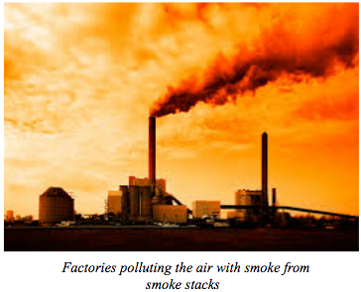

Climate change could potentially kill us. No matter what we do climate change will in some way affect our health. Climate change is the changing of the Earth's weather patterns, which usually has a strong connection to global warming. Global warming occurs when there is increase in carbon dioxide or other gases.

Climate change has mostly proved to have more negative effects than positive effects on human health. Some may argue that it hasn’t affected us in any way now, so what’s to say that it will ever affect us. They are actually not completely correct, many countries have found an increase in death rates during heat waves, which are connected to climate change and global warming. <http://www.publichealthjrnl.com/article/S0033-3506(06)00005-9/fulltext>

One of the most likely negative effects of climate change on human health, will be the decrease in food and clean water. Heat waves could further the drought which will decrease the water supply, which means a decrease in farming. The drought would also cause water cleanliness to be jeopardized, small amounts of water means easier contamination of water.

Another negative effect would be the increase in vector borne diseases. Vector-borne diseases are infections that you receive through getting bitten by blood feeding insects such as mosquitoes, ticks, and fleas. According to the Public Health Journal, it is hypothesized that the climate change increases the duration of the transmission season. Studies have yet to prove exactly why the climate change creates an increase in these diseases.

Air quality will also be decreasing as a result of climate change.

While high income countries will see some effects, they won’t be as bad as low income countries because of their resources. High income countries will be able to develop technology to possibly filter water and support the growths of crops.

Low income countries ,will not have the resources or technology to sustain the food and water that they need to survive. This will cause the death rate to rise even more within these third world countries.

Sarah Potts Ashton a former Director of the [White House Climate Action Champion program](http://energy.gov/epsa/climate-action-champions) for the Obama Administration states that “[...]in reality, climate policy is shifting to what they call ‘Climate Adaptation or Resilience’ which basically means the global climate is changing, and we as a global community need to learn how to adapt and be more resilient to its changes. The more resilient we become, the more we can mitigate or reduce the extreme impacts of climate change on human health.”

Pesticides are Terrible or Pesticides are Terrible for the Environment?

Musa Alghweir | February 18, 2016 | Contributor

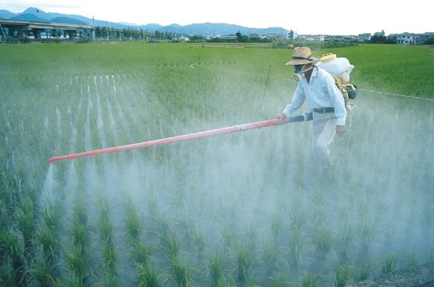

*A rice farmer spraying pesticides on crops.*

As the use of herbicides, insecticides, neonicotinoids and other types of pesticides increase throughout the world, many people turn a blind eye to the possible side effects of using these chemicals. The world's opinion about pesticides has been revolved around an ignorant idea that pesticides only target different kinds of pests, without having negative side effects on the environment.

The problem with pesticides today is not what they do by killing the pests, it's the fact that pesticides have spread to groundwater, the air we breathe, and the food we eat.

The World Health Organization, an agency of the United Nations concerned with international public health, states that pesticide poisoning has accounted for about 20,000 deaths per year.

Pesticide residue remains in the food humans eat today, and it brings a high risk of pesticide poisoning which creates numerous dysfunctions in the nervous system in the human body.

The US National Library of Medicine, the largest medical library in the world, states that pesticides used in industrial agriculture are associated with elevated cancer risks for workers who use pesticides, and consumers who eat food that has been sprayed with pesticides.

Pesticides used in agriculture enhance risks of endocrine disruption and reproductive dysfunction. Reproductive dysfunctions limits sexual activity in humans, while studies from Beyond Pesticides, an organization against the misuse of pesticides, show that pesticide use harms the sperm quality of some mammals.

According to the Natural Resources Defense Council, an international environmental action group, endocrine disruptions can lead to abnormalities in mammals. while human babies are at risk of receiving Impaired Reproductive Development.

While pesticides has been a major controversial topic for the past 30 years among political groups and scientists, voices of farmers like Jerry Rutiz who has a family-owned farm, have barely been heard.

When speaking with Jerry about why he doesn’t use pesticides, he stated that, “[we] don’t use pesticides because they are poisonous and have the ability to kill plants.” He also added that the “nature of pesticides that [they] kill organisms is bad, since they will have negative side effects that will harm [humans] and the environment.”

However, the big question still lies in the air, does the use of pesticides affect the taste and growth of plants? When asking Jerry, he stated that, “As long as the pesticides are being used with thorough use, and follows federal law, it won’t change the taste and growth of vegetables or plants. However, the residue on pesticides may leak into the food of humans, groundwater and can accumulate over time and poison people.”

So if pesticide use meets federal law and does not exceed its legal amount of pesticide use, then does that mean pesticides won’t harm the humans or the environment if it meets the federal standards? As a human, I always think of think of the things that I eat, and where they come from. Breathing in pesticides and being exposed to them causes nausea and headaches; I can’t trust eating something that is being sprayed with chemicals that will harm me if I breathe them in.

Still Not Done

Tesla, The Future of Auto Industry?

Adrian Sanchez

Mr.Eynon

English-10

18 March , 2016

The Bugatti Grand Sport been the fastest car in the world and runs on 16-cylinder engine it gets to 60 mph in 2.5 seconds. Imagine a car that runs on a battery and gets you to 60 in 2.8 seconds, well that's what Tesla has done with their Model S. The Model S an 85 kWh microprocessor controlled lithium-ion battery can get you to 60 in 2.8 seconds. But the question I'm asking is how good are hybrids for the environment, specifically Tesla?

|  |
| --- |
| Tesla Model S(Left) and Model X(Right) at a Supercharger Station |

Tesla did not only make this car just to make it. Tesla is combating fuel running engine cars that are hurting or ecosystem. Automobiles, according to the U.S Environmental Protection Agency, are responsible for more than half of the pollution in this nation.

An interview with Kevin Mawhinney, an Inside Sales Advisor, at Tesla, was asked in an interview conducted by me, I asked him how important are zero emissions to Tesla?

Mawhinney response was: "Zero emissions is our number one concern. Our mission as a company is to accelerate the world's transition to renewable energy."

Car's that run on fuel are responsible for polluting more than 50% of our nation's air. Zero emissions have been Tesla number one concern, and they showed this by them making cars that don't pollute our air.

Tesla number one sold car is the P90-D. Is a car that not only delivers performances but helps our eco-system, some may say why not purchase a Prius or Chevy Bolt? I asked Mawhinney that question, he replied: Tesla differs greatly from these vehicles. First, Tesla is the first electric vehicle built from the ground up to be an electric vehicle, our acceleration is in the class of Ferrari’s and Bugatti's and our safety ratings are unprecedented. We broke some of the machinery they used to crush the cars previously recorded as the safest vehicles on the road. Aside from all of this our vehicle is the most technologically advanced car on the road and has the ability to drive itself.

John M. Broder from the New York Times conducted an experiment to see how efficient Tesla vehicles are. He made a road trip to different parts of the east coast. He started his road trip on a good foot until he arrived in New Jersey he notices the car was not made to handle cold weather. This experiment John conducted shows one of the issues why people won't buy an electric car.

A lot of people would say electric cars are not reliable since it's an electric car and it can leave you stranded. I asked Mawhinney how more efficient is Tesla electric motor than other vehicles? Mawhinney replied: Our cars are more reliable that any combustion engine and we have a fraction the amount of moving parts prone to breaking. If you can find a plug, you can charge your vehicle, if you get in a car accident you have the highest probability of living out of any vehicle ever made in the world, period."

Tesla has come a long way since 2003, from their roadster to their best selling car the Model S. Not only Tesla has come a long way but electric car in general. One of the last question I asked Kevin was if he think electric cars, will replace fuel cars? Kevin stated "I believe they will replace traditional cars within the next decade."

Electric cars are the future of the auto industry. Do you think electric vehicles will ever replace fuel running vehicles?

,