The Vitruvian

Share Google Doc with article to

[chaseshorses@gmail.com](mailto:chaseshorses@gmail.com)

[Perimurray2@gmail.com](mailto:Perimurray2@gmail.com)

Tajairineuson@gmail.com

[musaalghweir@gmail.com](mailto:musaalghweir@gmail.com)

|  |  |  |
| --- | --- | --- |
| Name | Type of Article | Topic |
| Adrian * | Opinion/Feature | The American Ford GT V.S The Italian Fighting Bull The Lamborghini Aventador |
| Cayland* | Feature | Taking steps to fix something on campus |
| Chase* | Opinion | Should teachers be required to be CPR/First Aid certified? |
| Donyaih * | opinion | Is the millennial generation more advanced than the earlier generation? |
| Miles* | opinion | Will north korea exist in the next 20 years |
| Musa* | Hard News | Should the U.S. accept Syrian refugees? |
| Peri* | Opinion | Recent Cartoons (AT and SU) and the positive messages, important concerns, and different types of positive relationships they depict in their shows that appeal to children. |
| Tajairi* | Feature/ Hard News | How Will the New Campus affect school culture |

Donyaih Thomas

Opinion

**Sub-Generation adjustment**



**Oict**

**Donyaih A. Thomas FEB. 3, 2016**

In January, I was a witness of the Martin Luther King Jr. Parade shooting in Los Angeles, California. Before the situation occurred, kids from ages approximately starting from 13 to 17 were not allowed in certain places of the mall. The Los Angeles Police Department began to enforce the laws throughout the mall because it was so chaotic. The police became aggressive by forcing people out of the mall.

It was very disturbing to see the police act in such ways as “belligerent” or hostile on a holiday to celebrate the life of a man that opened the door to our freedom and rights.

The way that the younger kids were acting in the mall was a little surprising compared to the way I would have acted when I was in the same age group a few years ago. There is a big difference in the way that each individual age group acts as a group. Certain ways that 13 year olds of today would respond to would not be the same as how the 17 year olds and 18 year olds of today would have responded to certain situations when they were of that age group a while back.

For an example, 13 year olds tend to grow older learning how to positively impact the world depending on if their age group agrees to follow along. They may intend to throw parties now rather than when I was 13, and I was excited to be awarded with candy in class. This is proving that time is adjusting to young children to do more of a mature action.

Millennials by definition are a person reaching young adulthood around the year 2000. As the authors Neil Howe and William Strauss a renowned speaker, writer, historian, and an authority on generational change in American history etc of “Millennials Go to College”, Strauss states “Millennials have driven down teen suicide rates, teen pregnancy and abortion, violent crime and drug use among teens… aptitude test scores for this group has risen across all grade levels, and the pressure to succeed has risen like-wise.”

Understanding that each year of the Generation Z, the cohort of people born between 1990s to modern time, call respond to situations differently whether they are positive or negative. Throughout the years, the generation will introduce the world into a new lifestyle.

Tajairi

Feature/Hard News

**How Will Da Vinci’s New Campus affect school culture? (Working Headline Most likely to be replaced)**

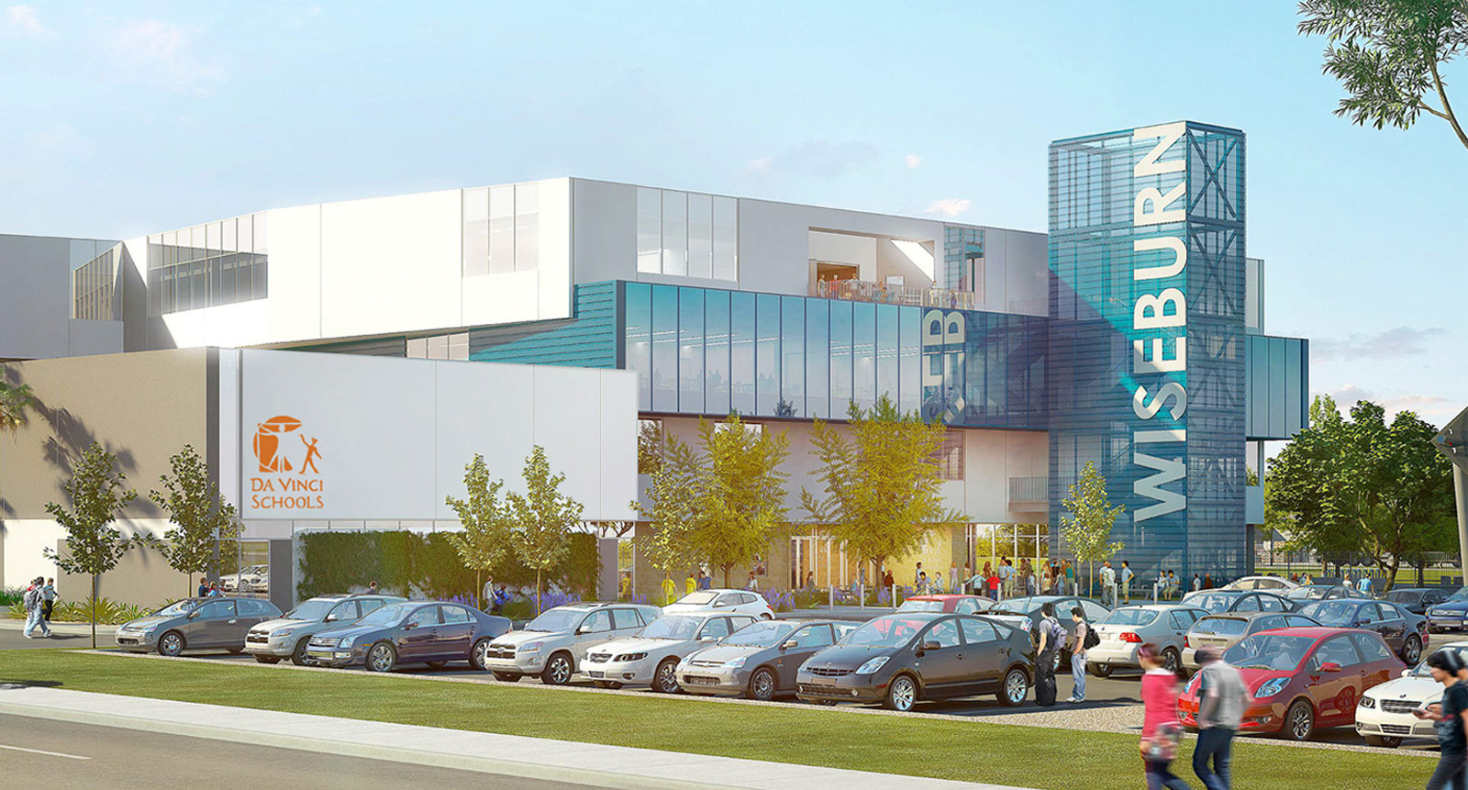

For the first time in Da Vinci history all 3 high schools (Design, Communication, and Science) will be housed underneath the same roof.

Once the doors opens on August of 2017 **1400+** kids will be ushered into a brand new Innovative and futuristic high school, located at [201 N. Douglas St., El Segundo, CA 90245](https://goo.gl/maps/ao8mbB6mWhq), officially named Wiseburn High School. The new high school will span 4 stories and 210 thousand square feet. Da Vinci students will certainly be in for a “one of a kind experience.”

Gensler’s Los Angeles office who also is responsible for [Denver’s revamped airport](http://www.gensler.com/projects/denver-international-airport?o=los-angeles) and [Topshop’s first West Coast location](http://www.gensler.com/projects/topshop-topman-the-grove?o=los-angeles) designed Da Vinci’s new campus. Communication on Gensler’s end was spearheaded by design director David Herjeczki along with 12 other designers and approximately 70 people overall who contributed to the design and engineering of the building.

Unlike most other high schools, Gensler personalized Wiseburn High School to fit Da Vinci Schools program instead of having Da Vinci Schools mold their program to fit a Gensler-designed building. Each of Da Vinci’s three High schools will have their own floor which will have nearly every aspect customized from the walls to furniture. With the schools sharing a common floor color.

Once Da Vinci students enter Wiseburn High School for the first time in August of 2017, they will encounter on the first floor an auditorium, administrative spaces, and other recreational space before they reach the stairwell that connects students to their individual school. Science will occupy the second floor, Communications the 3rd, and Design will be on the top floor.

**Construction Hiccups**

Although the main building is on track to open on schedule. The Gymnasium and Olympic Swimming Pool aren’t scheduled to open until Spring 2018 due to the project going over the budget.

According to Wiseburn’s Director of Facility Planning, Vince Madsen who has worked for the Wiseburn School District for 3 years and as a Director of Facility Planner for Los Angeles school districts for nearly 10 years ; Los Angeles’ city-wide construction boom caused prices to go up on construction the school because of “ an increased supply and demand.”

“I don’t know if you’ve been to downtown recently, but construction is going on everywhere,” he told me as I grilled him on a variety of questions ranging from the project’s budget to Da-Vinci’s and Wiseburn’s unique relationship.

**“We Do Things Differently” We Partner with School Districts**

While LAUSD, the second largest school district in the Nation [evaluates the possibility of becoming an all-charter school district](http://www.dailynews.com/social-affairs/20151117/la-unified-explores-becoming-an-all-charter-school-district)  Da Vinci is doing the opposite. Da Vinci’s current relationship with Wiseburn mostly includes just being authorized to operate in Wiseburn territory and being Wiseburn’s home school is set to grow significantly with the opening of Wiseburn High School. With Wiseburn having more influence in Da Vinci’s affairs students would be rightfully concerned that Da Vinci could be at risk of losing it’s identity by this partnership.

Fortunately,Wiseburn and Da Vinci have had a great relationship with little if any counterproductive interference on Wiseburn’s end. “Unless we really start bombing something or really start losing it, I think they’ll kinda let us do our thing,” Kate Parsons said after asked about how Da Vinci Identity would be effected. Nevertheless, Da Vinci’s Identity has been safeguarded in a series of documents called the Magna Carta. This yet-to-be signed document includes passages such as

* Da Vinci and Wiseburn must share board members for equal representation
* The two boards must have biannual joint meetings
* maintains Da Vinci’s lottery application process

and many more. This document can be viewed here.

**Wiseburn High School Will be Great for Students, Faculty, and the Wiseburn Community**

Da Vinci students and faculty should look forward to having all schools on the campus for the first time. With all the students being on the same campus Da Vinci will be able to have more balanced sports teams and an increased turnout rate to all events. Students should also look forward to new sports such as baseball, softball, swimming, and water polo.

The only current downside to the new campus is that Communications, Science, and Design students will interact less because of seminars becoming school-specific and there being different lunch times due to the logistical nightmare of having to serve 1400 kids at once.

The building is stunningly beautiful on the inside and the outside. Classrooms will include amenities such as dropdown projectors, built in computer carts, and window views. Also on the outside of each classroom will be a quad area where students can sit and work outside of the classroom.

Lastly, the building will be more earthquake resistant and sustainable than Dv’s current campuses.

**Communications and DVX continue to evolve**

Next year, Communications Juniors and Seniors will be given more freedom of choice with their education via “Pathway Projects.” The pathway projects will range from Communications first official newspaper to 72 and Sunny projects to projects involving artificial intelligence. These pathway projects will give students the opportunity to learn about what they are interested in instead of the traditional way of learning what the teacher chooses to teach.

Also classes for Seniors and Juniors will not only become shorter, but math classes will be mixed. Upperclassmen will still take their grade specific classes such as College writing for 12th graders and biology for 11th graders, but their math classes will be mixed by topic instead of grade.

Da Vinci’s college-ish program expands its focus. Besides helping students get into college, DVX will also explore how they can help Da Vinci’s alumni in college, Kim Merritt who will soon have a PhD in organizational leadership said.

**Da Vinci Lives Up To Its Name**

No matter how uneasy students are about the move to the new campus they should know that everyone on Da Vinci’s and Wiseburn’s faculty are not only qualified for their positions, but also extremely passionate about teaching and the students whose lives they have a significant impact on.

American Ford GT V.S Italian Horse Ferrari

# **Opinion-Article**

Ford GT,a 3.5-liter V-6 twin turbo Ecoboost car that produces 600 hp and 550 pound feet or torque. But is that enough power to compete against the Italian horse Ferrari. The Ford GT is an anticipated car by millions of car enthusiast and this is what Ford has created the new redesigned GT. Ford states that in 24 hours La Mans, a racing event that truly shows the cars endurance in capability in the track, they will arrive and run laps around Ferrari and I feel they are ready to do that.

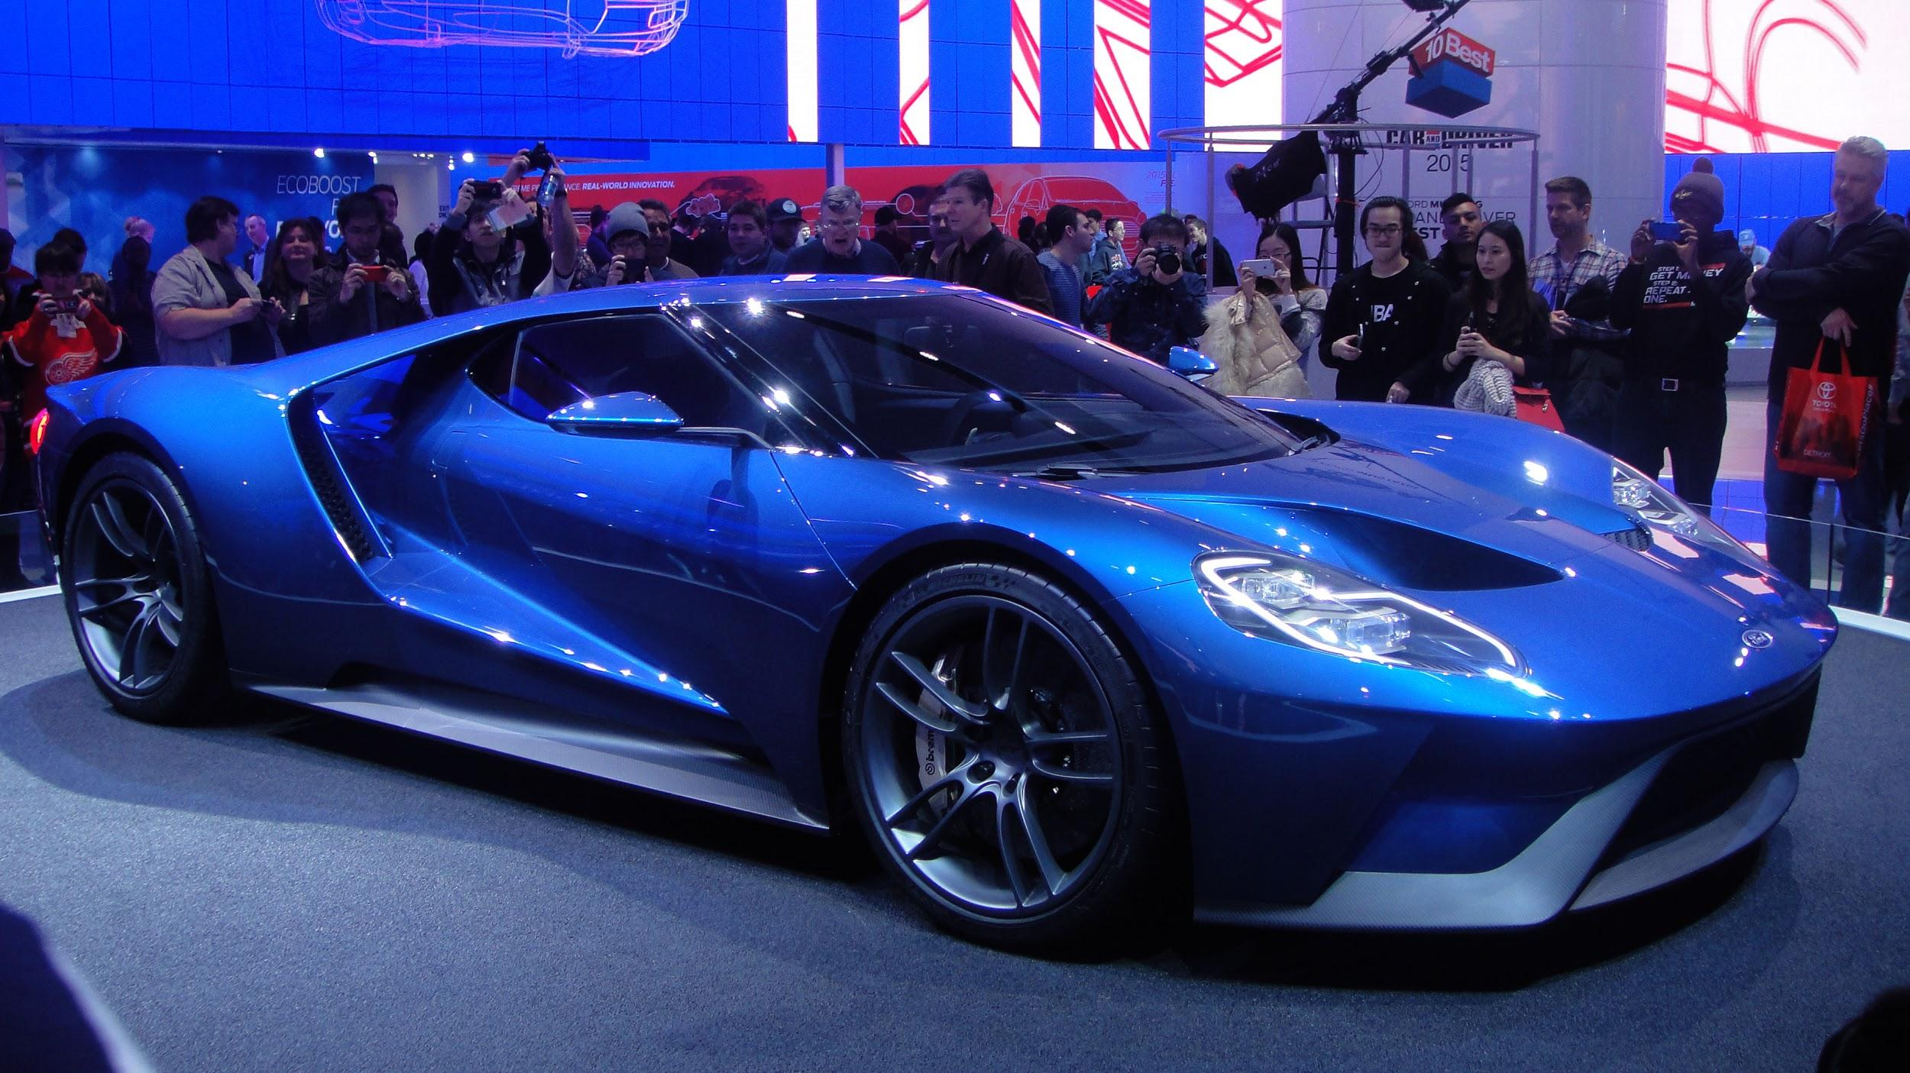

Fords feud with Ferrari started in 1963 Ford Motor company attempted buying Ferrari but Enzo (owner of Ferrari) refused to sell Ferrari to Ford. Ford knew they had to get back at Ferrari. Ferrari had won the 24 hours of le mans 4 years in a row.

Ford had tried to beat and compete against Ferrari in 24 Hours of Le Mans. But unfortunately they were not successful. After losing to Ferrari in Le Mans 4 years in a row ford decided to go back to the drawing board, and Carroll Shelby friend of Henry Ford and creator of Shelby automobiles stated “Next Year, Ferrari’s ass is mine”.

The year after that in 1966 Ford introduced the first ever Ford GT-40 and came 1st place in 24 Hours Le Mans. They won first place in 67,68, and 69 in 24 Hours of Le mans. Now in 2016 Ford is planning to do the same take the Ford GT to Le mans and prove Ferrari theirs even better then when they were in 1966-1969.

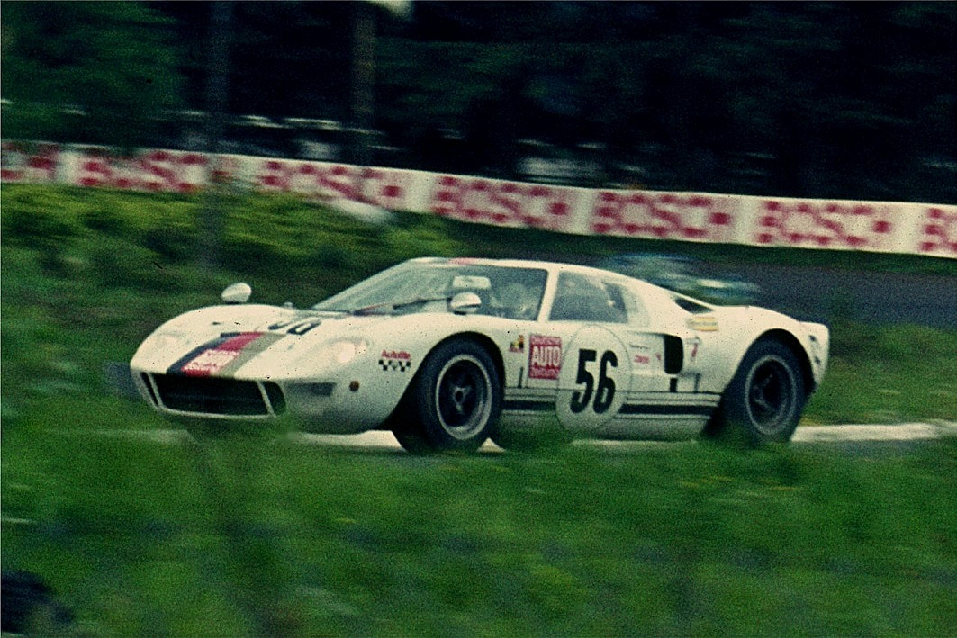

Although Ford's amazing design of their new Ford GT theirs is some disagreements going on about the GT. When people heard the new Ford GT is going to have 3.5-liter twin turbo V-6 they sort of disagreed with the type of engine it was going to have etc. They believed they should stick with a V8 supercharged engine due to Ford been an American car and company that is known to just produce V.8 engines.

Another thing that people are thinking is going to be a bad idea besides the engine type is going to have is that there are going to use an Ecoboost engine and Ford's Ecoboost engines are not known to produce over 600hp.

All those allegations of the Ford GT were answered threw out several interviews made with some people who were in charge of the vehicle production.

An interview made by Auto week they talked with the director of Ford Performance Gerard Quinn. In that interview they ask him about how people say that the Ford GT should stick with its roots and use V.8 supercharger instead of the 3.5-liter twin turbo V6 Ecoboost engine.

Quinn Director of Ford Performance states:

“A lot of people commented on that about the V.8 but when they actually saw the car revealed and then people have heard the car and it slowly starts to disapparate in their desire to have a V.8”

After that interview with Quinn we see that people really support the idea of Ford deciding to go with Twin Turbo V6 instead of sticking with their V.8. This also shows how ford is moving on to wanting to prove that American cars can compete in those events not only Ferrari, Lamborghini, Porsche etc. can compete in that supercar level.

We can also see in this in this other interview with Mark Fields C.E.O and President of Ford Motor Company made by ABC news he was asked based on the cars Ecoboost engine if it was efficient.

Mark then stated “To give them among the best or very best fuel economy”. He was stating that the Ecoboost put in it is not only for performance is also to give the client the best fuel economy.

In this interview made by CNET they got to interview a member of the Ford Performance Team. They ask him about if they are ready for Le Mans against not only Ferrari but against all the other cars that are going to be arriving at Le Mans.

In another interview made by CNET they got a chance to talk to a member of the Ford Performance team member and ask him a couple of question regarding 24 hours Le Mans and if their ready.

They ask the member of Ford Performance if the Ford GT will be ready for the 24 hours Le Mans and he states “We won races like 12 Hours of Sebring and 24 Hours of Daytona” this shows how much faith they have on the Ford GT and he stated towards the end of the interview “You know a lot of people want to know what we are doing. We are going to Le Mans with one hell of a race car”.

All in all, is the Ford GT ready for this 24 hours of Le Mans, and ready to show up and run laps around Ferrari, yes they are, Ford will show up with an amazing car and it will win 24 hours of Le Mans.



The Rapidly Increasing Syrian Refugee Problem

By Musa Alghweir, Contributor

JANUARY 26, 2016, 8:35 PM

Since the beginning of the Syrian civil war in 2011, 7 million Syrians have been internally displaced and are still looking for a place to stay. 4 million Syrians have escaped to neighbouring countries such as Turkey, Jordan, and Lebanon, while more than 16 million people are in need of assistance inside and outside of Syria.

As the conflict has evolved over the past five years, other players have become involved in the civil war, and have mostly brought negative effects to Syria. Although the fight has been mostly directed by ISIS, the Free Syrian Army, and the Syrian Armed Forces, other countries still play a role in the fight today.

According to the United Nations, over 250,000 people have died during the war. This high toll of deaths is not only credited to ISIS, the Syrian regime, and the FSA, but also to the United States, and Russia.

U.S. and Russian-led airstrikes supposedly targeted at “terrorist groups” have significantly destroyed much of Syria’s infrastructure, which has led to an increased amount of displaced Syrians. Although the U.S. has played a part in the increase of displaced Syrians, they have also played a tiny role in tackling the refugee issue.

Only 2,290 Syrian refugees have been relocated somewhere in the United States since the beginning of the civil war (FactCheck). As progress towards accepting more refugees has been shown by the Obama administration, opposing views from Republicans have sparked new debates about Syrian refugees.

As President Obama stated during remarks at the G20 economic summit in Antalya, Turkey, “Slamming the door in [the faces of refugees] would be a betrayal of our values.” Obama plans to take in 10,000 Syrian refugees into America by fiscal year 2016, however, other officials are skeptical of this due to the recent Paris attacks.

"The people who are fleeing Syria are the most harmed by terrorism," Obama stated. Although there might have been some refugees involved in the Paris attacks, Obama tackles the issue of Syrian refugees, rather than use the attack as an excuse not to help them.

Many Republican governors stated that they would not allow Syrian refugees to enter their states, and want the U.S. to have stronger border control. Although Obama only stated that he intends on accepting 10,000 Syrian refugees, many GOP candidates like Trump exaggerate the number to fuel anti-refugee attitude.

A Teacher's Responsibility to

Students

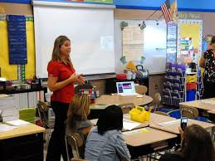

Parents all over the world send their children to school thinking they are in the safe hands of their teachers. Little do the parents know, that teachers are not required to stay up to date with their CPR certification. CPR stands for Cardiopulmonary Resuscitation, it can be performed in many emergencies, some of which include cardiac arrest or drowning. CPR keeps blood flowing to the brain and other vital organs.

It’s scary to think that there could be an emergency, and a teacher wouldn’t be able to assist the child. Most teachers think that after learning CPR once, that they will be prepared and won't need to renew their certification. The truth is that they may forgotten some aspects, or CPR techniques have changed to be more efficient.

Some may argue that they would rather wait for trained professionals to provide medical assistance.

Assistant Professor of Health Science/Emergency Medical Science at University of Arkansas Monte Gagliardi says public school teachers are a very effective first-response during disasters and other emergencies in school, so it is important that they are up to date on their CPR. Waiting trained professionals could possibly be even more harmful to the

I conducted a survey to see how parents and students felt about teachers being required to be up to date on their CPR certification.100% of the parents that took the survey thought it was very important for teachers to be up to date on their CPR certification and assumed that all teachers were in fact up to date. 80% of students also had assumed the teachers were up to date and thought it was important. This shows that parents should be more aware when sending their children to school.

We need to push schools to make it mandatory for teachers to stay up to date on their CPR. Schools should fund CPR programs for teachers, and also give an extra compensation for teachers since they are taking their time out of their life to learn CPR.

miles ehrhard

Why North Korea Won’t Exist In 20 Years

North Korea is one of the most infamous countries of recent years for the treatment of their people, it's not hard to see that this country is not going to last for 20 years, because of the threat against North Korea from Isis and how many enemies it has.

North Korea “ties” civil rights very tightly with passport for going outside and only government officials allow access to the internet. Most people don't know the term “3 generation of punishment” it is the act of committing a crime and having your whole family taken and put into a work camp and only after your children, Word this a little bit differently children are you allowed to leave.

It also simply does not have enough resources to support itself with its most popular resource,gold, made useless by the fact of their trading policies with the outside world. It simply does not have enough resources to exist right now unless North Korea opens up vastly changing the way the country operates or becoming a different country as a whole. Add some sources that can add credibility to your article, just so you can back up your opinion.



Cayland

*special*

<!DOCTYPE html>

<html>

<head>

<STYLE>

.pants{

border-radius: 50%;

border-color:purple;

height: 100px;

width: 100px;

color:red;

border-width 2px;

border-style: solid;

border-width: 5px;

margin:auto;

text-align:center;

}

h1{

margin-left:30%;

color:purple;

}

.transcript {

color:white;

background-color:purple;

text-shadow: 0 1px 0 #ccc,  
 0 2px 0 #c9c9c9,  
 0 3px 0 #bbb,  
 0 4px 0 #b9b9b9,  
 0 5px 0 #aaa,  
 0 6px 1px rgba(0,0,0,.1),  
 0 0 5px rgba(0,0,0,.1),  
 0 1px 3px rgba(0,0,0,.3),  
 0 3px 5px rgba(0,0,0,.2),  
 0 5px 10px rgba(0,0,0,.25),  
 0 10px 10px rgba(0,0,0,.2),  
 0 20px 20px rgba(0,0,0,.15);  
}

</STYLE>

</head>

<body>

<div class="pants"></div>

<hr size="6" color="purple">

<h1>Campus Improvement</h1>

<p>DaVinci is overflowing with young talent. We always showcase this talent around campus, but many say we don’t do it nearly enough. For those people, and for anyone who enjoys seeing beauty all around campus, we now have Campus Improvement. It’s a cornerstone and pillar of DVC’s school culture Each week, we will find a different place at DaVinci and make it even DaVinci-er. This can be anything from an artistic paint job, upgrading DVC’s tech, or even putting rockets under Eynon’s class and making it fly!

</p>

<h1>This week…</h1>

<p>I failed to get the blue lunch tables painted purple to match with the umbrellas. Here’s how:</p>

<br><br>

<p>

First, I went to Mr. Barrymore’s office. You can usually find the answers to anything school related in there. Unfortunately, Nathan wasn’t in the office at the time. I returned to class. I sat in my chair and brainstormed ideas for what to do next. I started researching paint and the levels to the game. Turns out the tables weren't painted in the first place because of paint issues. So i went to work researching facts about paint to help our situation.</p><br>

<hr size="6" color="purple"><div class=”transcript”>[Transcript of a cell phone conversation with a Home Depot Paint Expert(HDPE)]

Me: Hello, how are you?<br>

HDPE: Fine, thanks. Did you have a question about paint?<br>

Me: So there’s a group of tables outside at our school…<br>

HDPE: Okay…<br>

Me: They need to be painted with a finish that won’t crack and will be easy to clean. <br>

HDPE: High gloss paint is the most durable paint. It is also difficult to apply correctly.<br>

Me: Well, what do I need to know?<br>

HDPE: Sand the surface before you paint. When you apply the paint, apply it with lengthwise strokes and let dry for 24-36 hours before application of the second coat.<br>

Me: Thanks, have a good day and enjoy a complimentary CINNABON[**™**](https://en.wikipedia.org/wiki/Trademark_symbol) .<br></div>

<br>

<hr size="6" color="purple">

<p>My sources confirm that high gloss paint is the most durable paint, so that’s the one I recommended to Nathan when we met. Unfortunately, the next day, Nathan told me that John said getting the tables painted would be “impossible” to clean. I sat down at a table and accepted defeat. After that I opened this laptop and started to type this beautiful article.</p>

<h1>My Experience</h1>

<p>This week I had plenty of good experiences with this assignment. This week I had plenty of bad experiences with this assignment. I think on good experience was the meeting with Mr. Barrymore. That meeting made everything seem like things were doing well, but unfortunately things didn’t come to fruition. I think the lowest point was when the word “impossible” was used. The most interesting part of the week for me was learning about the different paints and their optimal applications. If I ever wanted to paint a high-gloss door, I would know exactly what to do.

I think i knew then that this week’s article would be a huge failure. But we do have some concept art of what the finished tables would look like.</p>

<br><br><p>concept art</p><br><br>

<h3> Now it’s time for…</h3>

<h1> What Did We Learn</h1>

<h2><i>”The only way this article could get better now is if I didn’t have to write it”<i></h2>

<ul style="list-style-type:square">

<li>The project should be finished before the article starts production.</li>

<li>Approval can sometimes be impossible.</li>

<li>When in doubt, ask Nathan.</li>

</ul>

<br><br>

<h1>Next Week…</h1><br>

<h1>1</h1><br>

<h2>... the water fountain. OR...<br>

<h1>2</h1><br>

<h2>... the gutters. OR...<br>

<h1>3</h1><br>

<h2>... the OFFICE.<br>

</body>

</html>

Adventure Time and Steven Universe: Delivering Messages Everyone Needs to Hear!

(Spoiler Alert Warning)

By: Peri Murray February 4, 2016

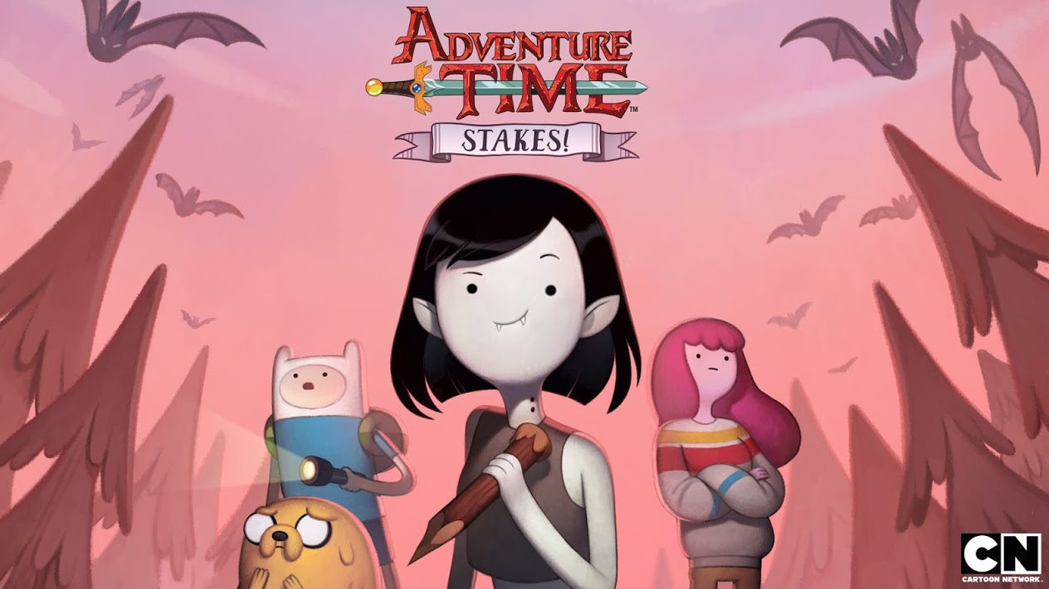

This is the title card for the new Adventure Time special called “Stakes” focusing on Marceline the Vampire Queen.

Cartoons are meant for the entertainment of children, teens, and adults. They are meant to give you an escape into a new and exciting world where possibilities are endless. But along with the fun and games come important subliminal and direct messages towards viewers of all ages. Recent cartoons that have done an amazing job at this are Steven Universe and Adventure Time.

Adventure Time, a show that follows Finn the Human and Jake the Dog on tons of fun adventures, had a recent special called “Stakes” which focused on Marceline the Vampire Queen and her struggle to grow up and become an adult. But in order to do that she must sacrifice her immortality. At the end of the special, she comes to terms with being immortal and even became more mature in the process. Adventure Time delivered a subliminal message saying that growing up is very difficult and validates that it’s okay because it is hard, and you don’t have to do it all at once; it's an adventure.

[Pendleton Ward, the creator of Adventure Time, in his interview with Rolling Stones in 2014 stated "I was fat and I had a bowl cut and I had rollerblades," he continues. "I would put my Magic cards in a backpack and skate down to the comic shop. Just super awkward."](http://www.rollingstone.com/tv/features/adventure-time-the-trippiest-show-on-television-20141002) Ward wasn’t a super cool or popular kid, he like to keep to himself. This made his adventure of growing up a little more challenging, but who’s coming to age journey doesn't have their ups and downs? This inspired Adventure Time because growing up can have it’s fun moments, but there can also be some serious situations and that’s what Adventure Time explicitly shows throughout each episode.

Steven Universe follows the half-magic, half-human Steven as he and his ageless, mystical mentors the Crystal Gems protect their home of Beach City from intergalactic threats. Everything happening in the series is from Steven’s perspective, so whatever is hidden from Steven is also hidden from the viewers. But Steven Universe has two recurring themes throughout their episodes; trust and validation.

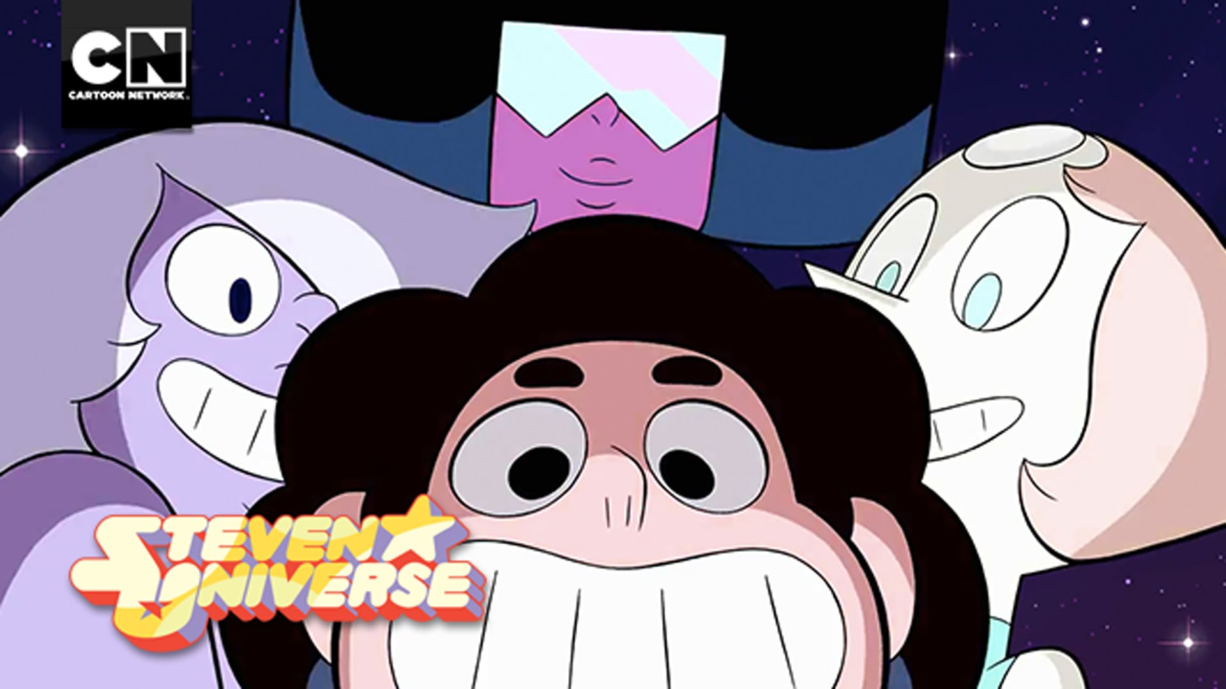These are the Crystal Gems! (Top: Garnet, Left: Amethyst, Right: Pearl, Middle: Steven)

In a recent episode called “Message Received”, Steven becomes heartbroken after Peridot, an alien from the Crystal Gems homeworld who becomes stranded on Earth who later befriends Steven, betrays his trust and disappoints him. Steven is upset with himself and his instinct to put all his trust in people so easily until mother figure, Garnet, comes to comfort him. [She tells him “ You offered her a lot of your trust…” Steven replies with “I know! And it blew up in my face!”](http://www.dailymotion.com/video/x3laaze_steven-universe-message-received_fun) You guys have been protecting the Earth for thousands of years...she could have destroyed all that… why did I think I could change her mind…” Garnet replies with “Its good you believe in everyone Steven, like your mother, you seem to have a little more patience than the rest of us. But the truth his, not everyone deserves that patience.”

Garnet validates how Steven feels and tells him it's good to believe in people and trust them but for some, you can't allow yourself to place so much of you into them.

I agree with these messages these shows are delivering and would be happy my children are being exposed to them. But some disagree with the portrayal of slight homosexuality in the Steven Universe. Russia has gone as far as to censor the show by turning Ruby, one of the gem that makes Garnet, into a man. There is even a petition in place to censor the LGBT themes in Steven Universe on Change.com by some who feels very strongly about the themes.

“I loved watching Steven Universe with my kids but same sex relationships is not a topic that should be discussed in children's programing. The kiss between Ruby and Sapphire was over the top for a children's cartoon. We are signing this petition for Cartoon Network to censor current episodes "Jailbreak" and "Roses Scabbard" to exclude LGBT themes and to censor future episodes.” This is the claim the creator of the petition is standing by. There's just so much hate on shows like Adventure Time and Steven Universe who really are passing on messages to this and the next generation, that they could relate to actual situations in their lives one day. All I ask is that you support these shows and along with the positive messages they are trying to convey to everyone of all ages.