A long-desired component to the U.S. operational observing systems is the capability to measure vertical profiles of wind, temperature and moisture in the lower troposphere at high spatial and temporal resolution (NRC, 2009). It has been suggested that such profiling could be done by small unmanned aerial vehicles (UAVs) assuming that autonomous flights at least through the depth of the boundary layer be permitted (Dabberdt et al. 2005). Since FAA permission has not yet been granted to test such an observing network, the potential improvement that a UAV network could have on storm-scale numerical weather prediction using an Observation System Simulation Experiment (OSSE) approach. An OSSE is performed over the state of Oklahoma in which it is assumed that a UAV could be launched from 110 Oklahoma Mesonet (McPherson et al. 2006) stations every hour, fly vertically to an assigned maximum altitude and return to its charging station, providing soundings at a roughly 35 km horizontal resolution. A case study of convective initiation (CI) was chosen for this study as a compromise between a fair-weather day and one with extensive ongoing convection. The OU ARPS (Xue et al. 2000) model provides a nature run at high (1 km) resolution, while the control run and OSSE experiments are done with the WRF-ARW model at 3 km. To simulate the effect of data from dozens of observing systems already included in operational models, the nature run data volume is sampled at synoptic scales and inserted into the control run via a 6-hr data assimilation (DA) period. Simulated hourly UAV temperature, moisture and wind data, with expected errors, are then added to the DA, followed by 12-hr forecasts. The analyses and forecasts are examined to assess the added value of UAV data. Tests are run to measure the impact of varying the maximum UAV altitude and the spatial density of UAV observations.

Initial results clearly show an improved boundary layer structure and subsequent CI location and timing when UAV data are added to the control experiment. Through a series of experiments testing various maximum flight levels of the UAVs, it was determined that although flights up to 3 km above ground level (AGL) provided the best analysis of the boundary layer (Figure 1), flights up to 1 km were found to be sufficient in producing an improved CI forecast (Figure 2). On a similar note, a series of network density experiments found that while a UAV network consisting of 110 UAV stations produced the best results, the CI forecast was improved with only 75 UAV stations. Although sensitivities to the quality of the moisture analysis are noted, the results suggest that a real-world deployment of automated UAVs could have a positive impact on atmospheric analyses and short-term numerical weather prediction of convective initiation.

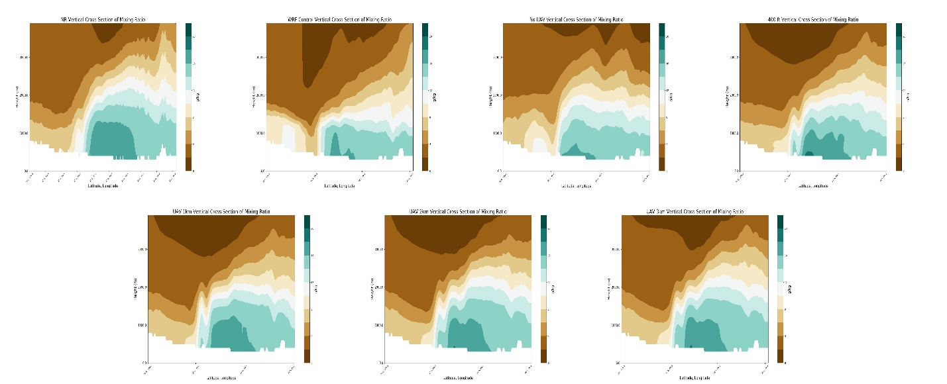

**C**

**A**

**B**

**D**

**E**

**F**

**G**

Figure 1: Cross section plots of mixing ratio for the Nature Run (A), WRF Control (B), No UAV (C), UAV 400ft (D), UAV 1km (E), UAV 2km (F), and UAV 3km (G) WRF analyses valid at 1800 UTC 20 May 2013. The Location of the cross section sample is depicted in the upper left image by the black line for reference.

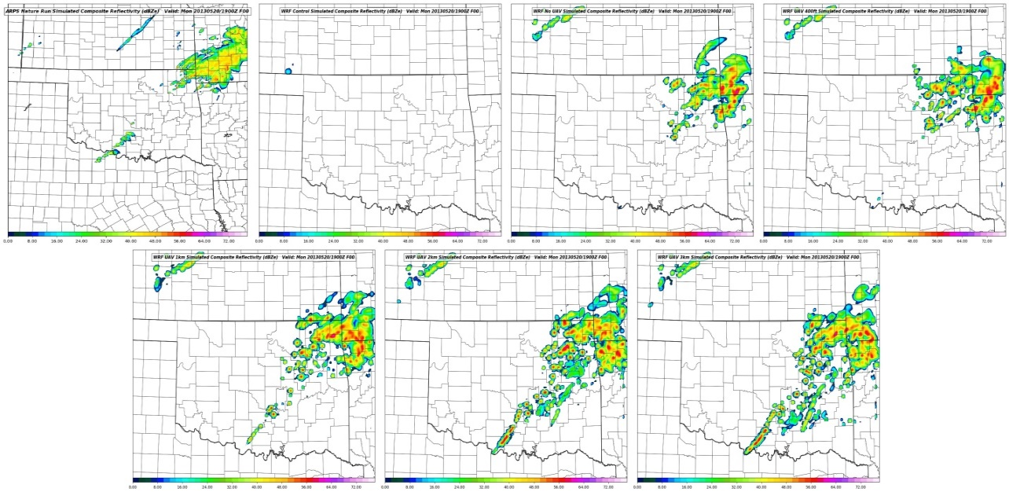

**C**

**A**

**B**

**D**

**E**

**F**

**G**

Figure 2: Comparison between modeled composite radar reflectivity between the Nature Run (A), WRF Control (B), No UAV (C), UAV 400ft (D), UAV 1km (E), UAV 2km (F), and UAV 3km (G) at 1900 on 20 May 2013.

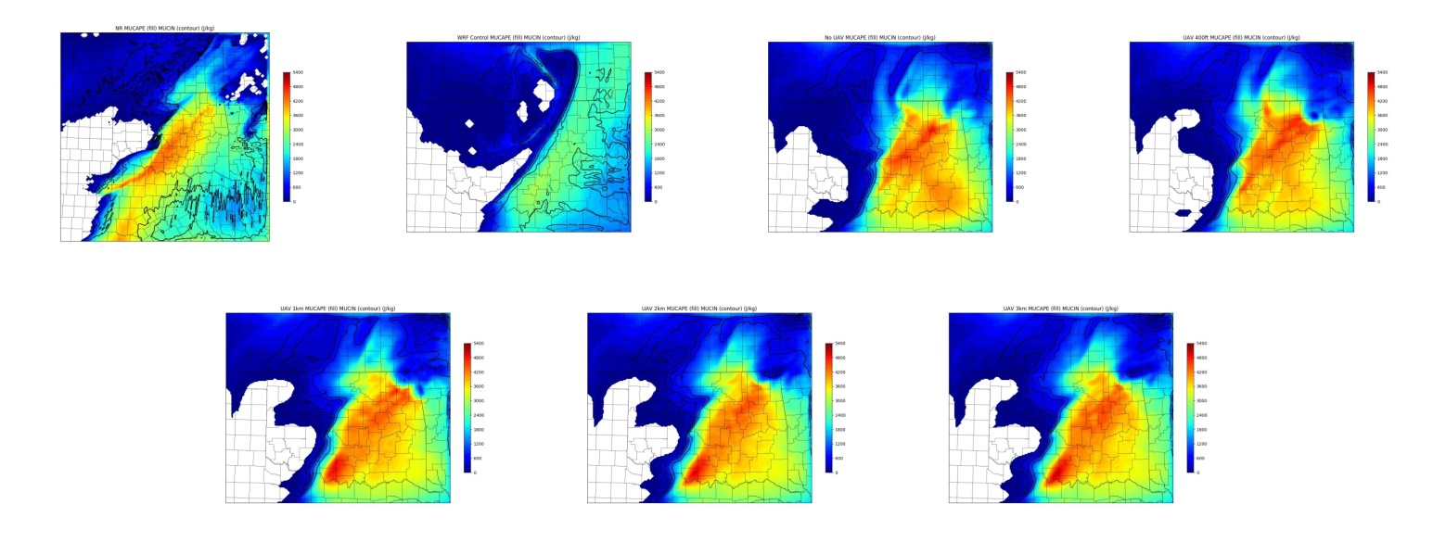

**C**

**A**

**B**

**D**

**E**

**F**

**G**

Figure 3: 1800 UTC analysis MUCAPE (fill) and MUCIN (contours) for the Nature Run (A), WRF Control (B), No UAV (C), UAV 400ft (D), UAV 1km (E), UAV 2km (F), and UAV 3km (G) model runs.

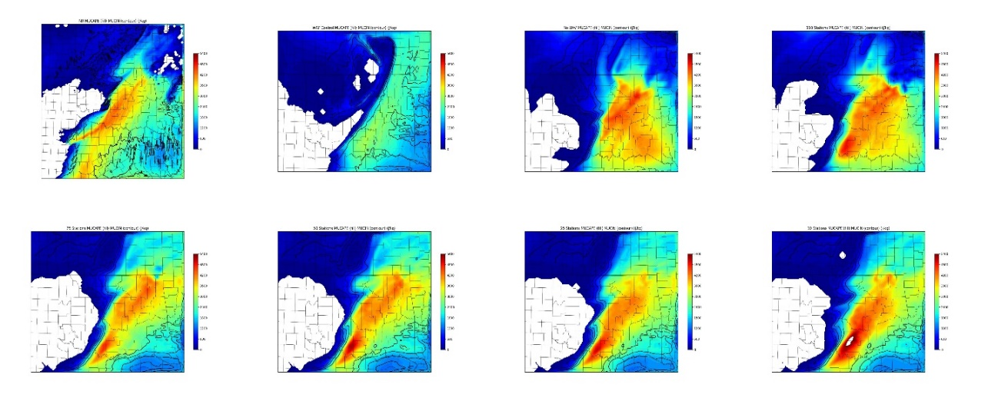

**C**

**A**

**B**

**D**

**E**

**F**

**G**

**H**

Figure 4: 1800 UTC analysis of MUCAPE (fill) and MUCIN (contours) for the Nature Run (A), WRF Control (B), No UAV (C), 110 stations (D), 75 stations (E), 50 stations (F), 25 stations (G), and 10 stations (H).

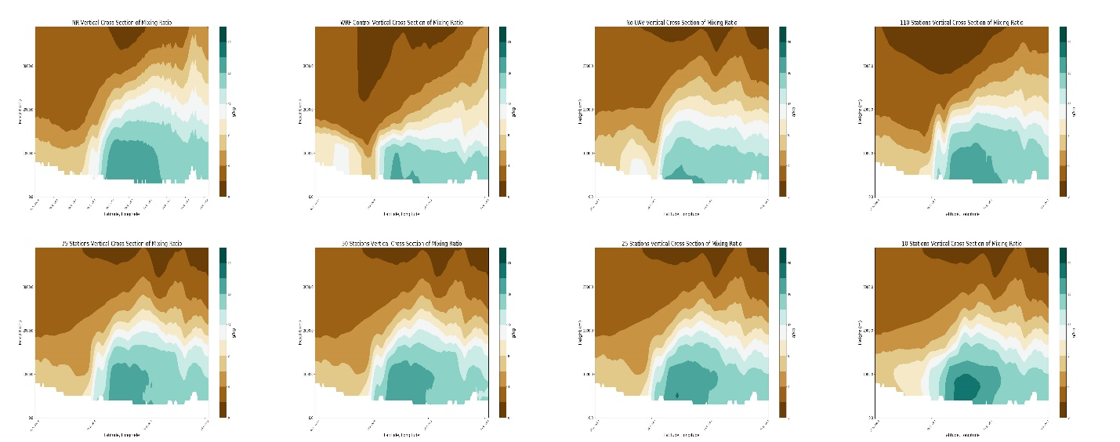

**C**

**A**

**B**

**D**

**E**

**F**

**G**

**H**

Figure 5: 1800 UTC analysis mixing ratio cross sections for the Nature Run (A), WRF Control (B), No UAV (C), 110 stations (D), 75 stations (E), 50 stations (F), 25 stations (G), and 10 stations (H).

References

Dabberdt, W., Schlatter, T., Carr, F., and Coauthors 2005: Multifunctioning mesoscale observing networks. Bull. Amer. Meteor. Soc. 86 (7), 961-98

National Research Council (NRC), 2009: Observing weather and climate from the ground up: A nationwide network of networks. Washington, DC: The National Academies Press. <https://doi.org/10.17226/12540>

McPherson, R., Fiebrich, C., Crawford, K., Kilby, J., Grimsley, D., Martinez, J., Basara, J., Illston, B., Morris, D., Kloesel, K., Melvin., A., Shrivastava, H., Wolfinbarger, J., Bostic, J., Demko, D., 2006: Statewide monitoring of the mesoscale environment: A technical update on the Oklhoma Mesonet. J. Atmos. Oceanic Technol., 24, 301 - 32

Xue, M., Droegemeier, K., Wong, V., 2000: The advanced regional prediction system (ARPS) - A multi-scale nonhydrostatic atmospheric simulation and prediction model. Part 1: model dynamics and verification. Meteor. And Atmos. Physics, 75, 161-19