AP BIOLOGY - UNIT 1: CHEMISTRY OF LIFE
WHO AM I? - STRUCTURE, PROPERTY & FUNCTION QUESTION BANK
Name: __________________________ | Class: __________________ | Date: __________________
Instructions: Read each clue carefully and write the most appropriate biological term, molecule, property, bond, interaction, or structural feature in the blank. Use the figures when referenced.
AP Scope Note: Questions emphasize Unit 1 Chemistry of Life concepts and supporting chemistry. They avoid requiring memorization of detailed molecular structures that the current AP Biology framework excludes.
Section A - Properties of Water & Hydrogen Bonding
Write the term that best matches each clue.
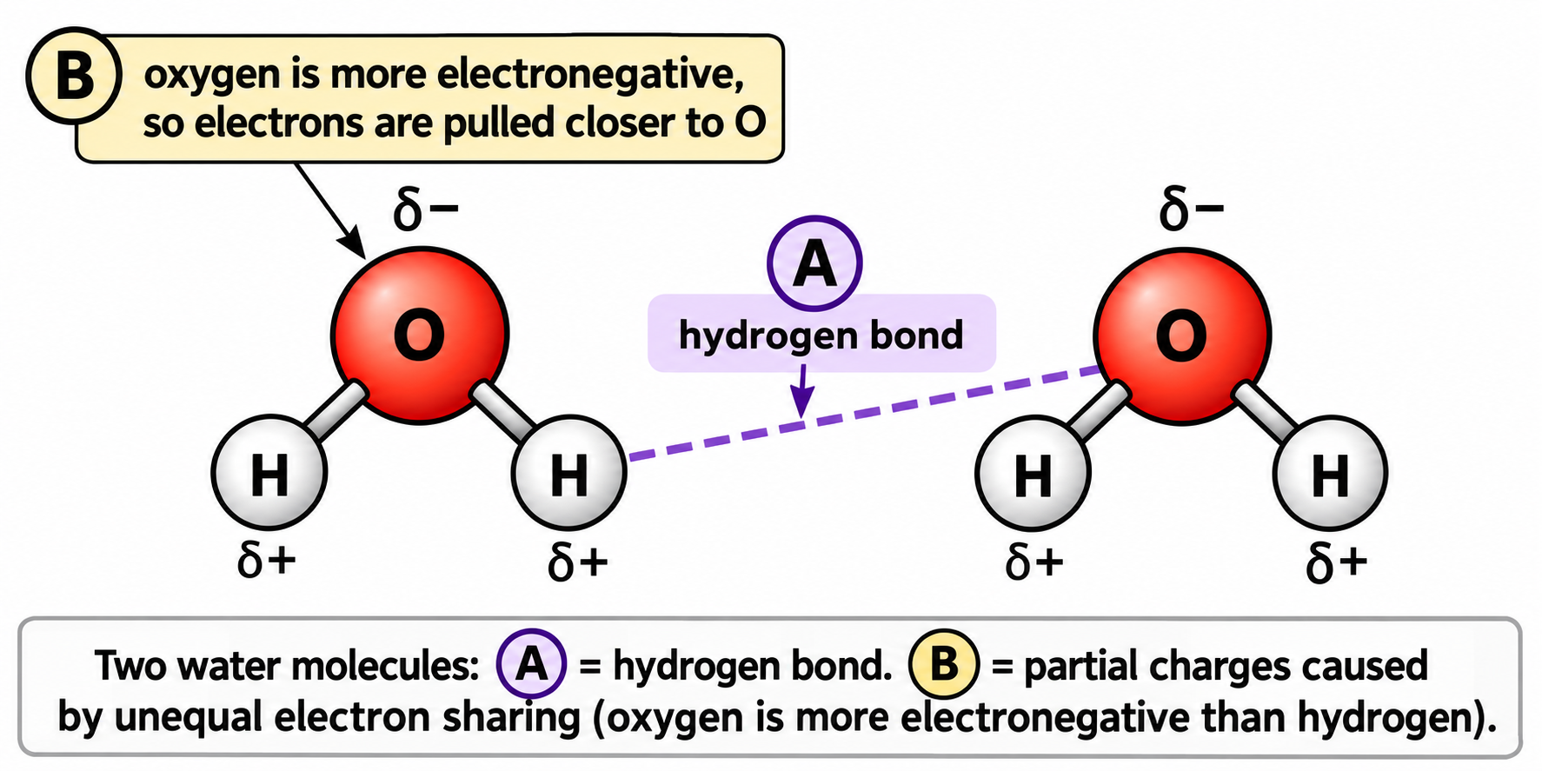
Figure 1. Water polarity and hydrogen bonding
1. I am often called the universal solvent because my polarity allows me to dissolve many ionic and polar substances. Who am I? __________
2. I am the type of covalent bond between oxygen and hydrogen within a water molecule. Because electrons are shared unequally, what am I? __________
3. In a water molecule, I carry a partial negative charge because I attract the shared electrons more strongly. Which atom am I? __________
4. In a water molecule, I carry a partial positive charge because electron density is pulled away from me. Which atom am I? __________
5. I am the weak attraction between the partially positive hydrogen of one water molecule and a partially negative electronegative atom of another molecule. What am I? __________
6. I am the property that describes water molecules attracting one another. What am I? __________
7. I am the property that describes water molecules being attracted to other polar surfaces. What am I? __________
8. I result from cohesive forces at the surface of water and can allow small organisms to remain on the water surface. What am I? __________
9. I am water's ability to absorb or release a large amount of heat with only a small change in temperature. What property am I? __________
10. I am water's property that requires a relatively large input of energy before molecules escape from the liquid phase as vapor. What am I? __________
11. I am the cooling process that occurs when the highest-energy water molecules leave a surface as vapor. What am I? __________
12. I am the upward movement of water through a narrow tube or plant tissue that is supported by both cohesion and adhesion. What process am I? __________
13. I am the reason large bodies of water can moderate environmental temperature and living organisms can resist rapid temperature change. Which property of water am I? __________
14. When water freezes, I form an ordered arrangement that spaces water molecules farther apart than in liquid water. What interaction helps produce this open structure? __________
15. I am the unusual property that allows solid water to float on liquid water. What density relationship am I? __________
16. I am a substance that interacts favorably with water because I am charged or polar. What term describes me? __________
17. I am a substance that tends to avoid water because I am largely nonpolar. What term describes me? __________
18. I surround dissolved ions or polar molecules with oriented water molecules, helping keep the solute dispersed. What structure am I? __________
19. I am the reaction in which water is added to break a covalent bond between monomers. What am I? __________
20. I am produced when monomers are joined by dehydration synthesis. What small molecule am I? __________
21. In Figure 1, label A marks a dashed attraction between two water molecules. What interaction does A represent? __________
22. In Figure 1, the partial charges arise because oxygen and hydrogen differ in their attraction for electrons. What molecular property does this create in water? __________
23. A lake changes temperature more slowly than nearby land. Which property of water best explains this observation? __________
24. Sweating cools the body because water molecules require energy to enter the gas phase. Which property of water is involved? __________
25. Water moves upward through xylem as molecules remain linked to one another. Which property of water is most directly responsible? __________
Section B - Functional Groups
Write the term that best matches each clue.
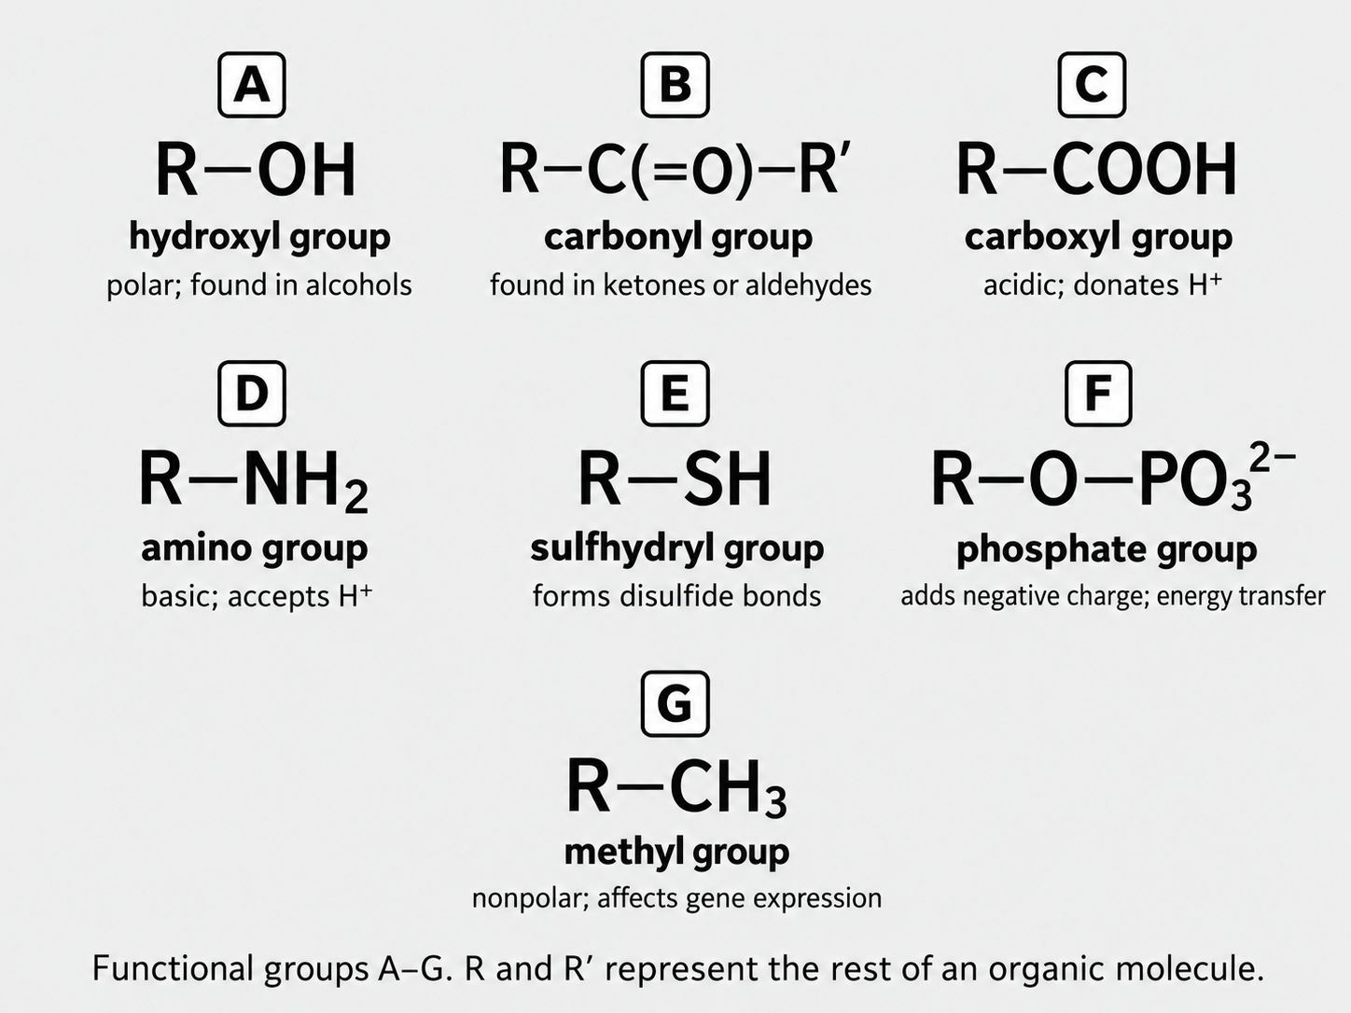
Figure 2. Common functional groups used as AP Biology supporting chemistry
26. I am the functional group written as -OH and I increase the polarity of many biological molecules. Who am I? __________
27. I am the functional group containing a carbon atom double-bonded to oxygen. Who am I? __________
28. I am the functional group written as -COOH and can donate H+ in solution. Who am I? __________
29. I am the functional group written as -NH2 and can accept H+ in solution. Who am I? __________
30. I am the functional group written as -SH and two of me can form a covalent link that helps stabilize some proteins. Who am I? __________
31. I am the negatively charged functional group important in nucleic acids, phospholipids, and energy-transfer molecules such as ATP. Who am I? __________
32. I am the nonpolar functional group written as -CH3. Who am I? __________
33. I am the functional group that makes alcohols and many carbohydrates more hydrophilic. Who am I? __________
34. I am the functional group found in both aldehydes and ketones. Who am I? __________
35. I am the acidic functional group present in fatty acids and amino acids. Who am I? __________
36. I am the basic functional group present in amino acids. Who am I? __________
37. I am the functional group whose oxidation state and position can influence the reactivity of sugars. Who am I? __________
38. I am the group whose presence often gives a molecule a negative charge at cellular pH. Who am I? __________
39. I am the pair of functional groups that are both attached to the central carbon of every amino acid. What two groups are we? __________ and __________
40. I am the group attached to the glycerol region of a phospholipid that contributes strongly to the molecule's hydrophilic head. Who am I? __________
41. I am the group frequently found on sugars and responsible for many hydrogen-bonding interactions with water. Who am I? __________
42. I am formed when two sulfhydryl groups on cysteine residues are oxidized and covalently linked. What am I? __________
43. I am a general term for a specific cluster of atoms attached to a carbon skeleton that gives an organic molecule characteristic chemical properties. What am I? __________
44. In Figure 2, structure A is R-OH. Which functional group is A? __________
45. In Figure 2, structure C is R-COOH. Which functional group is C? __________
46. In Figure 2, structure E is R-SH. Which functional group is E? __________
47. In Figure 2, structure F contains phosphate. Which functional group is F? __________
48. In Figure 2, structure G is R-CH3. Which functional group is G? __________
Section C - Chemical Bonds & Molecular Interactions
Write the term that best matches each clue.
49. I am a strong chemical bond formed when atoms share pairs of electrons. What am I? __________
50. I am a covalent bond in which electrons are shared approximately equally because the bonded atoms have similar electronegativities. What am I? __________
51. I am a covalent bond in which electrons are shared unequally, creating partial charges. What am I? __________
52. I am the attraction between oppositely charged ions that forms after electron transfer creates cations and anions. What am I? __________
53. I am the weak electrostatic attraction involving a partially positive hydrogen and an electronegative atom. What am I? __________
54. I am the covalent bond formed between the carboxyl group of one amino acid and the amino group of another. What am I? __________
55. I am the covalent bond that joins monosaccharides together in carbohydrates. What am I? __________
56. I am the covalent linkage that joins nucleotides within the sugar-phosphate backbone of DNA and RNA. What am I? __________
57. I am the covalent linkage commonly formed between glycerol and fatty acids in fats. What am I? __________
58. I am a covalent bond between sulfur atoms that can stabilize the tertiary structure of a protein. What am I? __________
59. I am not a true chemical bond, but I describe the tendency of nonpolar groups to cluster away from water and I strongly influence protein folding and membrane formation. What interaction am I? __________
60. I am the process that forms a covalent bond between monomers while removing the equivalent of a water molecule. What am I? __________
61. I am the process that breaks a covalent bond between monomers by adding water. What am I? __________
62. Within one water molecule, I connect H to O. What type of bond am I? __________
63. Between neighboring water molecules, I link a partially positive H to a partially negative O. What interaction am I? __________
64. Between complementary nitrogenous bases in DNA, I help stabilize base pairing while allowing the strands to separate when needed. What interaction am I? __________
65. Along the DNA sugar-phosphate backbone, I am the strong bond linking one nucleotide to the next. What am I? __________
66. Between amino acids in a polypeptide backbone, I am the strong covalent linkage produced during dehydration synthesis. What am I? __________
67. I am an attractive interaction between positively and negatively charged R groups within a protein. What type of interaction am I? __________
68. If a protein is exposed to a large change in pH, I may be disrupted because the charges on R groups can change. Which interaction between charged R groups am I? __________
69. I result from unequal electron sharing and help give water its polarity. Which bond type am I? __________
70. I am generally weaker than covalent bonds individually, but many of me together can strongly stabilize biological structures. What am I? __________
Section D - Carbohydrates
Write the term that best matches each clue.
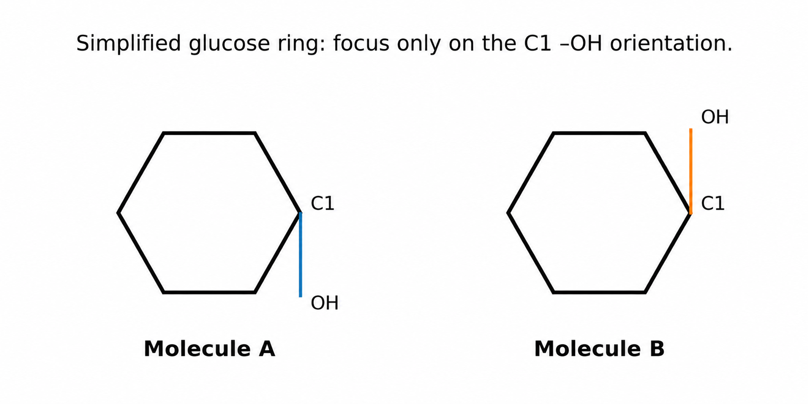
Figure 3. Simplified glucose anomers for structural recognition
71. I am the simplest type of carbohydrate and serve as the monomer from which many larger carbohydrates are built. What am I? __________
72. I am a six-carbon monosaccharide used widely by cells as a fuel and as a building block for polysaccharides. Who am I? __________
73. I am a carbohydrate made of many monosaccharide subunits joined by covalent bonds. What am I? __________
74. I am the main storage polysaccharide in plants. Who am I? __________
75. I am the highly branched storage polysaccharide found in animals. Who am I? __________
76. I am the structural polysaccharide that is a major component of plant cell walls. Who am I? __________
77. I am the covalent bond that links monosaccharides to one another. What am I? __________
78. I am the reaction that joins monosaccharides and releases the equivalent of water. What am I? __________
79. I am the reaction that uses water to break a carbohydrate polymer into smaller sugars. What am I? __________
80. I contain carbon, hydrogen, and oxygen and often provide readily accessible energy or structural support in living organisms. Which class of macromolecule am I? __________
81. I am the carbohydrate category to which glucose belongs. What am I? __________
82. I am the carbohydrate category to which starch, glycogen, and cellulose belong. What am I? __________
83. I store glucose units in plant cells for later energy use. Who am I? __________
84. I store glucose units in animal cells and am especially abundant in liver and muscle. Who am I? __________
85. I provide structural support to plant cells rather than serving primarily as an energy-storage molecule. Who am I? __________
86. I am a common functional group found repeatedly on monosaccharides and I make them strongly polar. What group am I? __________
87. I am another functional group found in sugars and contain a carbon double-bonded to oxygen. What group am I? __________
88. I am the small molecule removed when two monosaccharides are covalently joined by dehydration synthesis. What am I? __________
89. I am added when a glycosidic bond is broken by hydrolysis. What molecule am I? __________
90. I describe a carbohydrate polymer that may be linear or branched depending on how its monosaccharide units are connected. What general class am I? __________
91. In Figure 3, Molecule A has the C1 hydroxyl group below the plane of the simplified ring. Which glucose anomer is it? __________
92. In Figure 3, Molecule B has the C1 hydroxyl group above the plane of the simplified ring. Which glucose anomer is it? __________
93. I am the principle that explains why carbohydrates with similar monomers can have different biological functions when their covalent linkages and three-dimensional arrangements differ. What broad AP Biology idea am I? __________
94. A plant cell needs a carbohydrate for long-term storage rather than cell-wall support. Which polysaccharide should it synthesize? __________
95. An animal needs a rapidly mobilizable glucose-storage polymer. Which polysaccharide should it synthesize? __________
Section E - Lipids
Write the term that best matches each clue.
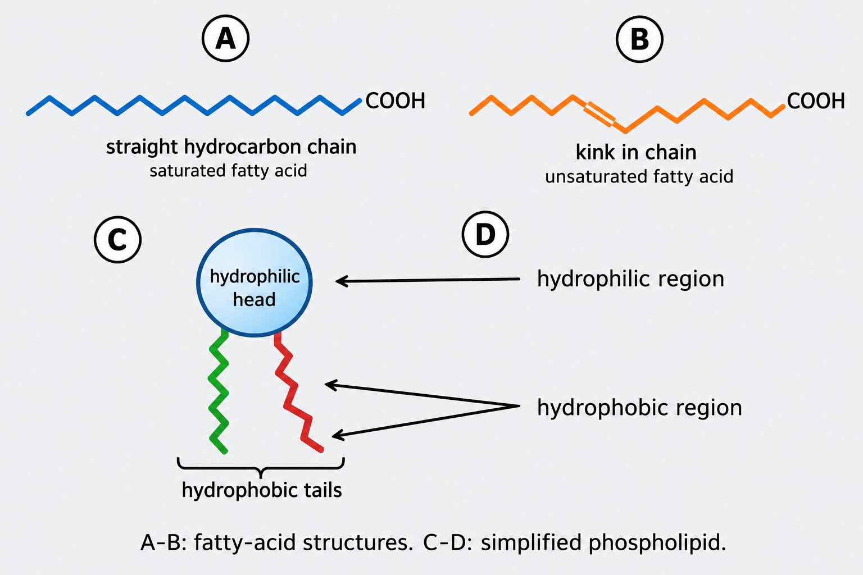
Figure 4. Fatty-acid saturation and phospholipid structure
96. I am a class of biological molecules that are typically nonpolar and hydrophobic. What class am I? __________
97. I am a long hydrocarbon chain with a carboxyl group and I am a common component of fats and phospholipids. What am I? __________
98. I am a fatty acid with only single carbon-carbon bonds in my hydrocarbon chain. What type am I? __________
99. I am a fatty acid with at least one carbon-carbon double bond that introduces a kink in the chain. What type am I? __________
100. As my number of carbon-carbon double bonds increases, a lipid generally becomes more fluid at room temperature. What property am I describing? __________
101. I am a lipid used primarily for long-term energy storage and may also provide insulation in mammals. What general type of lipid am I? __________
102. I am a lipid molecule that groups with others to form the basic bilayer of cell membranes. What am I? __________
103. I have both a hydrophilic region and a hydrophobic region in the same molecule. What term describes me? __________
104. In a phospholipid, I am the region that interacts readily with water. Which part am I? __________
105. In a phospholipid, I am the region that avoids water and points inward within a bilayer. Which part am I? __________
106. I am the membrane lipid that provides important structural stability to animal cell membranes. Who am I? __________
107. I am a class of lipids that includes many hormones involved in growth, development, metabolism, and homeostasis. What am I? __________
108. I form when phospholipids arrange with hydrophilic regions facing water and hydrophobic regions shielded from water. What structure am I? __________
109. I am the key property of phospholipids that drives bilayer formation in aqueous environments. What property am I? __________
110. I am the effect produced by carbon-carbon double bonds in unsaturated fatty acids, preventing straight chains from packing tightly. What structural feature am I? __________
111. In Figure 4, fatty acid A has no carbon-carbon double bond. What type of fatty acid is A? __________
112. In Figure 4, fatty acid B contains a kink produced by a carbon-carbon double bond. What type of fatty acid is B? __________
113. In Figure 4, structure C is the simplified molecule with a polar head and two nonpolar tails. What molecule is C? __________
114. In Figure 4, the arrow labeled D points to the water-attracting region of the phospholipid. What term describes this region? __________
115. A cell living in colder conditions benefits from lipids that remain more fluid. Which fatty-acid characteristic would increase membrane fluidity? __________
116. A lipid is mostly hydrocarbon and does not mix readily with water. What property of the lipid does this illustrate? __________
117. I am the relationship between molecular structure and biological role that explains why saturated and unsaturated lipids differ in physical behavior. What broad AP Biology idea am I? __________
Section F - Proteins
Write the term that best matches each clue.
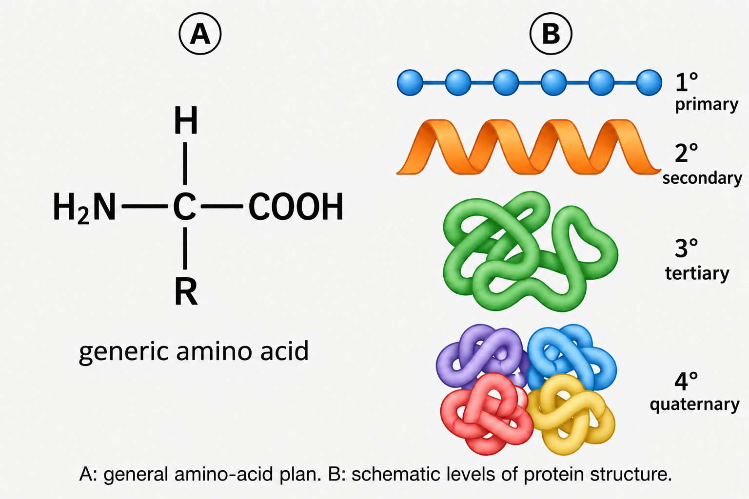
Figure 5. Generic amino acid and levels of protein structure
118. I am the monomer from which proteins are built. What am I? __________
119. I am the covalent bond that links amino acids into a polypeptide. What am I? __________
120. I am the reaction that forms peptide bonds while removing the equivalent of water. What am I? __________
121. I am the reaction that breaks peptide bonds by adding water. What am I? __________
122. I am the variable part of an amino acid that determines many of its chemical properties. What am I? __________
123. I am one of the three broad AP-relevant categories of amino-acid R groups: I avoid water. What category am I? __________
124. I am one of the three broad AP-relevant categories of amino-acid R groups: I interact favorably with water but may be uncharged. What category am I? __________
125. I am one of the three broad AP-relevant categories of amino-acid R groups: I carry a positive or negative charge. What category am I? __________
126. I am the level of protein structure defined by the linear sequence of amino acids. What am I? __________
127. I am the level of protein structure produced by local folding of the polypeptide backbone into alpha helices and beta pleated sheets. What am I? __________
128. I am the level of protein structure that describes the overall three-dimensional shape of a single polypeptide. What am I? __________
129. I am the level of protein structure produced when multiple polypeptide subunits interact. What am I? __________
130. I stabilize alpha helices and beta pleated sheets through interactions involving atoms of the polypeptide backbone. What am I? __________
131. I can stabilize tertiary protein structure when nonpolar R groups cluster away from water. What interaction am I? __________
132. I can stabilize tertiary structure through attraction between oppositely charged R groups. What interaction am I? __________
133. I am a strong covalent link that may form between sulfur-containing side chains and stabilize protein structure. What am I? __________
134. I am the loss of a protein's normal three-dimensional shape caused by changes such as extreme temperature or pH. What process am I? __________
135. I am the central AP Biology principle that explains why changing a protein's shape can change or eliminate its function. What principle am I? __________
136. A mutation changes one amino acid in a protein, potentially altering folding and function. Which level of structure is changed first? __________
137. If hydrogen bonding in a polypeptide backbone is disrupted, which level of structure is most directly affected? __________
138. If several polypeptide subunits can no longer interact, which level of protein structure is most directly affected? __________
139. If hydrophobic interactions among R groups are disrupted, which level of structure is likely to change directly? __________
140. In Figure 5A, the letter R represents which part of an amino acid? __________
141. In Figure 5B, the straight sequence labeled 1° represents which level of protein structure? __________
142. In Figure 5B, the local helix-like shape labeled 2° represents which level of protein structure? __________
143. In Figure 5B, the folded single-chain shape labeled 3° represents which level of protein structure? __________
144. In Figure 5B, the multi-subunit arrangement labeled 4° represents which level of protein structure? __________
145. I am a protein whose biological activity depends on a specific three-dimensional active-site shape. What broad class of biomolecule am I? __________
146. A high fever can alter the weak interactions maintaining a protein's shape. What process may result if the shape is lost? __________
147. A change in pH can change the charges on amino-acid R groups and disrupt folding. Which kinds of R-group interactions are especially sensitive to these charge changes? __________
Section G - Nucleic Acids
Write the term that best matches each clue.
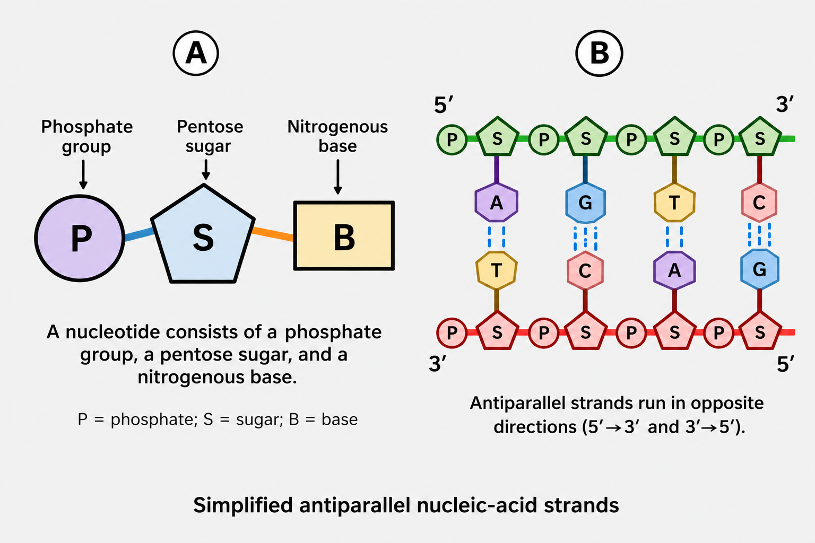
Figure 6. Nucleotide components and antiparallel strand orientation
148. I am the monomer of DNA and RNA. What am I? __________
149. I am one of the three components of every nucleotide and can be ribose or deoxyribose. What am I? __________
150. I am one of the three components of every nucleotide and contribute negative charge to the nucleic-acid backbone. What am I? __________
151. I am one of the three components of every nucleotide and carry variable genetic information through my sequence. What am I? __________
152. I am the nucleic acid that usually stores hereditary information in cells. What am I? __________
153. I am the nucleic acid that contains ribose and uses uracil rather than thymine. What am I? __________
154. I am the covalent linkage joining nucleotides in the sugar-phosphate backbone. What am I? __________
155. I am the end of a nucleic-acid strand defined by a free phosphate associated with the fifth carbon of the sugar. What end am I? __________
156. I am the end of a nucleic-acid strand defined by a free hydroxyl group associated with the third carbon of the sugar. What end am I? __________
157. During nucleic-acid synthesis, new nucleotides are added to me. Which end of the growing strand am I? __________
158. I describe the opposite orientation of the two DNA strands, with one running 5' to 3' and the other 3' to 5'. What term am I? __________
159. I am the nitrogenous base found in DNA but not RNA. Who am I? __________
160. I am the nitrogenous base found in RNA but not DNA. Who am I? __________
161. I am a nitrogenous base found in both DNA and RNA and pair with thymine in DNA or uracil in RNA. Who am I? __________
162. I am a nitrogenous base found in both DNA and RNA and pair with cytosine in DNA. Who am I? __________
163. I am a nitrogenous base found in both DNA and RNA and pair with guanine in DNA. Who am I? __________
164. I am the weak interaction that helps hold complementary DNA bases together across the two strands. What am I? __________
165. I am the sequence of nucleotide monomers that encodes biological information. What kind of macromolecule am I? __________
166. I differ from RNA because my sugar lacks one oxygen atom compared with ribose. What sugar am I? __________
167. I am the five-carbon sugar found in RNA. What am I? __________
168. In Figure 6A, the circle marked P represents which nucleotide component? __________
169. In Figure 6A, the pentagon marked S represents which nucleotide component? __________
170. In Figure 6A, the rectangle marked B represents which nucleotide component? __________
171. In Figure 6B, the two strands run in opposite directions. What term describes this orientation? __________
172. A nucleic-acid strand has a free 3' hydroxyl at one end. What end is this? __________
173. A nucleic-acid strand has a free 5' phosphate at one end. What end is this? __________
174. I am the strong covalent backbone of DNA and RNA, made of alternating sugar and phosphate components. What structure am I? __________
175. I am the principle that explains how the order of nucleotide monomers can store information that is later used by living systems. What broad AP Biology idea am I? __________
Alignment reference: College Board AP Biology Course and Exam Description, effective Fall 2025, Unit 1: Chemistry of Life.

