**Instructions to rebuild the Hardware**

Project

Judith Samlow, Sergej Maltsev, Pavel Povolni

November 2024

Content

1 Preamble 3

2 Hardware 3

2.1 Assembly Robot 3

2.2 Assembly PCB’s 4

2.2.1 General 4

2.2.2 Implemented Functions 5

2.2.3 CAD PCB 5

2.2.4 Assembly PCB 5

2.2.5 Wiring inside the Case 5

2.3 Assembly Case for Electronics 6

2.3.1 Case 6

2.3.2 CAD 6

2.3.3 Front Connections 6

2.3.4 Back connections 7

2.3.5 Wiring 7

3 Software 7

3.1 Arduino / C++ 7

3.2 PC / Python 7

# Preamble

As part of the low-field MRI research at our institute, the already known positioning robot „COSI Measure“ was rebuilt in 2023-2024 as part of several bachelor theses:

<https://www.opensourceimaging.org/project/cosi-measure/>

The mechanical design was a bit adapted to our needs, which is more or less a bit bigger measured Volume and a bit higher efficiency of the robot size.

The biggest change to published work was a redesign of the electronics part:

In contrast to the Beagle Bone Black with embedded Linux used back than with the original robot, we have chosen a much simpler design:

* The central µC is an Arduino MEGA. It controls the motors, evaluates the limit switches and communicates with a host PC via a serial interface
* A Python script runs on the host PC, which controls the mapping, serially communicates the new position to be approached by the robot and simultaneously communicates with a Hall sensor

In our case, the F.W. BELL Series 9900 Hall sensor with the ZOA99-3208 3D Hall probe was used. This sensor also has a serial output, which was evaluated with the running Python script.

In principle, however, this setup should allow the integration of any other sensor.

This work was presented and published as a conference paper:

Samlow J, Maltsev S, Buckenmaier K, Scheffler K, Povolni P (2024) Easy Rebuildable Cubic 3-Axis Positioning Robot Based on Open-Source Hardware: Validated via Camera-Based Motion Tracking and Initial Application in Magnetic Low Field Mapping. DACH-ISMRM 2024 Program & Proceedings. Tübingen, Germany, pp 1–2

# Hardware

## Assembly Robot

The assembly of the robot with all CAD design files & instructions is very well described and documented:

<https://www.opensourceimaging.org/project/cosi-measure/>

<https://github.com/opensourceimaging/cosi-measure/tree/master/Mechanical%20System>

Therefore, we refer at this point to the original Github. The used hardware of the drive and place to order them is also described there

However, we used the following parts for the 3D Drive (which is maybe important regarding the build PCB. However, it should be possible to attach any similar drive)

We used:

* Motor: NEMA23 60HS88, 3 pieces   
  No longer available, but this type should work just as well: <https://www.reichelt.de/hybridschrittmotor-nema-23-1-8-4-2-a-2-52-v-act-23hs9440-26-p316758.html?&trstct=pos_6&nbc=1>
* Motor driver: ACT DM542, 3 pieces  
  Link: <https://www.reichelt.de/schrittmotortreiber-fuer-nema-23-18-50-v-act-dm542-p237924.html?&trstct=pos_1&nbc=1>
* Limit Switch: LJ12A3-4-Z/BX DC6-36V, 3 pieces  
  Link: <https://www.roboter-bausatz.de/p/induktiver-sensor-lj12a3-4-z-bx-dc6-36v?number=RBS11420>
* Power source:   
  36V, 9.75A (350W)  
  Link: <https://www.reichelt.de/schaltnetzteil-geschlossen-351-w-36-v-9-75-a-mw-uhp-350-36-p256082.html?&trstct=pol_6&nbc=1>

## Assembly PCB’s

### General

In our version of COSI Measure, an Arduino Mega was used as the central microcontroller (µC).

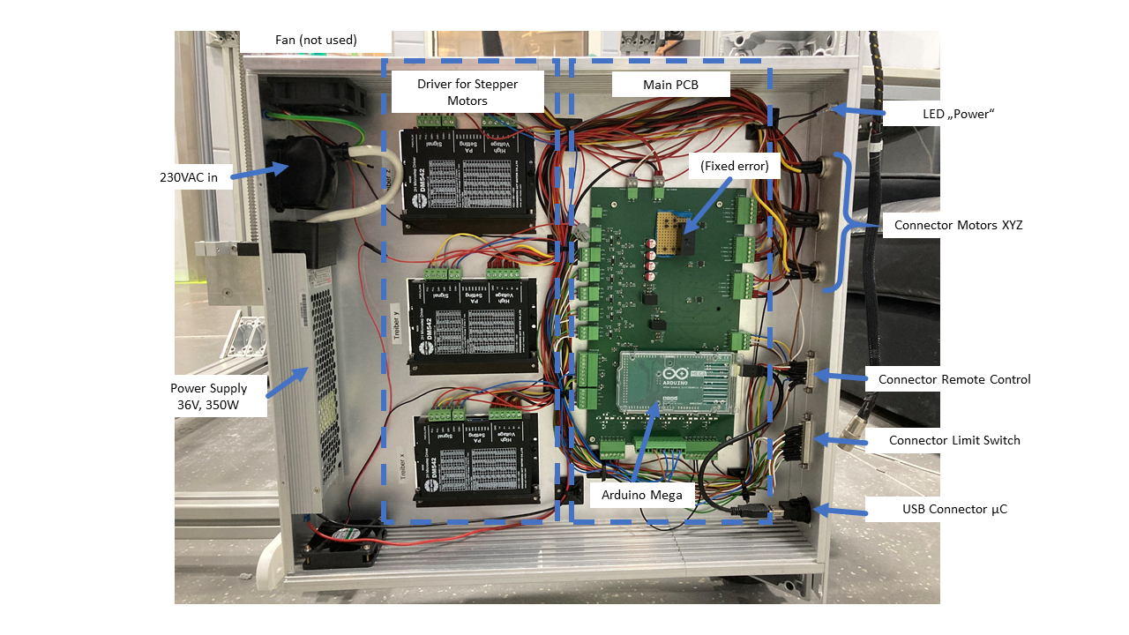

There were a few errors in the built circuit board (V1.0) that were fixed during the assembly of our robot. However, we fixed these errors in the V2.0 circuit board, which we made available here.

A two-part concept was developed.

In addition to the main PCB, a remote control was built that could be used to manually change the position of the Hall sensor. The connection of the buttons, encoders, etc. is still present in the hardware and can be used again without any problems. In the option presented here, the remote control was deactivated and no longer used. The same task was done using the software control in the running Python script.

If necessary, you can design the remote control according to your own needs and connect it to the 26-pin SubD connector in the case.

### Implemented Functions

* Control of 3 stepper motors via PWM signals
* Safety circuit: both the µC and an emergency stop disconnect the power supply to the motor drivers
* I2C output, e.g. for a display
* Serial communication (USB) with host PC
* Other analog inputs/outputs are available and can be used e.g. for additional sensors

### CAD PCB

The PCB was designed with the free software KiCad 8. No further packages are necessary. Comments in the schematic should explain the design.

For easy soldering of the PCB, all SMD components are selected as large as possible, e.g. SMD1206 for resistors and capacitors.

If you wish you can change that and adapt the footprints to the sizes you want. Then you would need to relayout the PCB

The PCB is designed in two layers to keep manufacturing costs low. The board size can be significantly reduced by adapting the footprints and possibly also by reducing the number of connectors required.

The BoM of all components is included in the attached Excel list.

### Assembly PCB

The assembly should not be a major problem due to the large component sizes that were chosen.

The Arduino Mega is simply plugged onto the soldered pin headers and can thus be easily replaced if necessary.

A cutout is provided in the circuit board at the location of the LED so that the built-in LED of the Arduino can be seen I mounted state

### Wiring inside the Case

Die Platine, das Netzteil, sowie die 3 Motortreiber sind alle im selben Gehäuse verbaut. Die Verkabelung ist durch die beschrifteten Stecker auf der Platine einfach möglich.

Es wurden Phönix 3.81mm Leiterplattenverbinder genutzt. Die Kabel können so einfach in den Schraubklemmen befestigt werden.

ACHTUNG!

Das Netzteil wird mit 230V betrieben! 230VAC sind lebensgefährlich!

Daher beschreiben wir die elektrische Verbindung zwischen Spannungseingang und Netzteil nicht!

Sucht euch für diesen Teil einen erfahrenen Elektriker mit entsprechender Ausbildung!

Denkt daran das Gehäuse zu erden und nur an einer FI-geschützten Steckdose zu betreiben!

The PCB, the power supply and the three motor drivers are all installed in the same case. The wiring cab be easily done through the labeled connectors on the PCB.

Phoenix 3.81mm PCB connectors were used. The needed wires can be easily attached to the screw terminals.

ATTENTION!

The power supply is operated at 230V!

230VAC is extremely dangerous!

Therefore, we do not describe the electrical connection between the voltage input and the power supply!

For this part, find an experienced electrician with the appropriate training!

Remember to ground the housing and only operate it on a FI-protected socket!

## Assembly Case for Electronics

### Case

The case is a standard 19-inch case with a side profile of 2 height units. The side profiles, front and back panels, top and bottom panels were milled by us in your mechanical workshop.

The front and back should be milled for best results.

At the same time, however, it is also possible to create the mounting holes by hand. Special accuracy is not required (in this case, pay attention to the mounting of the DSub connector).

We had also installed two 12V fans in our case to cool the internal electronics if necessary. This was not needed in the end and the fans were never on.

The motor drivers are mounted on the base plate, with the cooling fins of the drivers protruding through the base to the outside, in order to dissipate the heat. From experience, we think that this is not necessary and that a simpler design is possible with the drivers inside the case

### CAD

The CAD of the case was created in Autodesk Inventor 2022. All files were exported in Step-files and should be able to be imported in any CAD program.

The side profiles are only hinted at here!

These side profiles are sold on meter basis and can be cut by you to your desired size…. Depending on which electronics you have installed in the case.

### Front Connections

All parts that are built into the front are listed in the BoM list

* USB:   
  USB socket connected to the Arduino Mega (connection to the PC for serial communication)
* Limit switches: 25-pin Sub-D, male  
  Connection option for the built-in limit switches in the robot:  
  3 axes with 2 limit switches each = 6 sensors  
  Each sensor has 3 pins (+/-/sens) -> 18 pins in total
* Remote control: 26-pin Sub-D, female  
  Connection for a remote control (e.g. buttons directly to the Arduino's digital in pins, display/encoder via I2C)
* Motor X: 4-pin, DIN, male  
  Connection of the X-axis, 2-phase motor used (A+-/B+-)
* Motor Y 4pin, DIN, male  
  Connection of the Y-axis, 2-phase motor used (A+-/B+-)
* Motor Z: 4pin, DIN, male  
  Connection of the Z-axis, 2-phase motor used (A+-/B+-)
* Power: LED with socket  
  In our case, simply connected to the 36V output of the power supply with a series resistor. Indication of whether the power supply is switched on.   
  Could also be used to indicate the power supply to the motor drivers (thus acting as an indicator for the safety circuit consisting of the µC and emergency stop switch)
* Emergency Stop:  
  emergency stop switch that allows the user to immediately disconnect the power to the motor drivers via a relay. In our case, the emergency stop is installed on the remote control. However, it can also be easily integrated into this housing.

### Back connections

* 230V IEC plug with on/off switch and main fuse (1.75A, slow blow is sufficient).

### Wiring

Die Verkabelung ist durch die beschrifteten Stecker auf der Platine einfach möglich und sollte kein größeres Problem darstellen.

Das hängt auch sehr davon ab, was alles im Gehäuse verbaut worden ist.

Falls es Fragen gibt meldet euch einfach bei uns

The wire is easily possible through the labeled connectors on the board and should not be a major problem. It also depends on what has been installed in your housing.

If there are any questions, just contact us.

# Software

## Arduino / C++

## PC / Python