Gone I might be, yet these nimble words I do expect to meet your fair eyes.

I thought mailing a letter post leaving would really cement my status as an eccentric person (as if I needed any additional evidence). I’ve had a lot of time to reflect over the last week about my experience here, and I’ve come to the (unsurprising) conclusion that the friendships I’ve made were my favorite aspect of GS.

I hope we stay in touch, I’m pretty bad communication (at least so says my internal review), but no doubt with a little effort we can make it happen :D

**Good luck tech support girl.**

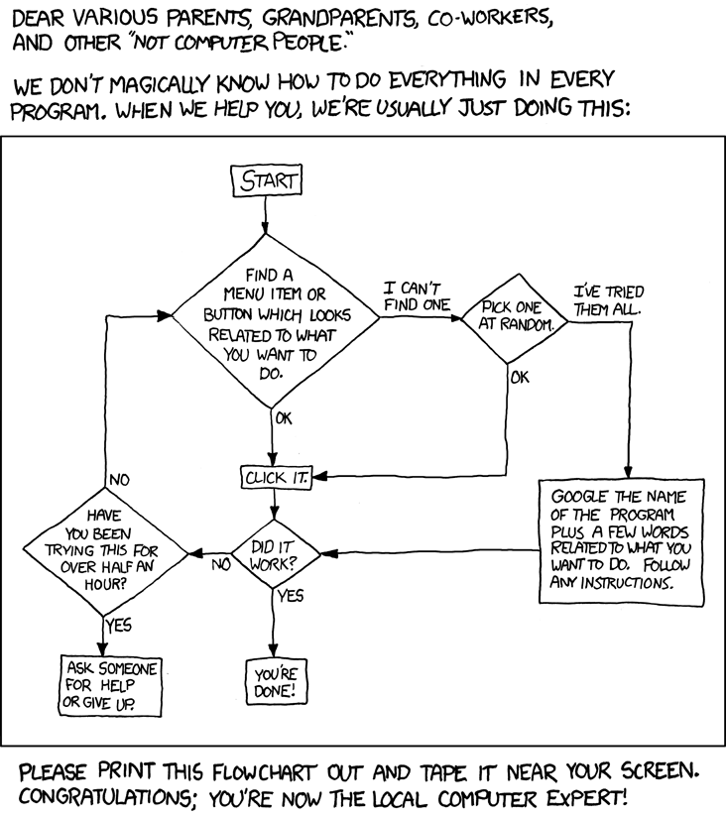

Also you better be inviting me to your future Mastrianni-Swain engagement party (see Beyoncé’s “single ladies” :P

Your friend always,