***Introduction to the Data***

The project is based on a survey on four mental health disorders: Anxiety, Depression, Insomnia and Obsessive-Compulsive Disorder or in short words OCD, for the survey.

To get an idea of ​​how the data moves around the four mental health disorders in this project, you can refer to the following donut charts images:

Figure 2

Figure 1

In the donut chart figure 1, you can see the percentage distribution for different age groups of people in the survey, as we can see that most of the people are under 30 years of age.

For the second chart figure 2, we reflect the percentage of the favorite type of music according to the votes of those surveyed, as we can see most of the percentage leans towards Pop and Rock.

Note, the age of less than 10 wasn’t included because the survey doesn’t apply to people at these ages.

With the above information it will be easier to understand the entire context of the questions raised during the implementation of the project.

Q.2

To understand the research on mental problems, one of the questions chosen was: Are there significant differences in mental health rankings based on age groups for those who frequently listen to specific genres?

Now to understand this question and the following ones, we must first understand the distribution of diseases by age, for this reason we create the below leaderboard that shows the averages according to the group ages. But before presenting it, it is important to mention that to create the leaderboard, the ages were grouped into ranges of 10 and then the percentage of each mental problem from total number of the ranking obtained.

Note that for the ranking the people identified their own numbers, where 0 meant nothing and 10 was extremely high, there was no explicit information clarifying how these numbers were obtained.

By grouping the ages into groups of 10, the averages of Anxiety, Depression, Insomnia and OCD, it became easier to visualize the information that was obtained during the survey, since it was observed that there is a relationship between the ages and levels of mental problems, like you can see on the next stacked bar chart.

In the bar chart we can observe the indicators for the average mental illness by age range and is easy to compare the differences between the different mental problems and how they are moving around the ages.

As a first indicator over all we have that the highest numbers for mental problems are before the age of 40, but at the same time in this range we can see that the higher number is on ages between 20-29, the reasons could be all the changes happening during that time of the life, like work, education, economic issues, marital status, etc. We can also see that at the age of over 30 years, these numbers start decreasing, but the biggest drop is after the 50s, which could be because people’s lives are more stable.

Site: <https://www.ncbi.nlm.nih.gov/pmc/articles/PMC7441973/>

Now doing a more specific review we can see that there are sudden changes between 30 and 49 years of age in the problem of insomnia, which is very stable at other ages, but then after the 50s start decreasing. One of the limitations in this research is that as we saw at the start of the project the mayor number of people is less than 30, this may be an indicator that the numbers came out high because the people who took the survey probably had sleeping problems, but since there were very few of them and the very high ranking made it reflect higher than normal, other research suggests that the People start to have problems sleeping after 50.

Site: <https://www.ncbi.nlm.nih.gov/pmc/articles/PMC5847293/>

Returning to another point about the graph for OCD, we do not see a big difference in the chart since this mental problem has been studied since 1980, and according to the results, this problem is presently diagnosed in people between 14 and 35 years old. You can see from the graph that this is true.

One more thing to add is that since this disease mentioned in the previous paragraph is not very common among the others, that is, it is new, some people confuse it with other mental problems such as anxiety or hyperactivity, due to these situations we cannot be 100% sure that the information obtained during the survey be totally accurate.

To present the percentages of mental problems, a pie chart was created to observe the distribution of the percentages of the ranking of the entire survey, this only to make it more visible which mental problem was classified as highest in the survey. This graph was not included in the presentation as it was more important to emphasize comparisons between ages and types of problem.

As we can see in the previous graph, the people who took this survey have a higher percentage of Anxiety and it is easily observed that the least mental problem is OCD, probably because of what was mentioned above.

Now that we review mental health problems and how they present according to age, we can understand the following scatter diagrams that reflect the relationship between ages and diseases with the favorite types of music in the survey.

To explain the range of mental health related to age and favorite type of music, you can see the color bar on the right side of each graph, the blue color represents a low range of illness, as the color becomes pinker, the disease worsens. Within the graph, if the color is closer to pink, the level of mental problem is higher.

Each of the graphs represents a different mental problem, look at the title for more information.

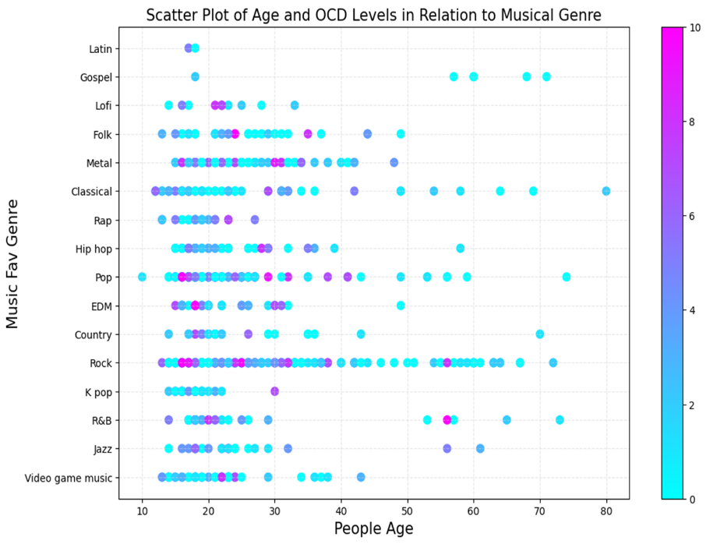

With the Anxiety graph, the pink colors are easy to observe in Metal, Pop, Rock and Video Games music, this means that the range is higher compared to other types of music, the same happens with Depression and Insomnia, the results are like those of Anxiety. For these three diseases, the range is higher in ages under 30, but for people over 40, we have lower disease ranges. The above is probably due to personal tastes in the type of music.

Alluding to the above, this could also be due to the fact that, as we see at the beginning of the presentation, the survey was completed by more people with ages close to 20 years old and their favorite music may be different from this one.

Finally, for the OCD graph, the figures remain quite low, which indicates that music does not have much effect on this problem or has a positive effect, all depending on what perspective you look at, although we observe some quite high outliers in Folk, Metal, Pop, EDM and Rock.

After analyzing all the information from the survey with the objective of making a correlation between two variables in the process, we realized that the correlations are weak with almost all the data since the results are subjective. It was decided to select two different examples in order to present two different cases of correlation, as will be seen below.

The first regression is very weak, which means that there is no correlation between age and the number of hours a day we listen to music, that is, everything depends on the personal taste of each person, which does not mean that if you are 20 years old you are going to listening to more hours of music than a person who is 50, also as a point to note we do not know when people are listening to music, that is, they may listen to more hours of music due to the type of work or simply for pleasure.

In the second graph we can see a stronger negative correlation because, as we saw at the beginning of the presentation, the rates of anxiety and depression decrease as we age, it is a clear example to be able to observe the relationship between mental problems and age. Some outliers can be observed but as mentioned before we cannot confirm 100% that the information is correct, due to the lack of information of how the survey was carried out.