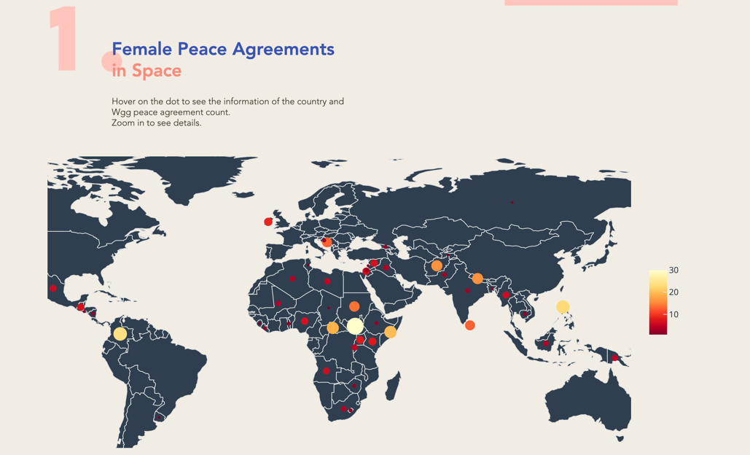

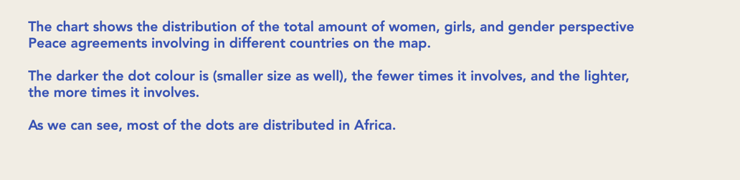

The first chart shows the distribution of the total number of women, girls and gender perspective peace agreements involving in different countries on the world map.

The darker the dot color is (smaller size as well), the fewer times it involves, and the lighter the dot color is (bigger size as well), the more times it involves. We choose the darker color to represent the fewer times it involves, and the lighter color to represent the more times it involves, since the light dots are clearer on our dark-color world map.

It can be seen from the map that most of the dots are distributed in Africa, which means that Africa has the most peace agreements. The African Union Commission mentions in its 2016 report that there had been many long-term armed conflicts and domestic and border wars in Africa since the Cold War ended, that many civilians, especially women and children, became refugees due to armed conflicts, and they were flooded out of their shelters and had health problems due to poor nutrition, and that women suffered heavy casualties in exile and sexual violence, and some of them were ruthlessly used and sacrificed as weapons of the wars. Because of the long-term violent conflicts in Africa, African stakeholders and organizations have been promoting international attention to addressing issues of women in armed conflicts in Africa (African Union Commission 2016). According to Gbowee (2019), women’s active participation in peace processes can make a significant difference in the effectiveness and longevity of peace agreements. Building sustainable peace entails wider participation in the establishment of solutions (Bell &amp; McNicholl, 2019). That is why Africa involves more in wgg peace agreements than any other regions of the world.

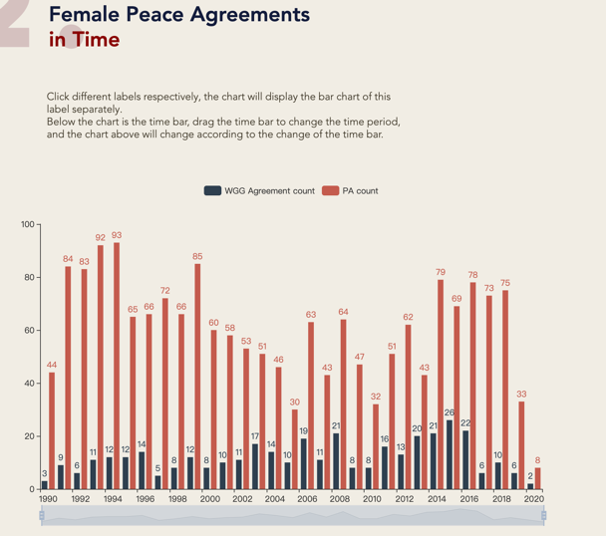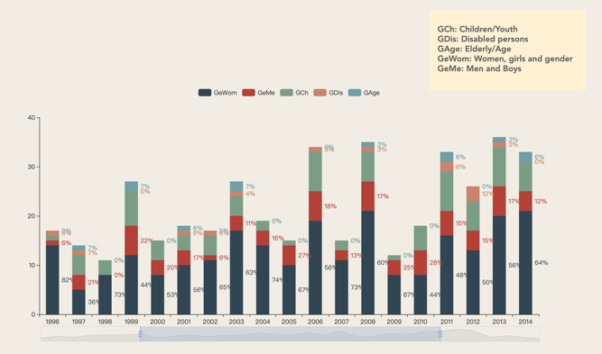

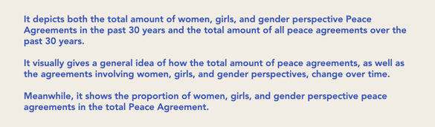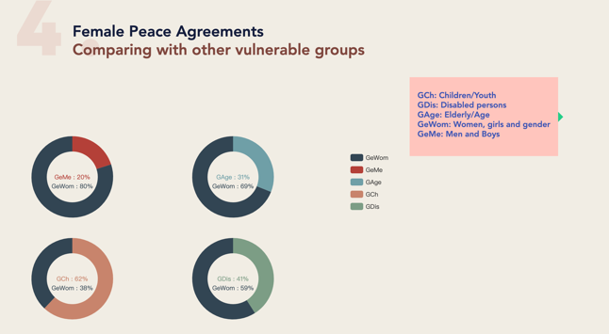

The chart on the left side above displays the total number of wgg perspective peace agreements and the total number of peace agreements, respectively, over the past 30 years spanning from 1990 to 2020.

We put two different data values in the same table and use the contrasting colors red and navy blue to help the audience compare the data visually, which can more clearly show the differences between the numbers.

The chart shows that gender perspective peace agreements make up only a small portion of the total peace agreements, but a larger one as compared to other vulnerable groups.

The left chart presents that the references to gender in peace agreements have slowly increased since 1990. From 2000 to 2008, while the total number of peace agreements declined, the total number of gender perspective peace agreements still increased slightly. Bell and O'Rourke (2019) stated that the rate of including references to women in agreements had accelerated and the references to women in various forms were higher than before since the signing of UN Security Council Resolution 1325 on October 31, 2000. This might possibly explain the continued increase in references to women since 2000, but they also considered it difficult to verify whether these changes were caused by Resolution 1325 or social progress and development over time (Bell &amp; McNicholl, 2019).

From the chart on the left side, we can also see that 2015 marked the peak of the number of references to women in agreements, more than 8 times the number of references in 1990. Visibly, references to women and gender in agreements in all forms have been more prevalent over time, and those were impossible in 1990. As can be seen from the data, however, women have relatively low participation in the making of peace agreements in any form.