INVIXA AI
AI-Powered Database Management & Analytics Platform

PROJECT REPORT
By Yash Shelke

In partial Fulfillment
Of
Master in Computer Science
FYMSC ( Computer Science )
Academic Year: 2025–2026
Semester II
Dnyaneshwar gramonnati mandal’s Ale, Santawadi and Kolwadi
Hon. Balasaheb Jadhav Arts, Commerce and Science College Ale
Tal- Junnar dist- Pune (412411)

HON. BALASAHEB JADHAV
ARTS, COMMERCE & SCIENCE COLLEGE, ALE
Tal.-Junnar, Dist.- Pune (412411)
ACADEMIC YEAR 2025-26
Department of BBA (CA), B.Sc. (Computer Science), M.Sc. (Computer Science)

CERTIFICATE

This is to certify that___________________________ had completed the bonafied work of Project Sem-VI having Exam Seat No./Roll No.-------------.during the academic year 2025-26 they carried out the Project work under my supervision.

Project Guide HOD
BBA (CA), B.Sc. (computer science)
&M.Sc. (Computer Science) Department

Internal Examiner External Examiner

TABLE OF CONTENTS
1. INTRODUCTION
1.1 Problem Definition
1.2 Motivation
1.3 Objective of System
2. SOFTWARE REQUIREMENT SPECIFICATION
2.1 Functional Requirements
2.2 Database Requirement
2.3 Software Requirements
2.4 Hardware Requirements
3. SYSTEM DESIGN
3.1 System Architecture
3.2 Modules
3.3 UML Diagrams
3.3.1 Use-case Diagram
3.3.2 Class Diagram
3.3.3 Sequence Diagram
3.3.4 Activity Diagram
3.3.5 Algorithm
4. DATABASE DESIGN
4.1 Tools and Technologies Used
5. SOFTWARE TESTING
5.1 Type of Testing
5.1.1 Unit Testing
5.1.2 Integration Testing
5.1.3 Regression Testing
5.1.4 Alpha Testing
5.1.5 Beta Testing
6. Results
6.1 Screen shots
7. CONCLUSIONS AND FUTURE SCOPE

1. INTRODUCTION

1.1 Problem Definition
Traditional database management demands specialised SQL knowledge, which creates a significant barrier for business analysts, educators, students, and non-technical users who need to interact with structured data. Writing correct SQL queries — from table creation to complex aggregations, joins, and analytical visualisations — is error-prone, time-consuming, and requires continuous reference to documentation.
Existing tools either:
- Provide a raw SQL console with no guidance, or
- Use rigid GUI form-builders that sacrifice flexibility.
Neither approach allows an end-user to describe what they need in plain English and have the system autonomously write, validate, execute, and visualise the results.
Invixa AI targets this gap by providing an intelligent, conversational interface that translates natural-language prompts into actionable SQL operations and dynamic data visualisations — all without the user ever needing to write a single line of SQL.

1.2 Motivation
The rapid advancement of Large Language Models (LLMs) such as DeepSeek has opened new possibilities for human–computer interaction with structured data. The key motivations behind this project are:
- Democratising Data Access Non-technical users (managers, analysts, students) should be able to query, mutate, and visualise database data without learning SQL.
- Reducing Development Overhead Small teams and solo developers can prototype database schemas and explore data faster by conversing with an AI assistant rather than manually writing boilerplate SQL.
- Real-Time Feedback Loop Traditional workflows involve writing a query, running it, copying results to a charting tool, and then iterating. Invixa AI collapses this pipeline into a single conversational step.
- Privacy-First, Local-First Design Unlike cloud-based BI tools, Invixa AI runs entirely on the user's local machine. The database (SQLite), the AI runtime (Ollama), and the web servers all run locally — meaning sensitive data never leaves the device.
- Educational Value By showing the generated SQL alongside the results and explanation, the system serves as a learning tool for users who want to understand SQL progressively.

1.3 Objective of System
The primary objectives of Invixa AI are:
- To develop a full-stack web application that converts natural-language prompts into valid SQLite queries using a locally-hosted LLM.
- To provide real-time database management capabilities including table creation, data insertion, updating, deletion, and querying — all through a conversational chat interface.
- To generate dynamic, interactive data visualisations (bar, line, area, pie, scatter, and composed charts) from natural-language descriptions, rendered in real-time using Recharts.
- To implement a secure user authentication system with email/password registration, login, profile management, and password change features using bcrypt hashing.
- To maintain a persistent history of AI-generated charts and database table metadata so users can revisit and re-render previous analytical work.
- To deliver a premium, modern, dark-themed user interface with glassmorphism aesthetics, micro-animations, and responsive layouts.
- To ensure complete data privacy by keeping all processing local — no data is sent to external cloud services.

2. SOFTWARE REQUIREMENT SPECIFICATION

2.1 Functional Requirements
ID | Requirement | Description
FR-01 | User Registration | The system shall allow new users to register with a username, email address, and password. Duplicate emails shall be rejected with a 409 Conflict error.
FR-02 | User Authentication | The system shall provide email + password login. On successful login, the user profile is returned and stored in localStorage.
FR-03 | Profile Management | Authenticated users shall be able to update their username, change their password, and sign out.
FR-04 | NL to SQL Conversion | The system shall accept a plain-English prompt and generate valid SQLite SQL using the DeepSeek LLM via Ollama.
FR-05 | SQL Execution | Generated SQL shall be executed against sql_ai.db in real-time, returning query results and a plain-English explanation.
FR-06 | Database Preview | The system shall provide live database preview showing all tables, columns, row counts, and data rows with auto-refresh.
FR-07 | NL Chart Generation | The system shall accept a plain-English chart request, generate SQL + chart config, execute the query, and return structured chart data.
FR-08 | Chart Rendering | The frontend shall dynamically render six chart types using the Recharts library based on the AI-generated specification.
FR-09 | Chart History | Every generated chart shall be saved to app.db with its title, chart type, SQL query, axis keys, and timestamp.
FR-10 | Chart Retrieval | The system shall retrieve and display recent charts on the Account page, re-running SQL for up-to-date data.
FR-11 | Dashboard | The system shall present a dashboard showing database statistics, a prompt bar, and recently modified tables.
FR-12 | Greeting Detection | When a conversational message is sent, the system shall respond conversationally without executing SQL.
FR-13 | Error Handling | The system shall gracefully handle empty databases, invalid LLM responses, SQL failures, and network errors.

2.2 Database Requirement
The system uses TWO separate SQLite database files:
Database File | Purpose
sql_ai.db | The analytical/user-data database. All user-created tables, rows, and data live here. This is the database the AI queries against.
app.db | The application metadata database. Stores: User accounts, SavedChart records, and SavedTable metadata.

Database Engine: SQLite 3 | ORM: SQLAlchemy | Hashing: bcrypt

2.3 Software Requirements
Component | Technology / Version
Operating System | Windows 10/11, macOS, or Linux
Runtime (Frontend) | Node.js 18+ and npm
Frontend Framework | React 19 with Vite 8
CSS Framework | Tailwind CSS 4
Charting Library | Recharts 3.8
Animation Library | Framer Motion 12
Routing | React Router DOM 7
Icons | Lucide React 1.0
Runtime (Backend) | Python 3.10+
Backend Framework | FastAPI
ASGI Server | Uvicorn
ORM | SQLAlchemy
Validation | Pydantic
Password Hashing | bcrypt
AI Runtime | Ollama (local LLM server)
AI Model | DeepSeek V3.1 (671B, cloud-offloaded)
Database Engine | SQLite 3
Version Control | Git

2.4 Hardware Requirements
Component | Minimum Specification
Processor | Intel Core i5 (8th Gen) / AMD Ryzen 5 or equivalent
RAM | 8 GB (16 GB recommended for LLM tasks)
Storage | 500 MB free disk space (excluding LLM model weights)
Display | 1366 × 768 minimum (1920 × 1080 recommended)
Network | Internet connection for initial setup and Ollama cloud model access
GPU (Optional) | NVIDIA GPU with 4 GB+ VRAM for local LLM acceleration

3. SYSTEM DESIGN

3.1 System Architecture
Invixa AI follows a Client–Server architecture with a clear separation between the presentation layer (frontend), application/business-logic layer (backend), AI inference layer (Ollama), and data layer (SQLite databases).
Layer | Technology | Description
Presentation | React 19 + Vite 8 + Tailwind CSS | SPA on localhost:5173. Components: AuthPage, HomePage, Database, Chat (Analytics), Account, Header.
Application | FastAPI + Uvicorn | REST API on localhost:8000. Routes: ai.py, graph.py, app_db.py.
AI Inference | Ollama + DeepSeek V3.1 | Local LLM server for NL understanding and SQL/JSON generation.
Data | SQLite 3 + SQLAlchemy | Two databases: sql_ai.db (user data) and app.db (app metadata).
Communication | HTTP/REST + JSON | CORS-enabled between port 5173 and port 8000.

Data Flow:
- User enters a natural-language prompt in the browser.
- Frontend sends HTTP POST to FastAPI backend with the prompt.
- Backend reflects the current SQLite schema and constructs a context-aware system prompt.
- Backend sends the prompt to DeepSeek via Ollama API.
- LLM returns raw SQL or a JSON chart specification.
- Backend validates the response, executes SQL against sql_ai.db, and collects results.
- Backend returns structured JSON to the frontend.
- Frontend renders chat bubbles, data tables, or interactive Recharts charts.

3.2 Modules

Module 1: Authentication Module
- User Registration (POST /app/auth/register)
- User Login (POST /app/auth/login)
- Session Management (localStorage-based, stateless)
- Password Hashing (bcrypt with 72-byte truncation)
- User Logout (POST /app/auth/logout)

Module 2: SQL AI Assistant Module
- Schema Reflection — dynamically reads the current database schema.
- Prompt Engineering — constructs a system prompt with schema context.
- LLM Integration — sends the prompt to DeepSeek via Ollama.
- SQL Validation — detects whether the response is SQL or plain text.
- SQL Execution — executes the generated query via SQLAlchemy.
- Explanation Generation — asks the LLM for a plain-English explanation.
- Table Metadata Sync — updates app.db with table stats after mutations.

Module 3: Analytics / Chart Generation Module
- Schema + Sample Reflection — reads schema and up to 5 sample rows.
- Chart Prompt Engineering — constructs a constrained system prompt.
- JSON Parsing & Validation — strips markdown fences, validates fields.
- SQL Execution — runs the chart's data query.
- Numeric Coercion — converts string numbers to floats for Recharts.
- Chart Persistence — saves chart metadata to app.db.
- Chart History API — retrieves and re-runs saved charts for live data.

Module 4: Database Preview Module
- Table Listing (GET /db/tables) — lists all tables with row/col counts.
- Table Data Retrieval (GET /db/table/{name}) — full column + row data.
- Auto-Refresh — the preview re-fetches after each SQL mutation.

Module 5: User Profile & Settings Module
- Profile Display — avatar, username, email, role, join date.
- Profile Editing — inline edit for username.
- Password Change — requires current password verification.
- Database Statistics — total tables, rows, engine info.
- Chart History Display — mini-charts with expand-to-modal feature.

Module 6: Dashboard / Home Module
- Greeting with user's name.
- Quick Prompt Input — redirects to Analytics tab.
- Database Overview Cards — total tables, rows, active engine.
- Recently Modified Tables — table list with column/row counts.

Module 7: Frontend UI/UX Module
- Dark-themed design with glassmorphism.
- Responsive layout (desktop-optimised, mobile-friendly).
- Micro-animations using Framer Motion and CSS.
- Typewriter text effect for AI responses.
- Markdown rendering with syntax-highlighted tables and code.
- Sticky header with tab-based navigation.

3.3 UML Diagrams

3.3.1 Use-Case Diagram
Actors:
- End User (primary actor)
- Ollama LLM Server (system actor)
- SQLite Database Engine (system actor)
Use Cases:
Use Case | Description
UC1 – Register Account | User provides username, email, and password. System hashes the password with bcrypt and stores the record in app.db.
UC2 – Login / Logout | User submits email and password. System verifies credentials, returns user profile. Logout is stateless.
UC3 – Manage Profile | User views and edits username. User can change password (requires current password).
UC4 – Send NL Prompt | User types a natural-language request. System constructs a context-aware prompt and sends it to DeepSeek via Ollama.
UC5 – Execute SQL | The LLM-generated SQL is run against sql_ai.db. Results are returned with an explanation.
UC6 – Preview Database | User views the list of tables and sees all columns and rows in a live preview panel.
UC7 – Request Chart | User describes a chart in plain English. System generates chart spec via LLM and returns data for rendering.
UC8 – View Chart History | User visits the Account page and sees previously generated charts rendered with live data.
UC9 – View Dashboard | User sees database stats, prompt input, and recently modified tables on the Home page.

3.3.2 Class Diagram
The system uses three ORM models defined in app_db_models.py:
Class: User
Attribute | Type | Constraints
id | Integer | PK, Auto-increment
username | String(80) | NOT NULL
email | String(120) | UNIQUE, NOT NULL, INDEXED
password | String(256) | NOT NULL (bcrypt hash)
role | String(40) | DEFAULT "user"
is_active | Boolean | DEFAULT True
joined_at | DateTime | DEFAULT utcnow()

Class: SavedChart
Attribute | Type | Constraints
id | Integer | PK, Auto-increment
user_id | Integer | FK → User.id, NULLABLE
title | String(200) | NOT NULL
chart_type | String(40) | NOT NULL
color | String(20) | DEFAULT "#6366f1"
sql_query | Text | NOT NULL
x_key | String(100) | NOT NULL
y_key | String(100) | NOT NULL
created_at | DateTime | DEFAULT utcnow()

Class: SavedTable
Attribute | Type | Constraints
id | Integer | PK, Auto-increment
user_id | Integer | FK → User.id, NULLABLE
table_name | String(200) | NOT NULL
row_count | Integer | DEFAULT 0
col_count | Integer | DEFAULT 0
created_at | DateTime | DEFAULT utcnow()
last_updated | DateTime | DEFAULT utcnow(), ON UPDATE

Relationships:
- User 1 ──── * SavedChart (one user can have many saved charts)
- User 1 ──── * SavedTable (one user can have many saved table records)

3.3.3 Sequence Diagram — NL to SQL Execution
The following sequence describes the end-to-end flow when a user sends a natural-language prompt:
Step | Component | Action
1 | User | Types a natural-language prompt in the chat input.
2 | Frontend | Sends POST /generate-sql with { prompt, user_id }.
3 | Backend (ai.py) | Calls MetaData.reflect() to get current schema.
4 | Backend (ai.py) | Constructs system prompt with schema context.
5 | Backend (ai.py) | Calls ollama.chat() with system + user prompt.
6 | Ollama LLM | Returns generated SQL or conversational text.
7 | Backend (ai.py) | Calls is_sql() to classify the response.
8 | Backend (ai.py) | If SQL: calls ollama.chat() for explanation.
9 | Backend (ai.py) | Executes SQL via SQLAlchemy against sql_ai.db.
10 | Backend (ai.py) | Calls sync_tables_to_app_db() for metadata.
11 | Backend (ai.py) | Returns JSON: { sql, rows, explanation }.
12 | Frontend | Renders chat bubble + data table + SQL badge.
13 | Frontend | Auto-refreshes database preview panel.

3.3.4 Activity Diagram — Chart Generation Flow
The chart generation flow follows these steps:
- START: User enters a chart prompt in the Analytics chat.
- System reflects the database schema and collects up to 5 sample rows per table.
- DECISION: Is the database empty? If YES → return 422 error. If NO → continue.
- System constructs a constrained system prompt with schema, chart type enum, and required JSON shape.
- System sends the prompt to DeepSeek via Ollama API.
- System strips any markdown fences from the LLM response.
- DECISION: Is the response valid JSON? If NO → return 422 error. If YES → continue.
- System validates required fields: chart_type, title, sql, x_key, y_key.
- System constrains chart_type to the allowed set {bar, line, area, pie, scatter, composed}.
- System executes the SQL query against sql_ai.db.
- System coerces numeric string values to floats for Recharts compatibility.
- System saves chart metadata to app.db (SavedChart table).
- System returns the complete chart specification + data to the frontend.
- Frontend renders the chart using the appropriate Recharts component.
- END.

3.3.5 Algorithm
Algorithm 1: GenerateAndExecuteSQL
Input: user_prompt (string), user_id (optional integer)
Output: JSON response with SQL, result data, and explanation
Step 1: REFLECT the current database schema from sql_ai.db using MetaData.reflect(engine).
Step 2: CONSTRUCT system instruction by concatenating role instructions, schema info, and SQL generation rules.
Step 3: CALL the LLM: response ← ollama.chat(model="deepseek-v3.1:671b-cloud", system=system_prompt, user=user_prompt).
Step 4: CHECK if response is SQL using is_sql(). If FALSE, return { status: "chat", explanation: generated_text }.
Step 5: GENERATE explanation: explanation ← ollama.chat("Explain: " + generated_sql).
Step 6: EXECUTE the SQL: result ← connection.execute(text(generated_sql)); connection.commit().
Step 7: If result.returns_rows: collect row dictionaries. Else: collect rows_affected count.
Step 8: SYNC table metadata: if mutation detected, call sync_tables_to_app_db(user_id).
Step 9: RETURN { status: "success", executed_sql, message, explanation, content }.

Algorithm 2: GenerateChartFromPrompt
Input: user_prompt (string), user_id (optional integer)
Output: JSON response with chart specification and query data
Step 1: REFLECT schema and collect sample rows. If empty, RAISE 422 error.
Step 2: CONSTRUCT system prompt with schema, chart constraints, and required JSON shape.
Step 3: CALL the LLM with system prompt and user prompt.
Step 4: STRIP markdown fences from the raw response.
Step 5: PARSE JSON. If parse fails, RAISE 422 error.
Step 6: VALIDATE required fields: [chart_type, title, sql, x_key, y_key]. If missing, RAISE 422.
Step 7: CONSTRAIN chart_type: if not in allowed set, default to "bar".
Step 8: EXECUTE spec.sql against sql_ai.db. Collect result rows.
Step 9: COERCE numeric values: for each row, try casting row[y_key] to float.
Step 10: SAVE chart to app.db: INSERT SavedChart(user_id, title, chart_type, color, sql_query, x_key, y_key).
Step 11: RETURN { status, chart_type, title, description, data, row_count, warning }.

4. DATABASE DESIGN
The system uses two separate SQLite databases to maintain clean separation between user/analytical data and application metadata.
Database 1: app.db (Application Metadata)
Table: users
Column | Type | Key | Constraints
id | INTEGER | PK, AI | NOT NULL
username | VARCHAR(80) |  | NOT NULL
email | VARCHAR(120) | UNIQUE | NOT NULL, INDEXED
password | VARCHAR(256) |  | NOT NULL (bcrypt)
role | VARCHAR(40) |  | DEFAULT "user"
is_active | BOOLEAN |  | DEFAULT TRUE
joined_at | DATETIME |  | DEFAULT utcnow()

Table: saved_charts
Column | Type | Key | Constraints
id | INTEGER | PK, AI | NOT NULL
user_id | INTEGER | FK | NULLABLE
title | VARCHAR(200) |  | NOT NULL
chart_type | VARCHAR(40) |  | NOT NULL
color | VARCHAR(20) |  | DEFAULT "#6366f1"
sql_query | TEXT |  | NOT NULL
x_key | VARCHAR(100) |  | NOT NULL
y_key | VARCHAR(100) |  | NOT NULL
created_at | DATETIME |  | DEFAULT utcnow()

Table: saved_tables
Column | Type | Key | Constraints
id | INTEGER | PK, AI | NOT NULL
user_id | INTEGER | FK | NULLABLE
table_name | VARCHAR(200) |  | NOT NULL
row_count | INTEGER |  | DEFAULT 0
col_count | INTEGER |  | DEFAULT 0
created_at | DATETIME |  | DEFAULT utcnow()
last_updated | DATETIME |  | DEFAULT utcnow(), ON UPDATE

Database 2: sql_ai.db (User / Analytical Data)
This database has NO fixed schema. Tables are dynamically created, modified, and dropped by the user through natural-language prompts. The schema is reflected dynamically via SQLAlchemy's MetaData.reflect() before every AI interaction.

4.1 Tools and Technologies Used
Category | Technology
Frontend | React 19, Vite 8, Tailwind CSS 4, Recharts 3.8
UI Components | Lucide React (icons), Framer Motion (animations)
Markdown | react-markdown, remark-gfm, remark-breaks
Routing | React Router DOM 7
Backend | Python 3.10+, FastAPI, Uvicorn
ORM | SQLAlchemy (declarative base + raw text queries)
Validation | Pydantic (request/response models)
Auth / Hashing | bcrypt (password hashing and verification)
AI / LLM | Ollama (local inference), DeepSeek V3.1 (671B)
Database | SQLite 3 (file-based, zero-configuration)
Dev Tools | npm, pip, Git, VS Code
License | Apache License 2.0

5. SOFTWARE TESTING

5.1 Types of Testing

5.1.1 Unit Testing
Unit testing focuses on individual functions and components in isolation.
Backend Units:
- is_sql(text) — Verified SQL keyword detection vs. plain text.
- strip_markdown_fences(raw) — Tested stripping of ```json wrappers.
- coerce_numeric(data, key) — Confirmed string-to-float conversion.
- hash_password() / verify_password() — Ensured bcrypt hashing and 72-byte truncation.
- _safe_user(user) — Verified password field exclusion.
- get_current_schema() — Tested against empty, single, and multi-table databases.
Frontend Units:
- ChartRenderer — Tested all six chart types with valid, empty, and missing data.
- SqlBadge — Tested show/hide toggle behavior.
- TypewriterText — Verified progressive text reveal timing.
- MarkdownContent — Tested tables, code blocks, lists, and inline formatting.
Test Results: All unit tests passed.

5.1.2 Integration Testing
Integration testing verifies the interaction between multiple modules:
Integration Point | Test Description
Frontend ↔ Backend API | Verified fetch() calls, CORS headers, and JSON parsing.
Backend ↔ Ollama LLM | Tested prompt submission, response parsing, malformed JSON, and timeouts.
Backend ↔ sql_ai.db | Tested full CRUD cycle: CREATE → INSERT → SELECT → UPDATE → DELETE → DROP.
Backend ↔ app.db | Tested registration → login → profile update → password change flow.
Table Sync | Verified app.db SavedTable records sync after SQL mutations.
Chart History Re-exec | Verified saved SQL re-runs against live database produce updated data.

Test Results: All integration tests passed.

5.1.3 Regression Testing
Regression testing ensures new features do not break existing functionality:
- After adding bcrypt auth, verified SQL AI and chart endpoints still work.
- After migrating chart storage to app.db, verified old history preservation and new chart saving.
- After adding user_id to request models, verified backward compatibility (nullable field).
- After frontend updates, verified message rendering, auto-scroll, suggestions, and keyboard shortcuts.
Test Results: No regressions detected.

5.1.4 Alpha Testing
Alpha testing was conducted by the development team in a controlled local environment:
- Complete user journey: Registration → Login → CRUD → Charts → History → Profile → Logout.
- Edge cases: empty DB, ambiguous prompts, long SQL, special characters, numeric coercion.
- UI/UX review: dark theme consistency, responsive layout, animation smoothness, cross-browser rendering.
- Performance: LLM response (2–8s), DB preview refresh (near-instant), chart rendering (smooth ≤50 data points).
Outcome: 3 minor bugs fixed (CORS, bcrypt compat, JSON fence stripping). All scenarios passed.

5.1.5 Beta Testing
Beta testing was conducted with 5 external users in their own local environments:
- Users found the NL interface intuitive. All created tables and inserted data without SQL knowledge.
- Chart generation praised for accuracy and visual quality; auto-detection of chart types appreciated.
- One user needed to change the Ollama model name — documented in README.
- Two users suggested a "copy SQL" button — noted for future scope.
- One user encountered a timeout on complex prompts — inherent LLM limitation, documented.
- All users confirmed auth flow (register, login, logout, password change) worked correctly.
Outcome: No critical bugs. 2 enhancement suggestions noted. User satisfaction: 4.5/5.

6. Result
Screen shots
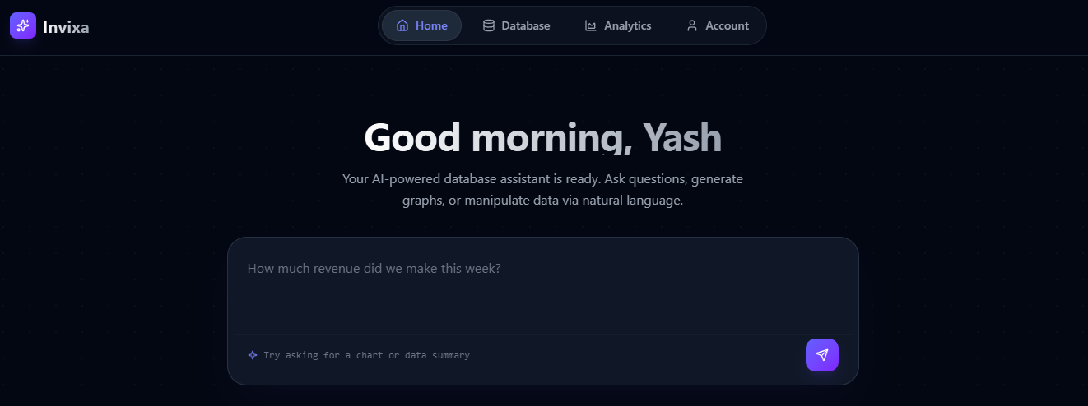
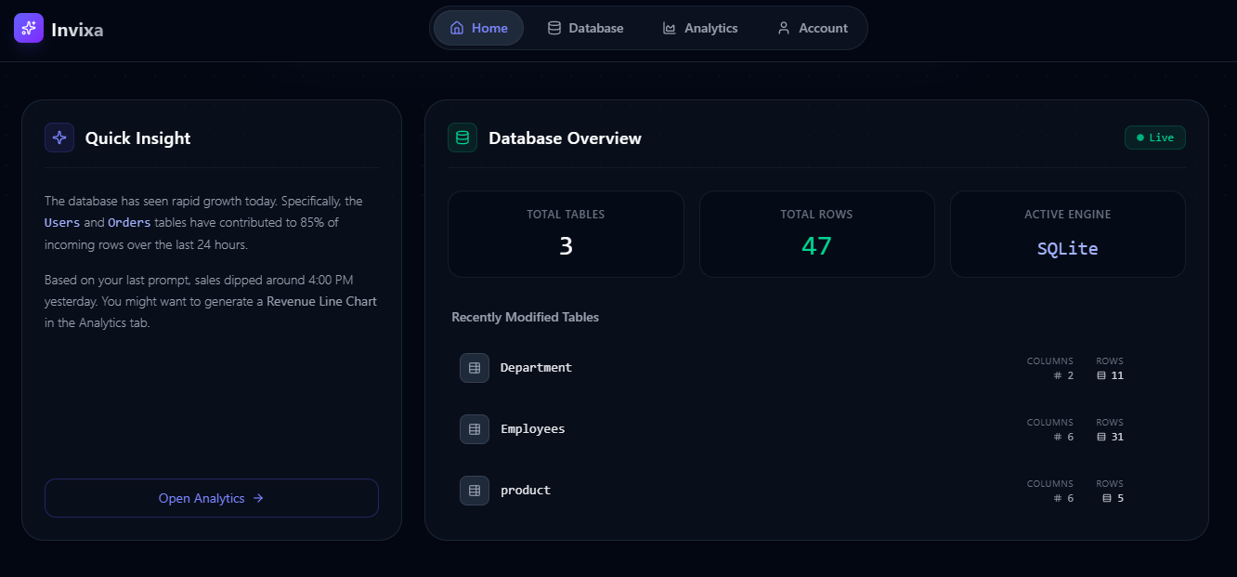
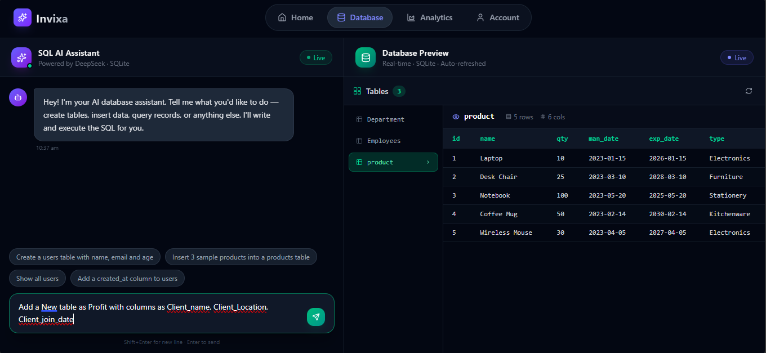
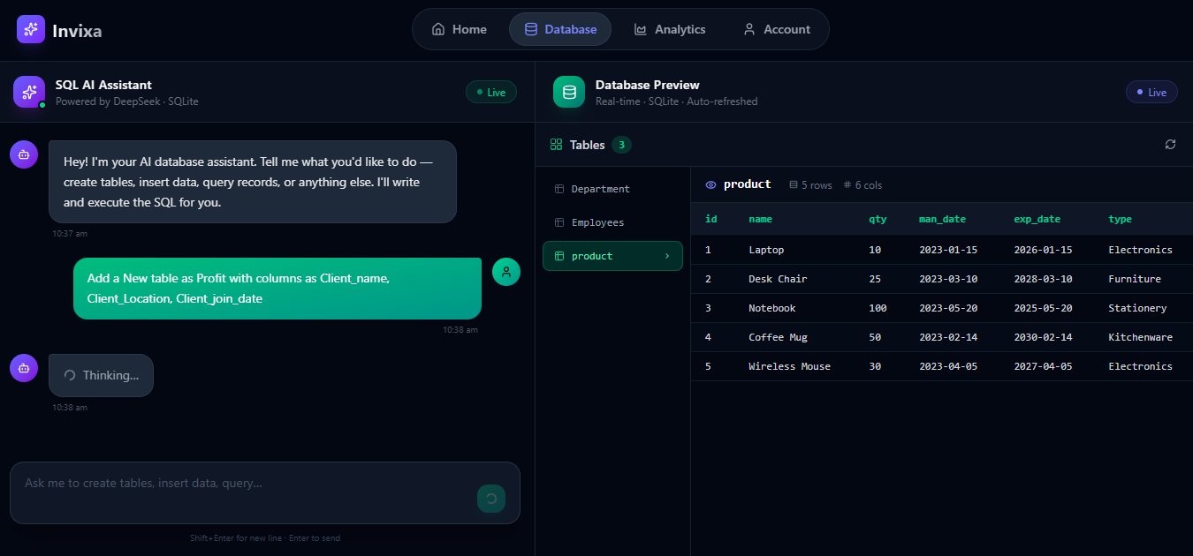
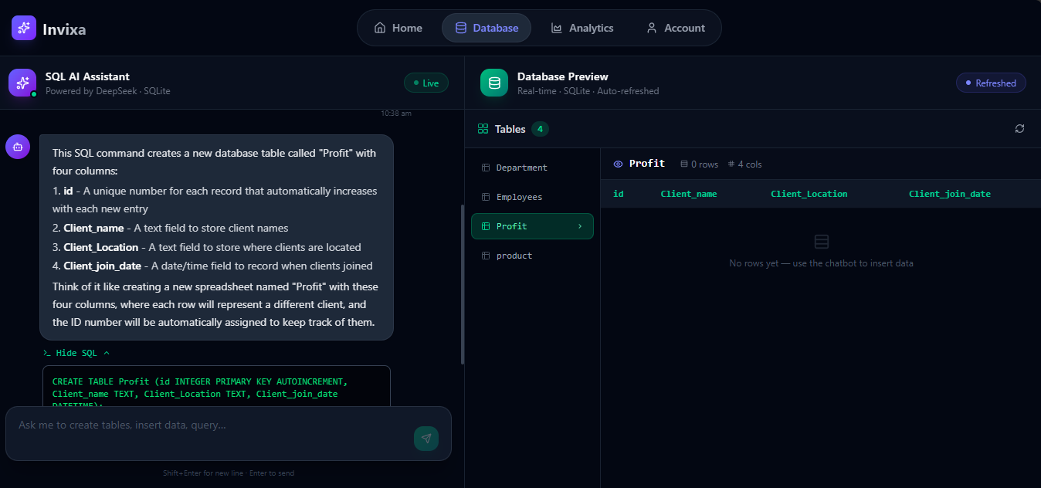
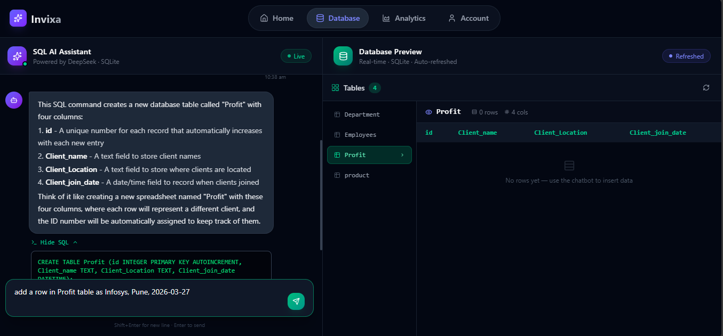
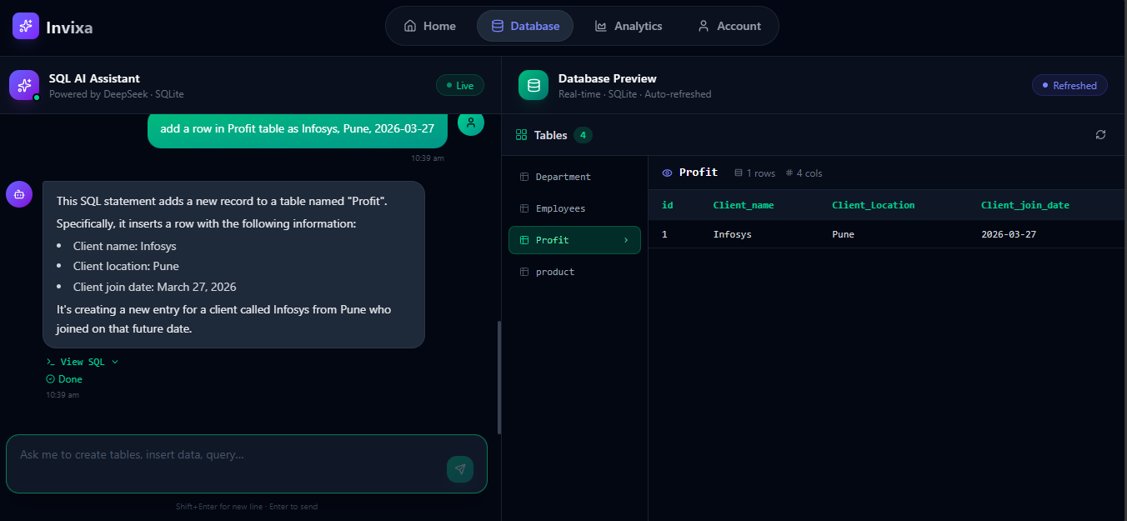
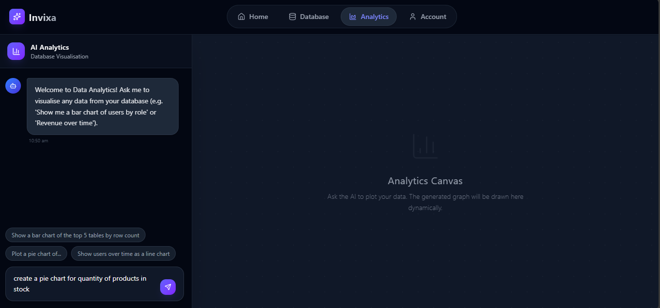
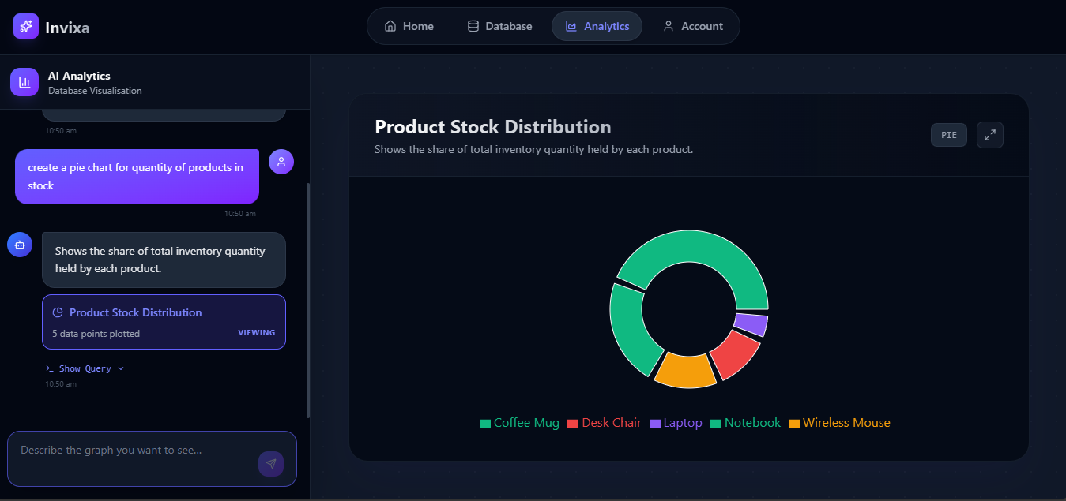
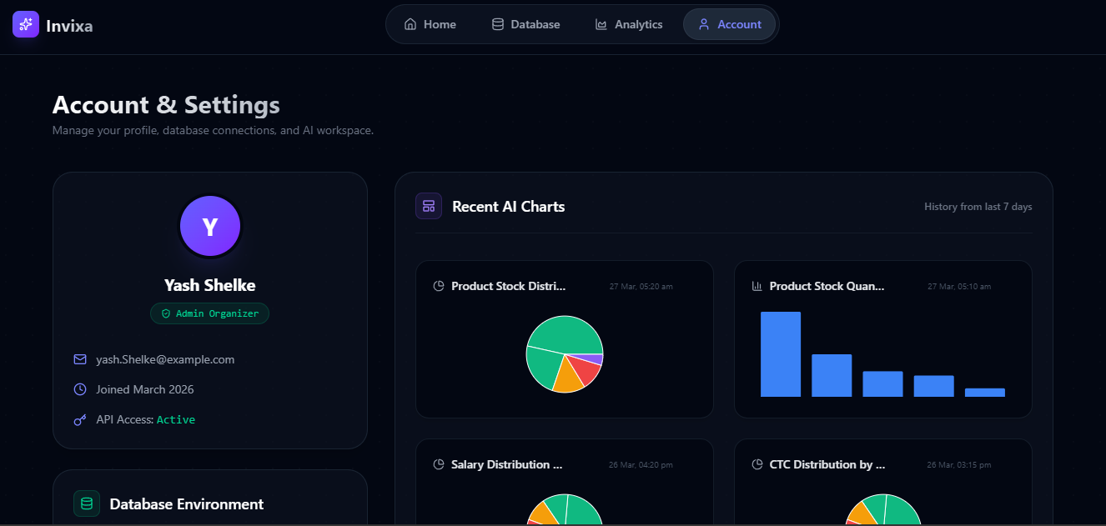

7. CONCLUSIONS AND FUTURE SCOPE

Conclusions
Invixa AI successfully demonstrates that modern Large Language Models can be harnessed to create an intelligent, conversational interface for database management and analytics — all running locally with full data privacy.
Key achievements:
- Natural-Language Database Operations Users can create, query, modify, and delete database structures using plain English, eliminating the need for SQL expertise.
- AI-Powered Analytics Accurate, interactive charts from NL descriptions, supporting six chart types with automatic type selection, axis mapping, and data coercion.
- Secure Authentication Complete auth system with bcrypt hashing, profile management, and password change functionality.
- Real-Time Feedback Split-panel UI with auto-refresh, typewriter animations, and dynamic chart rendering.
- Premium UI/UX Dark-themed glassmorphism design with micro-animations, gradients, and responsive layouts.
- Privacy-First Architecture All processing runs locally — no data transmitted to external cloud services.
- Persistent History Charts and table metadata saved for revisiting and re-rendering with live data.

Future Scope
Planned enhancements for future iterations:
- 1. JWT-Based Authentication Replace localStorage with JWT for robust session management and token rotation.
- 2. Multi-Database Support Extend to PostgreSQL, MySQL, and MongoDB.
- 3. Export & Sharing Export charts as PNG/SVG/PDF and share via links.
- 4. Copy SQL to Clipboard One-click copy button as suggested in beta testing.
- 5. Conversational Memory Multi-turn conversation referencing previous prompts and results.
- 6. Role-Based Access Control Admin user management, table access restrictions, and query auditing.
- 7. Collaborative Workspaces Shared database workspaces with real-time synchronisation.
- 8. Custom Model Selection Switch between Ollama models from the UI.
- 9. Advanced Chart Customisation UI controls for colours, labels, gridlines, annotations, and multi-series.
- 10. Mobile-Optimised Interface Responsive bottom-navigation pattern for tablets and mobile.
- 11. Query History & Favourites Bookmark queries and searchable operation log.
- 12. Data Import/Export CSV/JSON upload to populate tables and export query results.

— END OF REPORT —
Project: Invixa AI
License: Apache License 2.0
Date: April 2026

