**Introduction**

Welcome to ME! My projects, my education, my portfolio, and my future in coding and programming.

I am here for web site development and design and companies needing new employees.

**What’s Different**

Complete newbie with a 4.0 and passion for learning more. Coming from a zero-based computer back ground I am now very interested in UI/UX interfaces as well as front end development and design in general. Future interest in AR and continuing end user focus.

**Who’s Looking**

1. Hiring manager looking for entry level talent
2. Co-workers looking to give advice
3. Someone willing to take a chance on a newly minted graduate
4. A company looking to train into their mold
5. Colleagues looking for collaboration

**What I want you know:**

A new graduate looking for work in web development and design

1. Quick learner
2. Dedicated
3. Drive
4. Ambition
5. Passion

**Font choices:** I chose Kaushan Script because I thought it was a personal touch that is a hand scripted looking font, but still easy to read as the letters do not tough or blur together like a cursive font would. I would use that for main headers or titles. The second font is more of a print but is also clean enough that the letters aren’t touching but it isn’t as standard or boring as things like Ariel or Helvetica. It would be used for the lengthier texts, like <p>.

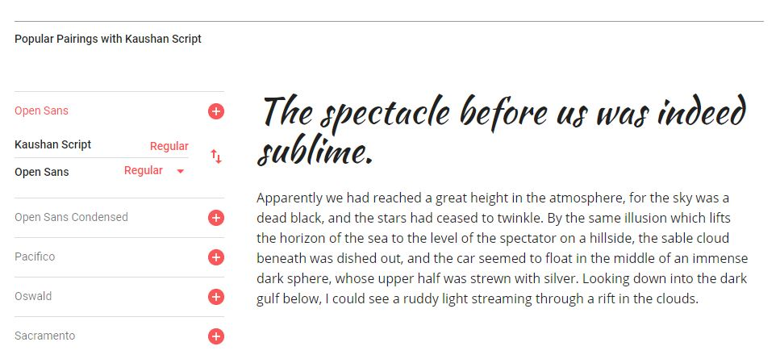

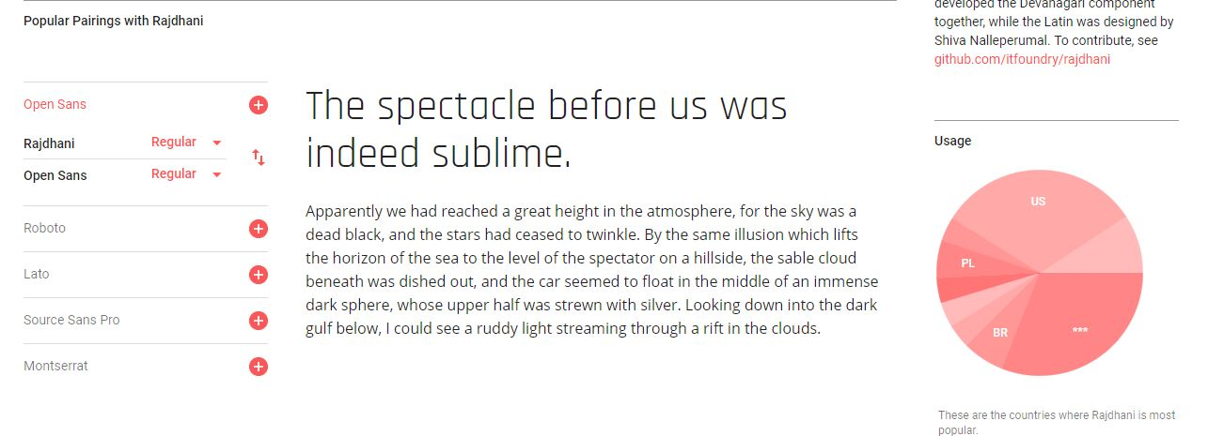

**Colors:** Shades of blue are my favorite colors, which is why I think they should be incorporated into a site that puts me on display. They also work well with white and black as backgrounds and accents.

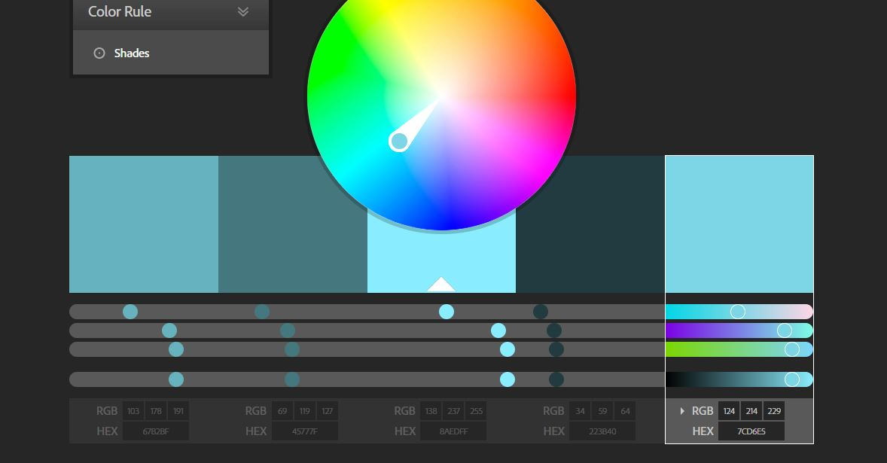

**Visually:** Smooth, clean, images, fonts, and feel. A single page site that makes you want to keep scrolling. Hero photos and colors will be captivating and engaging. Examples below:

