|  |  |  |  |
| --- | --- | --- | --- |
| **MODE OF TRANSPORT** | **EMISSIONS**  **[kg CO2e/pers.-km]** | **Notes** | **Reference** |
| IC3 Diesel | 0.022 | Based on DSB | [Cowi](https://www.dsb.dk/globalassets/om-dsb/baeredygtighed/miljo/sammenligning-af-emmisionsfaktorer_cowi-rapport-til-dsb_okt-2023.pdf) |
| IC4 Diesel | 0.028 | Based on DSB | [Cowi](https://www.dsb.dk/globalassets/om-dsb/baeredygtighed/miljo/sammenligning-af-emmisionsfaktorer_cowi-rapport-til-dsb_okt-2023.pdf) |
| **Train Diesel average** | **0.025 (0.090)** | 63.4 (45) % in DK (EU) | [Cowi](https://www.dsb.dk/globalassets/om-dsb/baeredygtighed/miljo/sammenligning-af-emmisionsfaktorer_cowi-rapport-til-dsb_okt-2023.pdf) ([NAVIT](https://www.navit.com/resources/bus-train-car-or-e-scooter-carbon-emissions-of-transport-modes-ranked)), [EU stats](https://ec.europa.eu/eurostat/statistics-explained/index.php?title=Characteristics_of_the_railway_network_in_Europe), [DK stats](https://uk.bane.dk/en/Projects/Electrification-Programme), |
| IR4 El | 0.0041 | Based on DSB. | [Cowi](https://www.dsb.dk/globalassets/om-dsb/baeredygtighed/miljo/sammenligning-af-emmisionsfaktorer_cowi-rapport-til-dsb_okt-2023.pdf) |
| EB+DD El | 0.0024 | Based on DSB | [Cowi](https://www.dsb.dk/globalassets/om-dsb/baeredygtighed/miljo/sammenligning-af-emmisionsfaktorer_cowi-rapport-til-dsb_okt-2023.pdf) |
| S-train | 0.0027 | Based on DSB | [Cowi](https://www.dsb.dk/globalassets/om-dsb/baeredygtighed/miljo/sammenligning-af-emmisionsfaktorer_cowi-rapport-til-dsb_okt-2023.pdf) |
| **Train electric average** | **0.00307 (0.033-0.058)** | 36.6 (55) % in DK (EU) | [Cowi](https://www.dsb.dk/globalassets/om-dsb/baeredygtighed/miljo/sammenligning-af-emmisionsfaktorer_cowi-rapport-til-dsb_okt-2023.pdf) ([NAVIT](https://www.navit.com/resources/bus-train-car-or-e-scooter-carbon-emissions-of-transport-modes-ranked)) |
| DK train average |  |  |  |
| Long-distance bus | 0.031 (0.02) | EU (DK) | [Cowi](https://www.dsb.dk/globalassets/om-dsb/baeredygtighed/miljo/sammenligning-af-emmisionsfaktorer_cowi-rapport-til-dsb_okt-2023.pdf) ([NAVIT](https://www.navit.com/resources/bus-train-car-or-e-scooter-carbon-emissions-of-transport-modes-ranked)) |
| Average petrol car | 0.129 (0.122) **(0.1779)** | Petrol (diesel)  (klimakompasset) | [Cowi](https://www.dsb.dk/globalassets/om-dsb/baeredygtighed/miljo/sammenligning-af-emmisionsfaktorer_cowi-rapport-til-dsb_okt-2023.pdf) |
| Electric car | 0.015 **(0.0188)** | Depends on electricity type (Klimakompasset) | [Cowi](https://www.dsb.dk/globalassets/om-dsb/baeredygtighed/miljo/sammenligning-af-emmisionsfaktorer_cowi-rapport-til-dsb_okt-2023.pdf) |
| Domestic flight | **0.246** | Estimated length of single domestic flight: (238 + 156) / 2 = 197 km  (Aalborg or Aarhus) | [ourworldindata](https://ourworldindata.org/travel-carbon-footprint) |
| Short-haul flight | **0.151** | Less than 1500 km | UK government |
| Medium-haul flight | **0.1495** | 1500 km > and < 3000 km |  |
| Long-haul flight | **0.148** | More than 3000 km | [Why long-haul is better pr/km than short](https://theicct.org/sites/default/files/publications/ICCT_CO2-commercl-aviation-2018_20190918.pdf) |
| Stopovers (additional) | Additional **29 %** for long distance |  | [stopovers](https://climateactionaccelerator.org/solutions/direct_flights/) |
| Ferries as passenger on foot | **0.915** | Estimated ferry travel distance: (62.3 + 69) / 2 = 65.65 km  (Ebeltoft or Aarhus) | [Cowi](https://www.dsb.dk/globalassets/om-dsb/baeredygtighed/miljo/sammenligning-af-emmisionsfaktorer_cowi-rapport-til-dsb_okt-2023.pdf) |
| Ferries (with a car) | 0.109 |  | [Cowi](https://www.dsb.dk/globalassets/om-dsb/baeredygtighed/miljo/sammenligning-af-emmisionsfaktorer_cowi-rapport-til-dsb_okt-2023.pdf) |



# DATA

* Data is only for half a year
* Underrepresenting Greenland field season
* Missing 25 % response rate (more, if we consider that some of the people who answered that they did not travel might have travelled but cant remember or did not want to fill out the survey)
* Likely to miss some actual business travels as only relying on the memory of the respondents.
* Estimates on electric/petrol car
* Emission factors: We need better estimates – e.g. from the emission groups – for more accurate calculations
* No knowledge of where stopovers are. Should preferably be a trip separated in short-haul; stopover; long-haul (or however the trip is carried out).

NATIONAL TRAVELS

## NUMBER OF TRAVELS, DISTANCES AND EMISSIONS

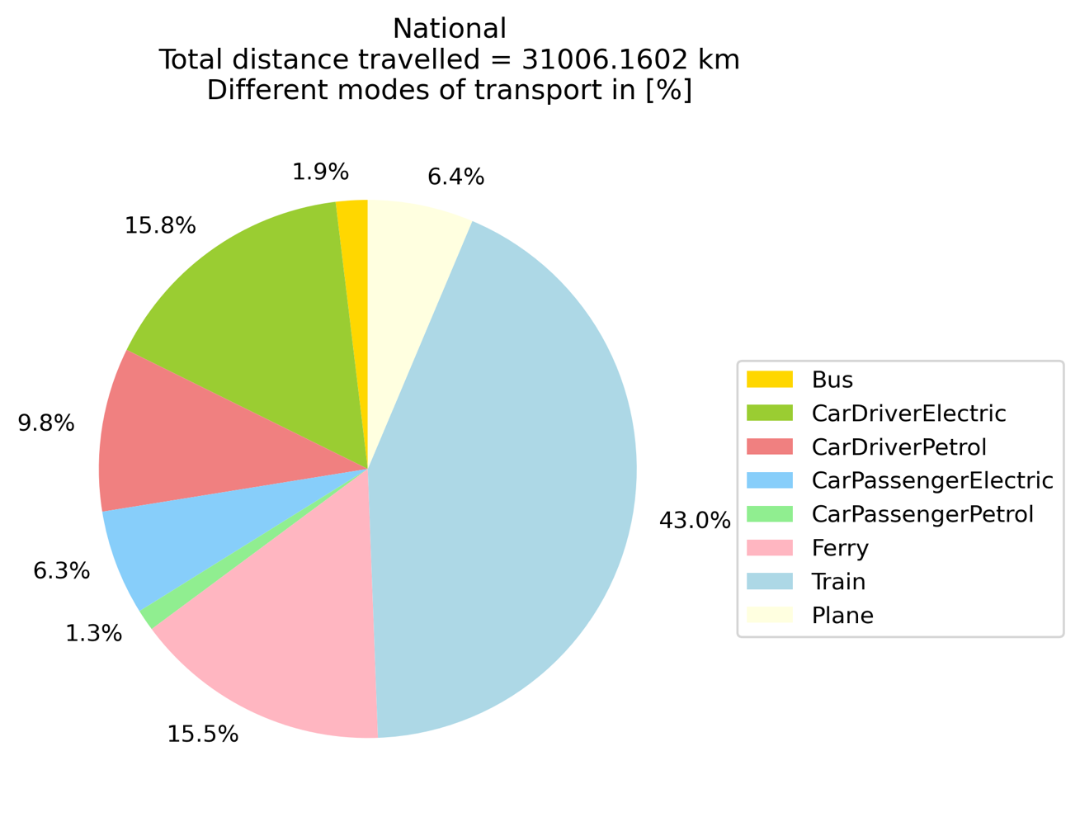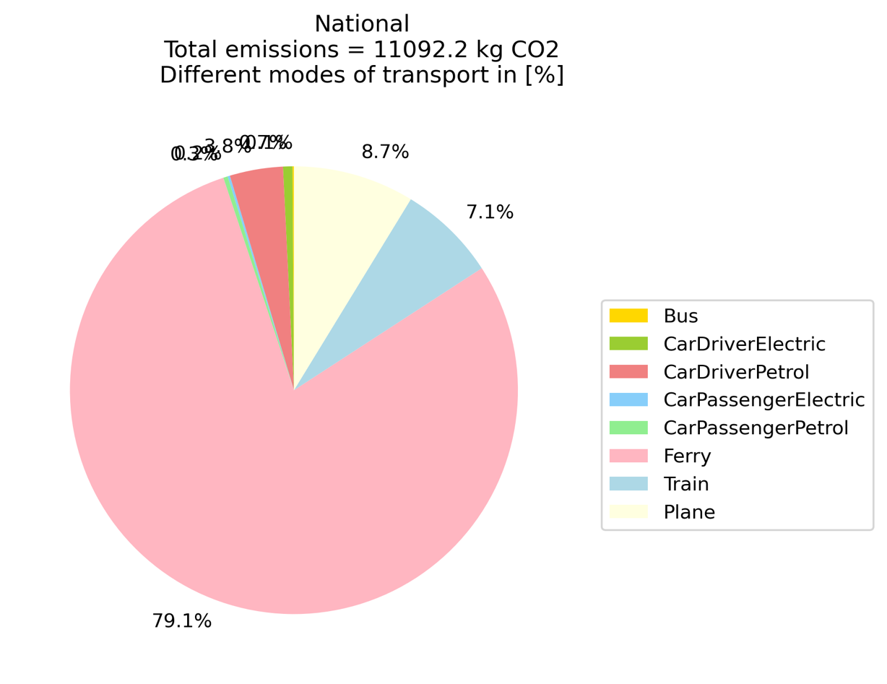

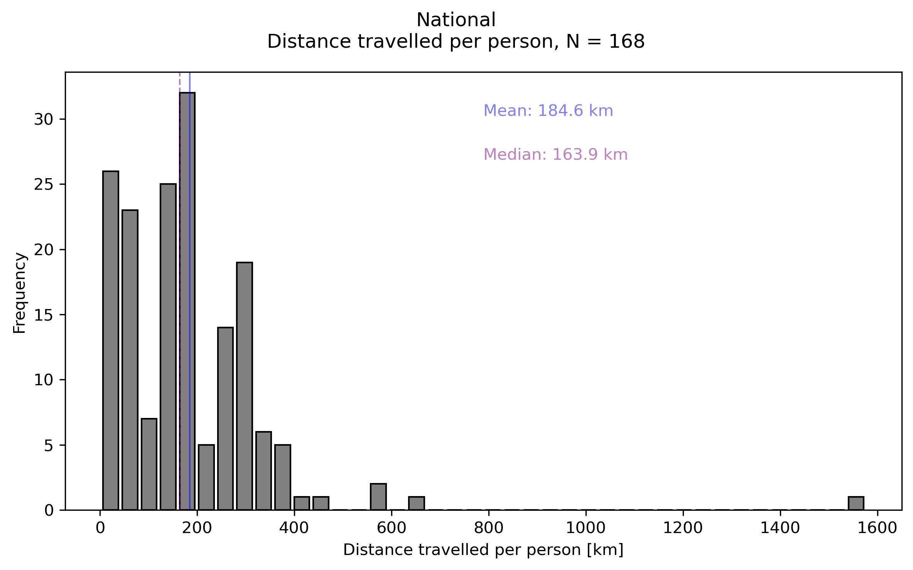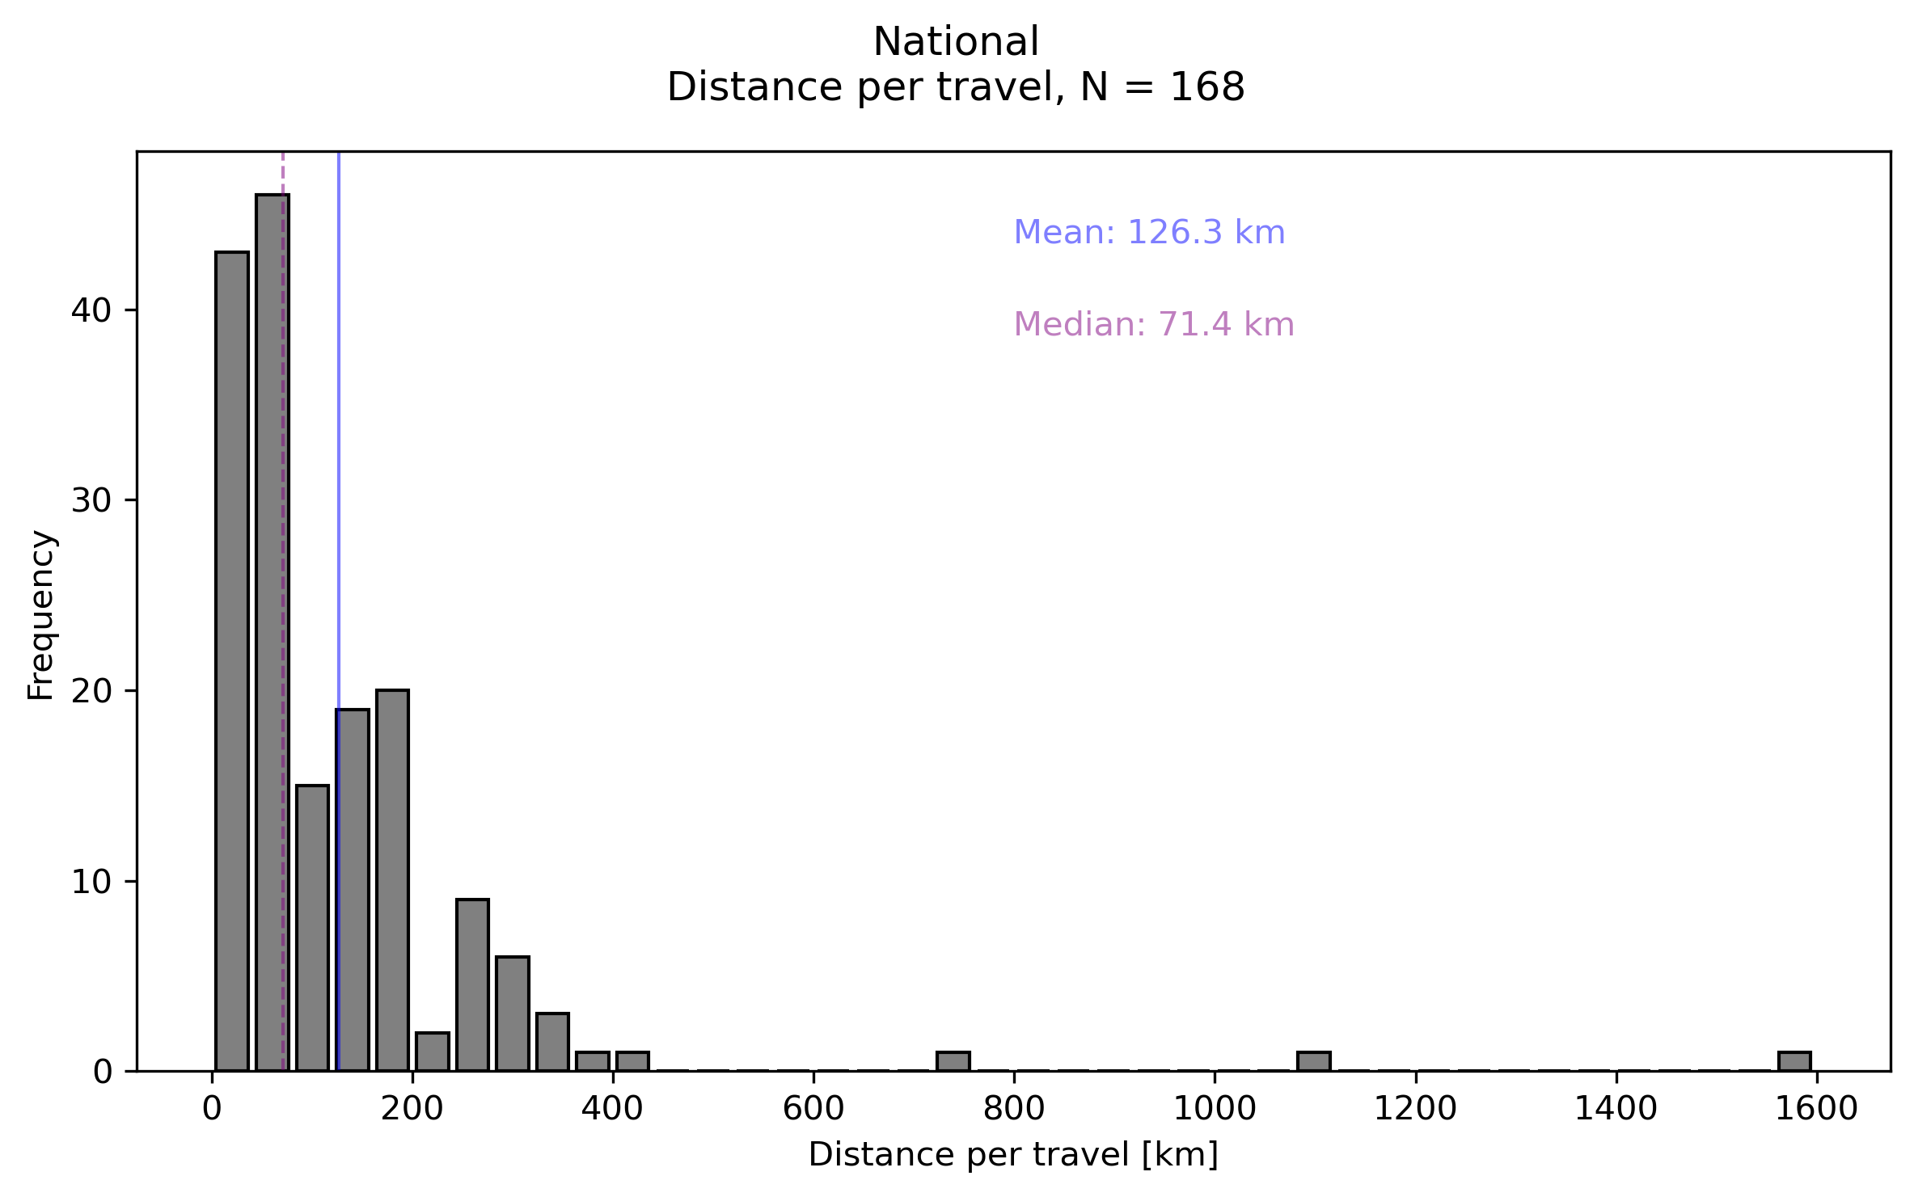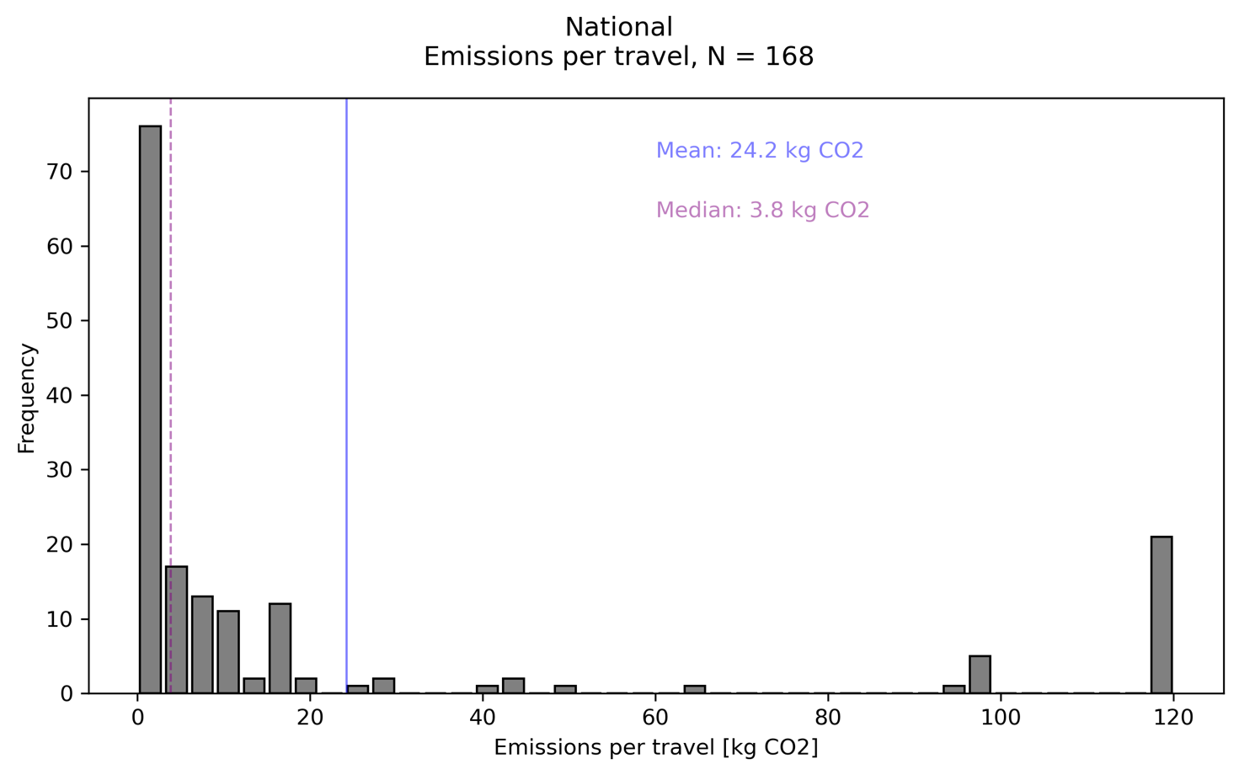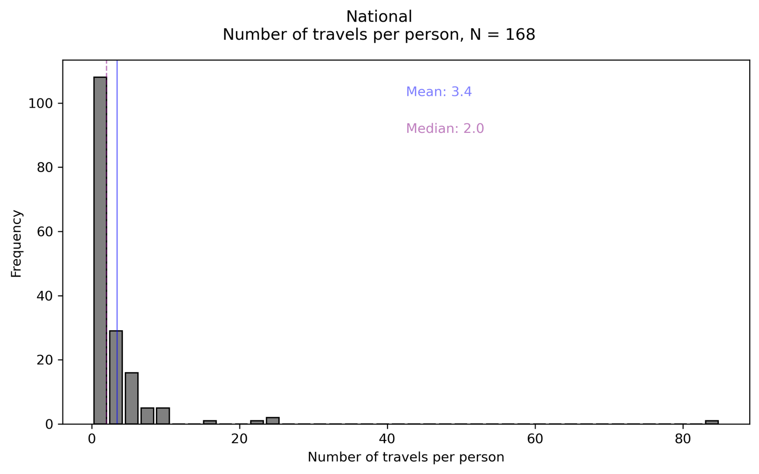

INTERNATIONAL TRAVELS

