Automated Credit Card Notification System

**Project Report**

Submitted by:  
Sudhanshu Anand  
B.Tech,  
BIT Mesra

# 1. Introduction

The Automated Credit Card Notification System is a Python-based solution designed to streamline customer communication. It dynamically sends email notifications based on credit card availability status by integrating Python with MySQL databases, SMTP protocols, and data handling through Pandas. This system reflects a practical, real-world implementation of backend automation and client notification management.

# 2. Technologies Used

• Python

• Pandas

• MySQL (Database)

• SMTP (Simple Mail Transfer Protocol)

• Gmail SMTP Server

• CSV for intermediate data storage

# 3. Workflow

1. Customer information is stored in MySQL database tables:

- Table 1: customers (id, name, email)

- Table 2: credit_card (id, credit_card_number, flag)

2. A SQL JOIN operation is used to combine these tables on the 'id'.

3. The joined data is exported as a .csv file.

4. Python reads the .csv file using Pandas.

5. Based on the 'flag' value (Y/N), a personalized email is prepared.

6. Emails are sent using Gmail's SMTP server.

# 4. Database Schema & Query

The customer and credit card information are split across two relational tables: (Snippets of the actual table are attached in the end.)

Table: customers

| id | name | email |  
|----|-------|------------------------|  
| 1 | Alice | alice@mail.com |  
| 2 | Bob | bob@mail.com |

Table: credit_card

| id | credit_card_number | flag |  
|----|---------------------|------|  
| 1 | 1234-5678-9012-3456 | Y |  
| 2 | NULL | N |

Sample SQL Query Used:

SELECT customers.id, customers.name, customers.email,   
 credit_card.credit_card_number, credit_card.flag  
FROM customers  
JOIN credit_card ON customers.id = credit_card.id;

# 5. Python Code Logic

The script reads the CSV data generated from the MySQL JOIN operation. It checks the 'flag' column:  
- If 'Y', the user already owns a credit card and receives promotional offers.  
- If 'N', the user is encouraged to apply for a credit card.  
It personalizes the message for each user and sends it via the Gmail SMTP server using the provided app password.

# 6. Sample Output Screenshots

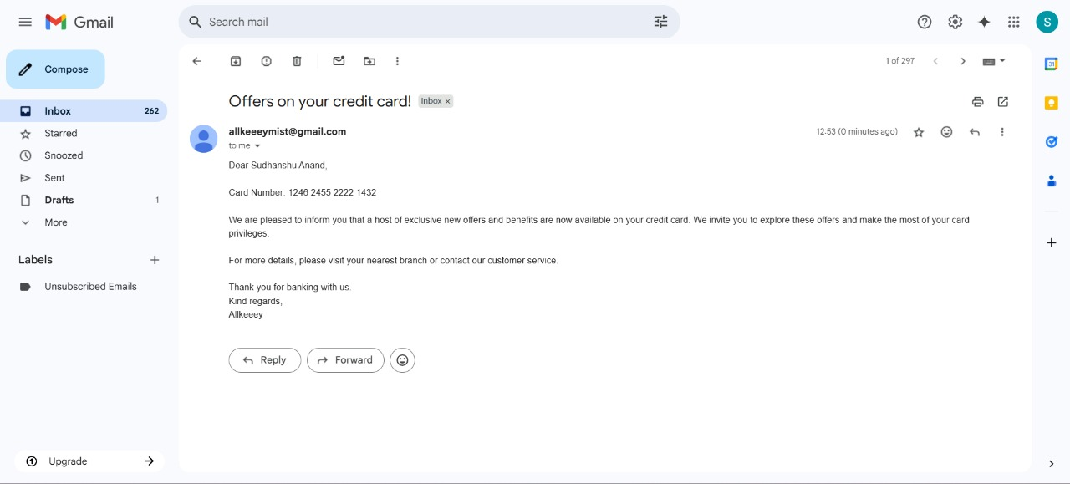

Fig1: If the user already owns a credit card.

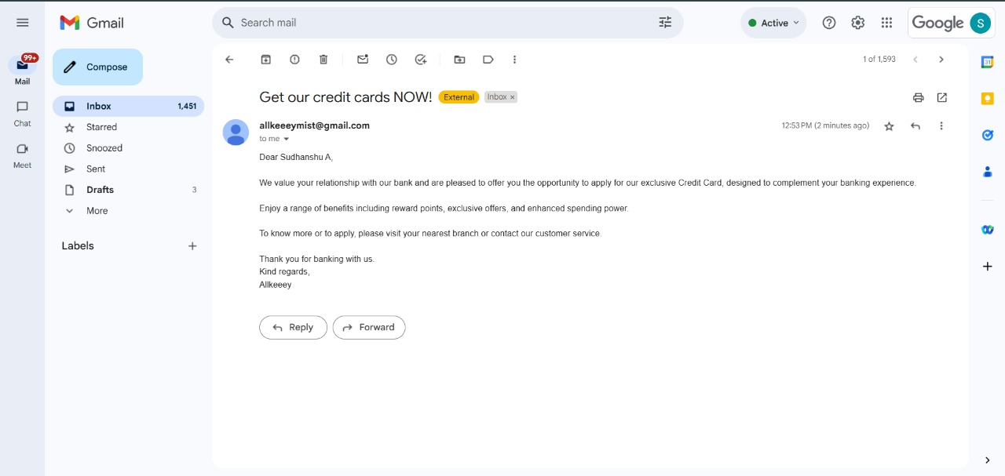

Fig2: If the user doesn’t own a credit card.

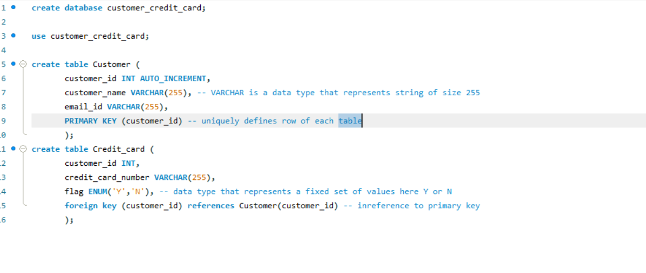

Fig3: Creation of Database and the two schema used.

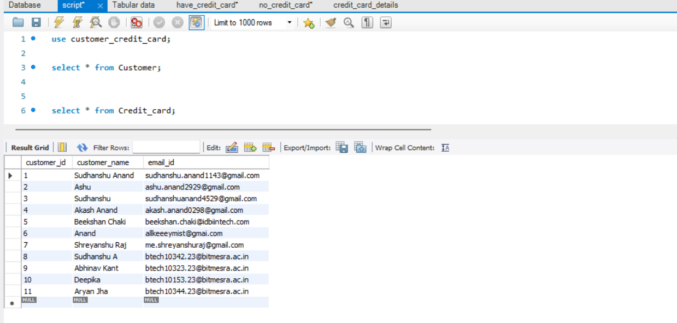

Fig4(a): All the queries.

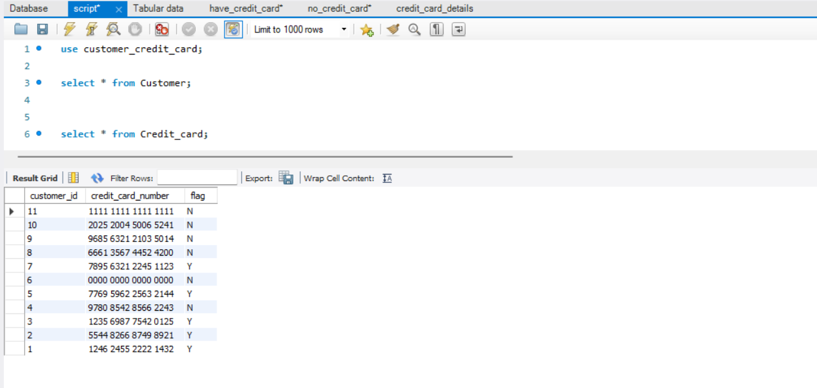

Fig4(b): All the queries

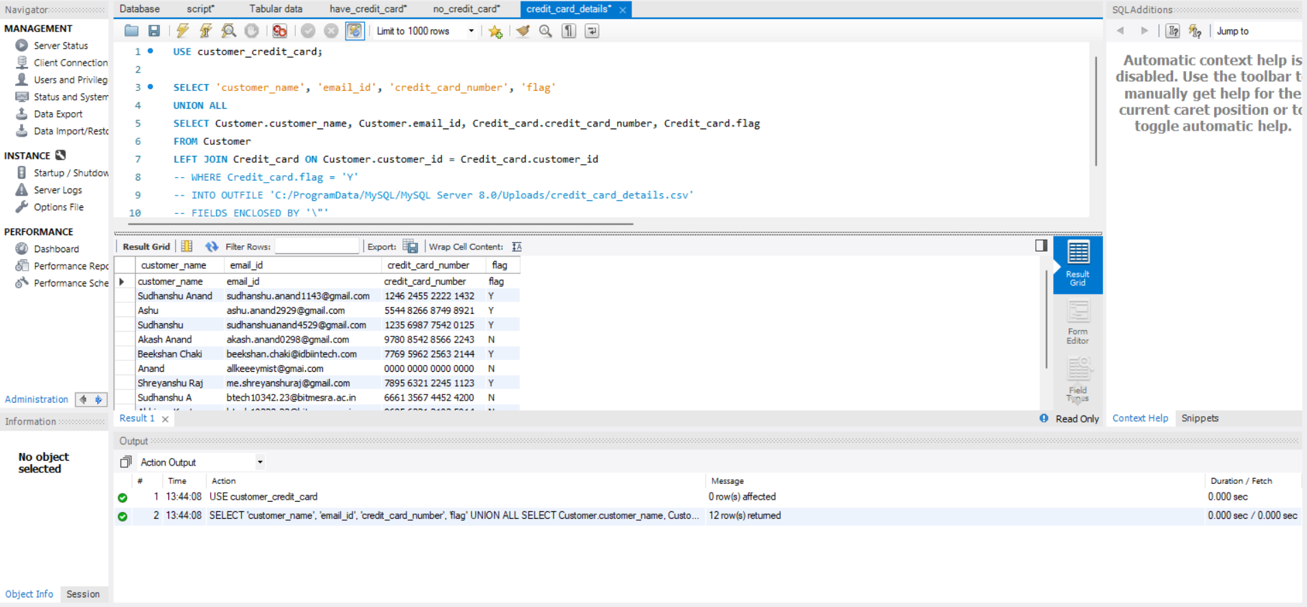

Fig5: Overall Credit Card Details

# 7. Conclusion

This project demonstrates effective integration of backend technologies—MySQL, Python, Pandas, and SMTP—for automating banking notifications. It showcases skills in database management, Python scripting, email automation, and system workflow design. This type of solution is commonly used in real-world fintech and CRM systems.