Application of Linear Algebra in Neural Networks
The Anh, Ivan, Owen

Abstract:
This paper presents the development and implementation of a feedforward artificial neural network (ANN) designed to classify handwritten digits. The core challenge addressed is teaching a neural network to reliably associate complex visual input with its correct label.
Our methodology uses a dense, neural network architecture featuring an input layer of 784 neurons, two hidden layers of 16 neurons each, and a 10-neuron output layer. For linear transformations between layers, the network uses three weight matrices (W₁ ​,W₂ ​,W₃​), followed by the sigmoid function for activation. The forward process then computes the predicted output. The training of the model’s network is facilitated by backpropagation and gradient descent, where the squared error is reduced with respect to the weights and biases using partial derivatives.
Results show that by repeatedly adjusting weights and biases based on the gradient, the network is trained to recognize the features and edges within the input images, enabling digit classification. Furthermore, by using matrix operations, the computation can be made more efficient during both the forward and backpropagation steps.
In conclusion, this project successfully applies linear algebra, to create an intelligent system capable of carrying out high-accuracy pattern recognition for the task of handwritten digit classification.

- Introduction: Learning by Observation
When we see something—such as a butterfly—we can immediately identify it as a butterfly. However, this ability is not innate for everyone. For example, a child does not automatically know that the insect they are observing is called a butterfly. Instead, adults take on the responsibility of explaining and labeling objects in the child’s environment. The child receives the visual input of the insect, and through repeated teaching, they learn its name. After learning, the child can recognize a butterfly on sight.
Similarly, an artificial neural network must undergo a training process. During training, the network is repeatedly shown input data along with the correct labels. Over time, it learns to associate specific input patterns with their corresponding outputs. Once trained, the neural network can recognize similar inputs—just as a child eventually learns to identify a butterfly.
- The Forward Process: Predicting an Output
For recognizing (or predicting) an image, we refer to this procedure as the forward process. This forward process can be understood analogously to evaluating a function f(x), where x is the input and f(x) is the corresponding output (similar to how the visual input is the insect and the output is the identification “butterfly”). In our program, the input is a 28×28 image containing a total of 784 pixels. We represent these 784 pixels as a vector in $R^{784}$ :
$$x=\left(\begin{matrix}x_{1} \\ x_{2} \\ ⋮x_{784}\end{matrix}\right)$$
Think of each individual pixel as a neuron or a parameter that holds data, in this case, an activation number between 0 and 1 that represents how strongly the pixel lights up (0 dark, 1 white).
The output consists of 10 elements, corresponding to the digits 0 through 9. We represent this as a vector in $R^{10}$ where the element’s value corresponding to the correct digit is set to 1, and all other elements are set to 0:
$$y=\left(\begin{matrix}y_{0} \\ y_{1} \\ ⋮y_{9}\end{matrix}\right)$$
For example, a digit 3 will become a vector:
$$3 = \begin{matrix}0 \\ \begin{matrix}0 \\ \begin{matrix}0 \\ \begin{matrix}1 \\ \begin{matrix}... \\ 0\end{matrix}\end{matrix}\end{matrix}\end{matrix}\end{matrix}$$
- Linear Transformation and Weight Matrices
In MTH 160, we learned that a linear transformation from $R^{n}$ to $R^{m}$ can be represented by a matrix. Likewise, in neural networks, we multiply the input vector by a matrix—called the weight matrix—to transform the 784-dimensional input into a 10-dimensional output.
$$[y=Wx + b]$$
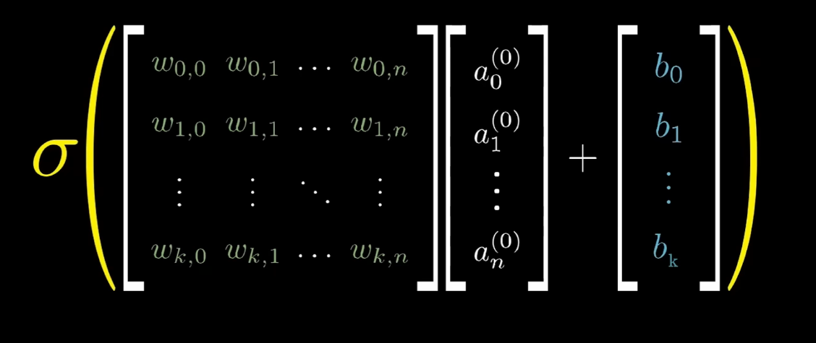
Representation of multiplying the Weight matrix with our pixels vector
Weights determine how strongly each element of input contributes to the output—essentially indicating how important a given neuron is in producing the correct prediction. A positive weight pushes the output upward, while a negative weight pushes it downward. If a feature contributes to predicting the correct outcome, its weight increases; if it does not, the weight decreases.
For example, consider a linear equation in the weight multiplication:
$$N_{1}=W_{1,1} {\text{pixel}}_{1}+W_{1,2} {\text{pixel}}_{2}+⋯+W_{1,784} {\text{pixel}}_{784}.$$
If a pixel—such as pixel 1, which stays at the edge of the image—is not likely to light up, then its corresponding weight will gradually decrease during training.
These weights are initially chosen randomly and then adjusted through a process called gradient descent (discussed later). The iterative adjustment of these weights is known as backpropagation, which tunes them to values that move the network toward the correct output.
Another component of the network is the bias, a value that shifts the activation threshold. The bias allows a neuron to activate only when the combined input surpasses a certain level, giving the model more flexibility and improving its ability to fit the data. In this layer, we apply the sigmoid activation function to keep the output values between 0 and 1, ensuring consistency across all neurons.
- Multi-layer Neural Network Architecture
In our program, using only one weight matrix would not provide sufficient accuracy. Therefore, we include two hidden layers, each containing 16 neurons, between the input layer and the final output layer. Think of these layers as a process of breaking the digit into distinct shapes and edges, then combining these parts to determine the most likely number. The first layer is our image of the digit represent as a vector. The next layer analyzes smaller sub-regions within the area where pixels light up (breaking down to 16 edges or shapes). The following layer integrates these sub-regions into more complex patterns. Finally, the output layer uses this information to predict the digit. This hierarchical breakdown is illustrated well in 3Blue1Brown’s visualization of how a neural network interprets hand-drawn numbers.
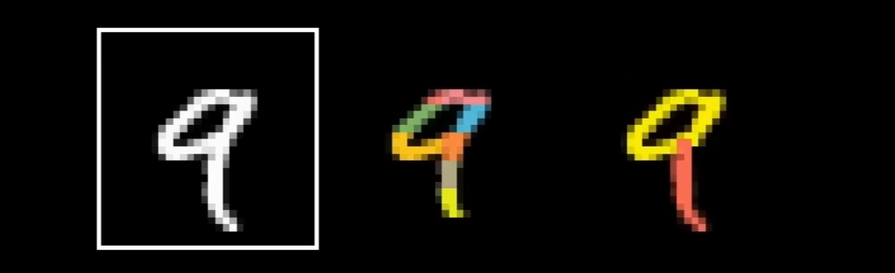
Breaking a number to edges
As a result, we will have three weight matrices (W1, W2, and W3) to perform the linear transformations between the layers.
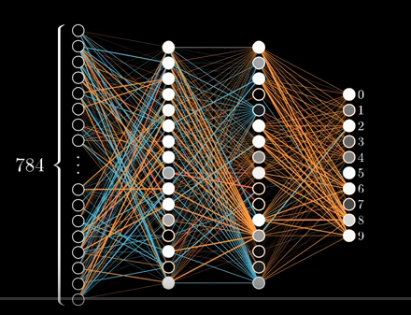
Representation of our Neural Network with 2 hidden layers
Initializing our neural network class with Python code:
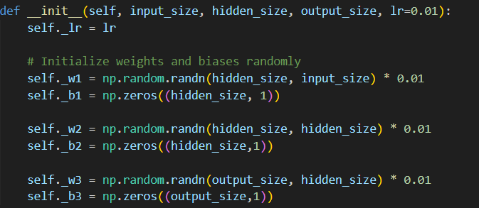
Snippet of code for initialization
self._w1, self._w2, and self._w3 are the weight matrices of our neural network. All weight matrices are initialized randomly using NumPy. Their dimensions are as follows:
- W1: 16 × 784
- W2: 16 × 16
- W3: 10 × 16
All bias vectors are initialized to zero for simplicity.
As mentioned earlier, the forward process predicts the output by applying linear transformations to the input vector using the weight matrices. In Python, this process is implemented as follows:
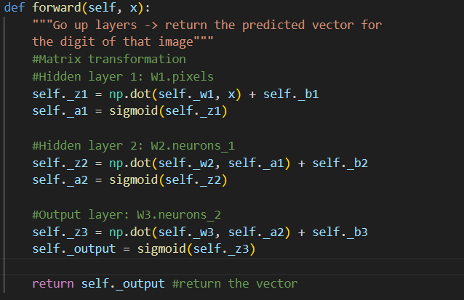
Forward function code snippet
self._z1 is the result of the first linear transformation using the weight matrix W1 and the bias b1(bias is set as 0 in this case):
$$z_{1}=W_{1}x$$
- Activation Function
The sigmoid compresses any real number into a value between 0 and 1.
- If a component of z1 is large and positive → the sigmoid output (in a1) will be close to 1.
- If it is very negative → the output will be close to 0.
We then repeat this pattern (linear transformation → activation) for each layer until we produce the final output vector (z1 -> a1 -> z2 -> a2 -> z3 -> output).
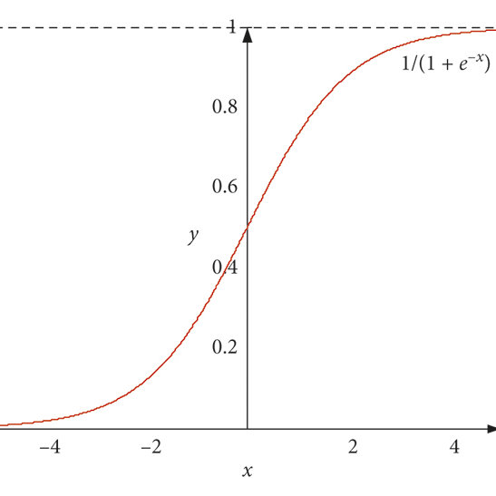
Sigmoid function
Initially, the predicted output is likely to be far from the actual expected result because the weights are randomly initialized. This is why training is necessary.
- How can we update the weight through each training? (Backpropagation)
In Make Your Own Neural Network by Tariq Rashid, he mentions that the error can be distributed according to the contribution of each weight. As discussed earlier, if a neuron corresponding to a particular weight has a high activation, it indicates that the neuron is relevant. Therefore, we should assign a larger portion of the error to those weights during training.
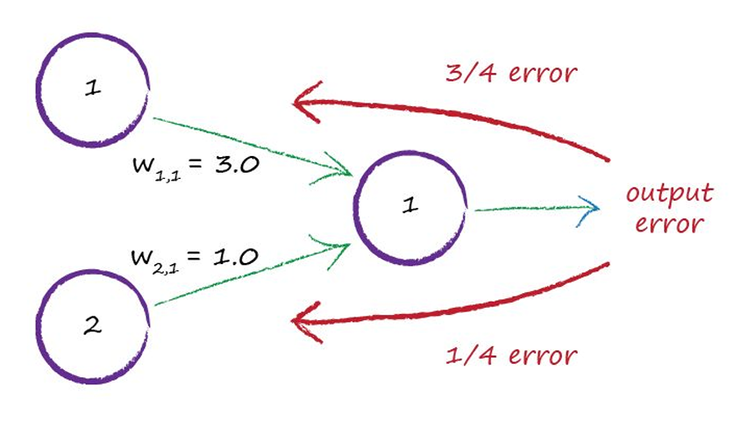
In the example on page 74 of Make Your Own Neural Network, we see that for small-weight values, W1,1 ​ contributes ¾ ​ of the output. Consequently, it receives ¾ of the output error. However, we do not need to explicitly calculate each weight’s portion of the contribution because weights with higher activation values are already larger. Therefore, we can simply multiply the weight by the error directly.
To update the weights, we need to compute the loss of our predicted output. There are many possible loss functions, but here we use the sum of the squared differences between the elements of the expected vector and the predicted vector. Using the functions explained in the video "Mathematics of gradient descent” we arrive at this equation to compute the total loss (error value) of the prediction our neural network makes.
$$L=\sum_{i=1}^{n}{{\left(g_{i}-y_{i}\right)}^{2}}$$
$$L=\sum_{i=1}^{n}{{\left({\text{error}}_{i}\right)}^{2}}$$
Cost functions
This function yields the difference between the guess out network produced (g – normalized by the sigmoid function) and the expected value. This number is then squared to suppress variance, make all results positive, and make larger errors punished harder. Since we have multiple weights corresponding to neurons in each layer, we need to determine how a change in each weight affects total loss. This is simply the derivative, a concept familiar to mathematics students. Because there are many weights, we need to use multivariable differentiation; however, with NumPy, this differentiation can be computed automatically.
$\frac{∂L}{∂W}=2⋅\text{error}⋅\frac{∂\left(\text{error}\right)}{∂z_{3}}⋅\frac{∂z_{3}}{∂w_{3}}$
$$\frac{∂\left(\text{error}\right)}{∂z_{3}} is sigmoid derivative$$
$$\frac{∂z_{3}}{∂w_{3}} is activation from Hidden layer 2$$
“Error” in this case is the vector after we did the predicted output vector minus the expected output vector, so error will have the same size with output vector.
Now, we need to find the point that minimizes the loss (which would be a local minimum in the simple xy-plane). However, since we are dealing with multiple variables, we need a different approach. This is where gradient descent comes in—it finds the direction to move in order to reach the point where the derivative is zero. The equation above indicates the direction to adjust the weights to minimize the loss value. Simply put, when the slope of the tangent line is positive, we move in the negative direction (left) toward $dy/dx=0​$; when the slope is negative, we move in the positive direction (right). As Rashid explains, it is similar to navigating a complex landscape filled with peaks, hills, and small bumps, gradually making our way downhill.

This is an oversimplification, but it conveys the basic idea. In practice, we repeat this process by training thousands or even millions of times to achieve the desired result.
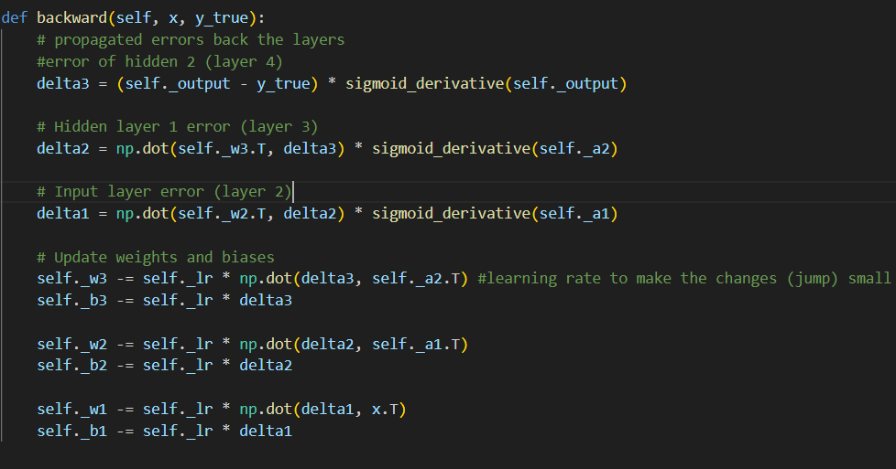
In our neural network, delta3 (size 10×1) represents the output layer error. Using delta3 as the output error, we backpropagate it by multiplying the transpose of W3 with delta3. This gives us the error for the neurons in the previous layer, which we call delta2 (size 16×1). We repeat the same process to obtain the error for the earlier layer, giving us delta1 (also 16×1).
With these error values, we update the weights by multiplying each delta value with its corresponding activation vector. This produces an updating matrix with the same shape as the corresponding weight matrix where weights connected to neurons with high activation values will receive larger positive updates from this updating matrix, while weights connected to low activation values will receive smaller updates. Finally, we simply subtract the weight matrixes to these updating matrixes—scaled by a small learning rate—so the weight updates remain small and stable. Thus, with thousands of input data, we can update these weight matrixes until the prediction becomes correct.
Conclusion:
Linear algebra is fundamentally the backbone of neural networks and how we can make predictive assumptions such as recognizing digits that are drawn in a manner that is traditionally indistinguishable to a computer. By representing images, activations, and transformations as vectors and matrices, we can design a feedforward neural network that is capable of performing hand drawn image classification. The process illustrates how successive linear transformations can extract meaningful information from the input image, while gradient descent reveals how calculus enables systematic improvement of model accuracy through iterations and the constant process of adjusting weights and biases (for our example biases are set to zero).
Through this integration of computational ideas, the network is capable of learning to identify patterns such as edges, curves, and shapes, ultimately allowing the network to map pixel data into accurate numerical predictions. This project highlights how mathematical operations allow us to express data to the computer in meaningful ways that can be converted into practical decision making. The application of linear algebra shows the power it holds in terms of data representation and how it can be used to build models for efficient pattern recognition.

References
Course Hero. “The Math behind Neural Networks (01).” YouTube, 8 Nov. 2018, www.youtube.com/watch?v=RiqWATOoos8. Accessed 13 Nov. 2025.‌
Rashid, Tariq. Make Your Own Neural Network. CreateSpace Independent Publishing Platform, 31 March. 2016.
Course Hero. “The Math behind Neural Networks (01).” YouTube, 8 Nov. 2018, www.youtube.com/watch?v=RiqWATOoos8. Accessed 13 Nov. 2025.‌
Sanderson, Grant. “But What Is a Neural Network? | Deep Learning, Chapter 1.” YouTube, 5 Oct. 2017, www.youtube.com/watch?v=aircAruvnKk&list=PLZHQObOWTQDNU6R1_67000Dx_ZCJB-3pi
The Coding Train. “3.5: Mathematics of Gradient Descent - Intelligence and Learning.” YouTube, 5 June 2017, www.youtube.com/watch?v=jc2IthslyzM. Accessed 16 Jan. 2025.‌

‌

