"Kyiv Vocational College of Communication"

Cyclic Commission of Computer Engineering

EXECUTION REPORT

**Work - Case #1**

**from the discipline: "Operating systems"**

**Topic:** WORK-CASES IN LINUX

a list of additional practical tasks

from the discipline "Operating Systems"

It was performed by students of the RPZ group - 03B

Team 6: Sichkar Maxim,

Brytyuk Bohdan

Kyiv 2023

**Work-case 1**

**#1 Describe what git is used for, what basic actions and commands it performs.**

Git is a distributed version control system that allows you to track software development history and collaborate on complex projects from anywhere in the world. The main advantage of Git is that it is very fast and transparent.

**Basic Git commands:**

**Enter e-mail and name**

git config --global user.email "you@example.com"

git config --global user.name "Your Name"

**Initialize an empty local Git repository**

git init

**Clone an existing repository over HTTP (using GitHub as an example**)

git clone https://github.com/{vendor_name}/{project_name}.git

**Or clone an existing repository using SSH**

git clone git@github.com:{vendor_name}/{project_name}.git

**Check status**

git status

**Check if pull is required**

git status -uno

**Add file(s) to index**

git add file_name

**Add all files to the index**

git add .

**Commit the changes to the local repository**

git commit

**#2 Register your own git account (gitlab, github or another platform).**

**Accounts:**

Brytiuk Bohdan - Thebest1212d

Maxim Sichkar – ProstoChoodo

**#3 Create a new public repository, which you will use to add all completed works from the "Operating Systems" discipline (if you work in a team, add other team members to its editors).**

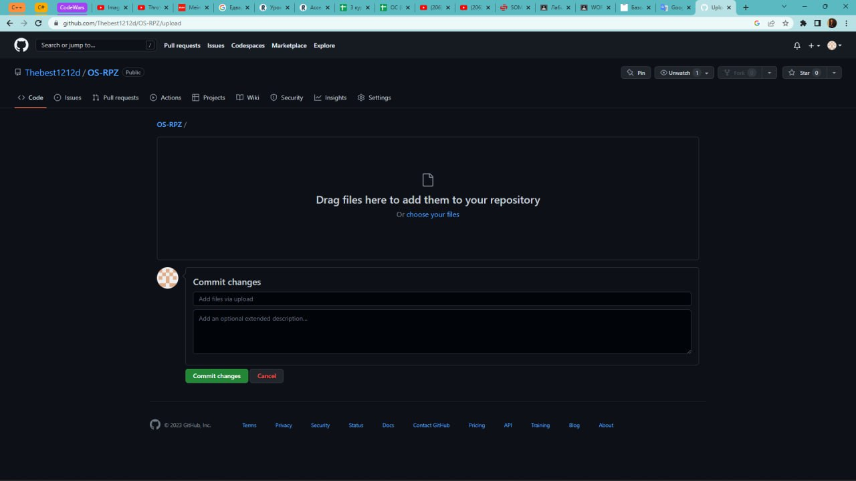

**Figure 1**

**Placing the report in the repository**

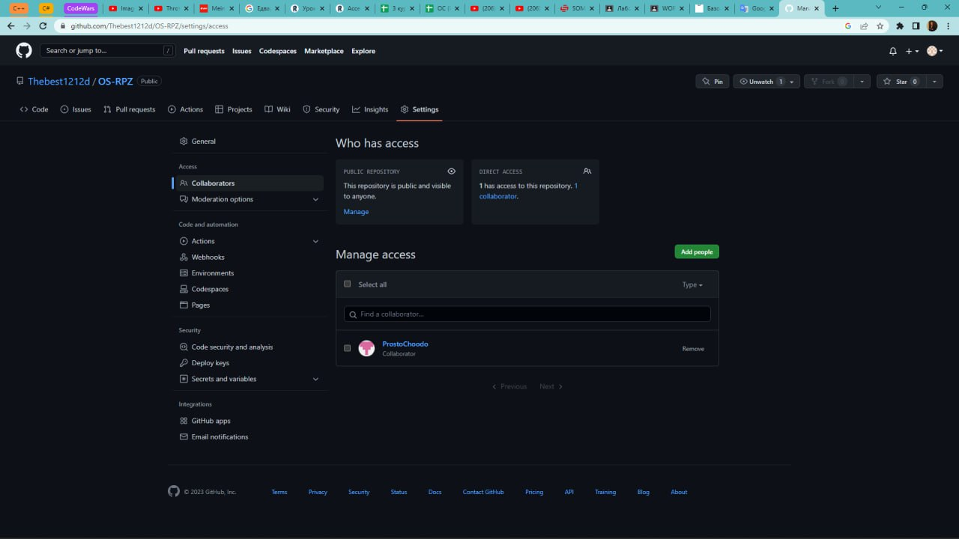

**Figure 2**

**Adding a team member to the repository**

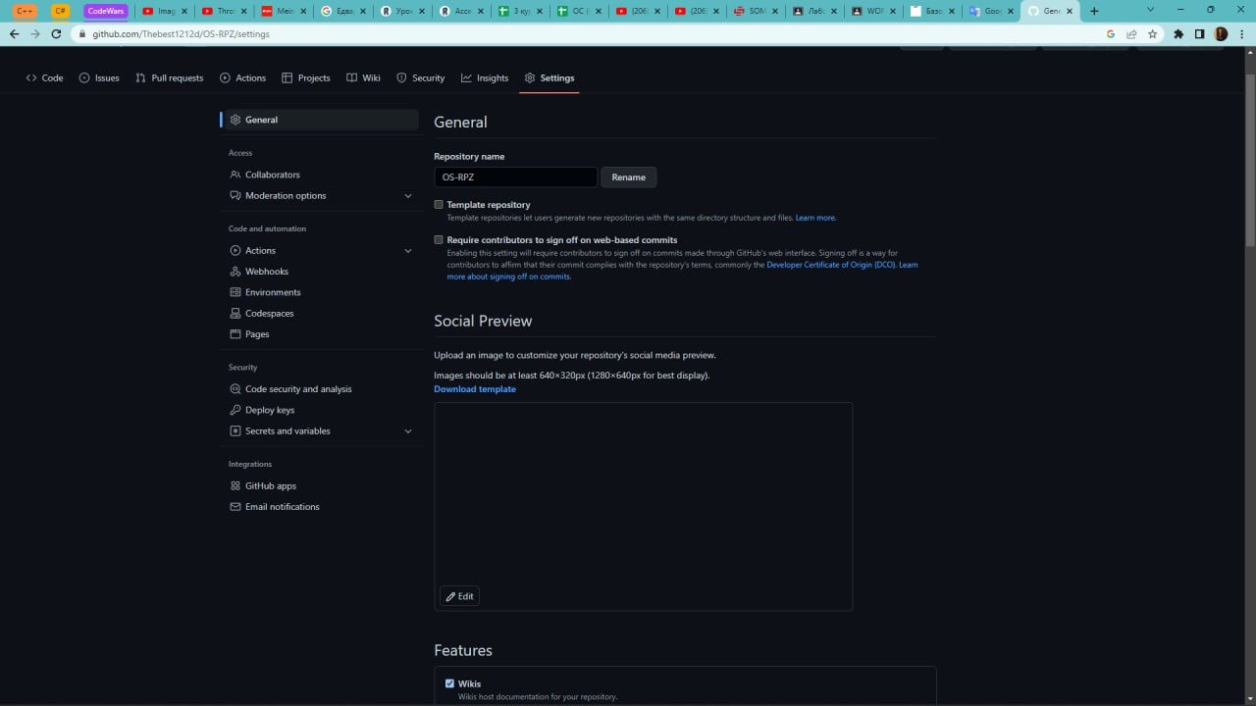

**Figure 3**

**The name of the repository**

**№4 Place your first report on completed Work-case 1 (presentation, text file, html page) in this repository.**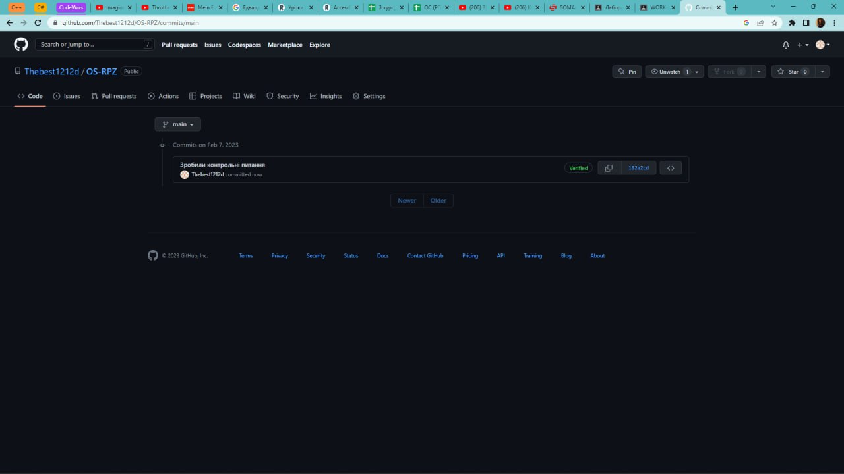

**Figure 4**

**First report**

**Conclusion: During the implementation of WorkCase 1, I gained initial knowledge of using the Git application, the issue of initial git commands was theoretically investigated in more detail. Acquired practical skills of working with git commands.**