"Kyiv Vocational College of Communication"

Cyclic Commission of Computer Engineering

EXECUTION REPORT

**Work - Case #2**

**from the discipline: "Operating systems"**

**Topic:** WORK-CASES IN LINUX

a list of additional practical tasks

from the discipline "Operating Systems"

It was performed by students of the RPZ group - 03B

Team 6: Sichkar Maxim,

Brytyuk Bohdan

Kyiv 2023

**Work-case 2**

**1. Install a type II hypervisor on your home workstation - Virtual Box, VMWare Workstation, Hyper-V (or another one of your choice).**

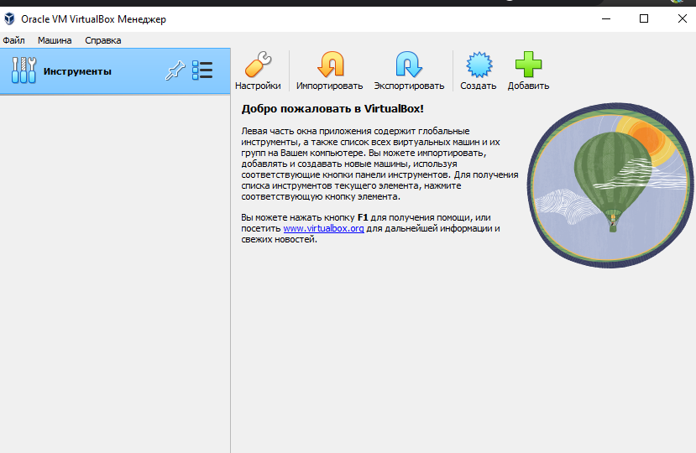

**2. Describe a set of basic actions in the hypervisor you set:**

**● creation of a new virtual machine;**

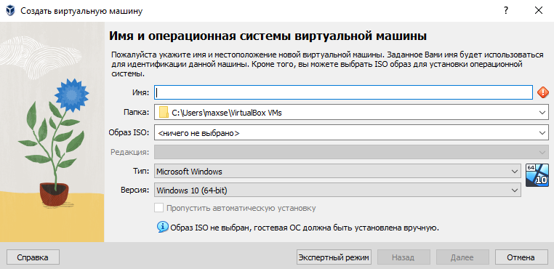

**● selecting/adding equipment available for the Virtual Machine;**

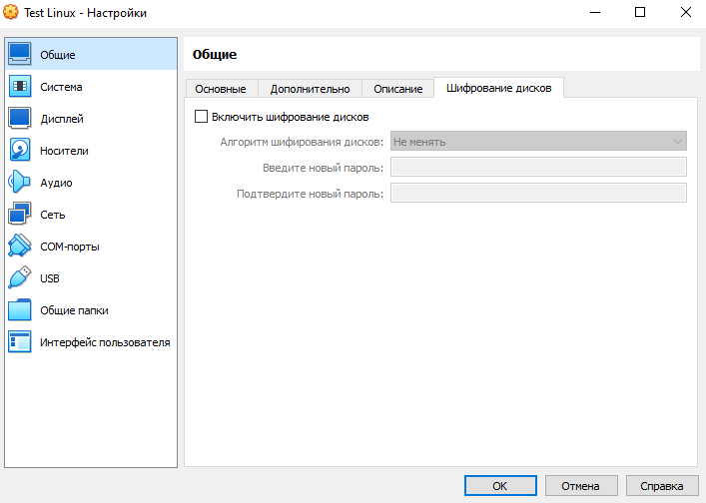

**● network adjustment and connection to Wi-Fi points;**

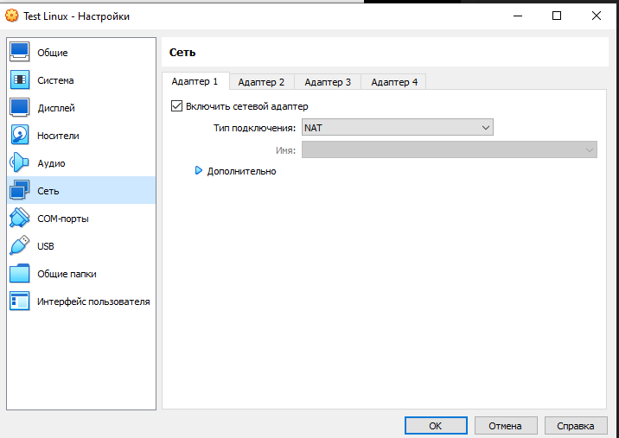

**● Ability to work with external media.** 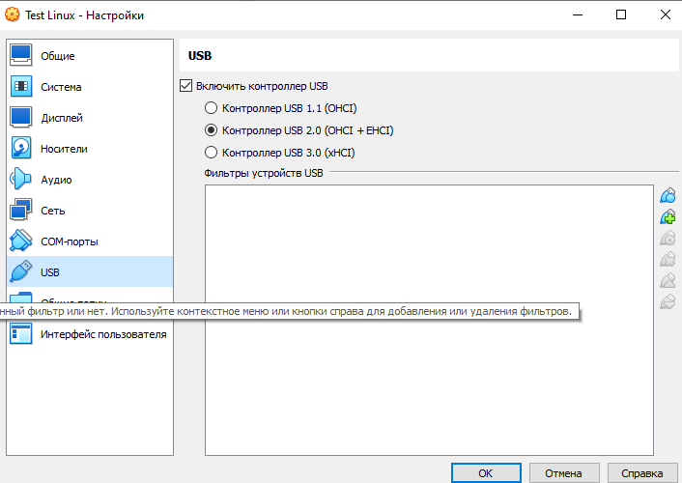

**3. Install GNU/Linux Centos in your hypervisor another handy distribution to you) in the base configuration with graphic shell.**

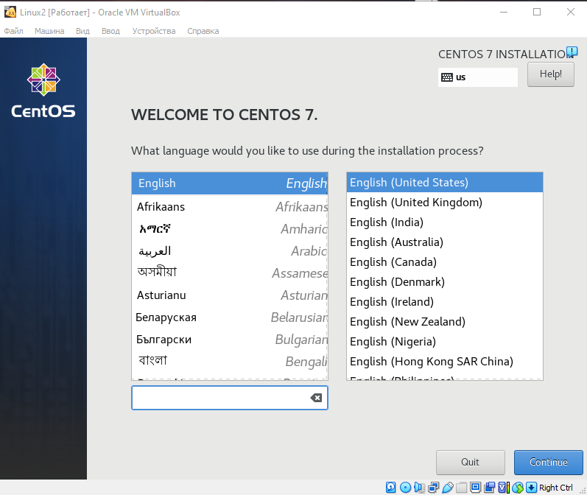

**4. Create a second virtual machine and perform the following steps for it:**

**● Set in the minimum configuration with the terminal input**

**without a graphical interface GNU/Linux Centos;**

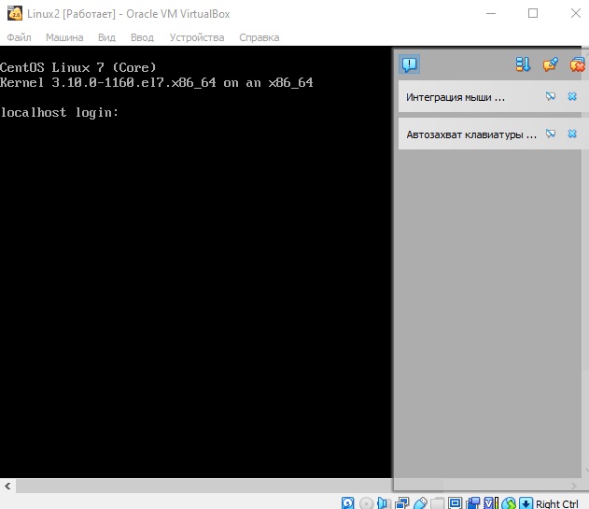

**● Set the Gnome graphic shell over the set in the previous point of OS;**

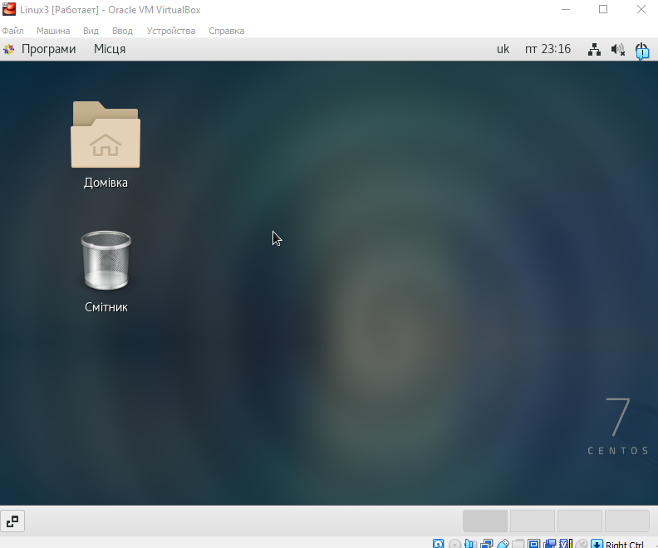

**Gnome**

**● Set the second graphic shell (their listing is possible can be found in laboratory work # 1) and compare its capabilities with Gnome.**

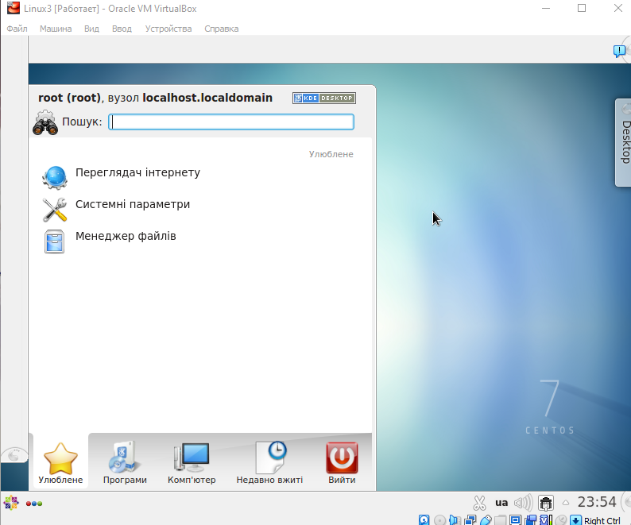

**Plasma**

**Conclusion: І installed and figured out the virtual machine. Installed new graphical interfaces. I learned how to install the GNOME graphical shell and create a virtual machine**