ACKNOWLEDGEMENT

Drafting this document would have not been possible without the contribution of some people who took upon themselves to see this work being accomplished. Our gratitude goes to the following people:

* The Resident Representative of AICS-Cameroon, **Mr. ARMAND Claude Abanda**, for his support, words of encouragement and the different advice on how to approach situations.
* The director of MickMaq for Self-worth , **Mr. HASSAN** and his staffs for trusting us by given us the opportunity to serve as interns in their prestigious enterprise.
* Our academic supervisor **Mrs.ONGUENE** for his moral support, effort and advice throughout the academic year.
* To our academic teachers **Mr. AGBOR ANDERSON, Mrs. EBENYE AND Mr. MESSIO ULRICH**  for their advice and assistance in realizing this document.
* To all my teachers of **AICS CAMEROON** for the knowledge they impacted me with for me to be where I am today.
* A special thanks tomy brothers and sisterswho helped me all through this project from beginning to the end and who even gave me the idea of the project
* Tomy parents for their moral and material support.
* To all my classmates for their collaborative work throughout the academic year.

GLOSSARY

* 2TUP: Two Track Unified Process
* AICS : AFRICAN Institute of computer sciences
* APK: Android Package Kit.
* MVC: Model View Controller.
* UML: Unified Modelling Language
* DBMS : Database Management System
* GUI: Graphical User Interface
* IDE: Integrated Development environment
* IPA: iOS App Store Package.
* JSON: JavaScript Object Notation

ABSTRACT

In the digital age, eCommerce has become a critical component of business strategy, enabling companies to reach a global audience and provide customers with convenient access to products and services. This report details the conception and realization of an eCommerce website designed to offer a seamless online shopping experience. The project began with a comprehensive market analysis to identify target audiences, competitors, and key features that would differentiate our platform from others.

The development process involved the selection of a robust technology stack, including a content management system (CMS), secure payment gateways, and responsive design techniques to ensure accessibility across various devices. The website's architecture was carefully planned to support scalability, security, and ease of navigation, with particular attention paid to user interface (UI) and user experience (UX) design.

Throughout the development, emphasis was placed on security measures to protect user data and ensure safe transactions. Rigorous testing was conducted to guarantee the website's functionality, performance, and reliability before deployment. The result is a fully functional eCommerce platform that meets modern standards of online retail, providing both customers and administrators with an efficient and user-friendly environment.

This report outlines the methodologies used, challenges encountered, and solutions implemented during the project, offering insights into the successful development of an eCommerce website capable of competing in today's dynamic online marketplace.

**KEYWORDS**

* ecommerce
* Online Shopping
* User Experience (UX)
* User Interface (UI)
* Web Development
* Payment Gateway
* Market Analysis
* Security

RESUME

À l'ère numérique, le commerce électronique est devenu un élément essentiel de la stratégie commerciale, permettant aux entreprises d'atteindre un public mondial et d'offrir aux clients un accès pratique aux produits et services. Ce rapport détaille la conception et la réalisation d'un site web de commerce électronique conçu pour offrir une expérience d'achat en ligne fluide. Le projet a débuté par une analyse de marché approfondie visant à identifier les publics cibles, les concurrents, et les fonctionnalités clés qui différencieraient notre plateforme des autres.

Le processus de développement a impliqué la sélection d'une pile technologique robuste, incluant un système de gestion de contenu (CMS), des passerelles de paiement sécurisées, et des techniques de conception responsive pour garantir l'accessibilité sur divers appareils. L'architecture du site a été soigneusement planifiée pour soutenir l'évolutivité, la sécurité, et la facilité de navigation, avec une attention particulière portée à la conception de l'interface utilisateur (UI) et de l'expérience utilisateur (UX).

Tout au long du développement, l'accent a été mis sur les mesures de sécurité pour protéger les données des utilisateurs et assurer des transactions sûres. Des tests rigoureux ont été effectués pour garantir la fonctionnalité, la performance, et la fiabilité du site avant son déploiement. Le résultat est une plateforme de commerce électronique entièrement fonctionnelle répondant aux normes modernes du commerce en ligne, offrant aux clients et aux administrateurs un environnement efficace et convivial.

Ce rapport décrit les méthodologies utilisées, les défis rencontrés, et les solutions mises en œuvre au cours du projet, offrant des perspectives sur le développement réussi d'un site web de commerce électronique capable de concurrencer dans le marché en ligne dynamique d'aujourd'hui.

### Mots-clés

* **Commerce électronique**
* **Achat en ligne**
* **Expérience utilisateur (UX)**
* **Interface utilisateur (UI)**
* **Développement web**
* **Passerelle de paiement**

GENERAL INTRODUCTION

Technology is advancing at an incredible rate, spanning almost every sector from business to agriculture and other sectors. Due to the huge technological advancement, we now live in a fast-paced society where everything is gradually being digitalized making life easier. As a developing country, most businesses in Cameroon strive to make advantage of the digital economy to grow their businesses thereby boosting the economy as well. To achieve such a goal enterprise, need qualified personnel having skills in computer sciences and related fields. Second year students in AICS Cameroon, are required to carry out a three (3) months’ academic internship at an enterprise to put into practice the knowledge gotten from school in the professional milieu. For this reason, we applied for an internship at MickMaq, which specializes in providing IT solutions. While there, we were attributed the theme “CONCEPTION AND REALIZATION OF AN ECCOMERCE PLATEFORME”. We divided this report into eight (8) parts which are as follows:

1. **Insertion Document:** In this book, we shall present the company in which we spent our internship period and the integration of interns.
2. **Existing System:** Here, we shall present the already present system in place, that is the one used for consultation and follow-up purposes.
3. **Specification Book:** In this book, we specify the needs of the user taking into considerations the time and cost of the project.
4. **Analysis Document:** Here, we shall present the analysis method chosen together with the presentation of all the diagrams used for the analysis of this project.
5. **Conception phase:** This presents the generic and detailed conception of the project to bring out real world constituents.
6. **The Realisation phase:** This phase will permit us to visualize the implementation process of the solution.
7. **Test of functionalities:** In this phase, we shall present to you the different functionalities or modules of our application and how they work.
8. **The User Guide:** This elaborates on all conditions necessary to use the application and how to use it.

**PART I**

**INSERTION PHASE**

# Preamble

This section of the report will cover details of how we were welcomed in the host company, presentation, organization and brief introduction to our project.

# Content

INTRODUCTION

I.

II.

WELCOME AND INSERTION

GENERAL

COMPANY

PRESENTATION

OF

THE

1. ORGANIZATION OF THE COMPANY
2. GEOGRAPHICAL LOCATION
3. BRIEF PRESENTATION OF THE PROJECT THEME

CONCLUSION

INTRODUCTION

The insertion phase in a company is a period during which we discover our working environment, the staff of the company and other interns. Here, we will begin by discussing our first two weeks in the company, how we were welcomed and how we began adapting to our internship environment, we will proceed by exploring the history of the company, discovering its missions, learning what its major activities are, and witnessing some of its key realisations. We will also get to understand how the company is structured administratively and functionally so that it operates effectively and accomplishes its goals. Furthermore, we will look at the hardware equipment used by the company, and the software resources used in its daily operations. We will then introduce our chosen theme for the internship period, briefly elaborate on it.

# WELCOME AND INSERTION

We arrived at MickMaq on Monday 01 July 2024, at 09:00 a.m. we were received by the director of the IT department, Mr. HASSAN, who introduced me to our workspace, gave us an official welcome to the enterprise, its activities and its different rules and regulations. Also, we discussed on the enterprise’s preferred languages and frameworks, our professional supervisor encouraged us through his past working experiences in different enterprises.

The first week we did verification of concept with basic HTML and CSS to ensure that everybody was at the same level before kicking off. There was a talk on project ideas, we were advised to propose project ideas and we were assigned the tasks to carry out research on these ideas. The objective was that the enterprise did not want to impose some themes on us.

The second week we proceeded with verification of JavaScript concepts with some exercises, to test our reasoning and understanding faculties. We also discussed about the specification book with our professional supervisor and its different components, with him explaining what was required from us in each component. We discussed further on our different project ideas to give it shape.

# GENERAL PRESENTATION OF MICKMAQ

### Background:

Mickmaq is a Cameroon based non-governmental tech company institute founded by Ndelogakeh Daniel in 2022 which proposes IT solutions and empowers the use of new technologies in Cameroon.

### Missions

The mission of Mickmaq mainly relates to the empowerment and the perpetuation of Technology use. These include:

* + Design and Mickmaq mobile-oriented software for companies and individuals.
  + Assist newborn companies for quick growth using computer sciences.
  + Provide training and certifications to improve qualified human resources in many fields of study.
  + Take an active part in the sustainable development of the world through innovative solutions and virtual reality.

### Vision :

At Mickmaq, we believe that the true potential of every organization and individual can be unlocked through the harmonious fusion of analysis, development, realization, and data analytics. Our vision propels us forward, guiding us to make a lasting impact on the digital landscape and shape a future where innovation knows no bounds."

### Activities

The activities of Mickmaq range from computer sciences, engineering, and training. We can outline the following:

* Conception realization, and hosting of websites.
* Software development and maintenance.
* Training in Software related fields.
* Conception and realization of multimedia.
* IT consulting and innovation
* IT support

# ORGANIZATION OF MICKMAQ

### A. Administrative organization

Mickmaq is administratively organized as follows:

* 1. The General management

This is the highest level of the company, which takes care of the following:

* + - Proper functioning of each department.
    - Define project strategies.
    - Provide leadership and guidance to the company’s employees.
    - Makes critical decision that could affect the company’s operations or reputation
    - Severe as a point of contact for key stakeholders such as investors etc.
  1. Human resource department

This department is in charge of the following:

* + - Recruitment and Hiring.
    - Acts as a liaison between employees and management;
    - Manages employee compensation and benefits programs;
    - Develops and implements company policies and procedures, ensuring compliance with employment laws and regulations.
    - Manages administrative tasks related to employee records, data management, and HR systems.
  1. Communication Department

This department is in charge of the following:

* + - Handles public relations activities, which involve managing the company’s reputation and image.
    - Responsible for crafting and delivering messages to external stakeholders such as customers etc.
    - It fosters effective communication within the company.
    - They create and manage content across different platforms and channels.
  1. Department of Financial Affairs

This department is in charge of the following:

* + - Responsible for developing and managing the company’s financial plans and budgets.
    - Prepare and present accurate and timely financial reports to management, stakeholders, and regulatory authorities.
    - Responsible for managing costs and expenses within the organization.
    - Ensures compliance with tax laws and regulations. Etc.
  1. Technical department

This department is in charge of the following:

* + - Managing the company’s technological infrastructure, including networks and hardware.
    - Play a role in managing and maintaining the company’s data.
    - Implementing and maintaining cybersecurity measures to protect the company’s digital assets from potential threats.
    - Interacts with technology vendors and manages relationships with external service providers. Etc.
  1. Software Engineering Department

This department is in charge of the following:

* + - Primarily responsible for developing software applications and systems.
    - Responsible for maintaining and supporting software applications throughout their lifecycle.
    - Evaluation and realization of projects etc.

# B.FUNCTIONAL ORGANISATION OF MICKMAQ

The functional branch of Mickmaq is organized as follows,

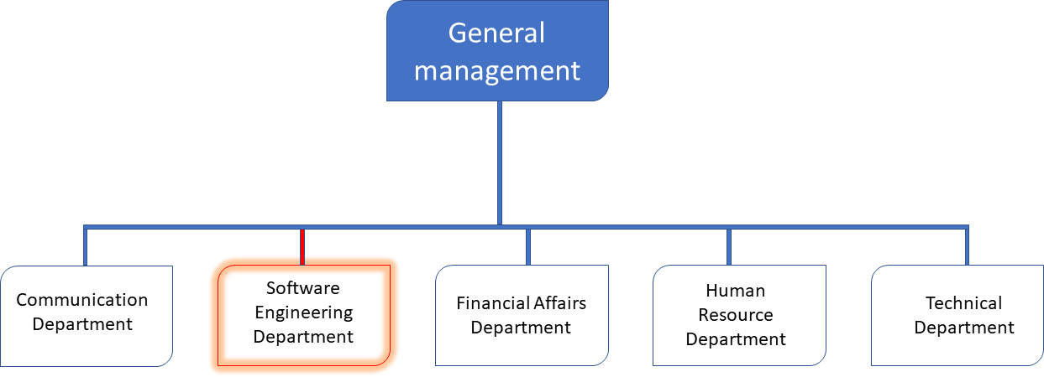

*Figure 1: Functional Organization of Mickmaq*

# GEOGRAPHICAL LOCATION

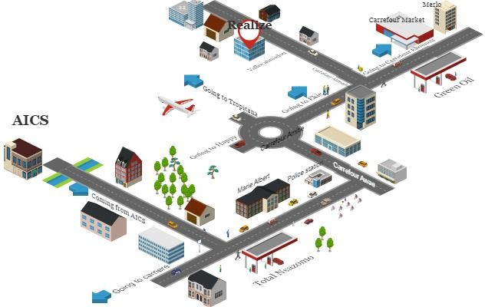

*Figure 2:* *GEOGRAPHICAL LOCATION OF MickMaq*

# BRIEF PRESENTATION OF THE PROJECT THEME

Following our arrival at MickMaq, we were encouraged to suggest innovative project ideas for our internship. Following the mission of MICKMAQ that demonstrate the company’s willingness to take active part in the sustainable development of the world through innovative solutions, we saw the room for creativity in our project idea and proposed the theme “**CONCEPTION AND REALIZATION OF AN ECOMMERCE PLATEFORM**”. This system that we named Calex optic is made up of an admin dashboard, ,Patient’s dashboard.

Calex optic’s patient’s dashboard provide the patients with a list of available hospitals from which he/she can get a list of trained medical personnels in various fields where they can book for an appointment for consultation or in cases of emergency locate the closest hospital or free health professional, a chat section for discussions with these medical professionals on light or less serious cases, a geolocalisation section where they can locate the different pharmacies that are opened at that particular time, that have the required drugs they are looking for and most importantly that are not far from their current position. Consultations are also made through video calls.

# CONCLUSION

Our insertion phase at MICKMAQ lasted for two (2) weeks. We discovered the amazing environment where we found ourselves in. This environment gives room for hard work, perseverance and collaboration, what most students are looking for. We learned about the missions of the company, its activities. We met and got acquainted with the staff and other interns at MICKMAQ. Finally, we chose our theme “**DEVELOPMENT OF A PATIENTS’ CONSULTATION AND FOLLOW-UP PLATFORM FOR CAMEROON GOVERNMENT HOSPITALS**”.

**PART III**

**SPECIFICATION BOOK**

# Preamble

The Specification book is a document which is been established by the customer needing a particular product and the producer (engineer) who is to create the product, which is to be respected to its fullness during the realization of the product. From this, we obtain the major importance of the specification book.

Content

PLAN

INTRODUCTION

1. CONTEXT
2. PROBLEM DEFINITION
3. OBJECTIVES OF THE PROJECT
4. EXPRESSION OF NEEDS
5. PROJECT PLANNING
6. DELIVERABLES

CONCLUSION

INTRODUCTION

IN order to efficiently Mickmaq our project “CONCEPTION AND REALIZATION OF AN ECOMMERCR PLATEFORM” it is important to create a specification book . The specification book of our report helps us provide details about our theme to improve our understanding of it and increase the likelihood of it succeeding. To delimitate the scope of our project, we will specify the context of our theme. From the context, we will list the problems we have decided to address throughout the project. After presenting our solution, we will talk about the objective we have set for the project. Also, we will explore the needs to which our system will respond both at the functional and non-functional level. We will then look at the estimated financial requirements for our project and establish a plan we will follow to complete our project on time. From here, we will discuss what is expected of us by the end of the project under the project deliverables

1. CONTEXT–

E-commerce ,also known as electronic commerce , refers to the buying and selling of goods or services over the internet .In recent years ,the rapid growth of the internet has facilitated the widespread adoption of e-commerce ,enabling business of all