**Planning**

In planning, the internet research was conducted to gather some information on how the library management works, how the librarian manages the books, borrowed books, returned books, and all records of the students who are registered in the library. The observation resulted that a lot of the libraries have automated their systems but there are still some libraries where the librarian writes the records manually of every student who borrowed or returned the books. The student makes use of the form provided by the librarian.

**Analysis**

Without considering restrictions of hardware (e.g. computers), the Computerized Library System in question is based/designed solely from the users’ point of view. Additionally, the necessary system structures to achieve the designs are discussed. The overall view of the project is depicted through the implementation of flowcharts and diagrams in order to ensure that the processing and data flow can be simply understood.

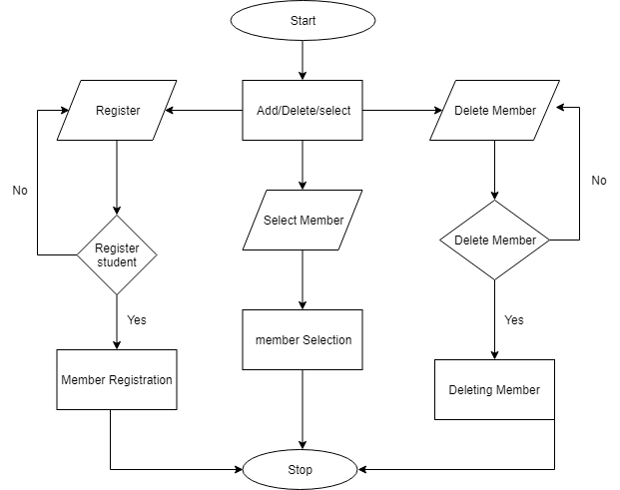

*Fig 3.2.1 – Select Member Flowchart*

Fig 3.2.1 shows the aspects of the member selection of the system. The flow chart shows three main functions Select, Register, Delete Member. The user can select the member by clicking ‘Select Member’ button to select the member from the registered members list. The user can also delete a certain member who does not want to have the library membership anymore by clicking the ‘delete’ button. The person who wants to borrow a book but is not registered in the library, the librarian can register him by pressing the ‘register’ button.

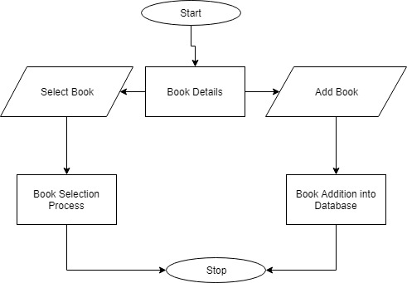

*Fig 3.2.2 – Book Details Flowchart*

Fig 3.2.2 shows the aspects of Book Details section, it shows two main functions Select Book, Add Book. The user can select the book by clicking ‘Select Book’ button to select the book that the member wants to borrow. The system will not allow the user to select the book that is already being borrowed. When the management brings new set of books to the library, the librarian can add them to the system as there is an option in the system for adding books in the database, the user can add new books to the database by clicking ‘ADD’ button.

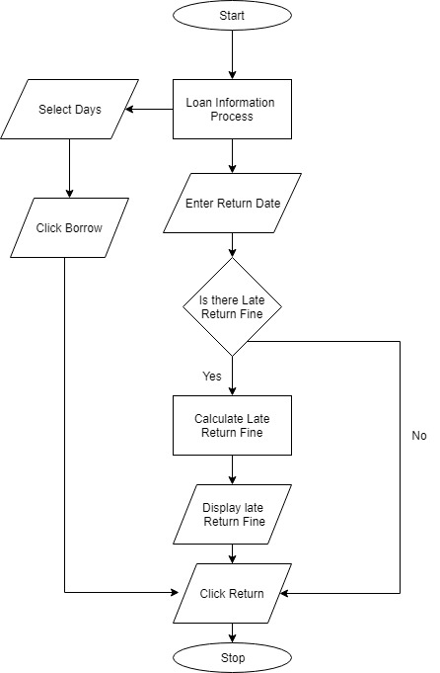

*Fig 3.2.3 Loan Information Flowchart*

Fig 3.2.3 shows the aspects of Loan Information sections where the user can lend out books to the members. Here the user can select the total numbers of days that the member wants to borrow the book for then the user clicks the ‘Borrow’ button to lend the book. The program will also automatically calculate the late return fine if the member returns the book after the due date has passed. This process will execute when the user enters the valid return date in the ‘date return’ textbox and clicks the ‘Date Return’ button.

# IMPLEMENTATION DETAILS

Implementation is the stage of the project when the theoretical design is turned out into a working system. Thus it can be considered to be the most critical stage in achieving a successful new system to be used. The implementation stage involves careful planning, investigation of the existing system and its constraints on implementation. The three main sections implemented in this project are the selecting Members who wants to borrow a book, selecting the book that they wish to borrow and the Library Loan Information, where the user can select days that the student wants to borrow the book for and calculate the fine if the book is returned late.

**4.1** **DESIGN IMPLEMENTATION**

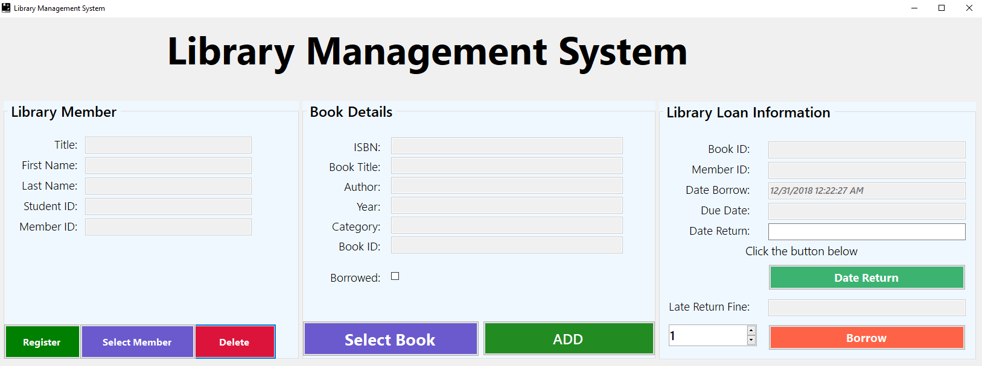

*Fig. 4.1.1 Main window*

Fig 4.1.1 shows the main window that shows the three main aspects of the system that are, ‘Library Member’, ‘Book Details’ and ‘loan Information’. In the Library Member section the user can see all the list of the members by clicking ‘Select Member’ Button. The user can register new members by clicking the ‘Register button under the Library Member’ section. The user can also delete any registered member from the database by clicking ‘Delete’ button under the Library Member section.

Under the Book Details section the user can select the book that the member wants to borrow by clicking ‘Select Book’ button. When there are new books available in the library the user can add them to the database by clicking ‘Add’ button (see fig 4.1.5). Under the Loan Information section the user can select the number of days that the member wants to borrow the book for and by clicking the ‘Borrow’ button the system will save the book ID and the member ID in the database. When of returning the book the system automatically calculates the late return fine if the book is returned late. This process executes when the user clicks the ‘Date Return’ button (see fig 4.1.7).

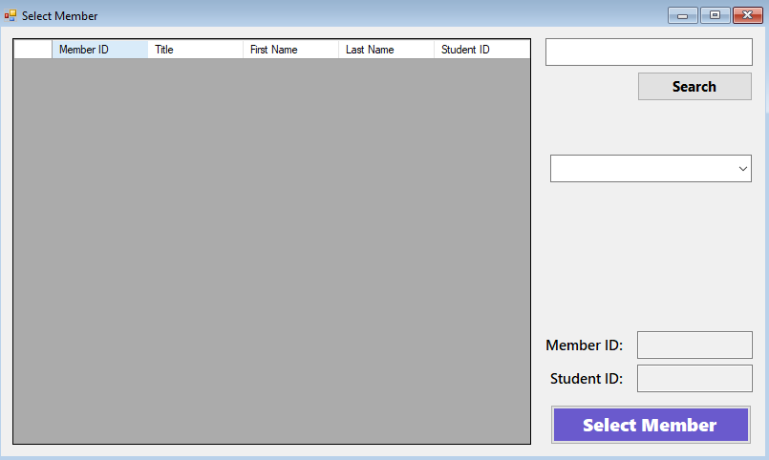

*Fig 4.1.2 Select Member Window*

The form in Fig 4.1.2 appears when the user clicks the register button under the Library Member section (see in fig 4.1.1). Here the user can select the registered member who wants to borrow a book from the library however if the person is not in the system the user can register him as shown in fig 4.1.3.

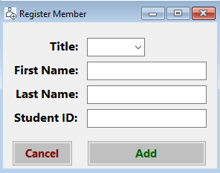

*Fig 4.1.3 Register Member Window*

The window in Fig 4.1.3 appears when the user clicks the Register button under Library Member section. Here the user can register new members by adding there details it is used for the registration of the new members.

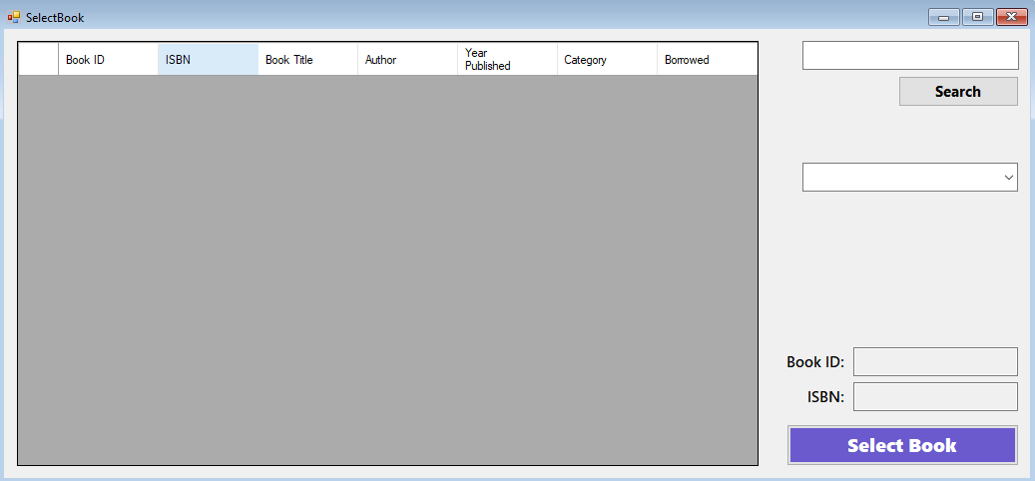

*Fig 4.1.4 Select Book Window*

The form in Fig 4.1.4 appears when the user clicks the ‘Select Book’ button under the Book Details section and it is used for selecting the book that a person wants to borrow. This window shows all the list of available book in the library. When the management get new books to the library the user can add all the new books in the system as shown in the fig 4.1.5.

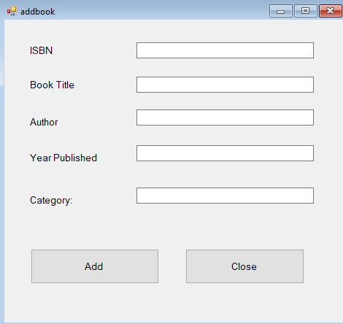

*Fig 4.1.5 Add Book Window*

The form in fig 4.1.5 appears when the user clicks the Add Button in the main window under the Book Details Section and it is used to add new books in the database. All the books added here will appear in the data grid view in the Book Selection window (see fig4.1.4)

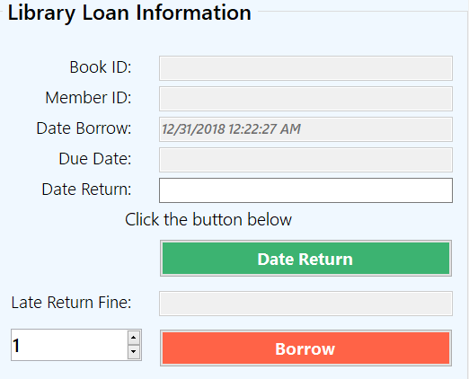

*Fig 4.1.6 Loan Information Window*

The library Loan Information section in fig 4.1.6 lets the user lend books to the members by clicking Borrow button and then it saves the data in the database. The user can select the number of days the member wants to borrow the book for. When the user clicks the ‘Date Return’ button the program automatically calculates the late return fine if the book is returned after the due date has passed as shown in the fig 4.1.7.

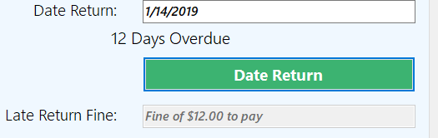

*Fig 4.1.7 Late Return Fine*

When the user clicks the ‘Date Return’ button the system automatically calculates the late return fine if the book is returned late. The user must enter a valid return date first in order to see if there is any late return fine. The system will show zero days overdue is the book is returned on time (see fig 4.1.7).