PROFESSIONAL PROFILE CAREER SUMMARY

I am an experienced designer with a proven track record for creating and maintaining functional, attractive, and responsive websites for a range of businesses.

COMPETENCIES

Coding Languages Marketing software
Various design programs Drawing programs

EDUCATIONAL TRAINING

ANYTOWN UNIVERSITY
Master of Computer Sciences 2019

ANYTOWN UNIVERSITY
Bachelor of Science 2017

ANYTOWN UNIVERSITY
Bachelor of Arts 2015

LEAD SITE DESIGNER
Anywhere Labs | May 2020 to present Planned site designs
Lead UX Reviewer
Raised UX scores by 66%.
Managed typography and branding Built wireframes & prototypes

WEBSITE DEVELOPER
Anytown Designs | Sept. 2018 to May 2020 Planned site designs
Lead UX Reviewer
Raised UX scores by 66%.
Managed typography and branding Built wireframes & prototypes

WEBSITE DEVELOPER
Anytown Designs | Sept. 2015 to May 2018 Planned site designs
Lead UX Reviewer
Raised UX scores by 66%.
Managed typography and branding Built wireframes & prototypes

WEBSITE DEVELOPER
Anytown Designs | Sept. 2015 to May 2018 Planned site designs
Lead UX Reviewer
Raised UX scores by 66%.

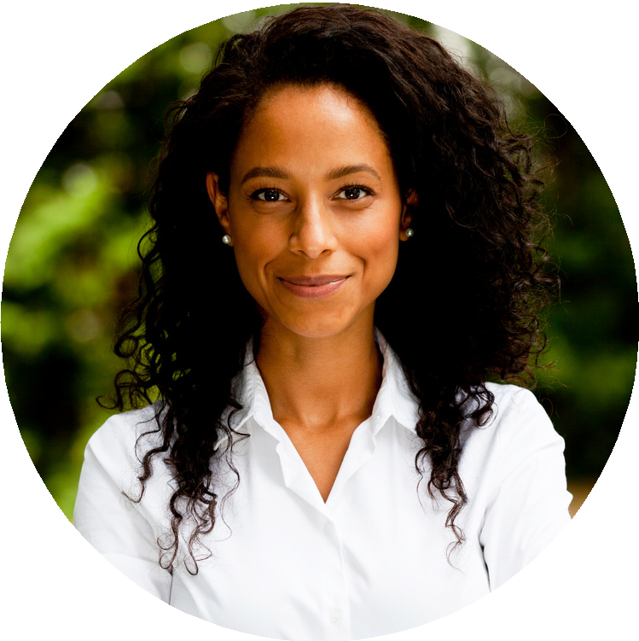
REACH ME
A N D R E A G I L L I S
WEBSITE DESIGNER
PROFESSIONAL
FOCUSED
COLLABORATIVE
 123-456-7890
 hello@reallygreatsite.com

www.reallygreatsite.com

COURSES

Advanced Coding UX/UI Academy
Beginners Design Advanced Design Advanced Coding

