# PROFESSIONAL PROFILE CAREER SUMMARY

I am an experienced designer with a proven track record for creating and maintaining functional, attractive, and responsive websites for a range of businesses.

# COMPETENCIES

 Coding Languages  Marketing software

 Various design programs  Drawing programs

# EDUCATIONAL TRAINING

## ANYTOWN UNIVERSITY

Master of Computer Sciences 2019

## ANYTOWN UNIVERSITY

Bachelor of Science 2017

## ANYTOWN UNIVERSITY

Bachelor of Arts 2015

## LEAD SITE DESIGNER

Anywhere Labs | May 2020 to present  Planned site designs

 Lead UX Reviewer

 Raised UX scores by 66%.

 Managed typography and branding  Built wireframes & prototypes

## WEBSITE DEVELOPER

Anytown Designs | Sept. 2018 to May 2020  Planned site designs

 Lead UX Reviewer

 Raised UX scores by 66%.

 Managed typography and branding  Built wireframes & prototypes

## WEBSITE DEVELOPER

Anytown Designs | Sept. 2015 to May 2018  Planned site designs

 Lead UX Reviewer

 Raised UX scores by 66%.

 Managed typography and branding  Built wireframes & prototypes

## WEBSITE DEVELOPER

Anytown Designs | Sept. 2015 to May 2018  Planned site designs

 Lead UX Reviewer

 Raised UX scores by 66%.

# REACH ME

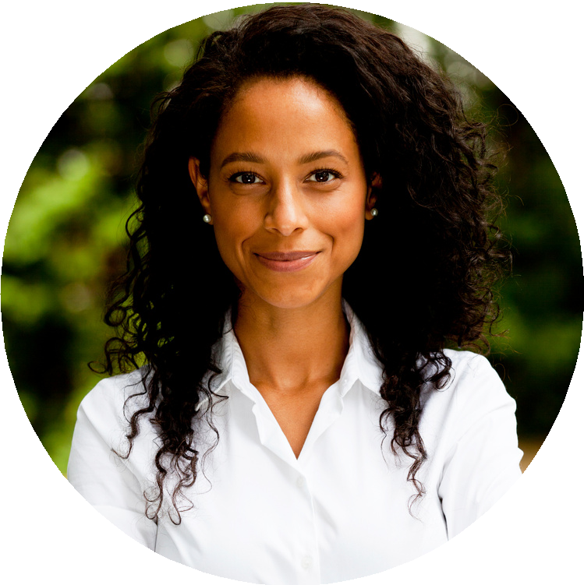

A N D R E A G I L L I S

WEBSITE DESIGNER

PROFESSIONAL

FOCUSED

COLLABORATIVE

 123-456-7890

 [hello@reallygreatsite.com](mailto:hello@reallygreatsite.com)

[www.reallygreatsite.com](http://www.reallygreatsite.com/)

# COURSES

 Advanced Coding  UX/UI Academy

 Beginners Design  Advanced Design  Advanced Coding