Kali Linux Lab Setup and Network Configuration (WK1-PM1)

📌 Project Overview
This project documents how I set up a cybersecurity practice lab on my own laptop using VirtualBox and Kali Linux, on a private NAT (Network Address Translation) network, and the problems I solved along the way.
The purpose of the lab is to create a safe, controlled environment for repeated hands-on practice with cybersecurity tools, such as network scanning, reconnaissance and vulnerability assessment.
The lab runs on a private virtual network, so I can add more machines later and use them as targets for authorized security testing.

Objectives
- Install and configure VirtualBox
- Import and configure Kali Linux virtual machine (VM).
- Create a NAT network on the range 10.0.0.0/24.
- Give Kali a fixed IP (Internet Protocol) address: 10.0.0.2/24.
- Verify network connectivity for Kali Linux
- Turn on the shared clipboard, drag and drop, and a shared Downloads folder.
- Confirm that Kali has full internet access.
- Take a snapshot so the lab can be restored.

Purpose of the Lab
A safe, separate environment is needed to practise ethical hacking. This lab lets me test tools on virtual machines without touching my real files or network, and the snapshot lets me undo mistakes quickly.

⚙️Lab Environment Configuration

Component | Configuration Details
💻 Host machine | HP laptop (my laptop)
🖥️ Host OS (Operating System) | Windows 11 Pro
🧠 Host RAM  (Random Access Memory) | 8GB
⚡ Host processor | Intel Core i5
🧰 Virtualization software | VirtualBox 7.2.10
🐉 Attacking machine | Kali Linux (VM named KALI 1)
🧠 Kali Linux RAM | 4200 MB
⚡ Kali Linux CPUs  (Central Processing Units) | 2
💿 VM disk | 75.51GB
🌐 Virtual network | NatNetwork, 10.0.0.0/24, DHCP (Dynamic Host Configuration Protocol) enabled
📡 Network address | 10.0.0.0/24
🐧Kali Linux IP Address | 10.0.0.2/24
🚪 Default gateway | 10.0.0.1
🌍 DNS (Domain Name System) server | 8.8.8.8
🔌 Network interface | eth0
🌐Subnet mask | 255.255.255.0 (/24)
📁 Shared folder | Windows Downloads, mounted in Kali at /media/sf_Downloads
📸 Snapshot | "WK1 - Kali 10.0.0.2 configured"

🪜Lab Setup Procedure
- Installed VirtualBox 7.2.10 on Windows 11.
- Imported the Kali Linux virtual machine.
- Opened File > Tools > Network > NAT Networks and set the IPv4 prefix of NatNetwork to 10.0.0.0/24, with DHCP enabled.
- In the Kali VM settings, attach Adapter 1 to NAT Network (NatNetwork) and set Promiscuous Mode to Allow All.
- Under General > Features, set Shared Clipboard and Drag'n'Drop to Bidirectional.
- Lowered the VM from 3 virtual CPUs (Central Processing Units) to 2 to match my laptop.
- Under Shared Folders, added my Windows Downloads folder with Auto-mount and Make Global turned on.
- Started Kali and set a fixed IP address with the Network Manager command line tool (nmcli).
- Tested the network, shared folder and clipboard.
- Shut the VM down and took a snapshot.

Commands Used
Check the IP address:
ip a
Set a fixed IP address, gateway and DNS server:
sudo nmcli connection modify "Wired connection 1" ipv4.method manual ipv4.addresses 10.0.0.2/24 ipv4.gateway 10.0.0.1 ipv4.dns 8.8.8.8
Turn off the DAD (Duplicate Address Detection) delay:
sudo nmcli connection modify "Wired connection 1" ipv4.dad-timeout 0
Restart the connection so the changes apply:
sudo nmcli connection down "Wired connection 1"
sudo nmcli connection up "Wired connection 1"
Test internet access and DNS:
ping -c 4 google.com
Check the shared folder:
ls /media/sf_Downloads

Verification Results
Test | Result
Kali IP address is 10.0.0.2/24 (ip a) | Successful
Internet and DNS (ping -c 4 google.com: 4 of 4 replies, 0% packet loss) | Successful
Shared Downloads folder visible in Kali | Successful
Shared clipboard between Windows and Kali | Successful
Drag and drop | Worked once, then unreliable
Snapshot taken | Successful

Problems I Faced and How I Fixed Them
- Wrong network range. My NatNetwork was set to 10.0.2.0/24, so Kali received 10.0.2.15 automatically. I changed the IPv4 prefix to 10.0.0.0/24 and set the fixed address 10.0.0.2.
- CPU warning. VirtualBox warned that I had given the VM more virtual CPUs (3) than my laptop has (2). I reduced it to 2.
- Settings in different places. In this VirtualBox version the clipboard options are under General > Features, and the shared folder option is called "Make Global".
- Drag and drop was unreliable. It worked once, then showed "Can't drop data to guest". I used the shared Downloads folder and the shared clipboard to move files instead.

Lab Evidence

NAT network set to 10.0.0.0/24
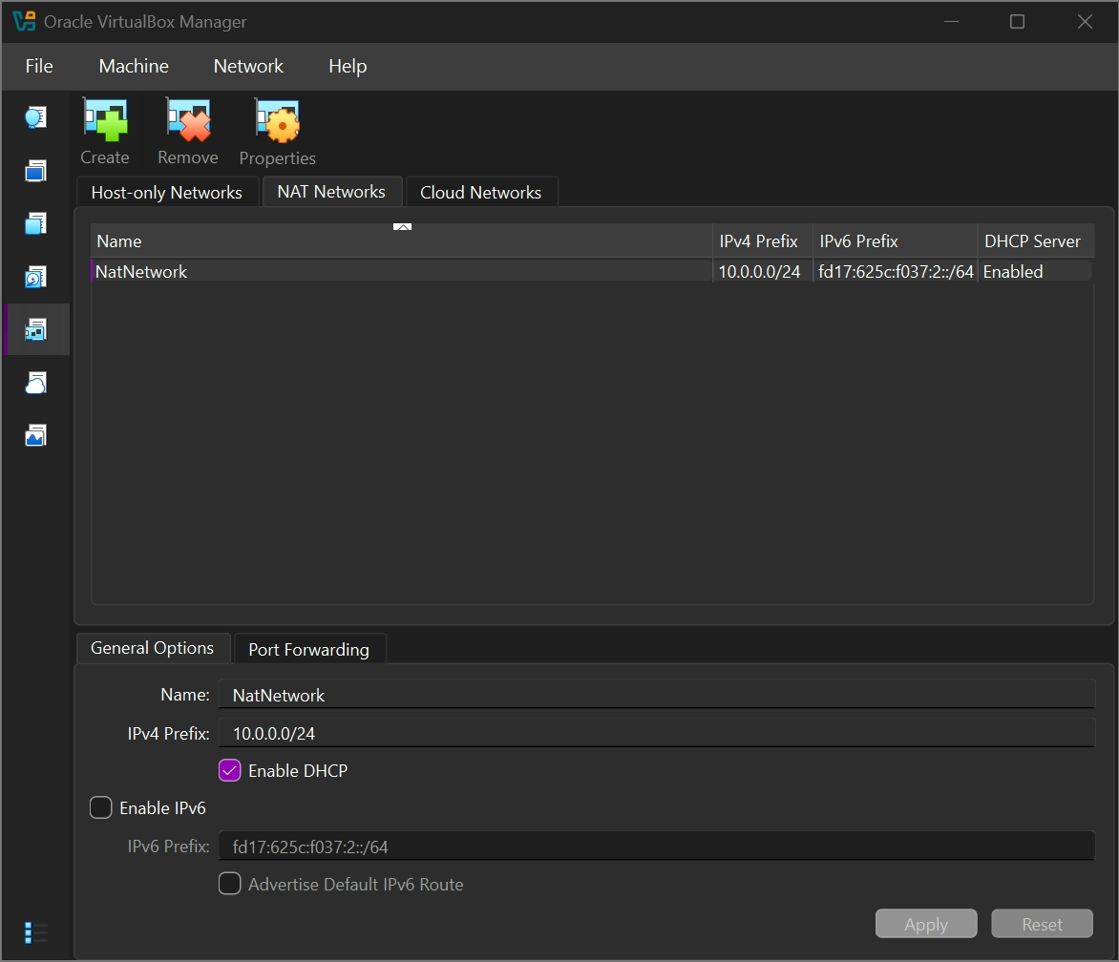

Kali IP address 10.0.0.2/24
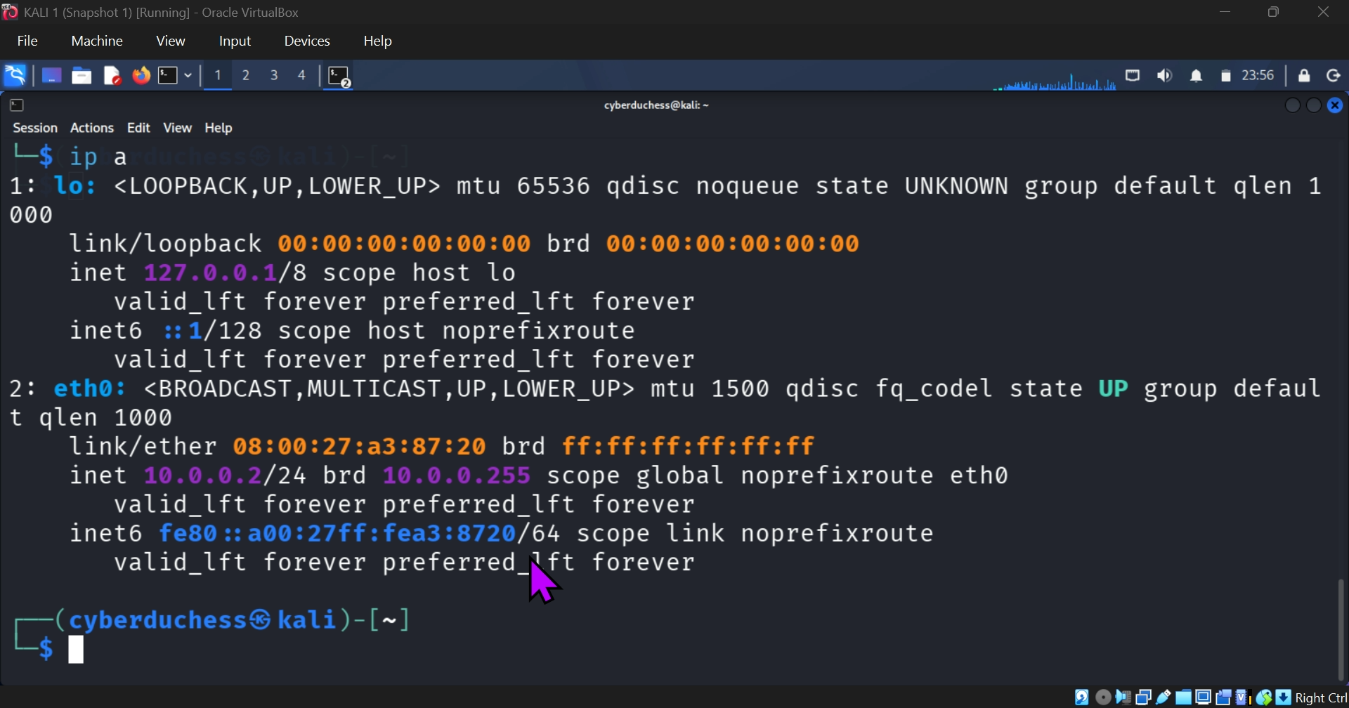

Internet check (ping google.com)
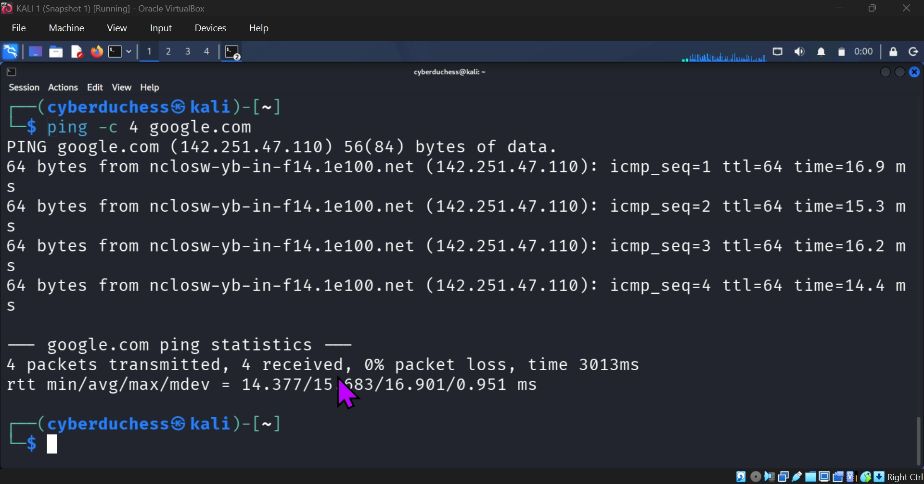

Shared Downloads folder
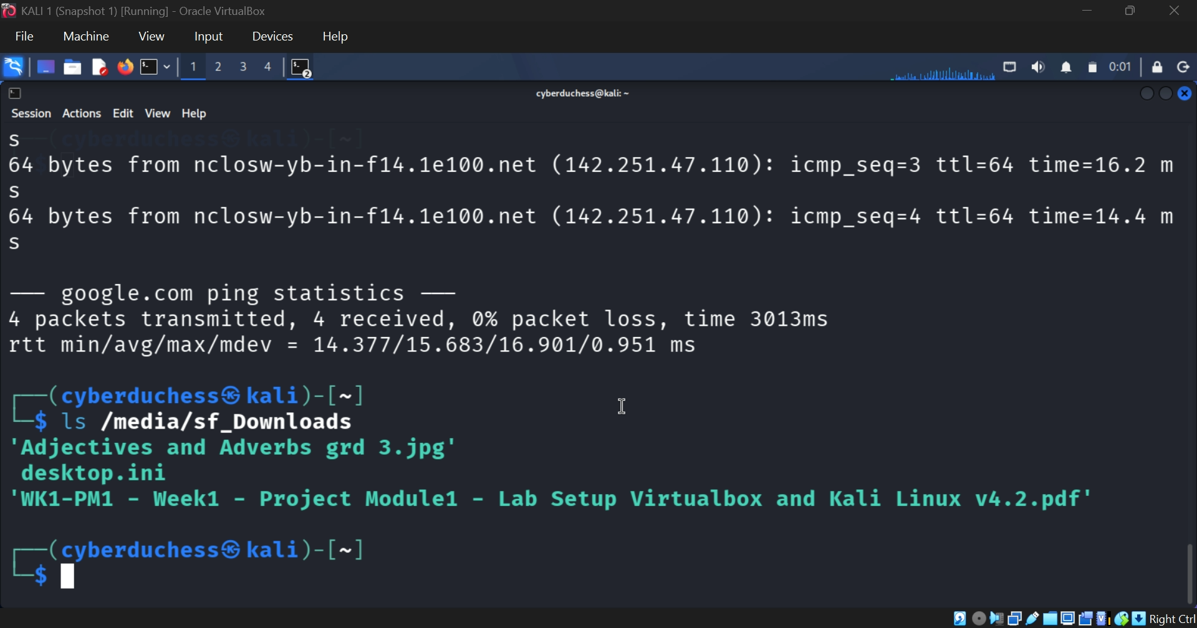

Snapshot
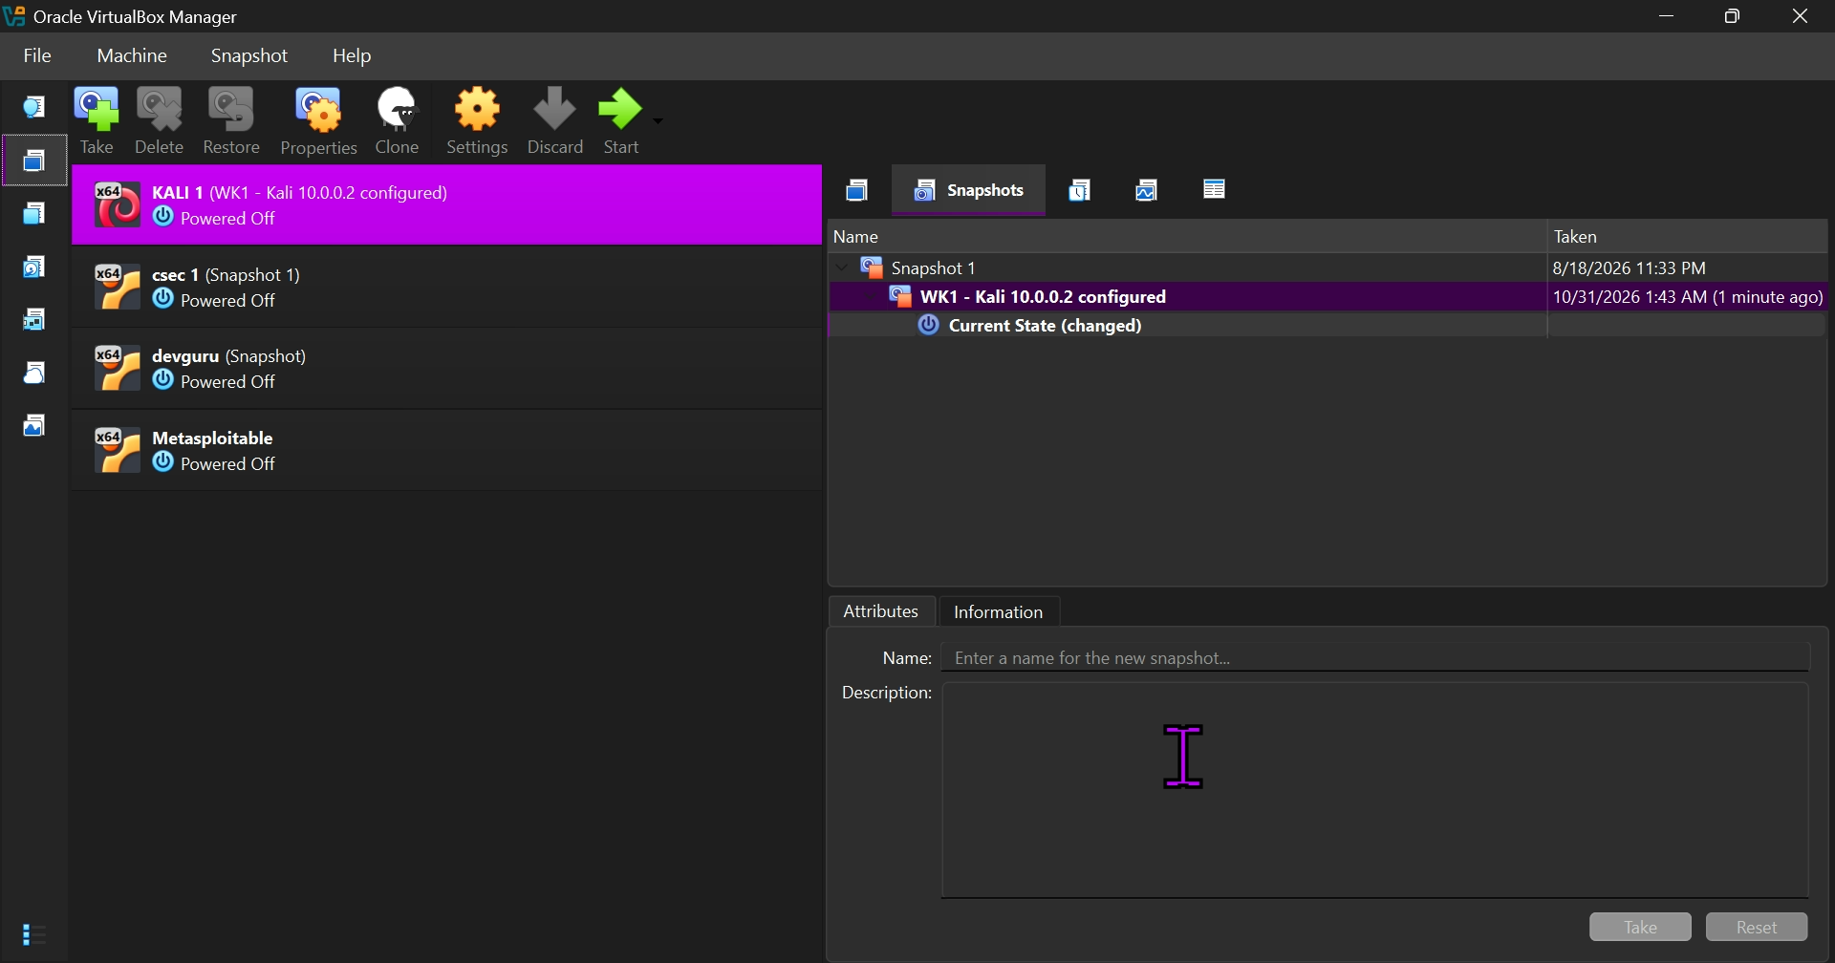

Problem: NAT network on the wrong range (10.0.2.0/24)
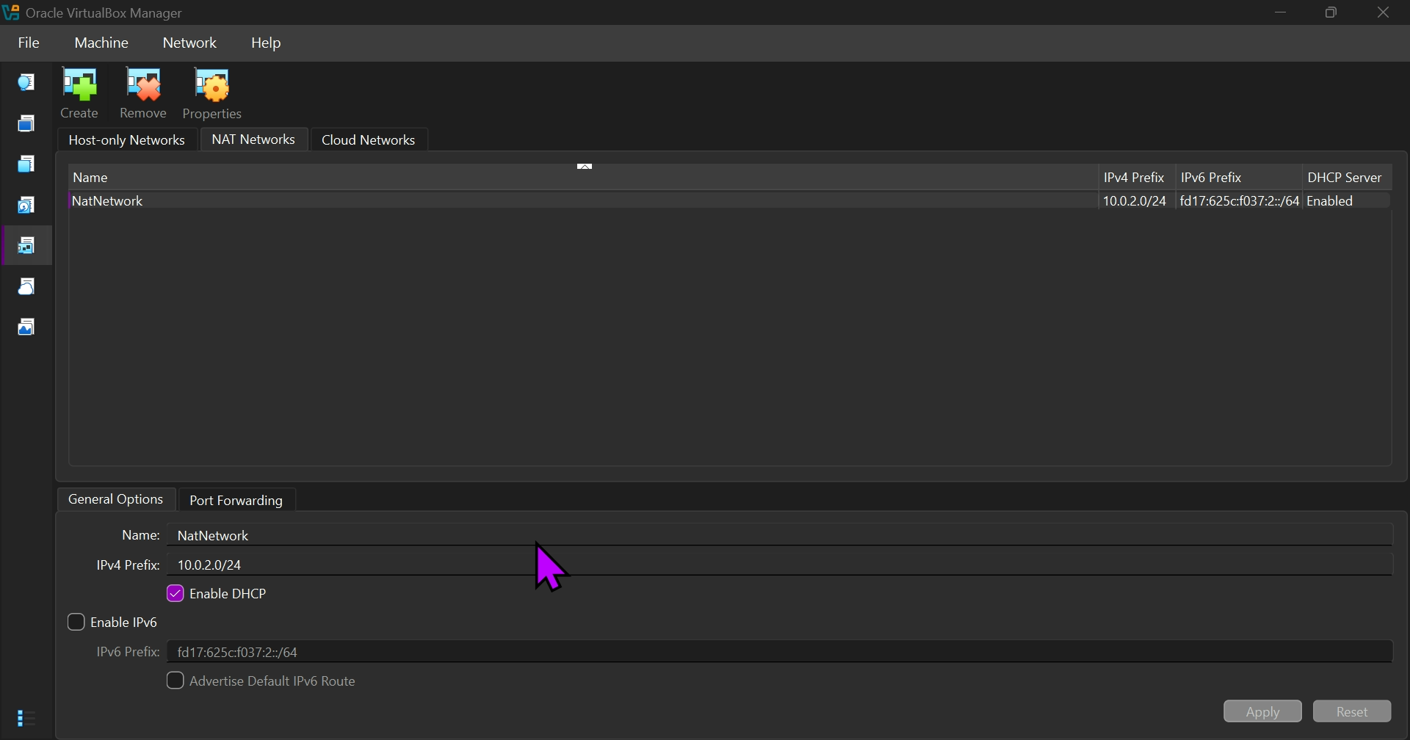

Problem: Kali received an automatic address (10.0.2.15)
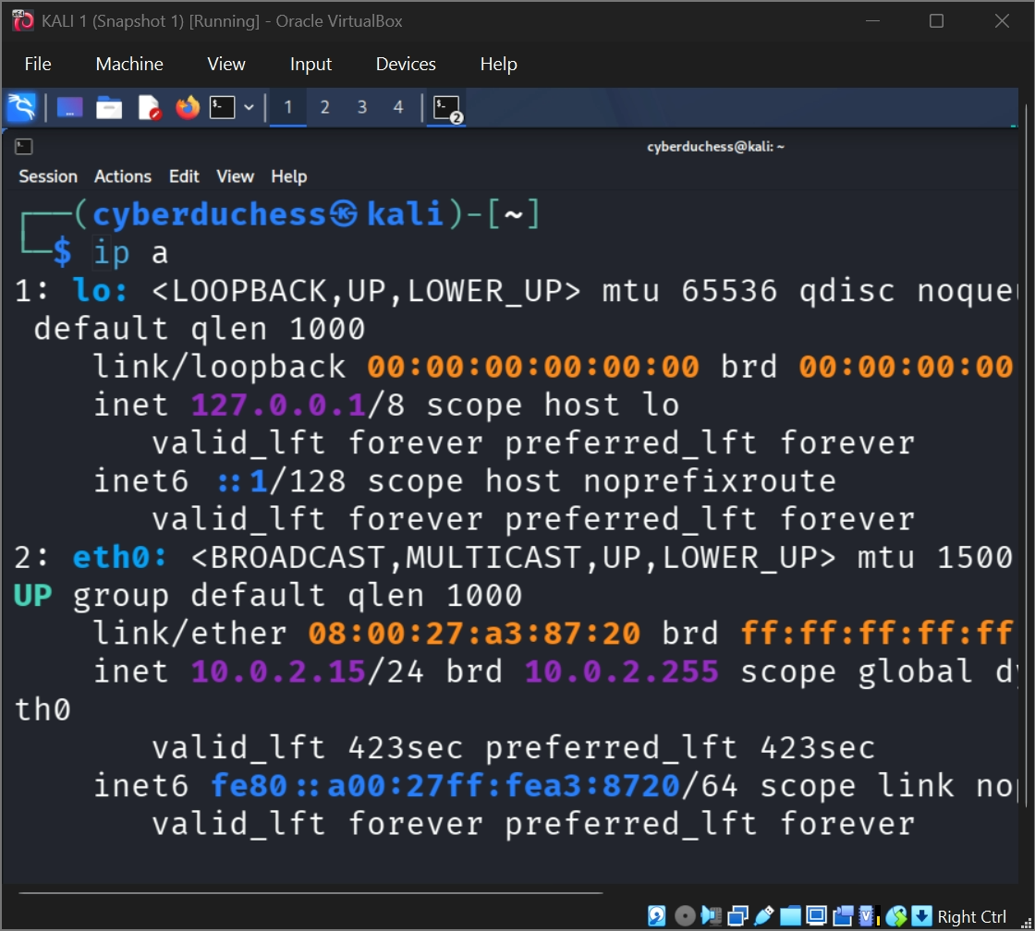

Key Learning Outcomes
- Building and configuring a virtual machine lab in VirtualBox.
- Creating a NAT network and choosing an IP range.
- Setting a fixed IP address, gateway and DNS server with nmcli.
- Testing connectivity with ping.
- Sharing files and the clipboard between a host and a virtual machine.
- Troubleshooting a wrong network range and a CPU setting.
- Documenting work with screenshots.

Author
Clementina Oluchi A.
Cybersecurity Personnel || Aspiring Ethical Hacker

