Cybersecurity & Ethical Hacking - Task 4 Submission
Name: Sameer Yadav
Target: DVWA (Damn Vulnerable Web Application)
Environment: Localhost (127.0.0.1)
Security Level: Low
Tools Used: Burp Suite Community Edition, DVWA, Web Browser

1. SQL Injection - Normal Request
Objective: Verify the normal functionality of the SQL Injection module before testing.
Observation: A valid User ID (1) was submitted through the application. Burp Suite successfully intercepted the GET request, allowing inspection of the request parameters, headers, and cookies. The application returned the details of the corresponding user, confirming that the application was communicating correctly with the backend database.
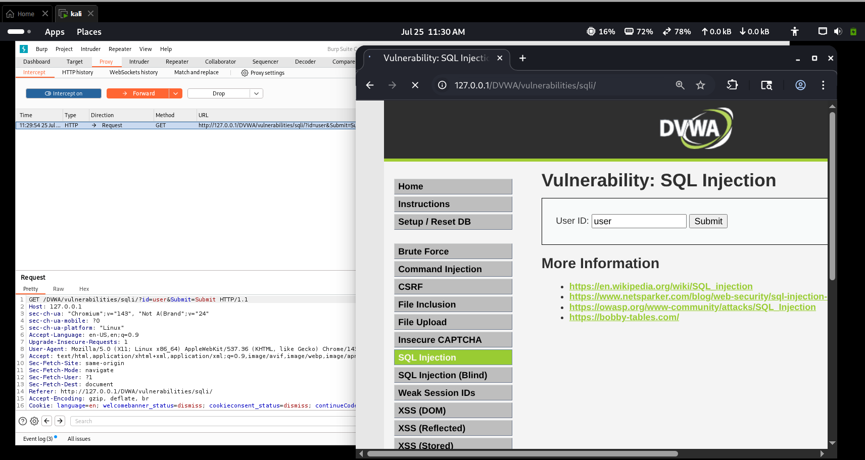
Figure 1: Burp Suite intercepting a normal SQL Injection request.
Analysis: The request contains the 'id' parameter submitted through the URL. Intercepting the request helps understand how user input is transmitted to the server.
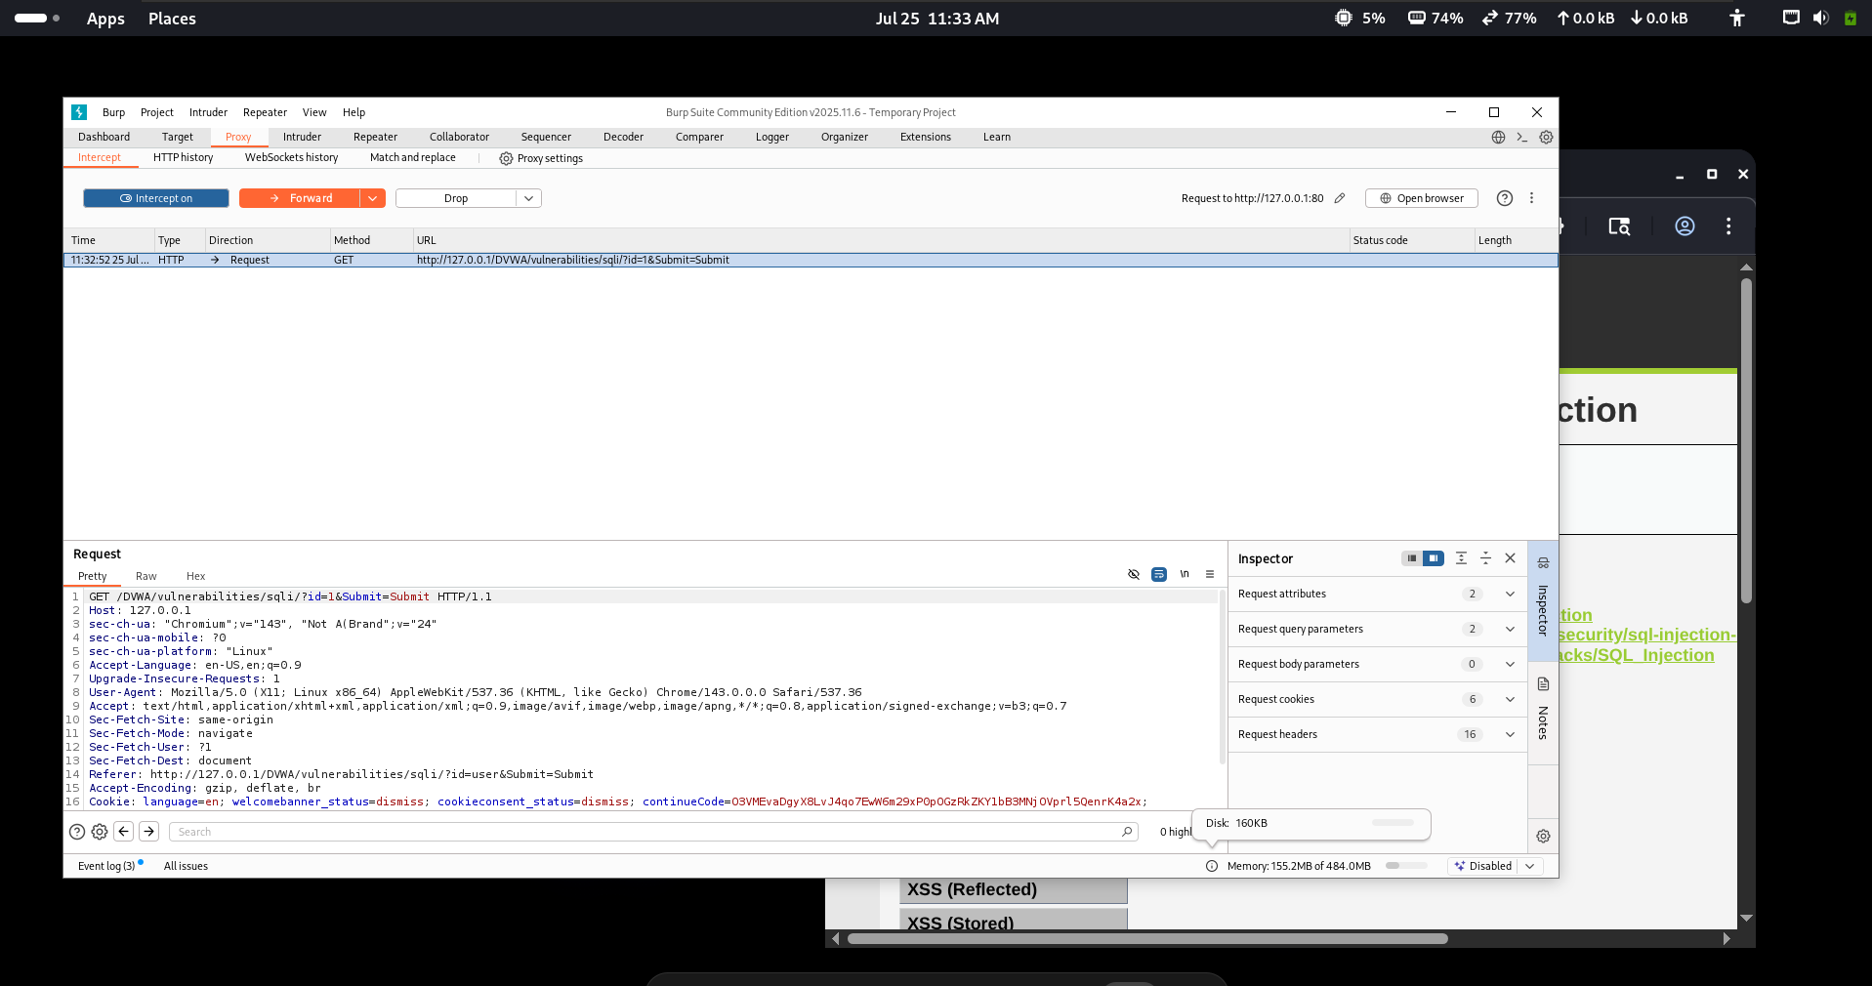
Figure 2: SQL Injection page before forwarding the intercepted request.
Analysis: The intercepted request was forwarded without modification to establish baseline application behavior.

2. SQL Injection - Vulnerability Demonstration
Objective: Observe how the application behaves when specially crafted input is supplied in the intentionally vulnerable lab.
Observation: The application accepted crafted SQL input and displayed multiple user records instead of a single record. This indicates that user input was incorporated into the SQL query without sufficient protection, demonstrating SQL Injection in the DVWA training environment.
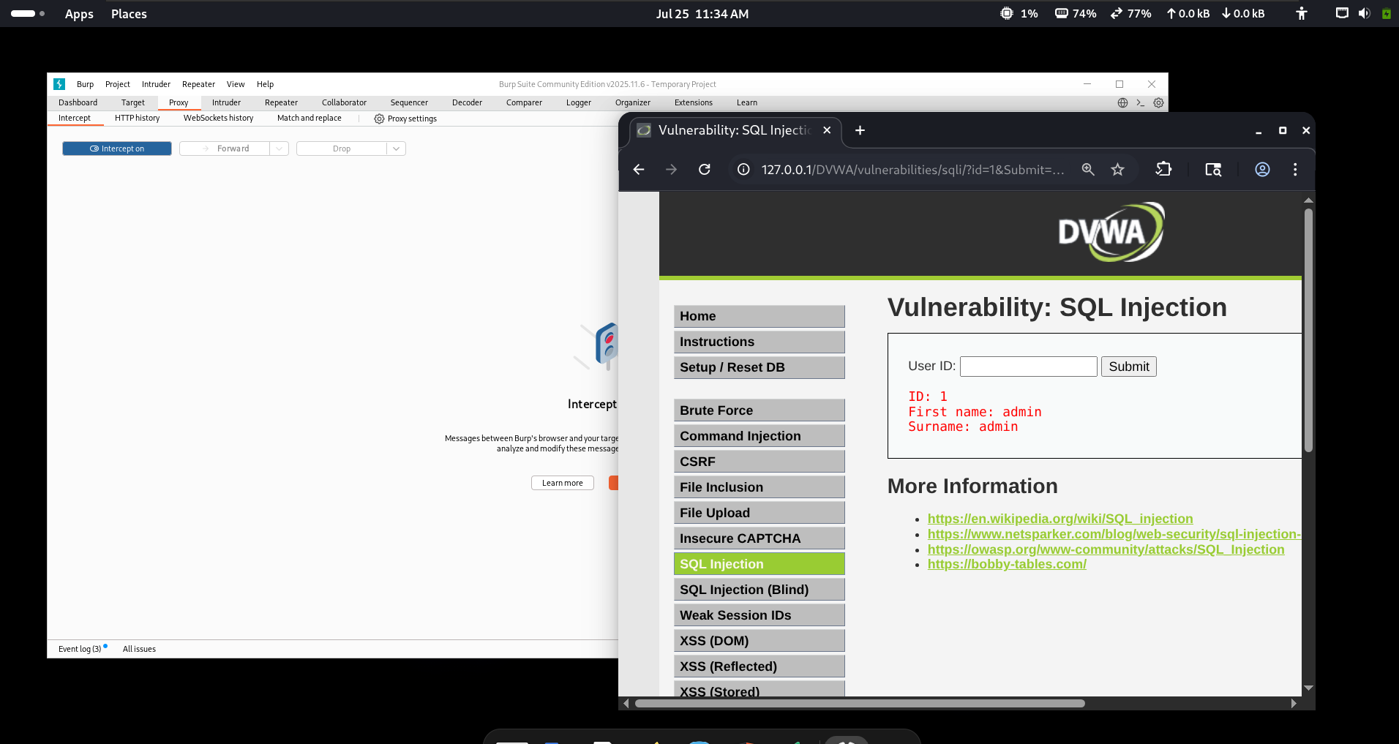
Figure 3: Successful retrieval of a valid user record (User ID 1).
Analysis: The application returned the expected record for User ID 1, confirming normal functionality.
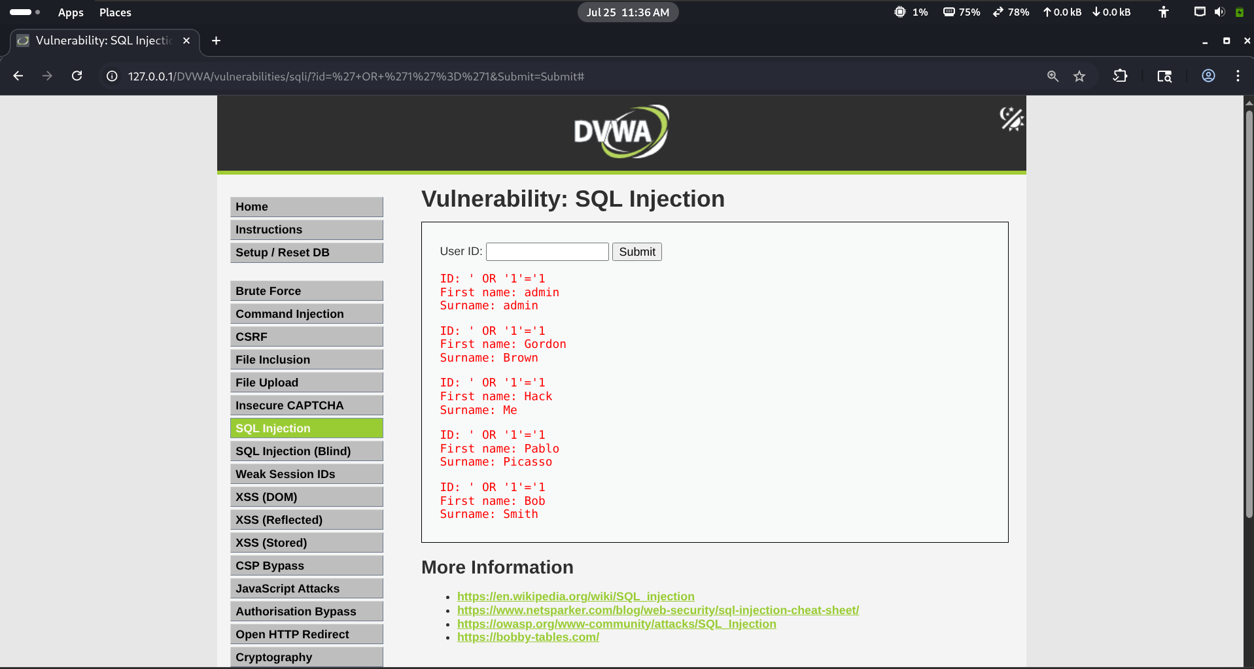
Figure 4: SQL Injection returning multiple records after crafted input.
Analysis: Multiple records were returned after crafted input, demonstrating the SQL Injection vulnerability intentionally present in DVWA.

3. Reflected Cross-Site Scripting (XSS)
Objective: Verify whether user input is reflected back to the browser without proper output encoding.
Observation: A normal value was first submitted and intercepted in Burp Suite. Later, JavaScript supplied through the input field executed in the browser, confirming that reflected input was rendered without adequate sanitization in the lab application.
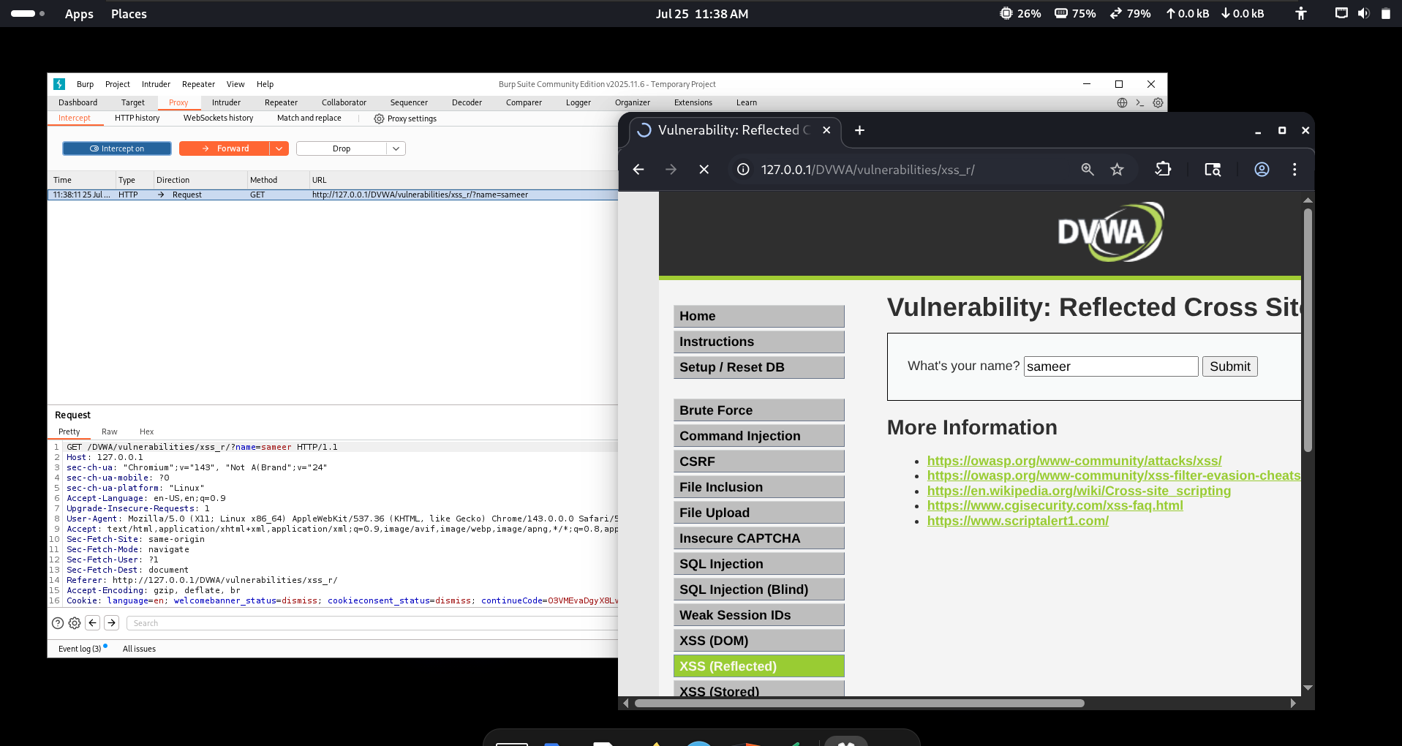
Figure 5: Additional evidence of the SQL Injection behavior.
Analysis: Multiple records were returned after crafted input, demonstrating the SQL Injection vulnerability intentionally present in DVWA.
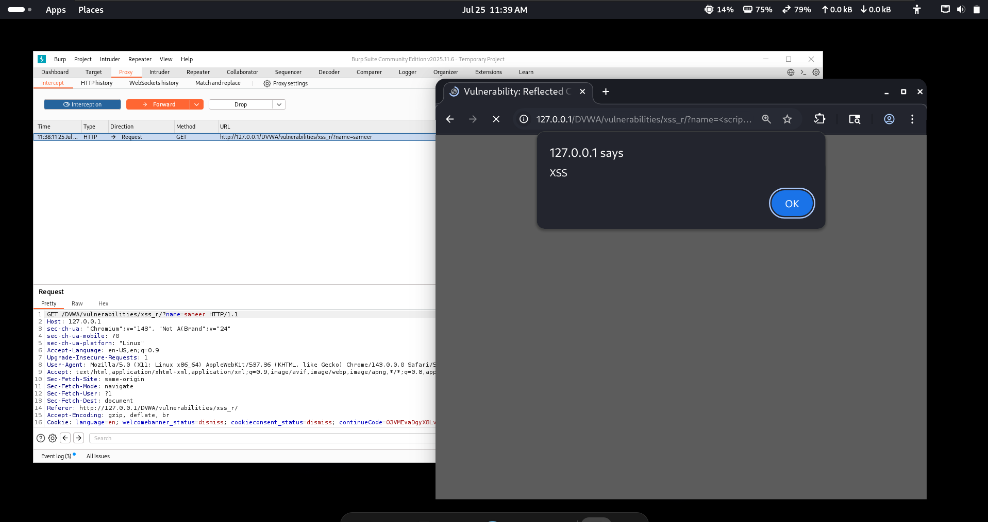
Figure 6: Burp Suite intercepting a normal Reflected XSS request.
Analysis: Burp Suite captured the reflected XSS request, showing the user-controlled parameter.

4. Directory & Application Reconnaissance
Objective: Perform basic reconnaissance against the local DVWA instance.
Observation: The application's pages and accessible resources were reviewed. This step helps identify publicly reachable functionality that may be useful during an authorized penetration test.
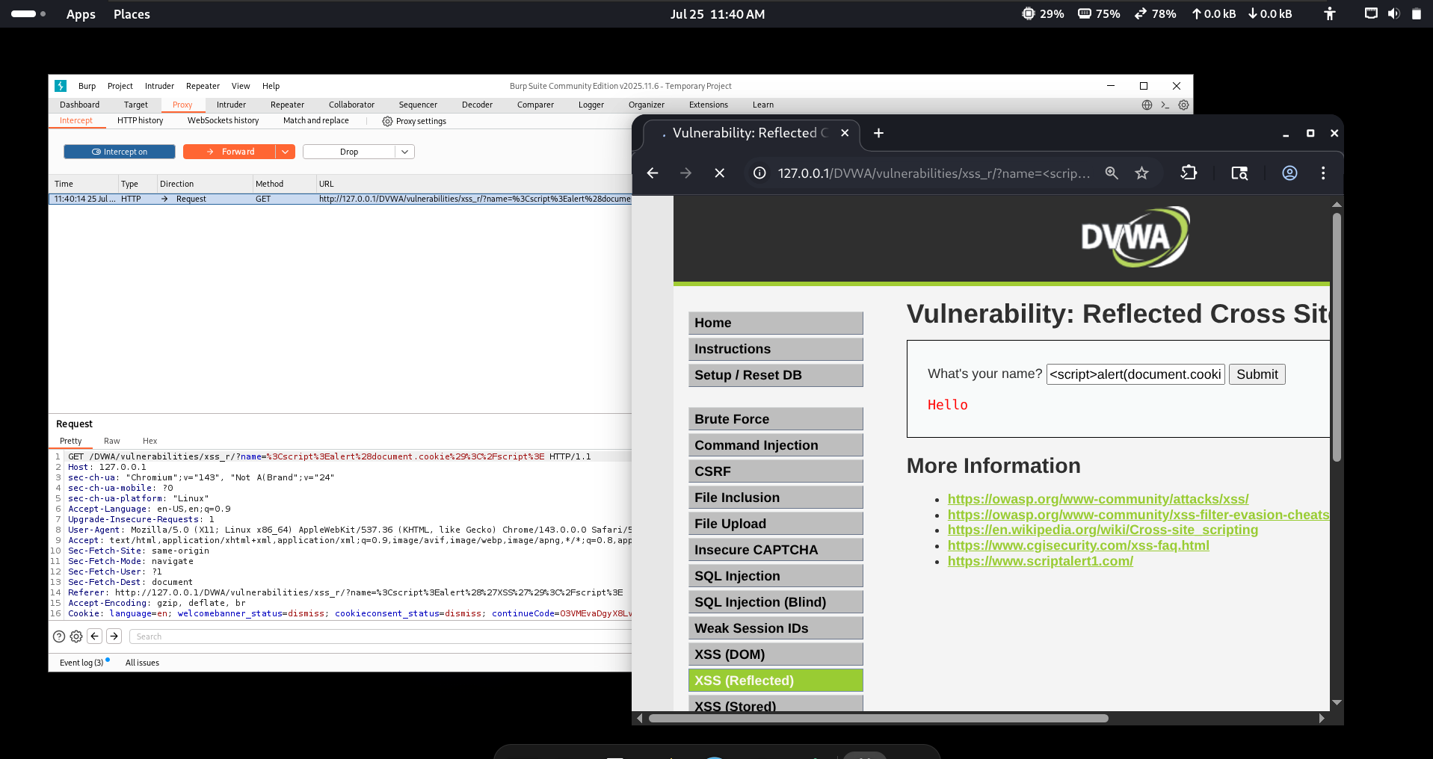
Figure 7: Reflected XSS page before testing.
Analysis: The page reflects user input back to the browser, making it suitable for reflected XSS testing.
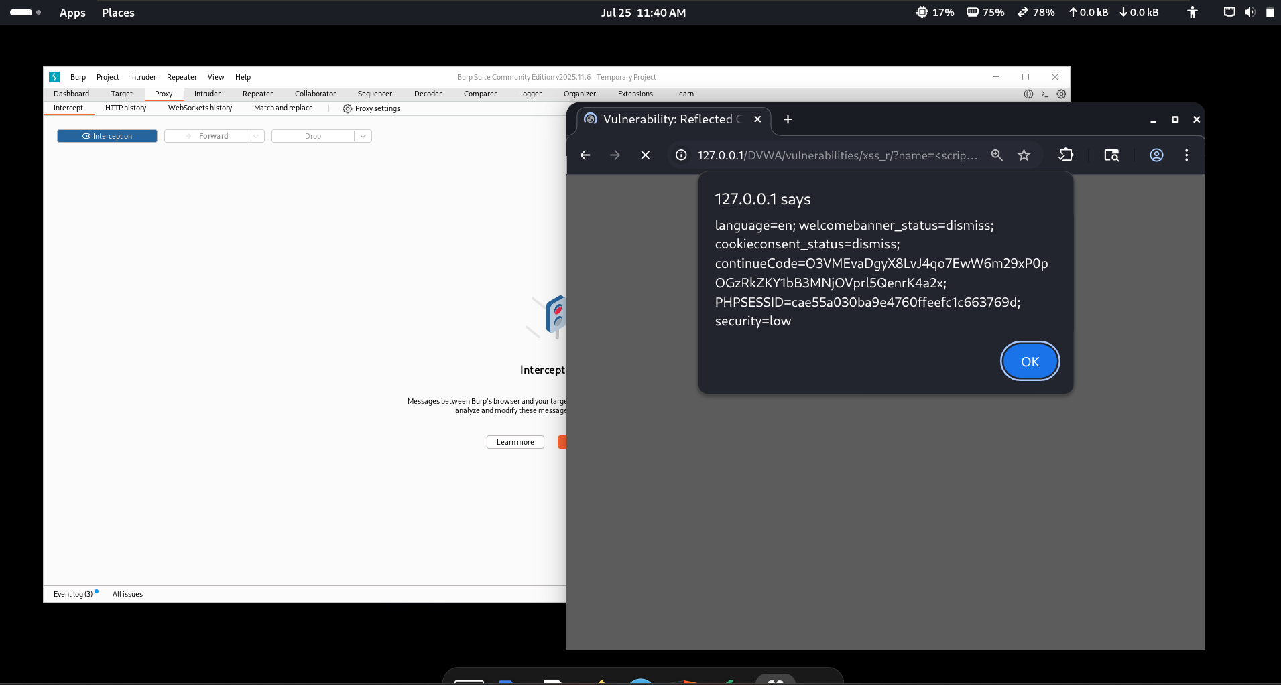
Figure 8: Browser executing the reflected JavaScript payload.
Analysis: The browser executed the supplied JavaScript, confirming reflected XSS.
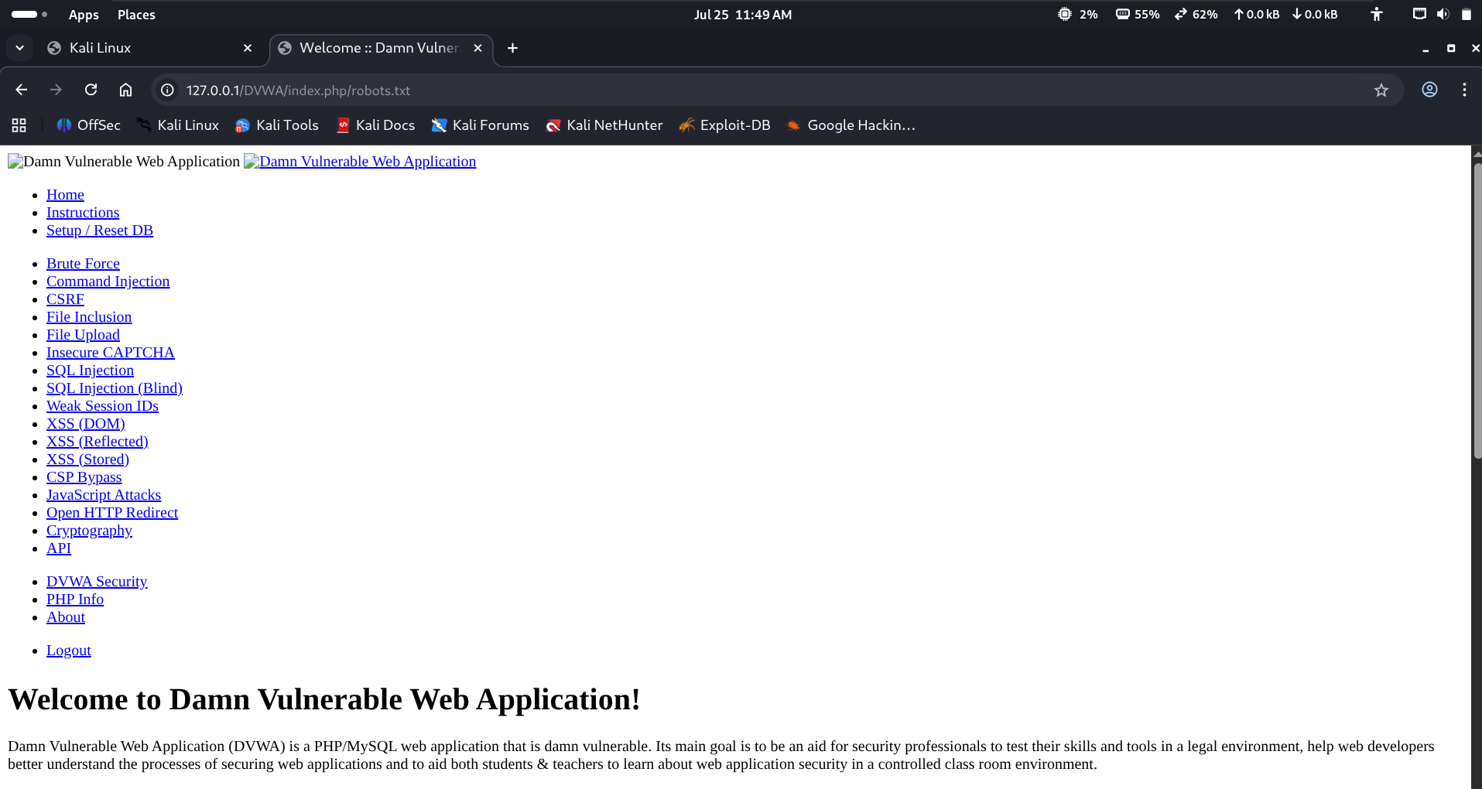
Figure 9: Demonstration of client-side access to cookie information in the DVWA lab.
Analysis: The demonstration showed client-side access to cookie information, highlighting the potential impact of XSS in a controlled lab.

Conclusion
The assessment was conducted only against the locally hosted DVWA training application. Burp Suite was used to inspect HTTP requests and responses, SQL Injection behavior was observed in the intentionally vulnerable module, and Reflected XSS was demonstrated in a controlled environment. These exercises improved understanding of common web application vulnerabilities and their impact.

