Web Application Development

20.2 PLY

Coursework – Research Document

**Part 1**

**Introduction the Sustainable Development Goals ( Agenda)**

UN Department of Economic and Social Affairs with the UN worked for decades since June 1992 with Agenda 21 adopting more than 178 countries up until September 2015 where the post 2015 development agenda was negotiated at the United Nations General Assembly and adopted on setting up achieving a collection of 17 goals by the year 2030 with the intention of been a “blueprint to achieve a better and a more sustainable future for all”.  
These goals were named as the **17 Sustainable Development Goals ( SDGs)**.

The 17 goals :

1 - **End poverty** in all its forms everywhere

2 - **End hunger**, achieve food security and improved nutrition and promote sustainable agriculture

3 - **Ensure healthy lives and promote well-being** for all at all ages

4 - Ensure inclusive and **equitable quality education** and promote lifelong learning opportunities for all

5 - Achieve **gender equality** and empower all women and girls

6 -Ensure availability and **sustainable management of water and sanitation** for all

7- Ensure access to **affordable, reliable, sustainable, and modern energy** for all

8- Promote sustained, inclusive, and **sustainable economic growth**, full and productive employment, and decent work for all

9- Build resilient infrastructure, promote inclusive and **sustainable industrialization and foster innovation**

10- **Reduce inequality** within and among countries

11- **Make cities and human settlements inclusive**, safe, resilient, and sustainable

12- Ensure **sustainable consumption and production** patterns

13- Take urgent action to combat **climate change** and its impacts*

14 - Conserve and **sustainably use the oceans, seas, and marine resources for sustainable development**

15 - Protect, restore, and promote sustainable use of terrestrial ecosystems, sustainably **manage forests, combat desertification, and halt and reverse land** degradation and halt biodiversity loss

16 - Promote peaceful and inclusive societies for sustainable development, **provide access to justice for all** and build effective, accountable, and inclusive institutions at all levels

17- Strengthen the means of implementation and revitalize the global partnership for sustainable development

As of the 2030 Agenda for Sustainable Development the main scope is in consideration to People, Planet, Prosperity, Peace and Partnership. The main aim of achieving these 17 goals was pointed out in the 2030 Agenda was to benefit the scope parties as mentioned.

The Sustainable Development Goals was signed by 193 countries globally, where they do trach the progress of each country within their 3 dimensions of Environment, Social and Economic developments. In long term, the SGDs will be a major factor to identify challenges, success turn and the gaps within the countries supporting the partnerships on identifying the best solutions and best practices. The agenda can also be known as the people centered process which would give the authority for human rights and gender sensitivity particularly focusing on the broken, vulnerable and the low rated citizens out there.

The 2030 agenda is following up a 3 level framework to be operated as of the National, Regional and the Global level where number of forum will be acting a role on each specific level.

The National level of sustainable development progress is conducted by the government of each country.

As of the Regional level, the 193 countries has been categorized as of 5 regions;

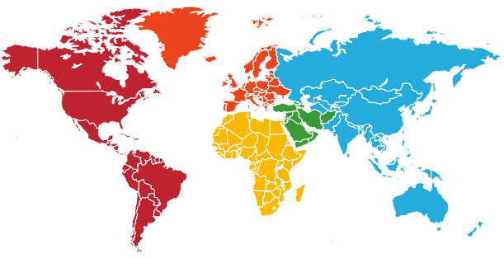

|  |  |  |
| --- | --- | --- |
| Region | Forum | Regulating Commission |
| Asia Pacific | Asia- Pacific Forum for Sustainable Development (APFSD) | Economics and Social Commission for Asia and the Pacific (ESCAP) |
| Africa | African Regional Forum on Sustainable Development ( ARFSD) | Economic Commission for Africa ( ECA) |
| Arab | Arab Forum on Sustainable Development ( ArFSD) | United Nations Economic and Social Commission for Western Asia (ESCWA) |
| Latin America and Caribbean | Forum of Countries of Latin American and the Caribbean on Sustainable Development | Economic Commission for Latin America and the Caribbean ( ECLAC) |
| Europe | Regional Forum on Sustainable Development (RFSD) | United Nations Commission for Europe (UNESCE) |

The global level of the framework is centrally reviewed by the UNITED NATIONS HIGH-LEVEL POLITICAL FORUM ON SUSTAINABLE DEVELOPMENT (HLPF) where it will be hosting several meetings in July annually in order to launch the annual SDG progress reports and the VNR reports which reviews the progress of regional perspective and on concentrating about the additional supporting tools for the countries undertaking the reviews.

Link to the 2030 Agenda for Sustainable Development - <https://sdgs.un.org/2030agenda>