

Subject Name:
Source Code Management
Subject Code:
CS181
Session:
2022-2023
Department:
B.E(CSE)

Submitted By: Submitted To:
Karan Arora Mrs. Neha Sharma 2210991749
G8-B
List of Programs
S. No | Program Title | Page No.
1 | Setting up of Git Client
2 | Setting up GitHub Account
3 | Generate logs
4 | Create and visualize branches
5 | Git life cycle description

Setting Of Git Client
STEPS:
- go to git-scm.com
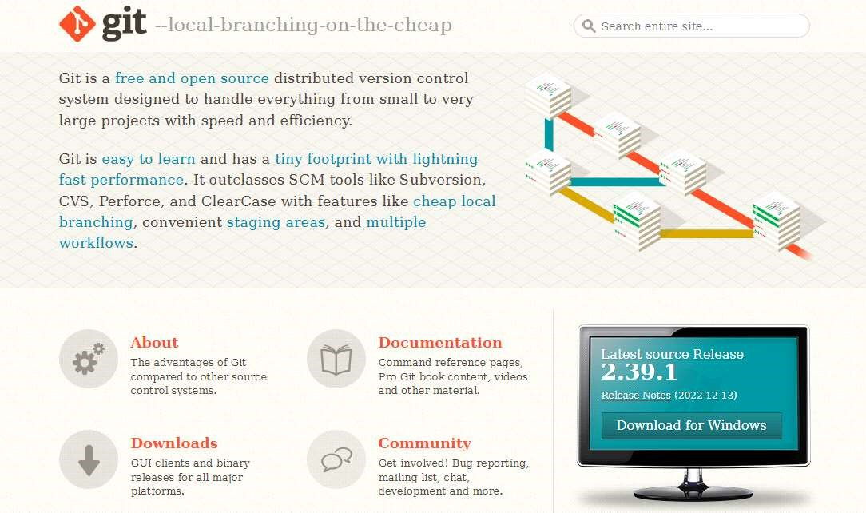
- click download for windows
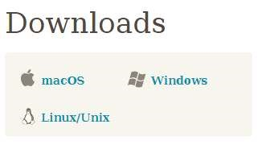
- click 64xbit for windows setup
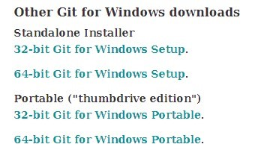
- run.exe file

5). Installing git.
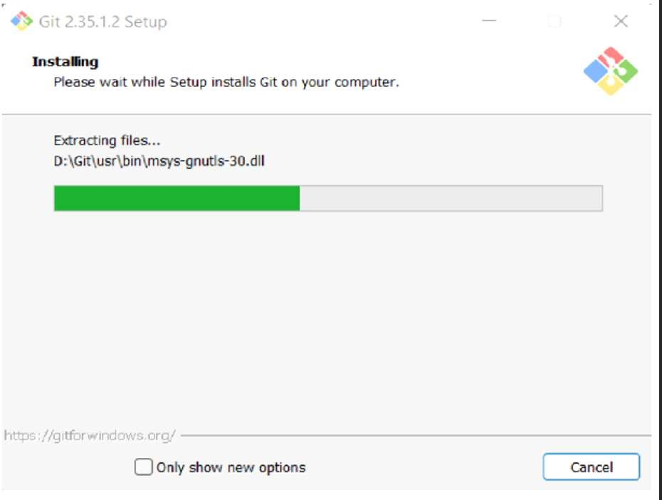
6).Launch the git bash/terminal
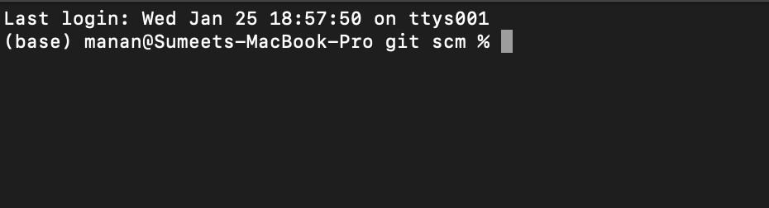
Setting Up GitHub Account
STEPS:
- go to github.com
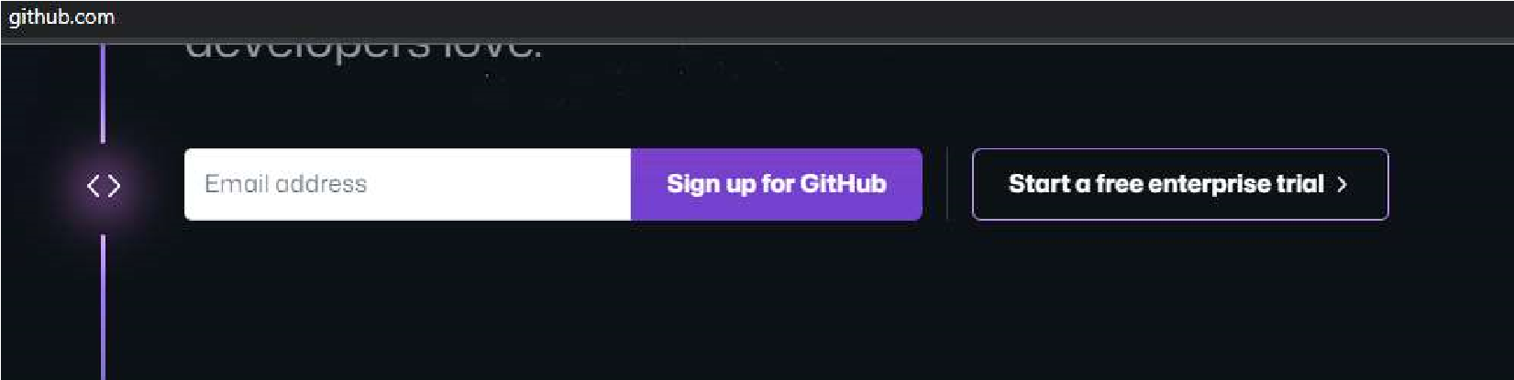
- Enter your email address

- Create a password

4). Setup your account.
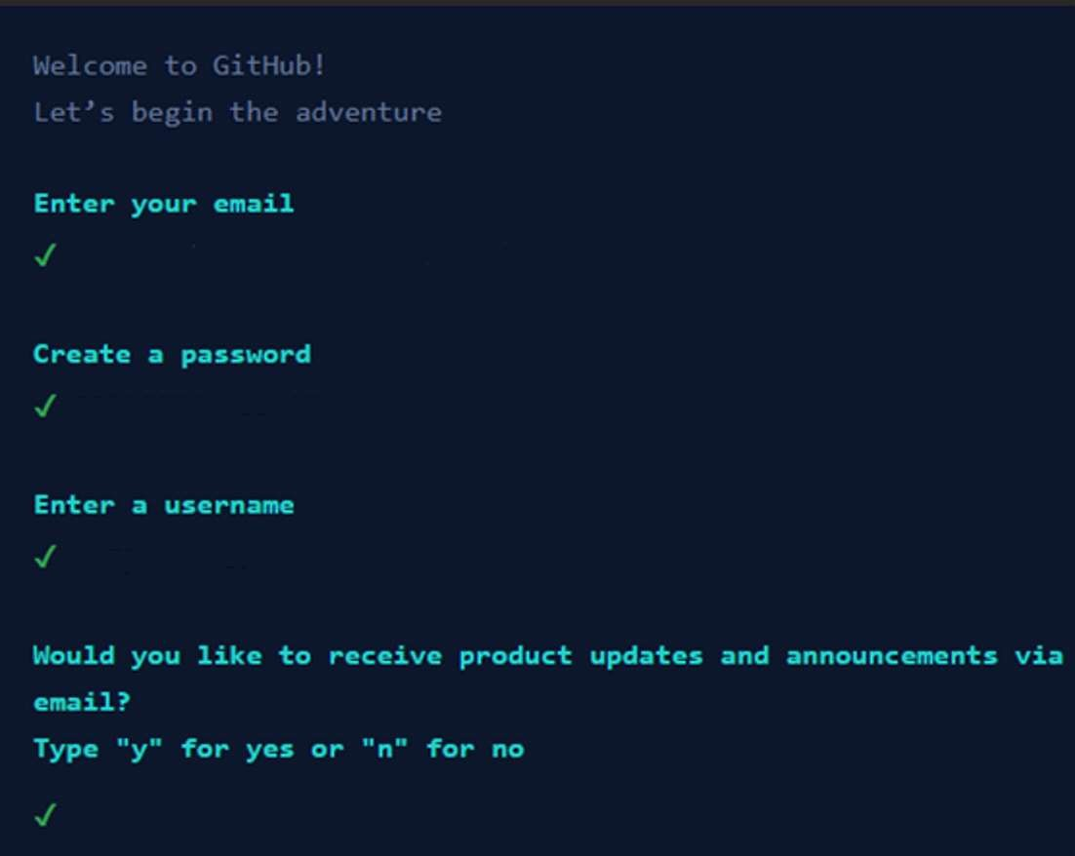
5). Your account has been setup.
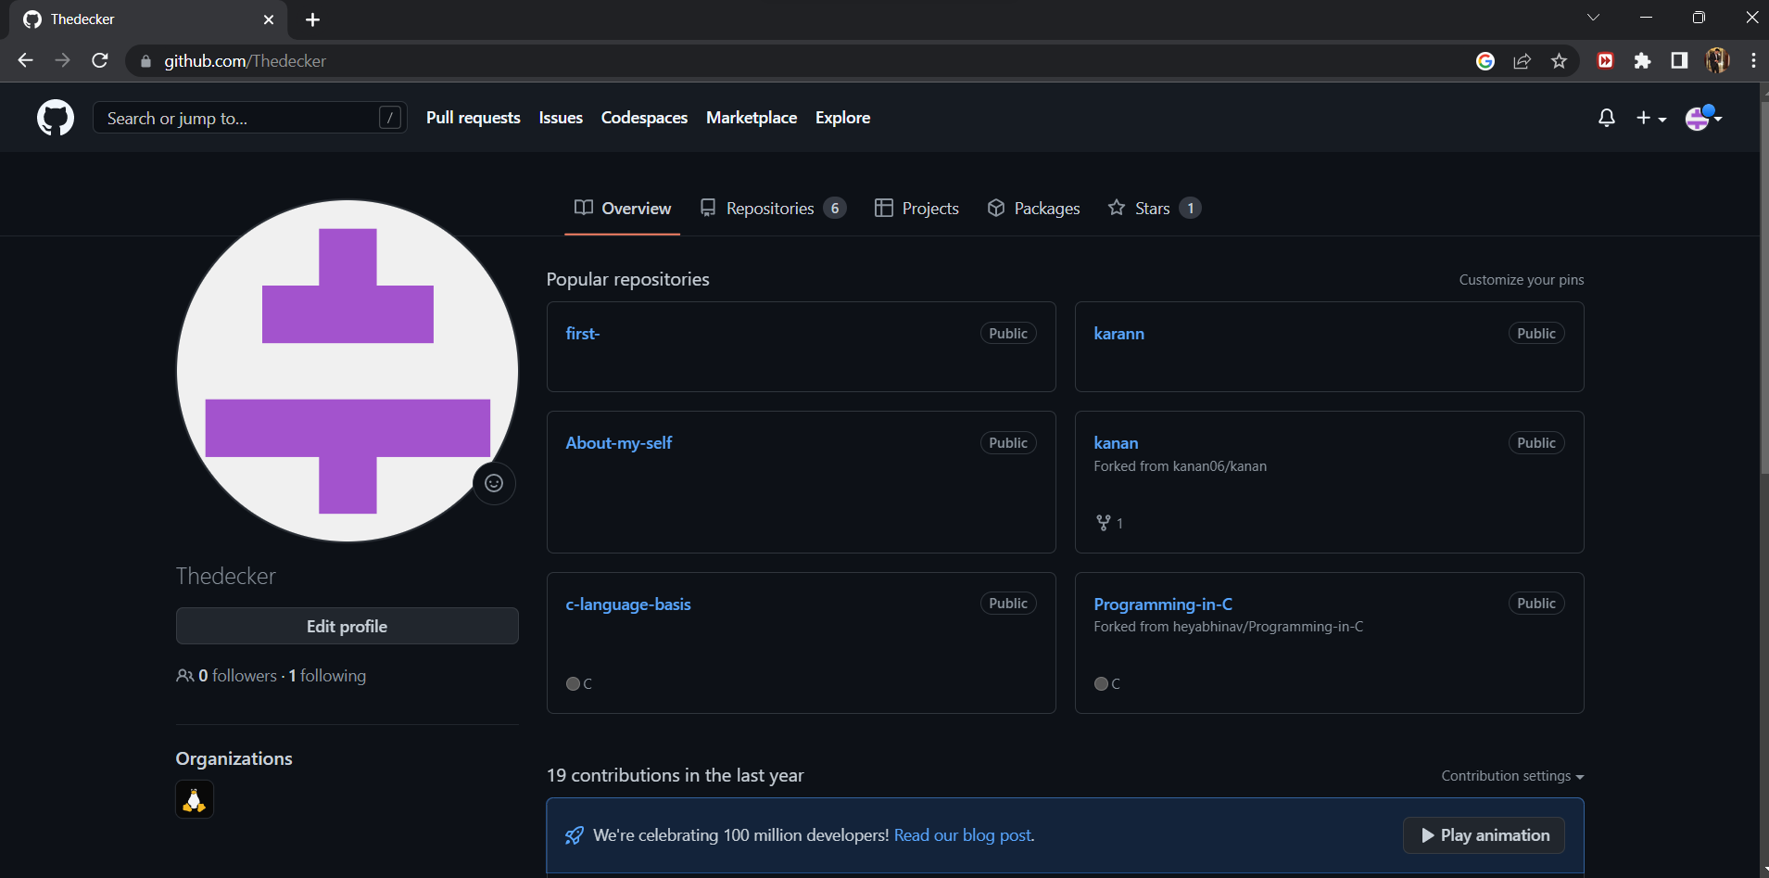

Generate Logs
Theory:
Git Logs:

Logs are nothing but the history which we can see in Git by using the code Git log. It contains all the past commits, insertions and deletion s which can be seen anytime.
Why do we need logs?
Logs help us to check the changes made in code or files and by whom. It also contains the details of insertions and deletions and also the time it was changed at.
Git Status : 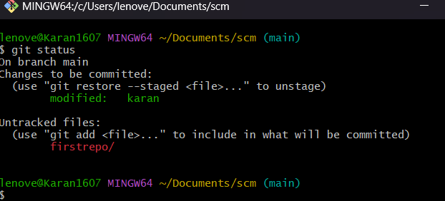
GIT LOG :
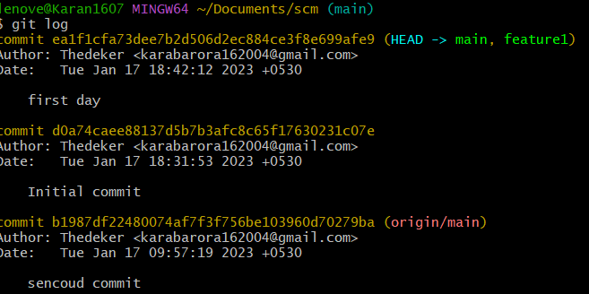
The git log command displays a record of the commits in a Git repository. By default, the git log command displays a commit hash, the commit message and other commit metadata.
CREATE AND VISUALISE BRANCHES
Theory:
How to create branches?
The main branch in git is called the master branch. But we can make branches out of this main master branch. All the files present in master can be shown in branch but the files which are created in branch are not shown in master branch. We can also merge both the parent (master) and child (other branches).
⦁ For creating a new branch: git branch “name of the branch”
⦁ To check how many branch we have: git branch
⦁ To change the present working branch: git checkout “name of the branch”
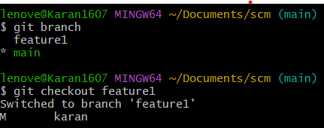
Visualizing branches:
To visualize, we have to create a new file in the new branch “activity” instead of the master branch. After this we have to do three step architecture i.e. working directory, staging area and git repository.
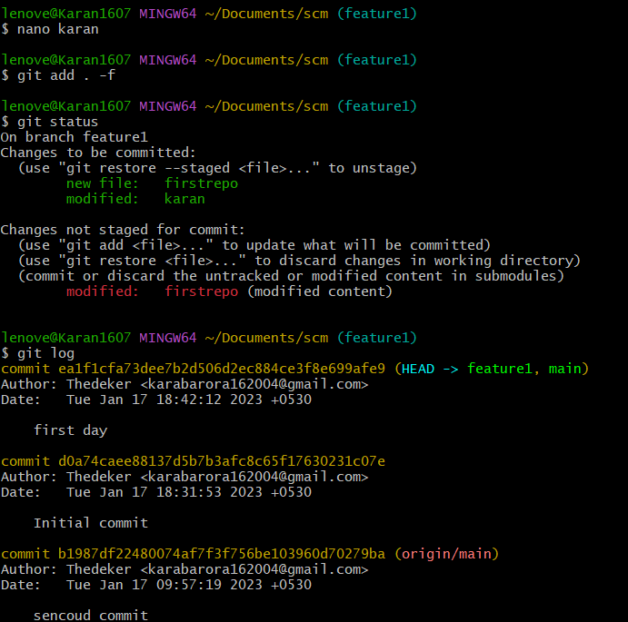

Git Lifecycle Description
Theory:
Stages in GIT Life Cycle: Files in a Git project have various stages like Creation, Modification, Refactoring, and Deletion and so on. Irrespective of whether this project is tracked by Git or not, these phases are still prevalent. However, when a project is under Git version control system, they are present in three major Git states in addition to these basic ones. Here are the three Git states
- Working directory
- Staging area
- Git directory
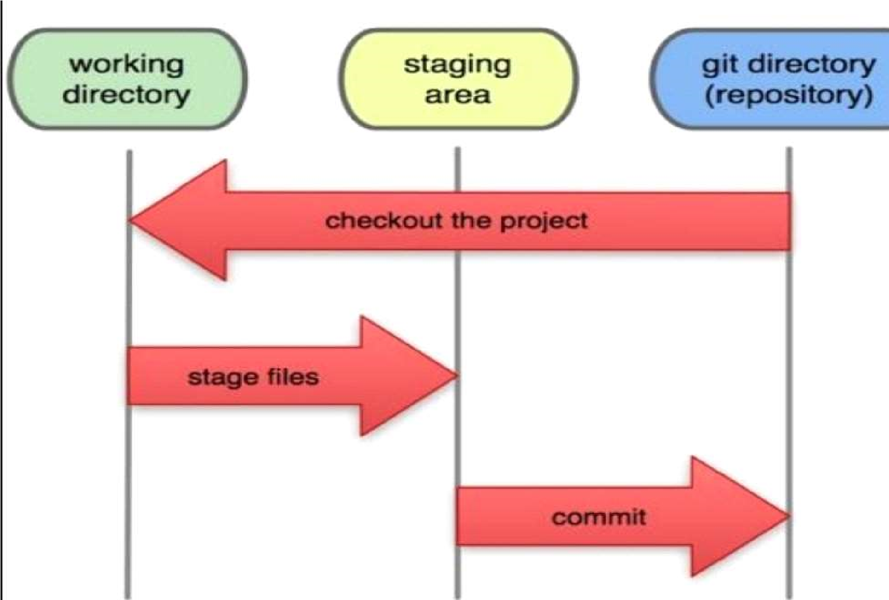
Working Directory: Consider a project residing in your local system. This project may or may not be tracked by Git. In either case, this project directory is called your Working directory.
Staging Area: Staging area is the playground where you group, add and organize the files to be committed to Git for tracking their versions
Git Directory: Now that the files to be committed are grouped and ready in the staging area, we can commit these files. So, we commit this group of files along with a commit message explaining what is the commit about. Apart from commit message, this step also records the author and time of the commit. Now, a snapshot of the files in the commit is recorded by Git. The information related to this commit is stored in the Git directory.
Remote Repository: It means mirror or clone of the local Git repository in GitHub.
And pushing means uploading the commits from local Git repository to remote repository hosted in GitHub.

