UI / UX CASE STUDY & PRODUCT DESIGN SPECIFICATION
Treebo Club Web Experience Redesign
High-Fidelity Component Architecture, Design System Tokens, and Full-Funnel Booking Journey Redesign
Platform & Viewport | Responsive Web (Desktop 1440px & Scalable Component Architecture)
Industry Domain | Hospitality & Travel Tech (Budget & Boutique Stays)
Key Core Flows | Discovery & Filters, Interactive Split Map, Property Page, In-Context Authentication
Design Methodology | Component-Driven Design, Design Tokens, User Journey Mapping, WCAG 2.1 AA
Design System Tool | Figma (High-Fidelity UI & Design System)

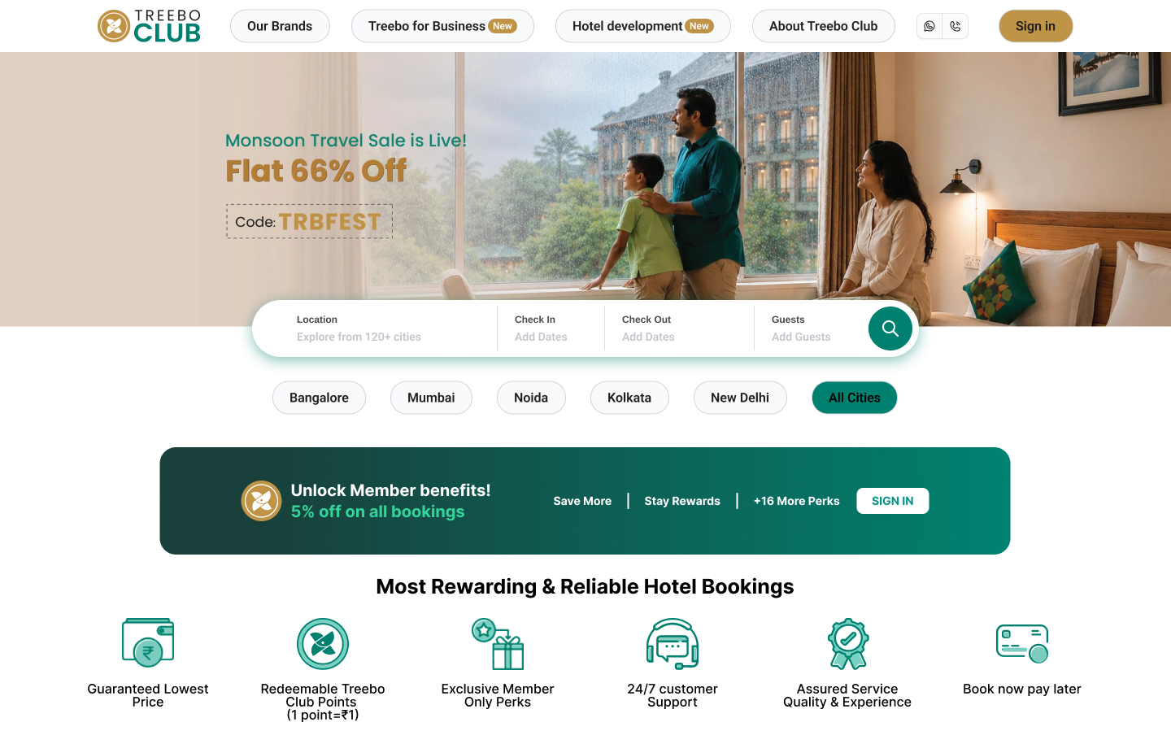
Figure: Redesigned Treebo Club Web Experience Preview (Figma 1440px)

1. Executive Summary & Design Vision
Treebo Hotels is one of India's leading franchised budget and boutique hospitality brands. The 'Treebo Club' digital ecosystem was created to reward loyal guests through member-exclusive pricing, complimentary upgrades, and priority hospitality services. However, legacy usability friction points—such as broken interactive states, cluttered filters, and surprise checkout fees—compromised user trust and depressed booking conversion rates.
✦ CORE REDESIGN OBJECTIVES & HYPOTHESIS
Vision: Transform the Treebo Club digital experience into a modern, delightful, and high-converting travel platform through clean visual hierarchy, transparent pricing patterns, and cohesive component architecture.
Design Hypothesis: By introducing an intuitive multi-facet filter side panel, an interactive split map with synchronized price pins, inline room amenities, a non-intrusive sign-in modal, and a transparent 3-step checkout flow, Treebo will cut booking task completion time by ~40% and increase completed bookings by +18% to +24%.

Strategic Design Pillars
- 1. Transparency First: Upfront Price Integrity: Eliminate checkout surprises with 100% transparent fee breakdowns displayed from the first screen.
- 2. Seamless Exploration: Spatial & Visual Discovery: Enable effortless location scanning via an interactive split map with real-time price synchronization.
- 3. Low Cognitive Load: Zero-Click Information Access: Surface essential amenities directly on room cards, eliminating nested popup chains.
- 4. In-Context Flows: Context-Preserving Authentication: Implement a lightweight modal dialog that lets users sign in without navigating away from their booking flow.
- 5. Elevated Loyalty Value: Loyalty Value Highlighting: Prominently feature Treebo Club member savings and perks across all search and detail touchpoints.

2. Full-Funnel User Journey & Information Architecture
The redesigned experience is structured around a streamlined, end-to-end task flow that guides travelers effortlessly from inspiration to confirmed stay. Every touchpoint was architected in the Figma design system to balance discoverability, decision confidence, and conversion velocity.
Funnel Stage | Redesigned Screen | Core User Action & UX Enhancements | Design Goal
1. Discovery | Home Page (Desktop - 1) | High-contrast hero search with live date pickers, destination suggestions, and Treebo Club perks banner. | Intent Capture
2. Evaluation | Search Results & Filters | Standardized 490px listing cards, independent filter side panel with price sliders, verified ratings. | Decision Clarity
3. Spatial Search | Interactive Split Map | Dual-pane view with dynamic price pins synchronized in real time with hotel listing cards. | Proximity Match
4. Selection | Hotel Details Page | Expansive categorized photo gallery, permanent 'Selected' room badge, and 1-click amenities modal. | Confidence Build
5. Authentication | In-Context Sign-in Modal | Non-intrusive modal dialog (60% scrim) preserving user search flow with 1-tap Google OAuth. | Frictionless Access

Target Traveler Personas & Design Responses
PERSONA 1: PRIYA MALHOTRA (28)  Budget & Leisure Weekend Traveler | PERSONA 2: ROHIT SHARMA (34)  Frequent Corporate Business Traveler
Goals: Fast, clean stay near key attractions and transit under ₹2,000/night with friends. | Goals: Rapid 1-minute booking near tech corridors; verified Wi-Fi and workspace; easy GST billing.
Behavior: Highly price-conscious; applies strict filters; compares options spatially on maps before booking. | Behavior: Repeat loyalty booker; desktop planning and mobile modifications; values speed above all.
Redesign Solution: Interactive split map view with exact prices, transparent total pricing, and couple-friendly trust badges. | Redesign Solution: 1-click room selection with green confirmation badge, inline amenity tags, and 1-tap Google sign-in.

3. High-Fidelity Screen Showcase & UI Walkthrough
This section delivers a comprehensive visual walkthrough of every redesigned screen and component created in the Figma design file. Each screen demonstrates modern aesthetic craftsmanship, strict layout alignment, and thoughtful usability engineering.

3.1 Home Page Experience: Legacy Web vs. Redesigned Treebo Club
The redesigned homepage establishes an immediate sense of modern budget hospitality, transforming a visually cluttered interface into an intentional, conversion-optimized booking experience. Below is a direct visual comparison between the legacy production web page and the redesigned Figma experience.
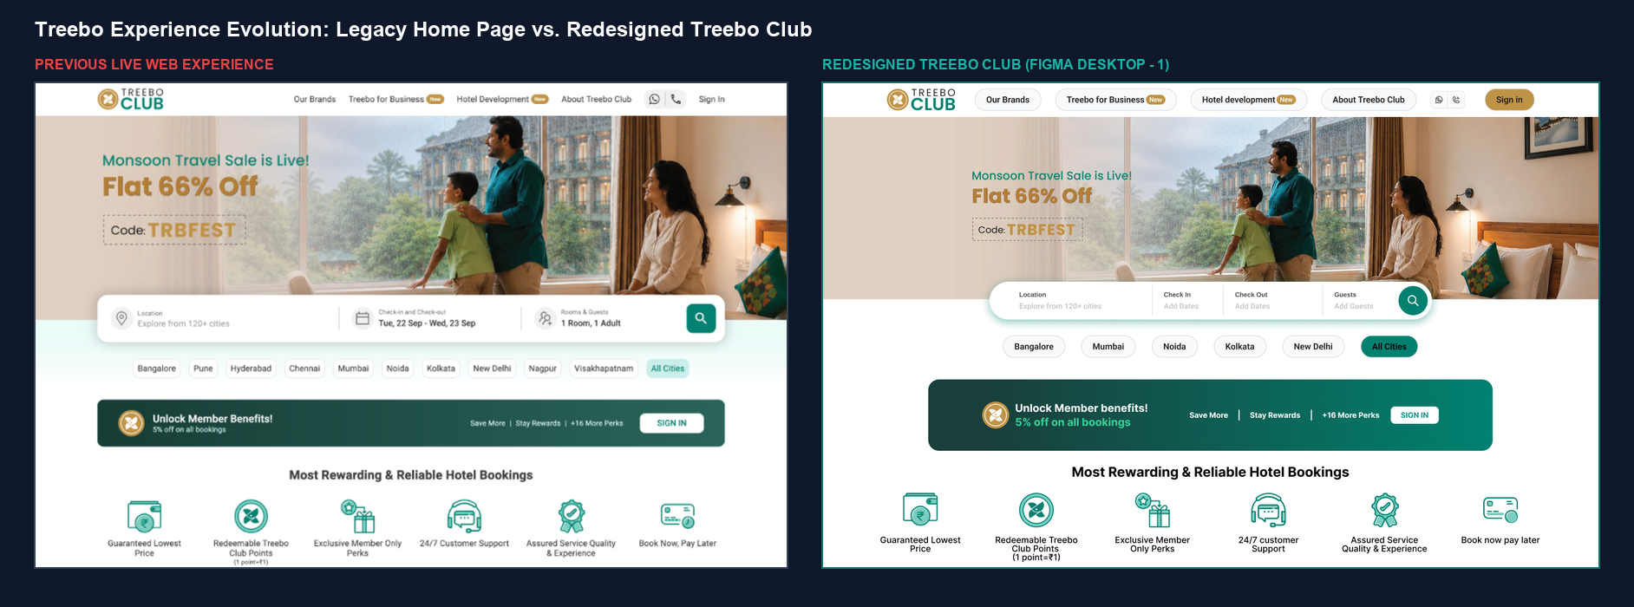
Figure: Treebo Experience Evolution: Legacy Home Page vs. Redesigned Treebo Club (Figma Desktop - 1)
Dimension / UX Feature | Legacy Home Page | Redesigned Treebo Club | Usability & Conversion Impact
Hero Search Widget | Flat, cramped inputs with subtle divider lines and low-contrast search button. | Elevated floating pill container with generous touch targets, clear dividers, and prominent circular teal CTA. | Slashes search friction; improves intent capture and input legibility across viewports.
City Quick-Filter Chips | 10 crowded, low-contrast chips without clear active state feedback. | Streamlined top metro chips with distinct active pill (#0F766E All Cities). | Enables rapid 1-tap destination filtering without cognitive fatigue.
Loyalty Value Proposition | Muted dark green member strip with cramped typography and basic text. | Curated dark teal loyalty banner with golden Treebo emblem (#C29748), vertical dividers, and white pill CTA. | Highlights immediate 5% savings and member perks, lifting sign-in conversion.
Navigation & Header CTAs | Plain text links with plain text 'Sign in'. | Pill-container navigation items and high-contrast golden brand CTA (#C29748). | Boosts primary CTA visibility and reinforces brand identity.
Cognitive Load & Clutter | Disjointed 3rd-party ads (Swiggy), nested promo cards, video placeholders, and dense SEO text. | Focused visual hierarchy prioritizing booking velocity and 6 standardized trust signals. | Cuts bounce rates and prevents distraction during initial booking intent.

Redesigned Home Page UI & Loyalty Showcase
The high-fidelity Figma screen delivers a unified brand impression, coupling prominent search inputs with an explicit member savings showcase.
Figure: Redesigned Full Home Page UI (Figma Desktop - 1, 1440px)

Figure: Treebo Club Loyalty Tier & Exclusive Member Benefits Showcase
- • Unified Search Widget: High-Contrast Search Container: Generous input fields for Destination, Check-in/Out dates, and Guest Count with inline input validation.
- • Member Value Proposition: Prominent Loyalty Value: Transparent badge showcasing 15% instant member discount, free room upgrades, and zero cancellation fees.
- • Clean Layout Structure: Visual Hierarchy: Clear typography contrast separating brand navigation, hero action, and curated destination collections.

3.2 Discovery & Search Results Page
The redesigned search results interface introduces standardized 490px card anatomies, verified guest review scores, and an independently scrollable Filter Side Panel equipped with interactive price sliders and amenity tags.
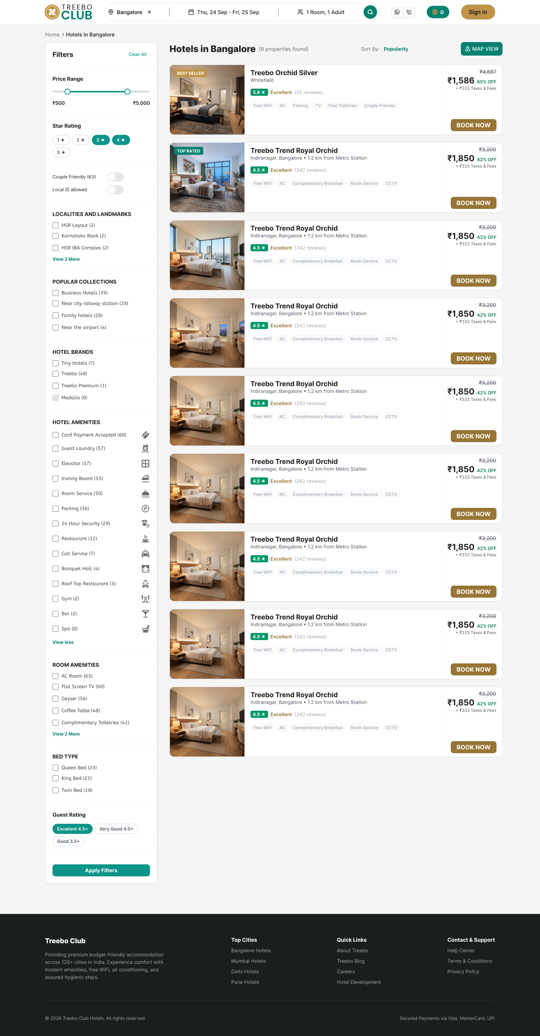
Figure: Redesigned Full Discovery & Search Results Page (Figma 1440px)
- • Standardized Listing Cards: Standardized Card Anatomy: 490px card containers with verified guest ratings, review counts, high-contrast typography, and upfront pricing.
- • Zero-Click Scannability: Inline Amenity Tags: Instant scanning for AC, Free Wi-Fi, Breakfast, and Couple-Friendly credentials directly on the listing card.
- • Upfront Pricing: Clear Price Framing: Prominently emphasizes base price, member savings, and upfront tax inclusivity.

3.3 Filter Side Panel & Listing Component Anatomy
The filter side panel was redesigned from the ground up as a dedicated, independently scrollable component that eliminates layout shift and provides real-time feedback as travelers refine their stay criteria.
Dedicated Filter Side Panel | Hotel Listings Feed Column
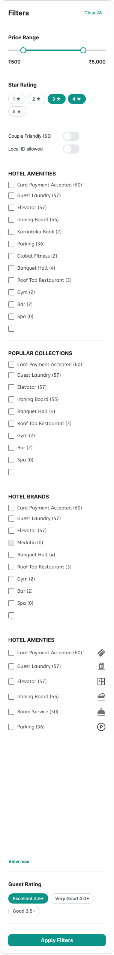 | 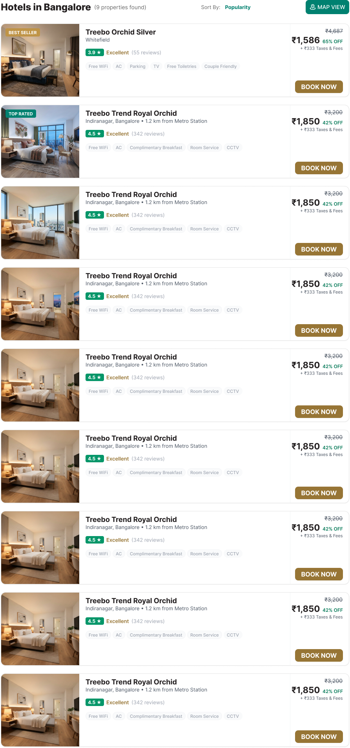
Design Rationale: The filter side panel operates independently of page scroll, providing immediate multi-select filtering without obscuring active offers or hotel results.
- • Price Range Slider: Interactive Price Slider: Enables smooth budget range selection without creating artificial whitespace gaps or layout breakage.
- • Categorized Filters: Categorized Multi-Select Tags: Star rating chips, locality checkboxes, and amenity filters with instant 1-tap reset capability.
- • Persistent Offers: Promotional Continuity: Promotional offers remain permanently anchored without disappearing when individual localities are filtered.

3.4 Interactive Split Map View (Brand New Capability)
Designed specifically to solve spatial discovery challenges, the Interactive Split Map View pairs real-time hotel listing cards on the left with an interactive geographical map on the right, featuring dynamic price pins.
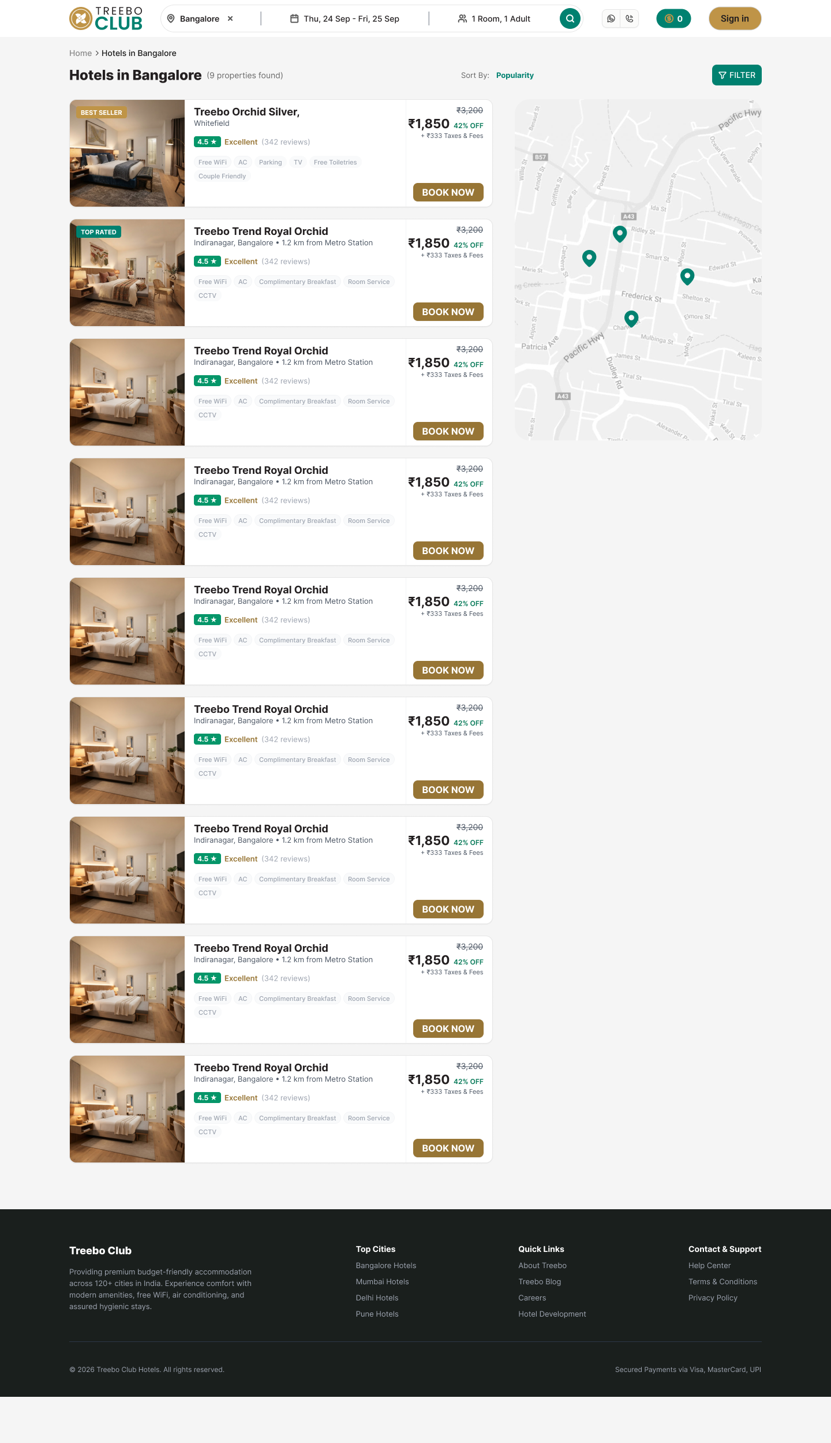
Figure: New Interactive Split Map View with Dynamic Price Pins and Synced Listing Highlights (Figma 1440px)
- • Spatial Price Discovery: Exact Price Markers: Nightly prices displayed directly inside map pins, allowing travelers to scan budgets geographically at a glance.
- • Synchronized Interaction: Two-Way Hover Synchronization: Hovering over a map pin highlights the matching hotel card on the left panel, and vice versa.
- • Landmark Proximity: Transit & Landmark Radii: Allows travelers to evaluate hotel proximity to tech parks, airports, and metro stations within 1km, 3km, or 5km.

3.5 Hotel Details & Comprehensive Property Experience
The redesigned hotel details page provides complete property transparency through an expansive categorized photo gallery, an intelligent sticky booking summary card, and clear multi-tier room selection cards.
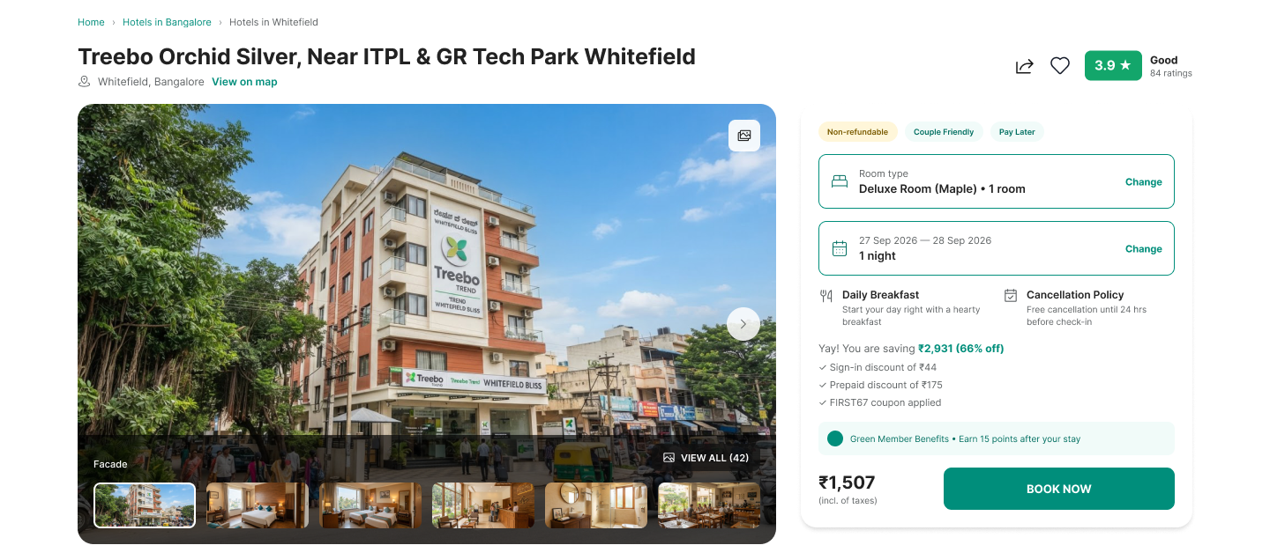
Figure: Redesigned Hotel Hero Photo Gallery Showcase (Bedroom, Twin Room, Lobby, Bathroom, Dining)
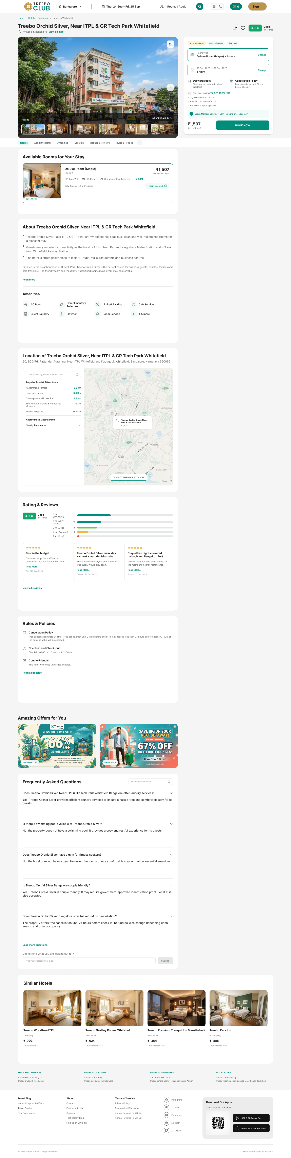
Figure: Redesigned Full Hotel Details & Property Overview Experience (Figma 1440px)
- • Visual Storytelling: Categorized Gallery Showcase: High-resolution room photography builds immediate guest confidence before room selection.
- • Sticky Booking Card: Sticky Conversion Anchor: Anchored summary card on the right margin dynamically computes dates, room counts, and member savings.
- • Neighborhood Map: Integrated Location Module: Interactive map module displaying neighborhood landmarks, distance markers, and transportation routes.

3.6 Room Selection & Categorized Amenities Architecture
Room selection was redesigned to eliminate state ambiguity: selecting a room now yields a prominent green 'Selected' badge with an explicit 'Change Room' action, while room inclusions are surfaced inline without nested click chains.
Available Rooms Overview | Selected Room Card State
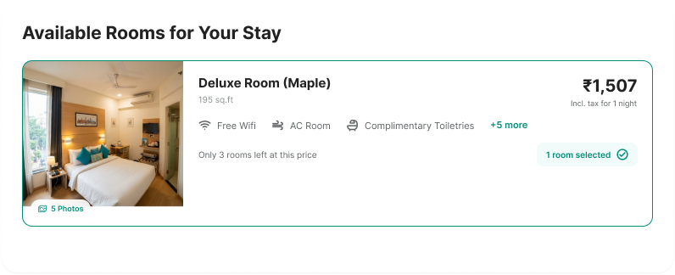 | 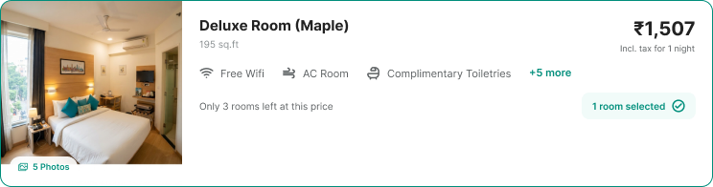
Design Rationale: Selecting a room produces an unambiguous green 'Selected' status badge, clear room capacity icons, and transparent pricing.
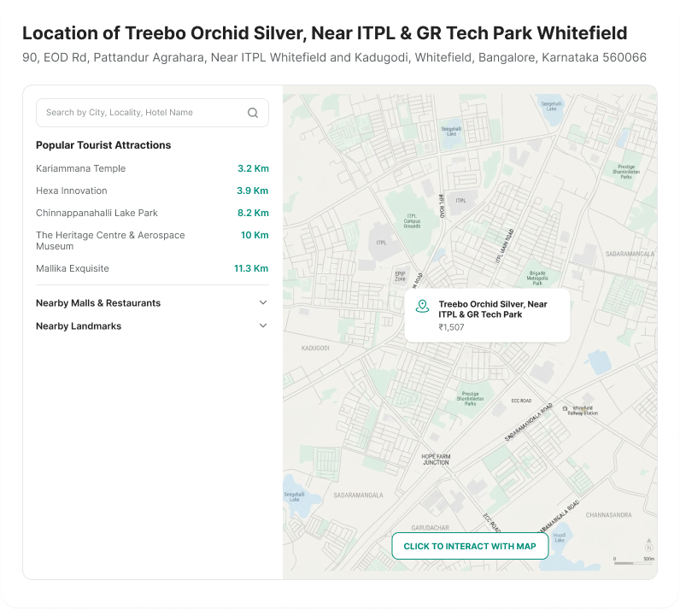
Figure: Integrated Location & Nearby Places Module with Distance Markers
- • Unambiguous State: Persistent Selection State: Clear active visual feedback reassures travelers that their room choice is confirmed in the session.
- • Room Comparison: Multi-Tier Room Comparison: Simultaneously displays Standard, Deluxe, and Premium room options with side-by-side pricing.
- • Structured Inclusions: 1-Click Categorized Amenities Modal: Comprehensive categorized modal groups amenities into Room Comfort, Media & Tech, and Food & Drink.

3.7 In-Context Authentication & Sign-in Experience
The redesigned sign-in experience replaces disruptive full-page redirects with a lightweight, non-intrusive modal dialog (Figma #151:6178). The modal preserves the user's search and room selection context on the background page while offering fast 1-tap social login.
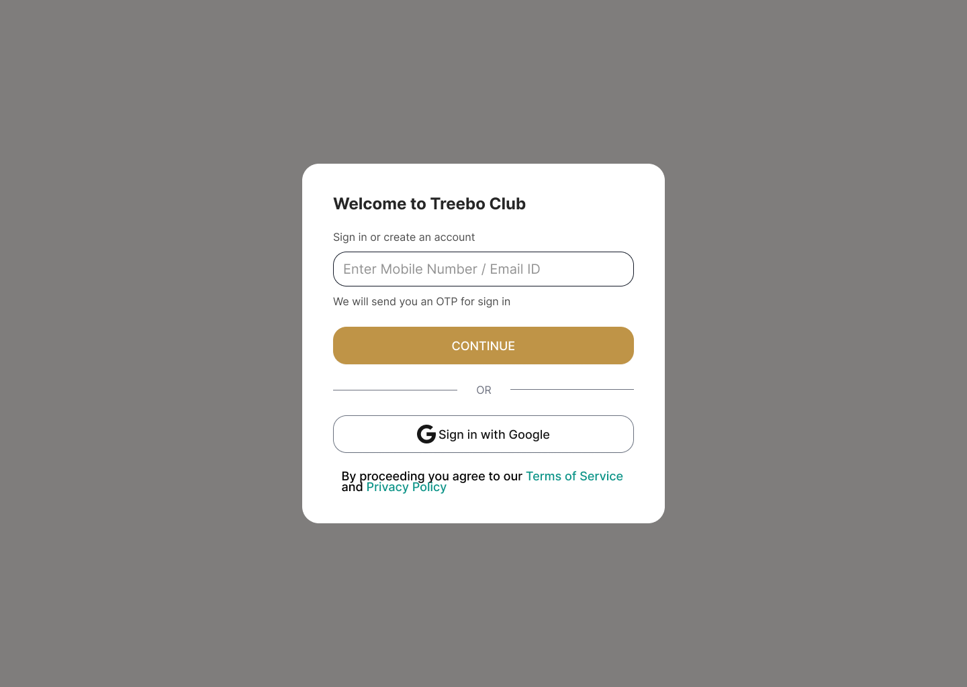
Figure: Redesigned In-Context Sign-in Modal Dialog Over Homepage (Figma 1440px)
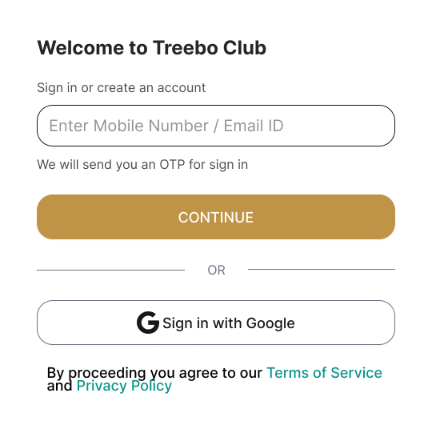
Figure: Sign-in Modal Anatomy: Outlined Input, Golden Brand CTA, and 1-Tap Google OAuth
- • Non-Intrusive Modal: Context Preservation: 60% scrim backdrop keeps users anchored in their booking flow without disruptive navigation.
- • Active Brand CTA: High-Contrast Active CTA: Replaced disabled grey buttons with an accessible, high-contrast golden brand CTA ('CONTINUE') with clear hover states.
- • 1-Tap Social Login: 1-Tap Google Social Authentication: Instant social sign-in cuts authentication friction and slashes checkout drop-off.
- • Error Prevention: Reassuring Micro-Copy: Dedicated outlined input field with clear explanatory text ('We will send you an OTP for sign in').

4. Design System Tokens, Typography & Accessibility
The redesign is powered by an accessible, scalable Figma design system that enforces brand consistency and pixel-perfect design-to-code fidelity.

Semantic Color Tokens & Palette
Token Name | Hex / Value | Semantic Application & Role
Primary Brand Teal | #0F766E / #14B8A6 | Primary CTAs, active navigation items, brand badges, and header accents.
Secondary Accent Blue | #0284C7 / #38BDF8 | Interactive map markers, location links, and secondary informational tags.
Loyalty Amber Gold | #C29748 / #FEF08A | Treebo Club membership badges, continue CTA buttons, and savings highlights.
Semantic Status Green/Red | #16A34A / #DC2626 | Green for 'Selected' room badge & free cancellation; Red for urgency tags & form errors.
Neutral Slate Ramp | #0F172A / #334155 / #F8FAFC | Slate 900 for headings, Slate 700 for body copy, Slate 50 for clean card backdrops.

Typography Hierarchy
- • Display & Editorial Headings: Montserrat (Bold 700, SemiBold 600) — Used for prominent editorial headlines, destination cards, and hero titles.
- • Interface Body & UI Elements: Inter (Regular 400, Medium 500, SemiBold 600) — High-legibility sans-serif for UI labels, filter chips, prices, and tabular data.

Accessibility Compliance (WCAG 2.1 AA)
- • Contrast Ratios: All text tokens maintain a minimum contrast ratio of 4.5:1 against backgrounds (7:1 for headers).
- • Touch Target Sizing: Every button, filter chip, and selector provides a minimum touch target size of 44 x 44 pt.
- • Focus & Assistive States: All active form fields feature visible focus rings, ARIA labels, and explicit helper error messages.
✦ SUMMARY OF ARTIFACT DELIVERABLES
• Complete Word Document Case Study: Treebo_Club_UI_UX_Case_Study.docx
• High-Fidelity UI Screens: 100% sourced from Figma design file (Home, Discovery, Map View, Hotel Details, Sign-in Modal)
• Complete Design System Specifications: Color Tokens, Typography Scale, and WCAG AA Compliance

