Blinkit on the Wrist
Designing a 10-minute experience for a 2-second glance. A watchOS concept for Blinkit.

Overview
Project | Solo UI/UX concept for a course
Platform | Apple Watch (watchOS), 208 × 248 screens
Role | Researcher and designer
Tools | Google Forms, FigJam, Figma
Scope | Reorder, live tracking, OTP handoff, delivery confirmation

The problem
Quick commerce promises delivery in 10 minutes, yet the experience around that promise still depends on the phone. To reorder everyday items like milk or bread, users must unlock their phone, open the app, find the product, and check out. While waiting, they pick the phone up again and again to check the ETA. When the rider arrives, they may be juggling bags, keys, or a door while trying to find and read out an OTP.
These moments are short, repetitive, and often hands-busy, which are exactly the conditions where a phone is slow and a wrist is fast. In my review of the App Store listings for Blinkit, Zepto, and Swiggy Instamart, I found no dedicated Apple Watch app (audit date: add date here), which leaves the wrist an unclaimed surface in Indian quick commerce.

The design challenge
How might we let people reorder their usual items, track their delivery, and complete the handoff in seconds from their wrist, without squeezing the full app onto a tiny screen?

Who, when, where, why
- Who: Urban, time-pressed people who order from quick-commerce apps regularly. In my survey they were mostly students and young professionals in metro and tier 2 cities.
- When: Three short, repeated moments: reordering a usual item, waiting for the rider, and the handoff at the door.
- Where: Wherever the phone is out of reach or out of hand: at home, at work or in a hostel, or at the door with hands full.
- Why: A 10-minute promise is undermined by a 30-second phone routine. A glance at the wrist takes about two seconds.

What I did
- Surveyed 10 quick-commerce users about recent behavior and had them try a prototype.
- Built a persona from the results.
- Turned seven insights into seven design decisions.
- Designed five screens covering the full journey, from reorder to delivered.

User Persona: Riya Sharma
Blinkit on Apple Watch · UI/UX case study · Built from 10 survey responses

Riya Sharma
22 · Final-year design student · Metro city · Orders quick commerce 4-8 times a month
"The delivery went smoothly, but the rider was a bit late. I appreciated the communication, though." (from a respondent's handoff story)

Snapshot
Riya lives in a rented flat near campus and orders from Blinkit and Instamart for snacks, fruit, and the odd household item. Most of her baskets include something she has bought before. She is always between lectures, cooking, or studying, with her phone in her bag or across the room.

Behaviors (what she does)
- Orders 4-8 times a month, and in most orders at least 3 of her last 5 included a repeat item (6 of 9 who answered)
- Checks order status 2-3 times while waiting, mainly for the ETA (5 of 10 checked 2+ times; ETA was the top item looked at)
- Reads notifications and checks a delivery or ride status on a watch or band (4 and 3 of 10)

Frustrations (what slows her down)
- Missing the rider's call, the top handoff problem (7 of 10)
- Maps are hard to read at a glance (7 of 10 found the map screen the most confusing)
- Wants to see an order summary before confirming (from an open-text response)
- Occasional trouble finding the OTP in time (2 of 10)

Goals (what she wants)
- Reorder her usuals in a few seconds, without unlocking her phone
- Know when the rider will arrive without opening the app
- Be alerted the moment the rider arrives, so she doesn't miss the call

Needs from a watch app
Need | Design implication
Fast glance at ETA | Big ETA and progress bar, not a map
Don't miss the rider | Haptic "Rider arrived" alert with OTP shown automatically
Quick repeat ordering | "Your usuals" based on her order history
Confidence before ordering | One-tap order summary and confirm step

A day in her life (scenario)
It's 8:40 p.m. and Riya is mid-assignment when she realizes she's out of snacks. She raises her wrist, sees her usuals, taps two, and confirms. For the next ten minutes she glances at her watch once or twice to check the ETA. When a vibration tells her the rider has arrived and the OTP is already on screen, she walks to the door without hunting for her phone.

What's data and what's assumption
- Backed by data: age group, occupation, order frequency, repeat buying, ETA checking, missed rider calls, map confusion, and the order-summary comment.
- Assumption: that Riya owns a watch you can design for. None of the 10 respondents owned an Apple Watch (3 use Wear OS, 1 a fitness band, 6 have none). In the case study, state this directly and treat the watchOS persona as a design hypothesis to validate with real Apple Watch users.
- Not from data: her name, her exact age (the middle of the 18-24 group), and her living situation. Do not present these as research findings.

Insights and Design Decisions

How the evidence was gathered
I ran a 4-part Google Form survey (demographics, recent behavior, a prototype walkthrough with three tasks, and open feedback). It gathered 10 responses, mostly students aged 18-24 in metro and tier 2 cities. All 10 had used quick commerce, but none owned an Apple Watch (3 use Wear OS, 1 a fitness band, 6 have no watch).
Because the sample is small, every number below is a count out of 10 and should be read as directional, not statistical. Two respondents reported zero orders in the past 30 days, so I excluded them from habit findings and kept only their prototype ratings. One respondent was under 18 and is excluded from anything published.

Key insights at a glance
# | Insight | Evidence
1 | People repeat purchases | 6 of 9 said at least 3 of their last 5 orders had a repeat item
2 | ETA is what people check most | ETA 6, map 4, rider name 2, order contents 2
3 | The map screen confuses people | 7 of 10 picked Arriving as the most confusing screen
4 | Missed rider calls are the main handoff pain | 7 of 10, versus hands full 2 and OTP trouble 2
5 | Watches already carry delivery status | 4 read notifications and 3 checked a delivery or ride status on a watch or band in the past week
6 | Home is the clearest screen | Home 4, Arriving 3, Rider at door 2, Delivered 1

Insight 1: Reordering is repetitive, so don't make people browse
Six of the nine people who answered said at least three of their last five orders included something they had ordered before. This supports the concept's core scope: the watch should handle repeat ordering and leave browsing to the phone. The most recent orders were mostly snacks and drinks (5) and fruit and vegetables (4), ahead of milk (3) and bread and eggs (3). A fixed "morning staples" list would miss what many people actually reorder.

Insight 2: The question on the wrist is "when?"
While waiting, 5 of 10 checked status two or more times, and the ETA was the most-looked-at detail (6 of 10), ahead of the rider's map location (4). People want a number they can read in a glance, not geography.

Insight 3: The map costs more than it gives
The Arriving screen scored lowest on rider-distance clarity (3.7 out of 5 on average) and was named the most confusing screen by 7 of 10 participants. On a small screen the map is hard to read, and it competes with the ETA that people actually want.

Insight 4: The real handoff problem is the missed call
I assumed the pain would be full hands or a hard-to-find OTP. The data points elsewhere: 7 of 10 had missed a rider's call, while only 2 had trouble with the OTP and 2 had full hands. A watch is well suited to this problem because it can interrupt gently at exactly the right moment.

Insight 5: The OTP screen needs stronger hierarchy
OTP ease averaged 3.8 out of 5, with two participants giving it a 2. One respondent also asked for more prominent buttons. The numbers are not alarming, but they show the most important screen in the flow is not yet obvious enough.

Design decisions
Each decision below ties a finding to a change. Where a change goes beyond what the survey tested, I say so.

Decision 1: Replace the map with a glanceable ETA view
- Finding: Insights 2 and 3.
- Before: A small map with an ETA chip and a distance chip layered on top.
- After: A large ETA as the hero element, the distance beneath it, and a simple progress bar showing the rider's journey. A "Continue on iPhone" action opens the full map.
- Why: It serves what people check most and removes the element they found most confusing.
- Trade-off: Less spatial context. The phone handoff covers people who want the map.

Decision 2: Turn the arrival into a haptic moment with the OTP built in
- Finding: Insight 4.
- Before: The OTP appears on a screen the user must navigate to.
- After: When the rider is at the door, the watch taps the wrist and shows the OTP immediately. A one-tap "Coming down" reply tells the rider to wait.
- Why: It addresses the main handoff problem, missed calls, instead of the one I originally assumed.
- Note: The quick reply goes beyond what the survey tested. Treat it as a hypothesis for usability testing.

Decision 3: Rename "Morning staples" to "Your usuals"
- Finding: Insight 1.
- Before: A fixed list of bread, eggs, and milk.
- After: Three items drawn from the person's own order history, so a snack-and-fruit buyer sees snacks and fruit.
- Why: The most recent orders were not mostly breakfast staples, and repeat buying is common.
- Trade-off: It depends on enough order history. New users would see a short fallback list.

Decision 4: Add a confirm step before an order is placed
- Finding: One respondent expected to see an order summary before checkout and could not find it.
- Before: Tapping the + button gives no clear total or confirmation.
- After: A compact summary showing items and the total, with a single confirm action, which reduces the risk of an accidental order.
- Trade-off: One extra tap. This is deliberate on a device where accidental taps are easy.

Decision 5: Give the Delivered screen a real purpose
- Finding: Delivered was the clearest screen for only 1 of 10 and the most confusing for 1.
- Before: A placeholder "Action" button.
- After: A specific primary action, such as "Rate delivery", with "Reorder" as secondary. The delivery time and rider name stay, since they make the moment feel complete.

Decision 6: Keep the home screen as the anchor
- Finding: Home was the clearest screen (4 of 10) and "add milk" was the easiest task (4.1 out of 5).
- Decision: Keep the layout of large, tappable rows with one + per item, and only change the content (Decision 3) and add the confirm step (Decision 4).

Decision 7: Test text and button size on a real watch
- Finding: 7 of 10 said text size was about right, 2 said too large, and 1 said too small. One person asked for more prominent buttons.
- Decision: Hold sizes, increase tap-target emphasis on primary actions, and verify on a physical watch, since most people likely viewed the prototype on a phone.

Final design: screen by screen
The final flow has five screens. Each answers one question the person has at that moment, and each keeps a single primary action.
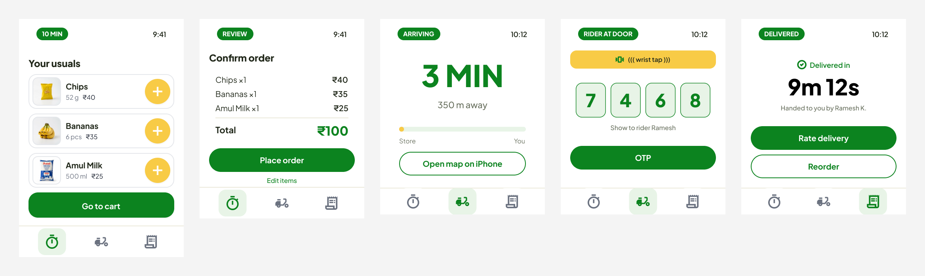
# | Screen | Question it answers | Primary action
1 | Home · Your usuals | What do I usually order? | Add an item, then Go to cart
2 | Confirm order | Is this right? | Place order
3 | Arriving · ETA | When will it get here? | Open map on iPhone
4 | Rider at door · OTP | What do I tell the rider? | Reply to the rider
5 | Delivered | Did it go well? | Rate delivery

1. Home · Your usuals
Open in Figma
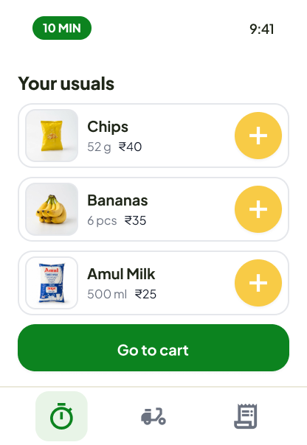
What's on screen: A green "10 MIN" pill and the time in the header, the title "Your usuals", and three product cards with photos (Chips ₹40, Bananas ₹35, Amul Milk ₹25). Each card has a large yellow + button. A full-width green "Go to cart" button sits below the list, above the three-tab navigation.
Why it looks this way:
- Repeat buying is common (6 of 9 respondents), so the screen shows a few likely reorders instead of a catalogue (Decision 3).
- Product photos make items recognizable at a glance, so people don't need to read names.
- Big yellow + targets are easy to hit on a small screen, and "Go to cart" moves the person forward without an extra decision.
- The frame is taller than the watch viewport, so the list scrolls vertically.

2. Confirm order
Open in Figma
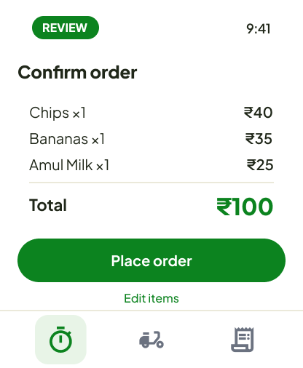
What's on screen: A "REVIEW" pill, the title "Confirm order", a summary of each item with quantity and price (Chips ×1 ₹40, Bananas ×1 ₹35, Amul Milk ×1 ₹25), a divider, the total (₹100) in large green type, a green "Place order" button, and an "Edit items" link.
Why it looks this way:
- One respondent expected an order summary before checkout, and a small screen makes accidental taps easy, so every order passes through one confirm step (Decision 4).
- The total is the biggest element because it is what people check before committing.
- "Edit items" is a quiet text link, so the main path stays clear.

3. Arriving · ETA
Open in Figma
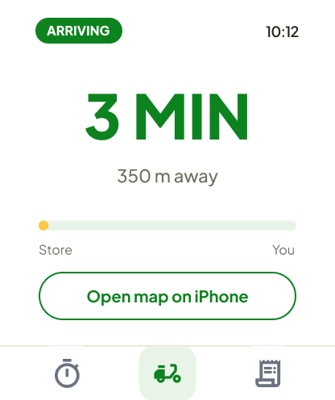
What's on screen: An "ARRIVING" pill and the time, a very large green "3 MIN", the distance ("350 m away"), a progress bar running from Store to You with a yellow rider marker, and an outlined "Open map on iPhone" button. The rider tab is highlighted in the navigation.
Why it looks this way:
- ETA was the most-checked detail (6 of 10), so it is the hero of the screen.
- The map was the most confusing screen (7 of 10), so it is replaced by a simple progress bar. People who want the full map are handed off to the iPhone (Decision 1).
- The primary action is deliberately secondary in weight, because the best experience here is simply looking and leaving.

4. Rider at door · OTP
Open in Figma
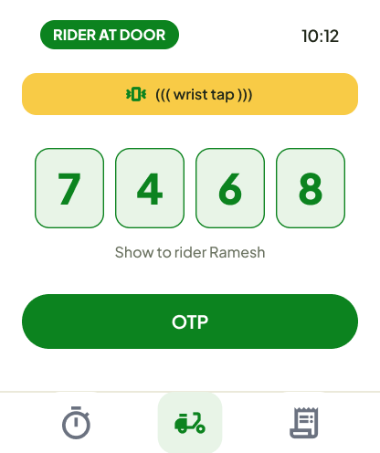
What's on screen: A "RIDER AT DOOR" pill and the time, a yellow banner with a vibration icon and "wrist tap", four large OTP digits in tinted boxes (7 4 6 8), the line "Show to rider Ramesh", and a full-width green primary button.
Why it looks this way:
- The most common handoff problem was a missed call from the rider (7 of 10), not trouble with the OTP. A haptic tap is a gentle, reliable way to interrupt at exactly the right moment (Decision 2).
- The OTP is shown automatically at that moment, in the largest type on the screen, so the person doesn't need to navigate or search.
- The yellow banner marks this as the one screen that interrupts, so it stands apart from the rest of the flow.
- The reply action is a hypothesis beyond what the survey tested and should be validated in usability testing.

5. Delivered
Open in Figma
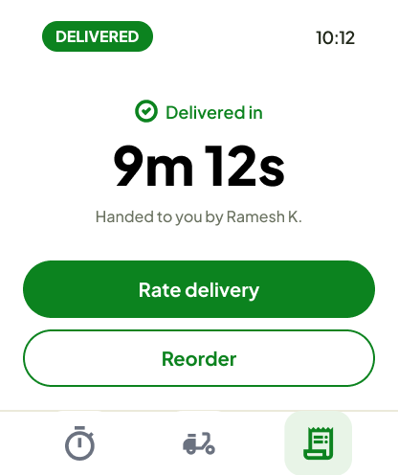
What's on screen: A "DELIVERED" pill and the time, a check icon with "Delivered in", the time "9m 12s" in large type, "Handed to you by Ramesh K.", a green "Rate delivery" button, and an outlined "Reorder" button. The orders tab is highlighted.
Why it looks this way:
- The delivery time closes the loop on the 10-minute promise and is the moment worth celebrating.
- A real primary action ("Rate delivery") replaces a placeholder, and "Reorder" gives repeat buyers an immediate next step (Decision 5).

Design system
All five screens share the same building blocks, which keeps the flow predictable at a glance.
Element | How it is used
Status header | A green status pill on the left and the time on the right. The pill changes with the stage (10 MIN, REVIEW, ARRIVING, RIDER AT DOOR, DELIVERED).
Three-tab navigation | Staples, tracking, and orders, with the active tab highlighted. The same three tabs appear everywhere.
Primary action | A full-width green pill button, one per screen.
Secondary action | An outlined pill button, used for "Open map on iPhone" and "Reorder".
Green | Status, totals, and primary actions.
Yellow | Add buttons, the rider marker, and the wrist-tap alert.
Large type | Reserved for the one thing that matters on each screen: the usuals list, the total, the ETA, the OTP, and the delivery time.

Where the evidence is thin
- No Apple Watch owners. Features specific to watchOS, such as haptics and the Digital Crown, are untested with real users.
- Small sample and mixed recruitment. Ten responses, mostly students, from classmates, communities, and a survey-exchange platform.
- Little qualitative data. Most open-text answers were blank, so reasons behind the ratings are unclear.
- Prototype viewed on a phone. Size and legibility feedback may not carry over to a wrist.

Next steps
- Run 3-5 short moderated usability tests on a real Apple Watch, with the three tasks from the survey plus a "you just missed a call from the rider" scenario.
- Update the Arriving and Rider-at-door screens in Figma and compare them with the originals.
- Add before-and-after screenshots under Decisions 1, 2, 3, and 5.
- Explore a Smart Stack widget and a complication for the ETA, since status checking is the most frequent behavior.

