<My Sushi>

<Jeffrey Morgan>

<UMKC >
<http://www.github.com/TheDonutz/My-Sushi>

Revision History
Last User to make Changes | Date | Summary of Changes
J. Morgan | 2/3/2018 | Initial Product Plan/ Backlog – Creation.
-- | 2/18/2018 | Sprint 1 completed. Entry for changes/review added.

[This section is optional. Revision history may also be recorded as part of version control.]
Table of Contents
Vision Statement 4
Categories of Users 4
Actor-Goal List 4
Stories/Product Backlog 5
Sprint #1 7
Sprint #2 8
Review 8
Retrospective 9

Vision Statement
For Sushi enthusiasts who what to know exactly what they are buying, and what should come in said Sushi-Roll. It will give you a sense of what it looks like, and determine exactly what makes up said sushi. The MySushi app is a easy to use on the go application to help identify sushi by appearance and determine if that is what you ordered! With easy to see pictures and contents with calorie counts for those who wish, MySushi will keep Sushi rollers honest. Unlike other food apps this doesn’t have variety, it is pure Sushi! Our application will make it easy to keep track of multiple sushi rolls, with correct appearance, contents, and with the correct pronunciation to boot!
Requirements

Categories of Users
-Sushi enthusiasts
-MySushi Admins
Estimated Effort-Values
*(1) Story point (=Equivalent) 3 Working Hours.

Actor-Goal List

Actor | Goal
Sushi enthusiasts | Determine if looking for Sushi or Nigiri or Sashimi
 | Browse all of current/local choices of selected category
 | Select a named (*item) and retrieve info page.
 | Look through ingredients and a vocal line of correct pronunciation
 | View calories of (*item)
 | Bookmark so it appears at top of list while searching.
MySushi Admin | Create entries for local sushi
 | Review sushi entry
 | Add in custom voice-line for pronunciation
 | Take photo to use a sushi image.
 | Delete entries created.

Stories/Product Backlog

Story ID | Story | Story Points | Priority | Status
S1 | Activity Layout Creation. | 8 | 1 | 2/11/18
S2 | Creation of all Buttons and function calling. | 8 | 1 | 2/15/18
S3 | Create Standard List of Sushi/Nigiri/Sashimi to Activity of Each Proper Category. | 13 | 1
S4 | Spike (DB: Persistent Storage MySqlLite) Need Case. | 5 | 3
S5 | App Icons | 8 | 5
S6 | Gather all Images Necessary for Standard List of All items. | 8 | 3
S7 | Create Bookmarking Function for User. | 8 | 6
S8 | Insert Ingredient List for Each Item. | 8 | 2
S9 | Import Sound to each Item with correct Pronunciation | 10 | 7
S10 | POC: (Optional Login Screen for Admin users) Viability? | 5 | 3
S11 | Spike: Investigate User Privileges based on Login. | 1 | 3
S12 | Reference: S11 (Create Menu item availability for MySushi Admins) | 5 | 4
S13 | Spike: Create Entries In-App. | 10 | 2
S14 | End-To-End Testing | 8 | 8

Sprint #1
Sprint Backlog
Story ID | Story / Task | Estimated  Hours | Actual  Hours
S1 | Activity Layout Creation.
 | Design UI | 4 | 5
 | Disable Screen-Rotation of App. | 1 | 1
 | Select aesthetic Color Scheme for Sushi. | 1 | 1
 | Junit Testing (If applicable) | 2 | 0
S2 | Creation of all Buttons and function calling.
 | Create Buttons in XML/Strings as Resource. | 2 | 1
 | Generate Button calling to take you to next Activity on Click. | 4 | 2
 | Junit Test of created methods. | 2 | 0

Sprint #2
Sprint Backlog
Story ID | Story / Task | Estimated  Hours | Actual  Hours
S3 | Create Standard List of Sushi/Nigiri/Sashimi to Activity of Each Proper Category.
 | Generate a scrollable screen for Sushi | 1
 | Generate a scrollable screen for Nigiri | 1
 | Generate a scrollable screen for Sashimi | 1
 | Create action button for each item in list | 2
 | Make each item transition to individual activity layout with specific information | 3
 | Create item layout design which all items will possess | 3
 | Brainstorm 3-4 Items for each category to start. | 1
 | Junit Test of created methods. | 4

Review
Iteration1: For the first iteration I wanted to start relatively small to gauge the learning curve and adjusted my hours to reflect working in Android to figure out the way I wanted my app to work. I have it currently working to take you to the 3 different activities but they are empty. I have my menu items of Sushi/Nigiri/Sashimi. I wanted to get a head start on the design for the scrollable Layout, but I’m still in the POC part and should have added in a story for learning different layout designs for menu items. So as for the first sprint I completed it all successfully except for Junit testing. Which for the methods given isn’t necessarily needed at this point in time.

Iteration2: TBA
Iteration3: TBA
Iteration4: TBA
Iteration5: TBA
Iteration6: TBA

Retrospective
What went well? What could have gone better? What lessons did you learn? What do you plan to do differently on the next iteration?
Iteration1: What went well was the initial setup and the time management I allocated to completing the tasks. I accounted for the learning curve, and took in the two easiest stories to make sure I had the process down, when the coding and data entry become more extensive I will have to make sure to allocate my timely wisely. I learned a bit, I currently do this process for my Apprenticeship for Cerner so I have a leg up and knowing not to overcommit and pull in extra stories as needed. For the next iteration now that I have the layout the way I want, disabled screen rotation and enabled this for a portrait only app I will start with the sushi activity and start populating it with data. I will probably keep the same pace of development as it is most comfortable unless told to otherwise. It keeps me active in the process, but not so much where I am overwhelmed with a 15 hour class schedule on top of a full-time job.
Iteration2: TBA
Iteration3: TBA
Iteration4: TBA
Iteration5: TBA
Iteration6: TBA

Project velocity: 10
Design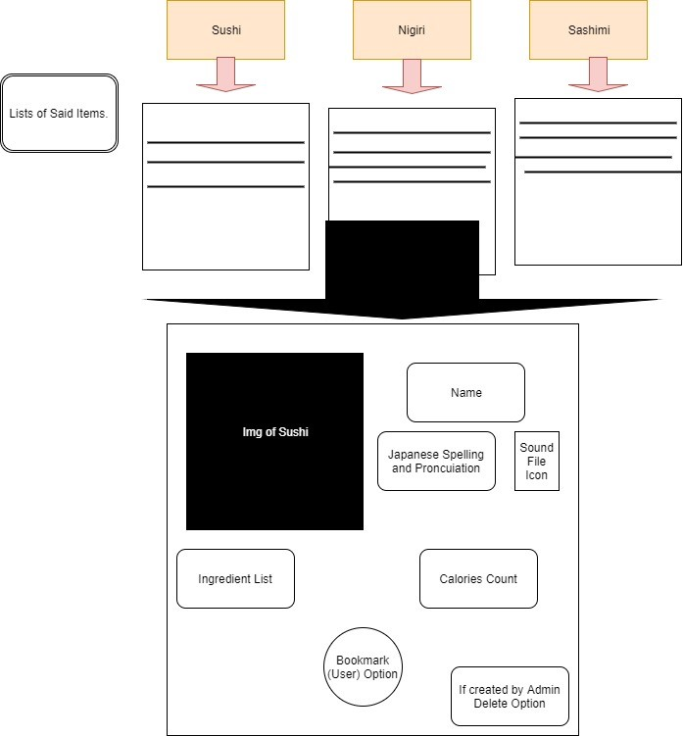

Coding Standards
-Auto-Import
-Test-Driven Development. Each method created, before the next is created will be thoroughly tested through JUnits. After 2+ are created, End to End and integration testing will start taking place. (Will try…)
-Java over Kotlin.
-XML Code first over design view.

