Exp.no: 1.a
AIM: Write a HTML program, to explain the working of lists.
DESCRIPTION:
This HTML document demonstrates the use of different types of lists in HTML. The background of the page is set to yellow, and the content is organized with headings and examples.
The following list types are shown:
- Ordered List (<ol>)
  - Displays a list of items in a numbered order.
  - Example: First item, Second item, Third item.
- Unordered List (<ul>)
  - Displays items with bullets instead of numbers.
  - Example: Apple, Banana, Cherry.
- Nested List (Unordered inside Ordered)
  - Demonstrates combining lists by placing an unordered list inside an ordered list item.
  - Example: Fruits → (Mango, Grapes), Vegetables → (Carrot, Broccoli).
- Nested List (Ordered inside Unordered)
  - Shows how an ordered list can be placed inside an unordered list.
  - Example: Steps to prepare tea → (Boil Water, Add Tea Leaves, Strain and Serve).
- Definition List (<dl>, <dt>, <dd>)
  - Used to define terms and their meanings.
  - Example:
    - HTML → Hyper Text Markup Language
    - CSS → Cascading Style Sheets
    - JavaScript → A scripting language for adding interactivity.

PROGRAM:
<!DOCTYPE html>
<html>
<head>
<meta charset="UTF-8">
<title> HTML LIST EXAMpLE </title>
</head>
<body bgcolor="red">
<h1> Demonstration of HTML lists (24B11CS039) </h1>
<!-- Ordered List-->
<h2>1. Ordered List</h2>
<ol>
<li>First item</li>
<li>Second item</li>
<li>Third item</li>
</ol>
<!-- Unordered List-->
<h2>2. Unordered List</h2>
<ul>
<li>Apple</li>
<li>Banana</li>
<li>Cherry</li>
</ul>
<!-- Nested List-->
<h2>3. Nested List (Unordered Inside Ordered)</h2>
<ol>
<li>Fruits
<ul>
<li>Mango</li>
<li>Grapes</li>
</ul>
</li>
<li>Vegetables
<ul>
<li>Carrot</li>
<li>Broccoli</li>
</ul>
</li>
</ol>
<!-- ordered list inside Unordered list-->
<h2>4. Nested List (ordered Inside Unordered)</h2>
<ul>
<li>Steps to prepare tea:
<ol>
<li>Boil Water</li>
<li>Add Tea leaves</li>
<li>strain ans serve</li>
</ol>
</li>
</ul>
<!-- Definition list-->
<h2>5. Definiton List </h2>
<dl>
<dt>HTML</dt>
<dd>Hyper Text Markup Language , Used to create webpages </dd>
<dt>CSS</dt>
<dd>Cascading Style Sheets , Used to style HTML elements </dd>
<dt>Java Script</dt>
<dd>Hyper A scripting language used to add interactivity to webpages </dd>
</dl>
</body>
</html>
OUTPUT:
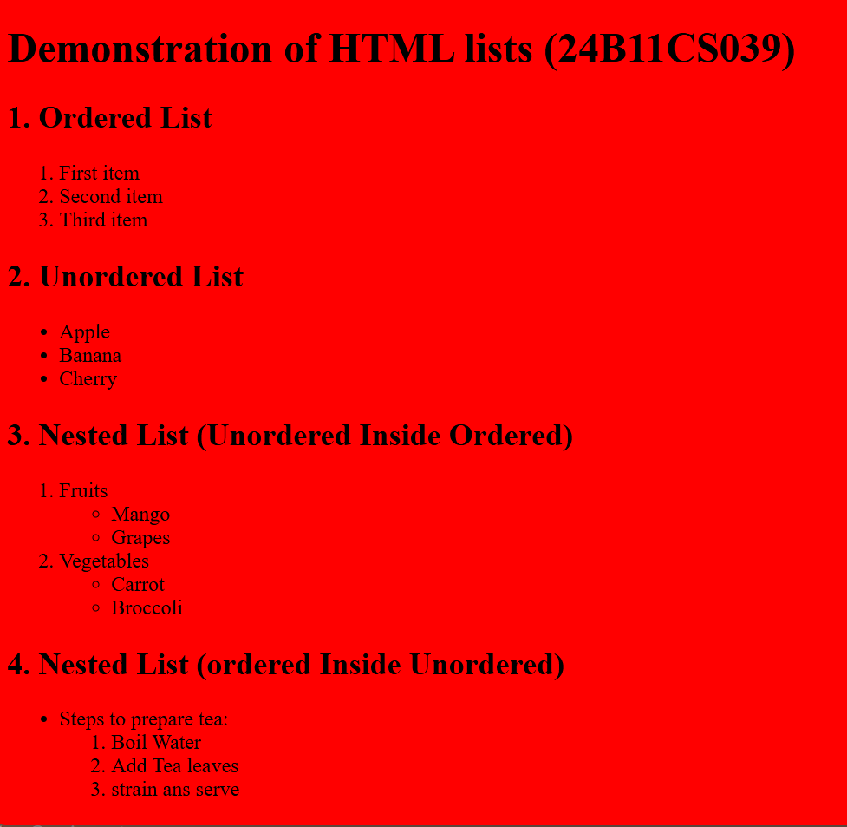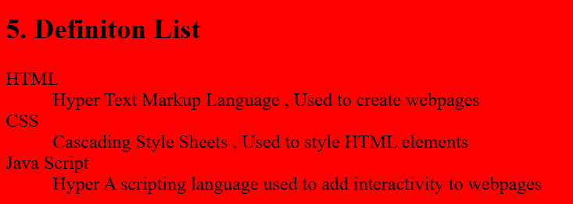

RESULT:

Exp.no: 1.b
AIM: Write a HTML program, to explain the working of hyperlinks using <a> tag and href, target Attributes.
DESCRIPTION:
This HTML document demonstrates the use of hyperlinks (<a> tag) in two different ways — text links and image links.
- Heading
  - The page starts with a main heading: “Demonstrating Hyperlinks in HTML (24B11CS039)”.
- Text Hyperlink
  - A clickable text link is created using the <a> tag with the href attribute.
  - Example: Visit Aditya Engineering College Website → clicking the text redirects the user to the official website.
- Image Hyperlink
  - Shows how an image or text can be used as a hyperlink.
  - The code uses the <a> tag with the href attribute pointing to an external webpage.
  - When clicked, it should open the Gallery Page (AEC site) in a new tab (target="_blank")

PROGRAM:

<!DOCTYPE html>
<html lang="en">
<head>
<meta charset="UTF-8">
<title>Hyperlink Example</title>
</head>
<body>

<h1>Demonstrating Hyperlinks in HTML (24B11CS039)</h1>
<!-- Text Hyperlink -->
<h2>1. Text Link using</h2>
<p>
Visit <a href="https://adityauniversity.in/">Aditya Engineering College Website</a>.
</p>
<!-- Image Hyperlink -->
<h2>2. Image Link using &lt;a&gt; and href</h2>
<p>
Click the image below to visit the <strong>Gallery Page</strong>:
<a hrefc:"\Users\DEEVENA\OneDrive\Documents\Downloads\WhatsApp Image 2025-09-01 at 23.35.42_e62f2ad7.jpg " target="_blank">Photo
</p>
<a href="https://www.aec.edu.in">
</body>
</html>

OUTPUT:

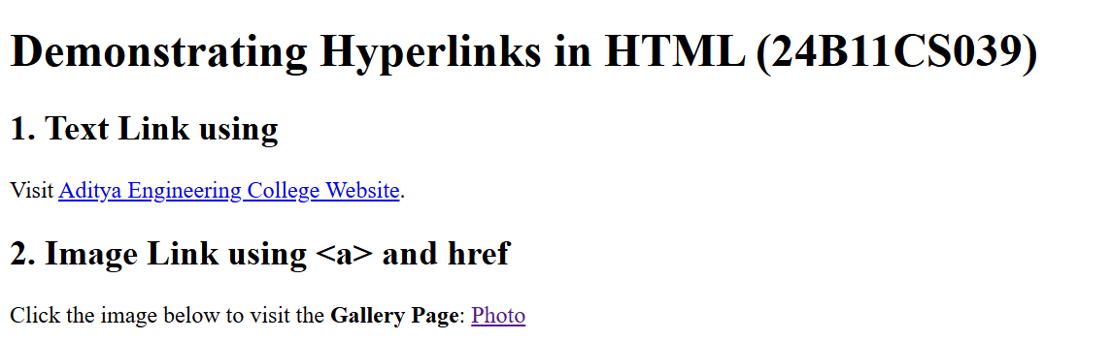
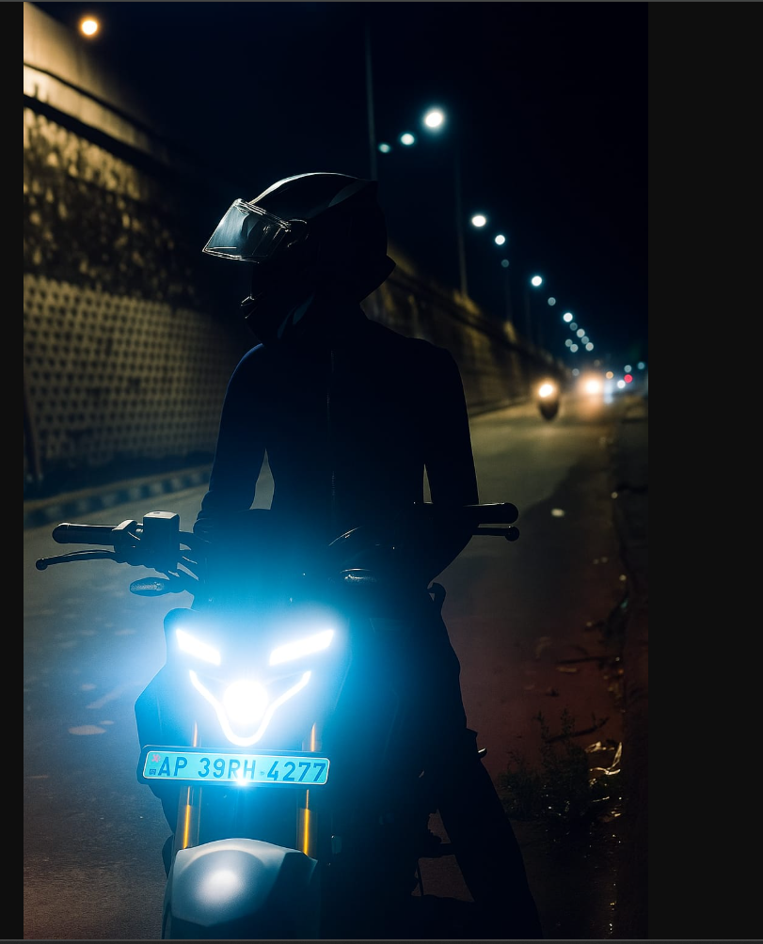
RESULT

Exp.no: 1.c
AIM: Write a HTML program, to explain the working of hyperlinks using <a> tag and href, target Attributes.
DESCRIPTION:
This HTML document creates a simple profile page with clickable images that act as hyperlinks to social media profiles. The background color of the page is set to yellow.
- Heading
  - Displays the title “My profile and My Friend's profile”.
- My Profile (Instagram link)
  - An <a> tag with the href attribute links to your Instagram profile.
  - Inside it, an <img> tag is used to display your profile picture.
  - When the image is clicked, it opens your Instagram page in a new browser tab (target="_blank").
- Friend’s Profile (LinkedIn link)
  - Another <a> tag links to your friend’s LinkedIn profile.
  - An image is displayed, and clicking on it redirects to the LinkedIn page in a new tab.

PROGRAM:
<!DOCTYPE html>
<html lang="en">
<head>
<meta charset="UTF-8">
<title>PROFILE</title>

</head>
<body bgcolor="orange">

<h1>My profile and My Friend's profile (24B11CS039)</h1>

<!-- My profile -->

<a href="https://www.instagram.com/mahi._.003._/
" target="_blank">
<img src="c:\Users\DEEVENA\OneDrive\Documents\Downloads\WhatsApp Image 2025-09-01 at 23.35.42_e62f2ad7.jpg
" width="150" height="150">
</a>
<!-- My profile -->

<a href="https://www.instagram.com/___.eevs._/?next=%2F " target="_blank">
<img src="c:\Users\DEEVENA\OneDrive\画像\me.jpg
" width="150" height="150">
</a>

</body>
</html>

OUTPUT:

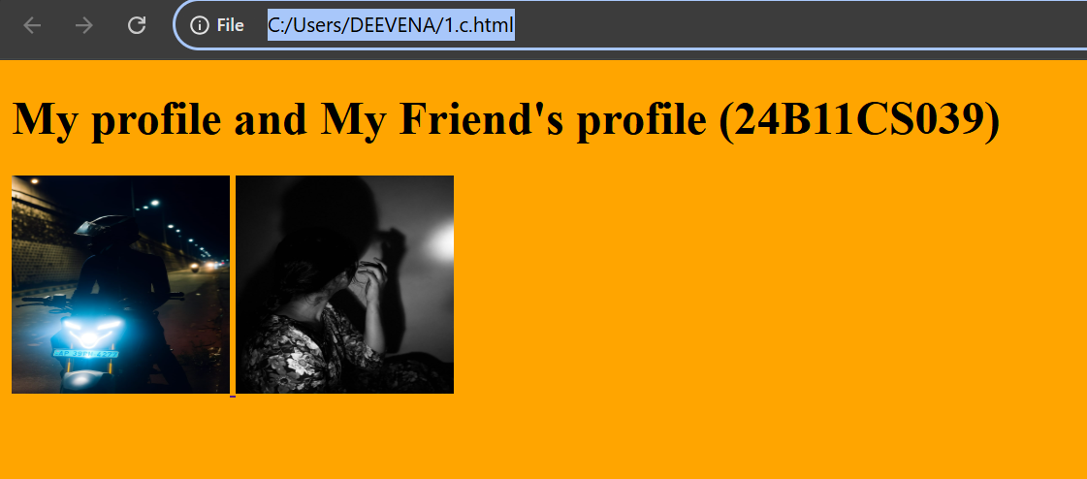

RESULT:

Exp.no: 1.d
AIM: Write a HTML program, in such a way that, rather than placing large images on a page, the preferred technique is to use thumbnails by setting the height and width parameters to something like to 100*100 pixels. Each thumbnail image is also a link to a full sized version of the image. Create an image gallery using this technique.
DESCRIPTION:
This HTML document creates a thumbnail image gallery where users can click small images (thumbnails) to open the full-sized images in a new tab. It also applies styling with CSS to make the gallery visually appealing.

🔑 Key Features:
- Page Setup
  - Title: Thumbnail Image Gallery.
  - Heading (<h1>) → “My Image Gallery (24B11CS002)”.
  - Paragraph explains → “Click on a thumbnail to view the full-sized image”.
- CSS Styling (<style>)
  - Uses flexbox (display: flex; flex-wrap: wrap; justify-content: center;) for arranging thumbnails neatly.
  - Adds gap of 15px between images.
  - Thumbnails styled with:
    - Fixed size → 100px × 100px.
    - Rounded corners (border-radius: 8px).
    - Border (2px solid #ccc).
    - Smooth hover effect → image enlarges (transform: scale(1.2)) and border color changes.
- Gallery Section (<div class="gallery">)
  - Each image is wrapped in an <a> tag.
  - Clicking the thumbnail opens the full image in a new tab (target="_blank").

PROGRAM:
<!DOCTYPE html>
<html lang="en">
<head>
<meta charset="UTF-8">
<title>Thumbnail Image Gallery</title>
<style>
body{
font-family: arial,sans-serif;
text-align: center;
}
.gallery{
display: flex;
flex-wrap: wrap;
justify-content: center;
gap: 15px;
margin-top: 20px;
}
.gallery a img{
width: 100px;
height: 100px;
object-fit: cover;
border: 2px solid #ccc;
border-radius: 8px;
transition:transform 0.3s;
}
.gallery a img:hover{
transform: scale(1.2);
border-color: #666;
}

</style>
</head>
<body >
<h1>My image Gallery (24B11CS039)</h1>
<p>Click on a thumbnail to view the full- sized image</p>

<div class="Gallery">
<a href="c:\Users\DEEVENA\OneDrive\Documents\Downloads\WhatsApp Image 2025-09-01 at 23.35.42_e62f2ad7.jpg" target="_blank">
<img src="c:\Users\DEEVENA\OneDrive\Documents\Downloads\WhatsApp Image 2025-09-01 at 23.35.42_e62f2ad7.jpg" alt="Image 1" width="100" height="100">
</a>

<a href="c:\Users\DEEVENA\OneDrive\画像\Saved Pictures\WhatsApp Image 2024-08-18 at 20.49.04_2c01efd2.jpg" target="_blank">
<img src="c:\Users\DEEVENA\OneDrive\画像\Saved Pictures\WhatsApp Image 2024-08-18 at 20.49.04_2c01efd2.jpg" alt="Image 2" width="100" height="100">
</a>

<a href="c:\Users\DEEVENA\OneDrive\画像\Saved Pictures\WhatsApp Image 2024-08-18 at 20.55.28_e3cc0d57.jpg" target="_blank">
<img src="c:\Users\DEEVENA\OneDrive\画像\Saved Pictures\WhatsApp Image 2024-08-18 at 20.55.28_e3cc0d57.jpg" alt="Image 3" width="100" height="100">
</a>

<a href="c:\Users\DEEVENA\Downloads\ChatGPT Image Mar 29, 2025, 08_12_49 PM.png" target="_blank">
<img src="c:\Users\DEEVENA\Downloads\ChatGPT Image Mar 29, 2025, 08_12_49 PM.png" alt="Image 4" width="100" height="100">
</a>

<a href="c:\Users\DEEVENA\Downloads\piclumen-1738220006448.png" target="_blank">
<img src="c:\Users\DEEVENA\Downloads\piclumen-1738220006448.png" alt="Image 4" width="100" height="100">
</a>

</body>
</html>
OUTPUT:

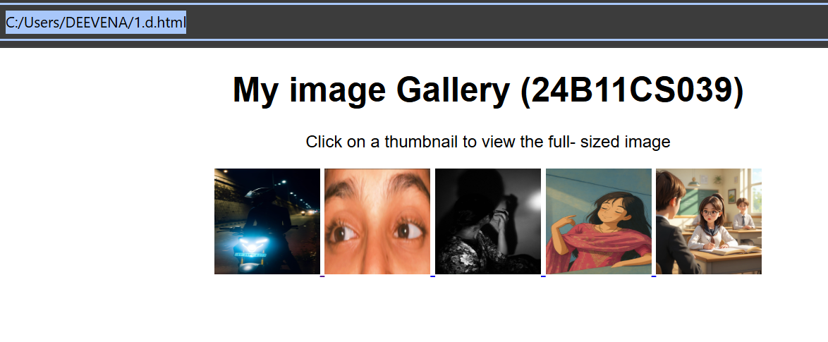
RESULT:

